MUH-1 Certification

TCM

Sunday, July 20, 2014

# Automated analysing submitted data for MUH-1 based on defined outliers

Thomas Meisel (2014-08-03)

### defining the RM and measurand to be analysed

refmat <- 'MUH' # defining the RM

opts_chunk$set(dev="png",dev.args=list(type="cairo"), dpi=300) options(base64_images = 'inline') ### general comments to the design

The data for this interlaboratory comparison based certification of property values were analysed by 36 labs following the nested design approached as proposed the IAG certification protocol. Participating labs received 3 packages of OKUM and MUH-1 respectively and one package of GAS. The latter was supplied as a "traceablility" sample and is here used for quality control purposes. It was the task of the labs to prepare two independent sample preparations (i.e. digstions) of each packet and analyse the preparations on two different days. Labs thus should have submitted 12 values (3x2x2 PacketxPrepxDay). The outliers have been selected based in Youden plots, Mandel's k and detection limit criteria. In this file the property values and the uncertainties are calculated for all analytes of a specific candidate MUH

'%p%' <- function(x, y) {as.character(paste (x, y, sep =""))}  
df <- data.frame(cbind(0,0,0,0,0,0,0,0,0,0,0,0,0,0,0,0,0,0,0,0))  
names(df) <- c("date", "RM", "measurand", "mean.before", "mean.after", "median.before", "median.after", "median.after.noPP", "unit", "sL", "sbb", "sr", "u", "u.alternative", "t.value", "outlier", "labs remaining", "based on", "property value", "U") # needed only the first time  
df <- df[!1,]  
write.table(df, "df1.txt", row.names=FALSE) # needed only the first time

# Data for certification project was gathered and joined in Excel. The files  
# were exported from Excel as xxxx.csv files to make them universially  
# readable. For this markdown the data is stored in the 'root/documents'  
# directory. Data is loaded ('GOMGather1.R') and merged ('GOMMerge.R') for  
# GAS, OKUM and MUH-1 are merged together with a methods file  
# ('OKUM.method') into a universal data.frame file named 'GOM'. All of this  
# happens in the 'Makefile.R'

#### importing the data and assigning factors

source("Makefile.R")

#### defining the function for plotting methods vs. measurand mass fraction. Sample preparation methods are also marked in the plot.

#### defining the function of Youden plots

#### initial calculations with complete data set

## means over packets within lab   
meanGOM <- function(x) mean(x, na.rm=TRUE) # defining a function for further calcuations  
sdGOM <- function(x) sd(x, na.rm=TRUE) # defining a function for further calcuations, here for calculating standard deviations needed for Youden plot  
meanGOM.packet <- ddply(GOM, c("Lab", "Packet"), numcolwise(meanGOM)) # calculated the mean for each Packet within each Lab by calculating the mean of days and preparations lumped together  
## mean over mean of packets within lab  
GOM.mean <- ddply(meanGOM.packet, c("Lab"), numcolwise(meanGOM))  
GOM.mean <- merge(GOM.mean, OKUM.methods, by="Lab")

## median over packets within lab   
medianGOM <- function(x) median(x, na.rm=TRUE)  
medianGOM.packet <- ddply(GOM, c("Lab", "Packet"), numcolwise(medianGOM))  
GOM.sd <- ddply(medianGOM.packet, c("Lab"), numcolwise(sdGOM))  
## median over median of packets within lab  
GOM.median <- ddply(medianGOM.packet, c("Lab"), numcolwise(medianGOM))  
GOM.median <- merge(GOM.median, OKUM.methods, by="Lab")

### plots before outlier removal and outlier removal

sequence <- seq(from = 1, to = length(names(MUH.outlier)), by = 3)  
col <- MUH.outlier[,c(sequence)]  
col.names <- colnames(col)  
for (m in col.names) {  
 measurand.name <- m  
 switch(  
 refmat,  
 GAS = rm1 <- 2,  
 MUH = rm1 <- 1,  
 OKUM = rm1 <- 0  
 )  
 if(rm1 > 0)   
 {measurand <- measurand.name %p% '.' %p% rm1  
 } else   
 {  
 measurand <- measurand.name  
 }  
 MorT <- grep(measurand.name, colnames(GOM), fixed=TRUE) # finding the position of the measurand.name in the Columnheaders of data frame GOM  
 ifelse(MorT[1]< 21, MorT <- 'M', MorT<-'T') # testing if measurand is a major or trace element/compound (col:5-20 majors)  
 ifelse(MorT == "T", unit <- 'mg/kg', unit <- 'g/100g') # testing which unit is needed   
  
print(plot_method(measurand))  
  
# outlier removal  
  
outlier <- MUH.outlier[[measurand.name]]  
outlier <- na.omit(outlier)  
leng <- length(outlier) ## counting the number of outliers for loop  
for(i in seq(leng)) ## looping  
 {  
 GOM[[measurand]] <- ifelse(GOM$Lab==outlier[i], NA, GOM[[measurand]]) ## replacing values of outlying lab with "NA" and defining new GOM  
 message("Lab ", outlier[i], " was removed")  
# print(summary(GOM[[measurand]], na.rm=TRUE, digits=4))  
 }  
}

## Warning: Removed 24 rows containing missing values (geom_point).

## Lab 0 was removed

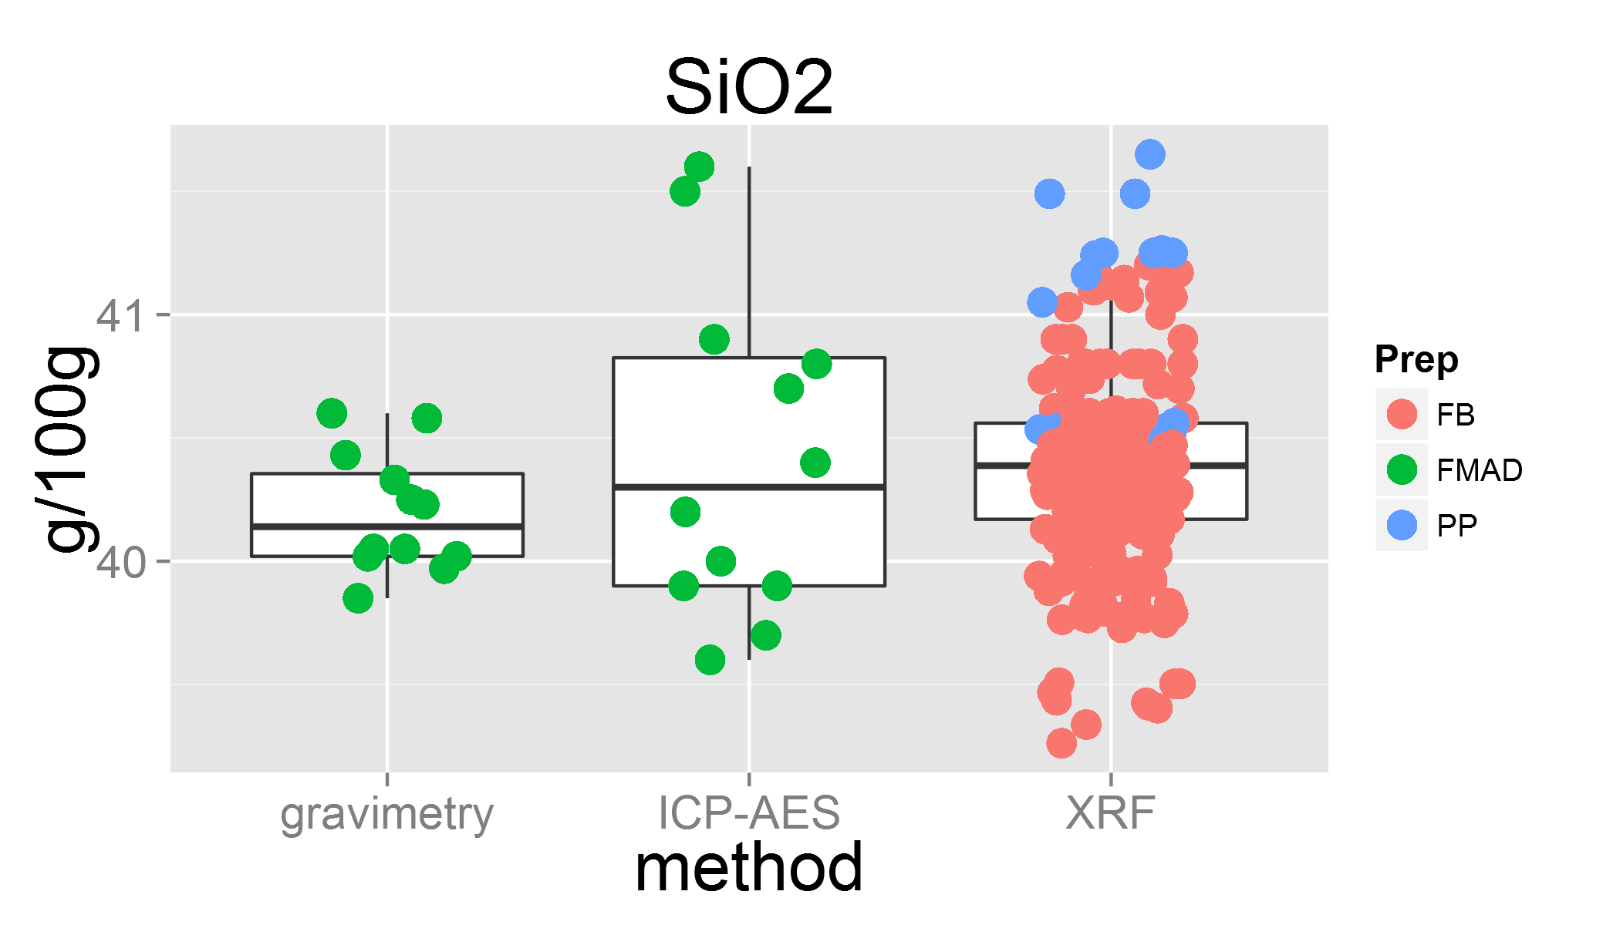

plot of chunk unnamed-chunk-3

## Warning: Removed 11 rows containing missing values (geom_point).

## Lab 12 was removed  
## Lab 23 was removed

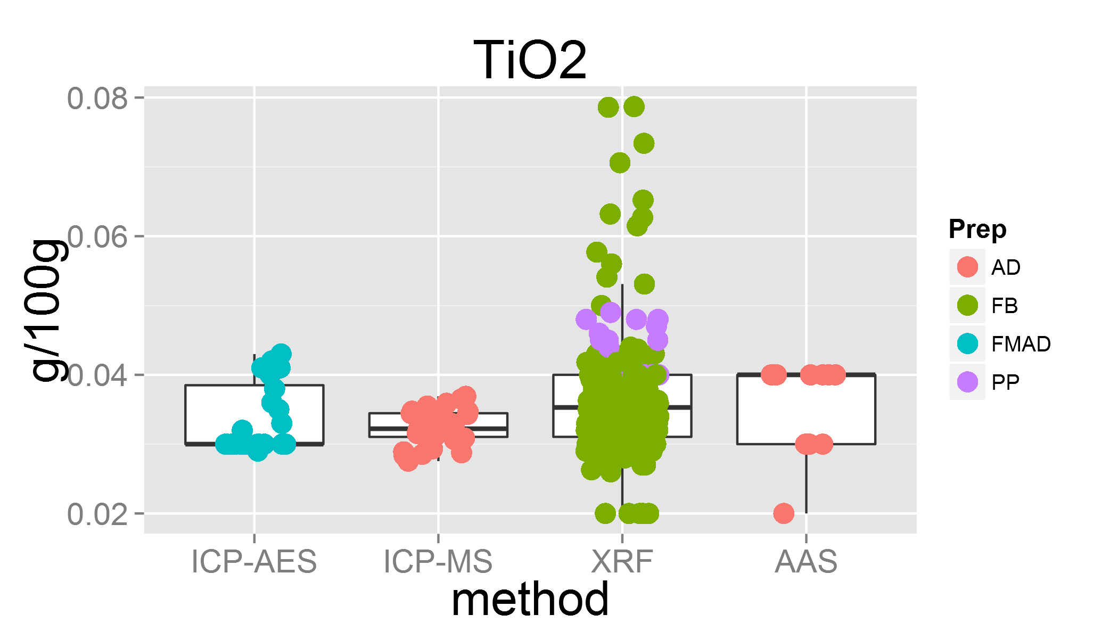

plot of chunk unnamed-chunk-3

## Warning: Removed 22 rows containing missing values (geom_point).

## Lab 12 was removed  
## Lab 14 was removed  
## Lab 31 was removed

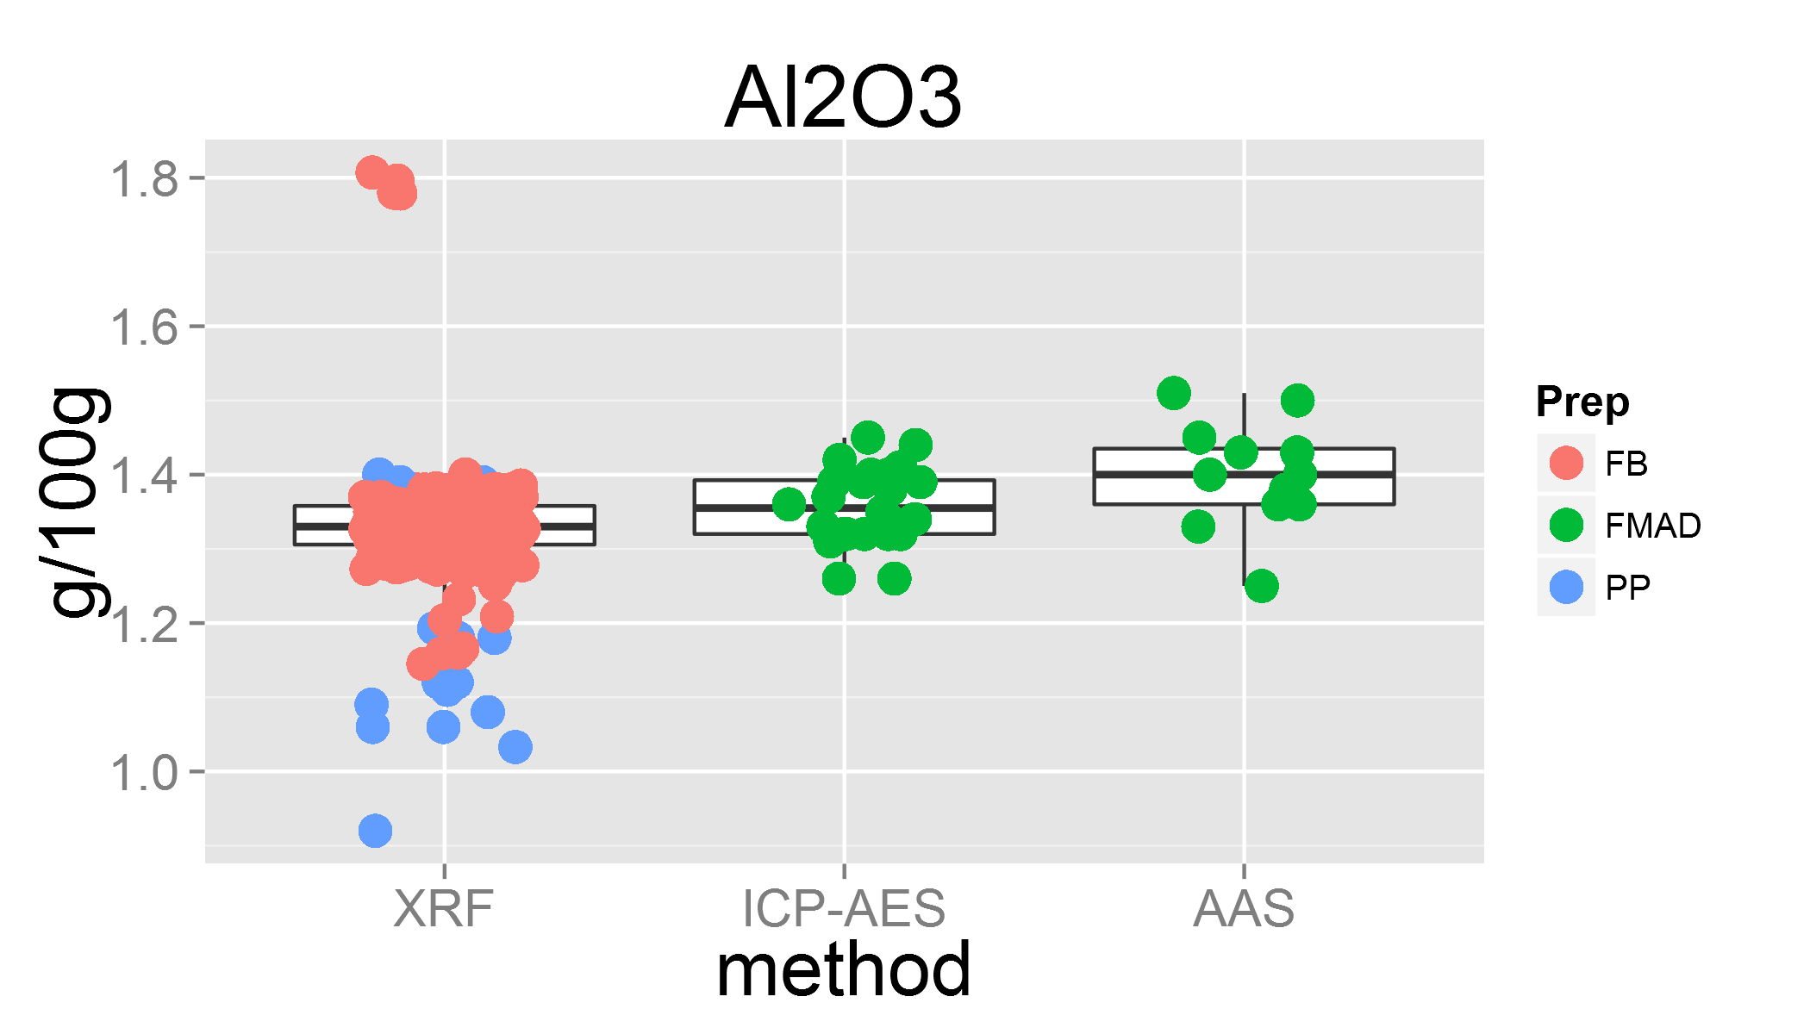

plot of chunk unnamed-chunk-3

## Warning: Removed 1 rows containing missing values (geom_point).  
## Warning: Removed 14 rows containing missing values (geom_point).

## Lab 16 was removed  
## Lab 31 was removed

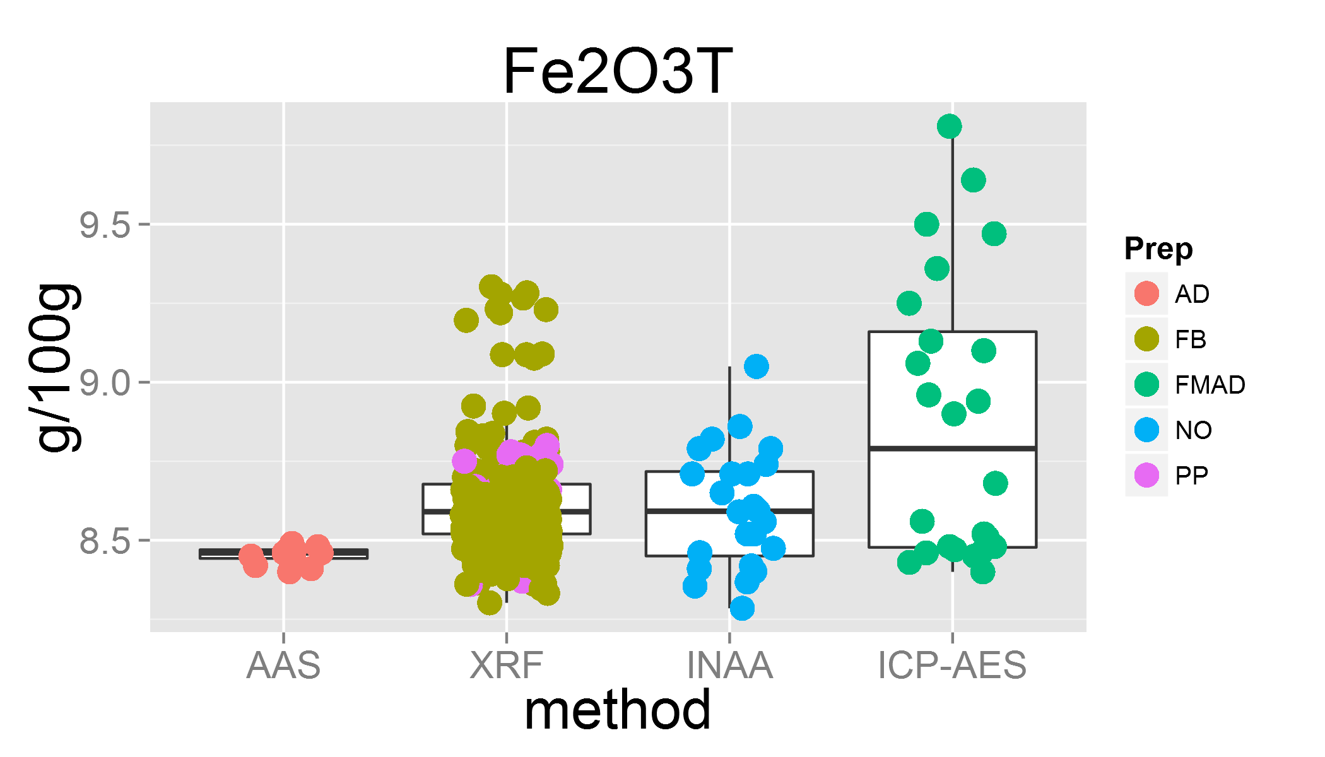

plot of chunk unnamed-chunk-3

## Warning: Removed 3 rows containing missing values (geom_point).

## Lab 0 was removed

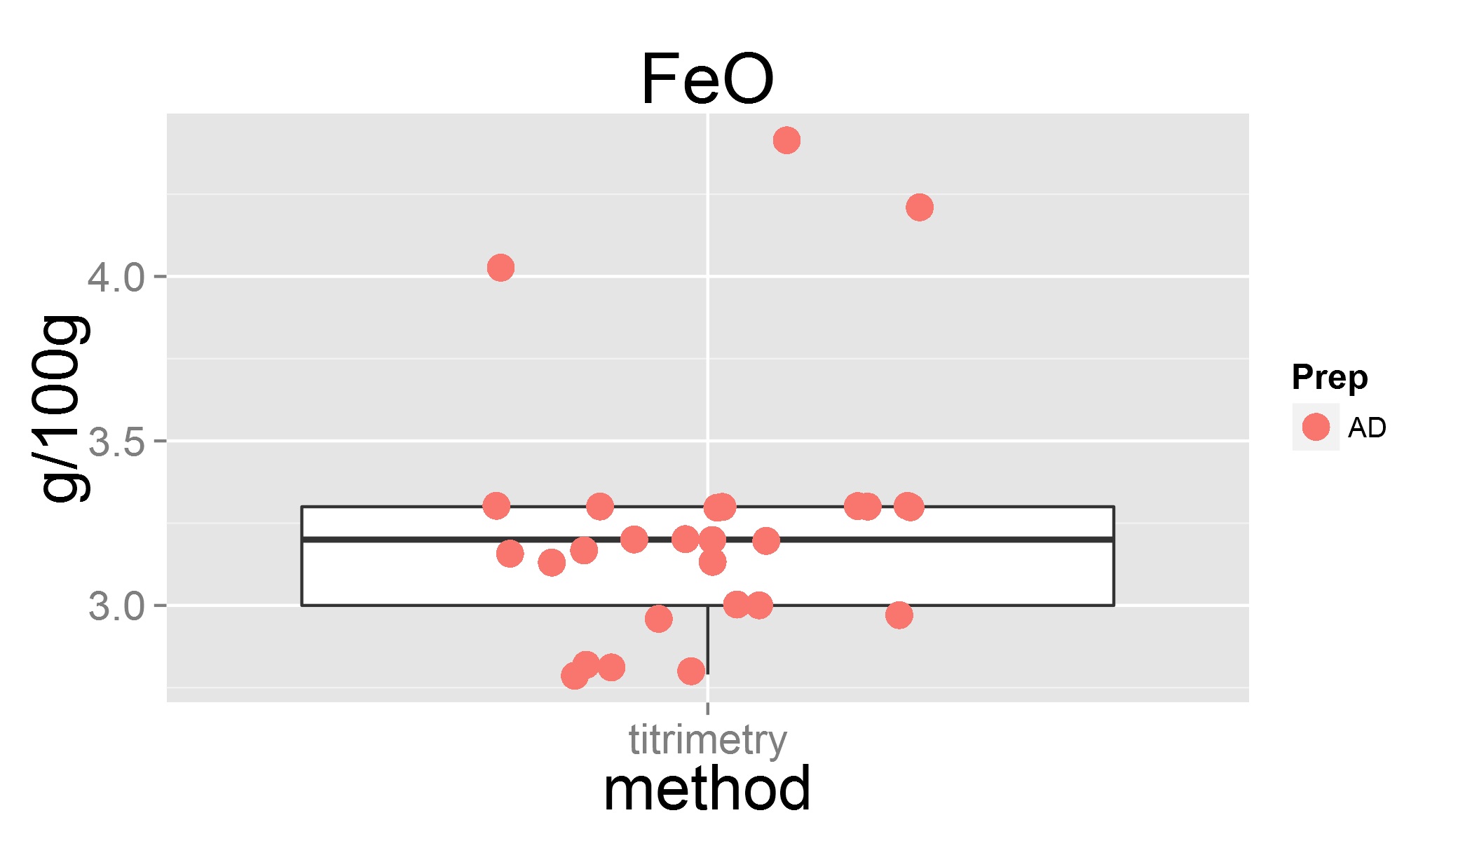

plot of chunk unnamed-chunk-3

## Warning: Removed 60 rows containing missing values (geom_point).

## Lab 12 was removed  
## Lab 16 was removed  
## Lab 23 was removed  
## Lab 24 was removed

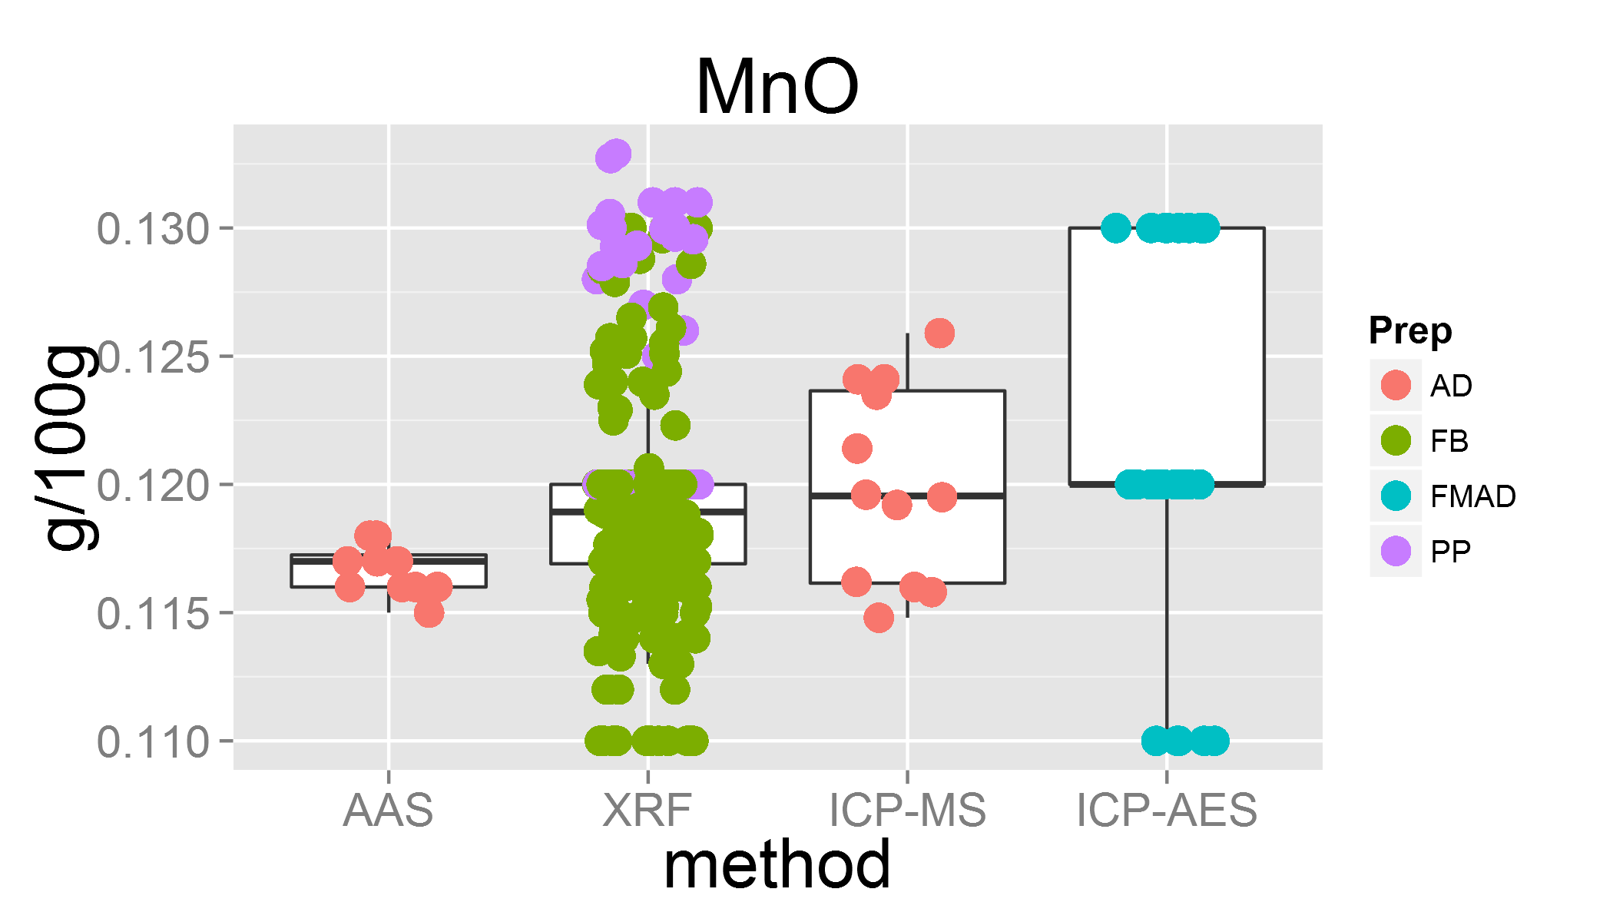

plot of chunk unnamed-chunk-3

## Lab 32 was removed

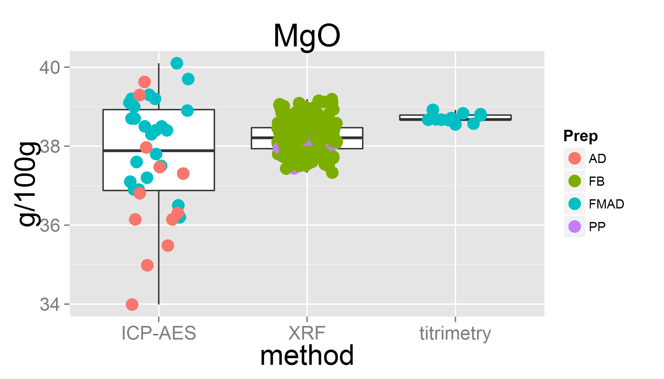

plot of chunk unnamed-chunk-3

## Warning: Removed 1 rows containing missing values (geom_point).  
## Warning: Removed 3 rows containing missing values (geom_point).  
## Warning: Removed 27 rows containing missing values (geom_point).

## Lab 12 was removed  
## Lab 30 was removed

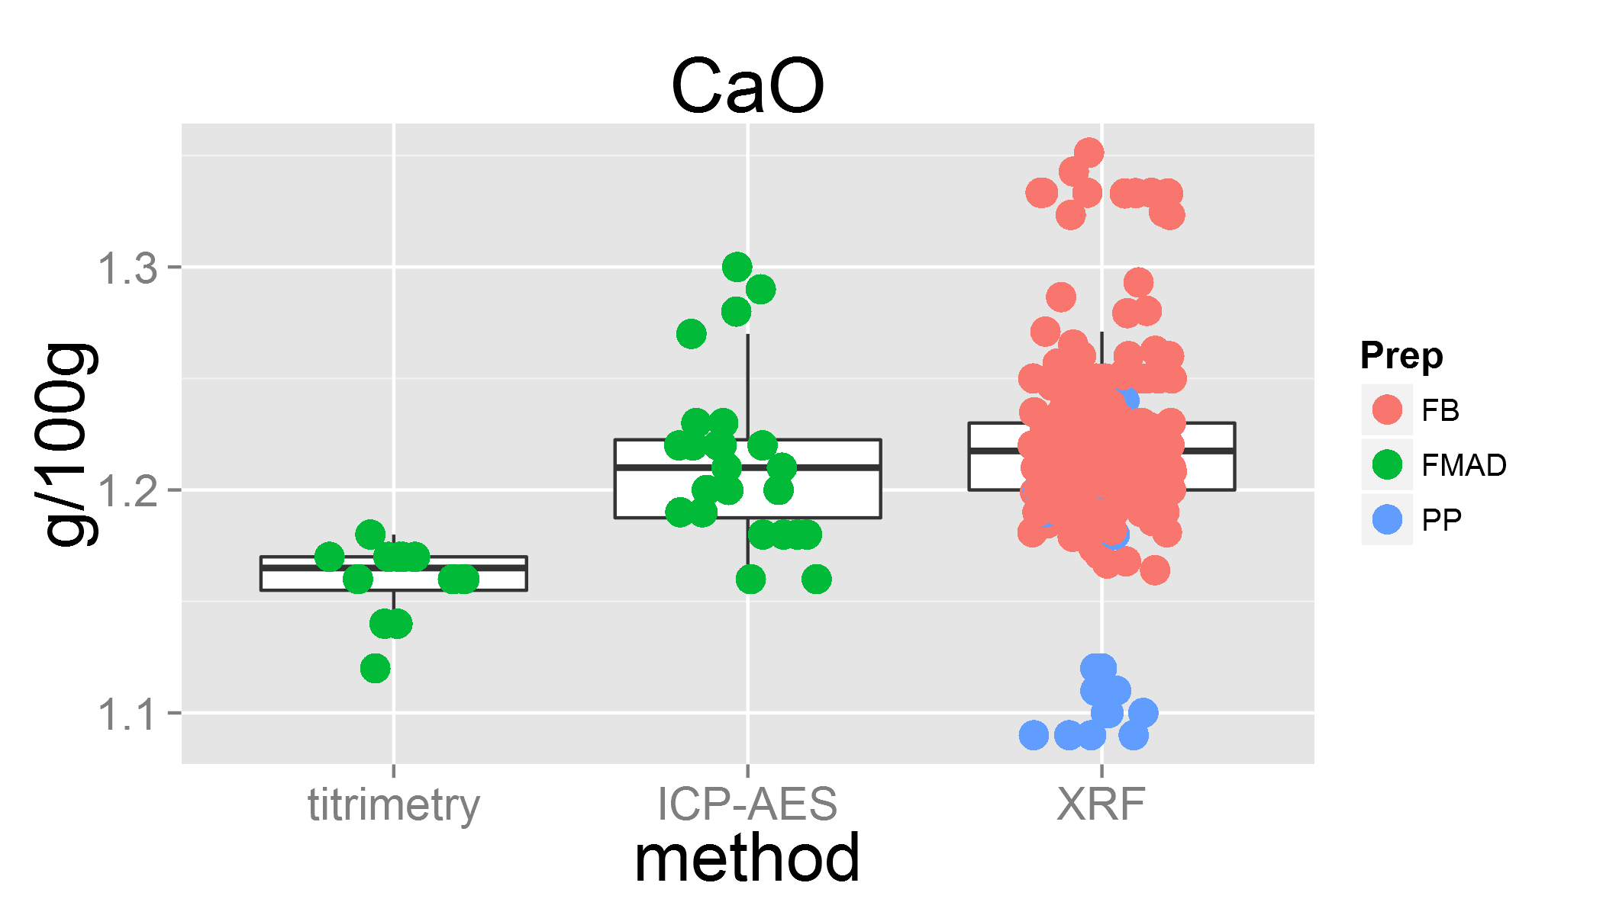

plot of chunk unnamed-chunk-3

## Warning: Removed 27 rows containing missing values (geom_point).

## Lab 3 was removed  
## Lab 22 was removed  
## Lab 33 was removed

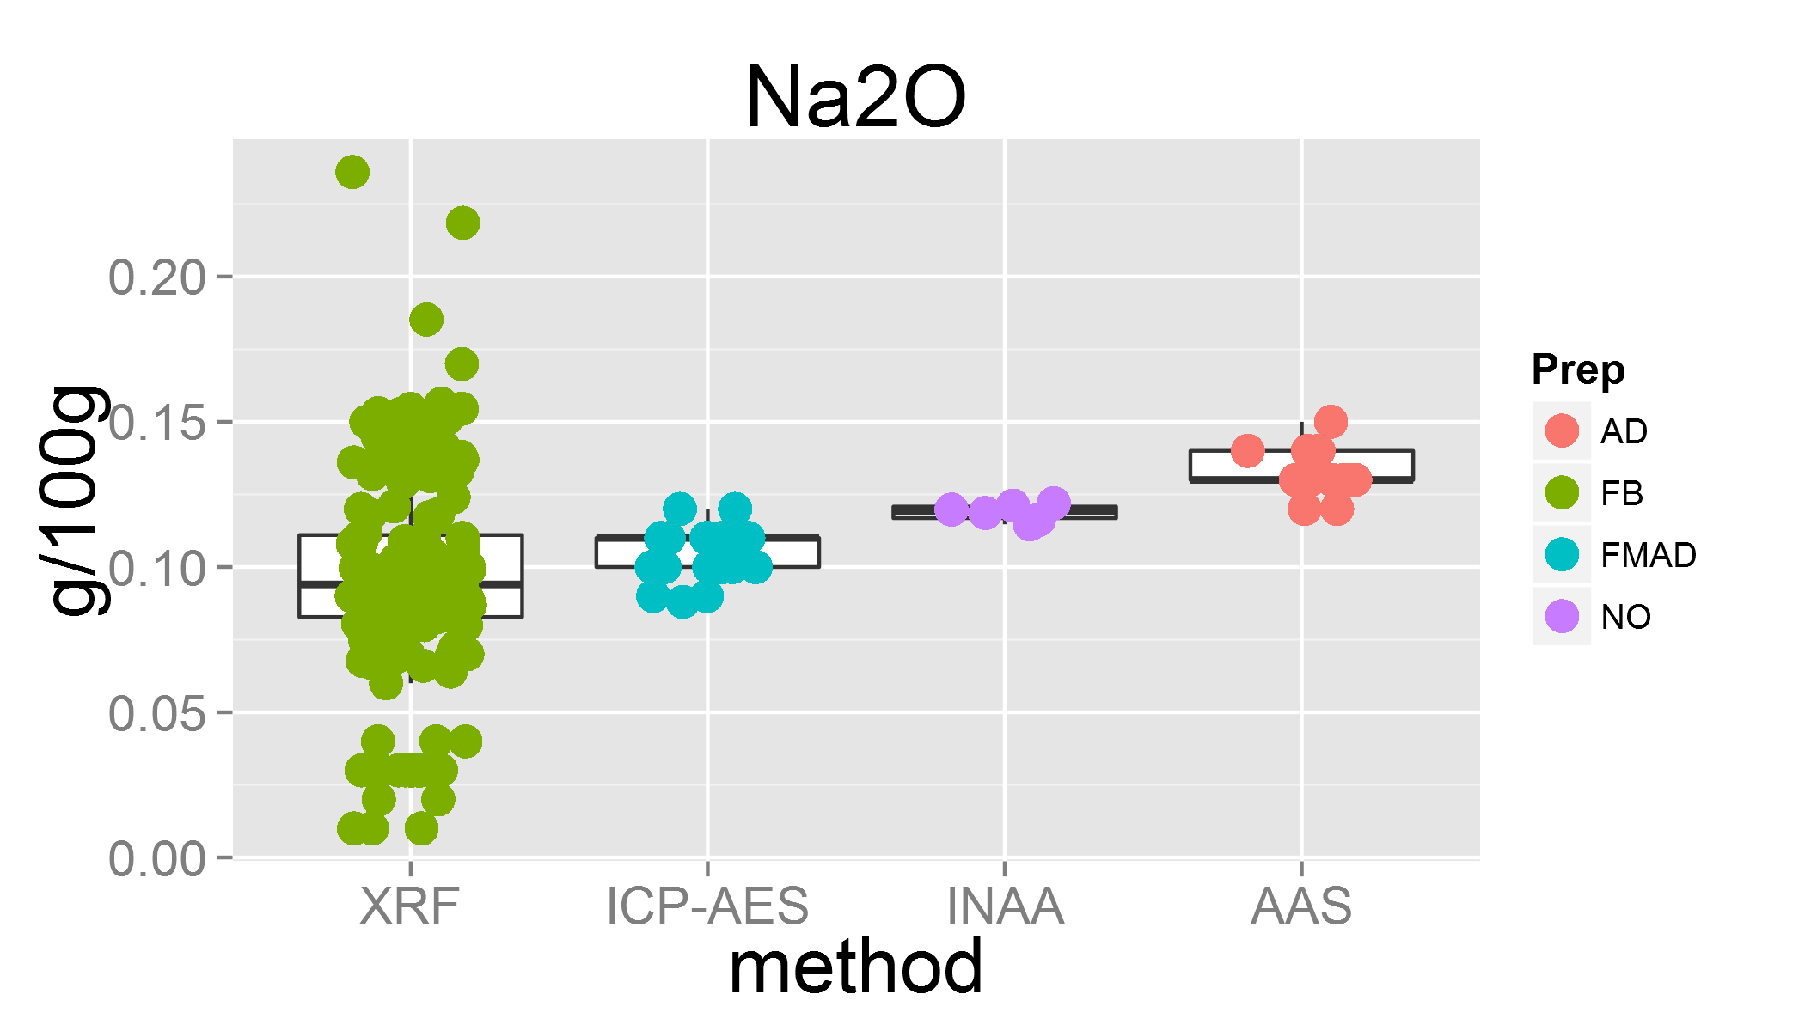

plot of chunk unnamed-chunk-3

## Warning: Removed 8 rows containing missing values (geom_point).

## Lab 7 was removed  
## Lab 12 was removed

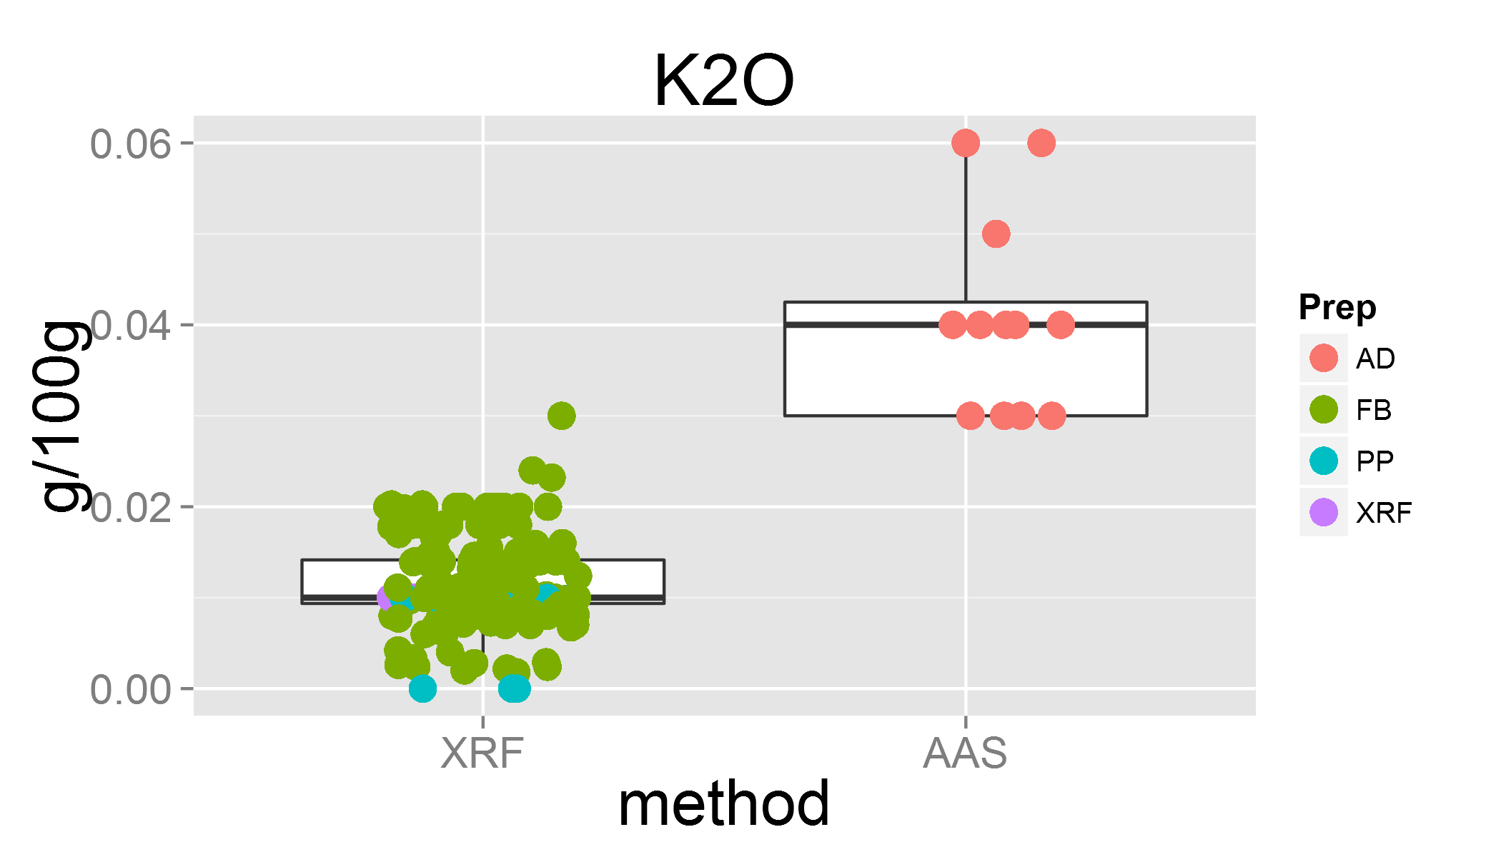

plot of chunk unnamed-chunk-3

## Warning: Removed 12 rows containing missing values (geom_point).  
## Warning: Removed 1 rows containing missing values (geom_point).  
## Warning: Removed 1 rows containing missing values (geom_point).

## Lab 6 was removed  
## Lab 33 was removed

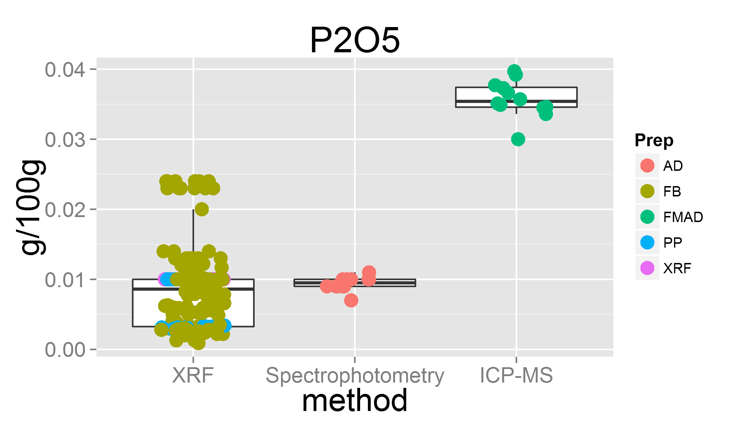

plot of chunk unnamed-chunk-3

## Warning: Removed 1 rows containing missing values (geom_point).

## Lab 0 was removed

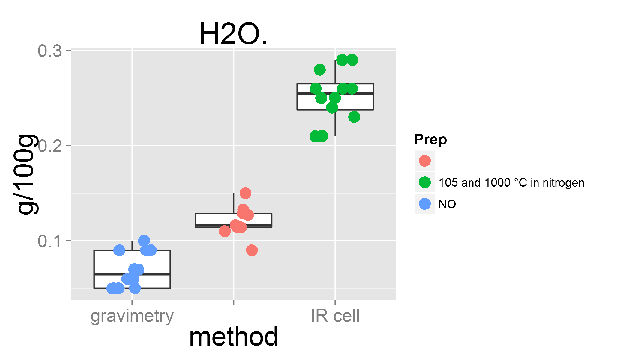

plot of chunk unnamed-chunk-3

## Lab 0 was removed

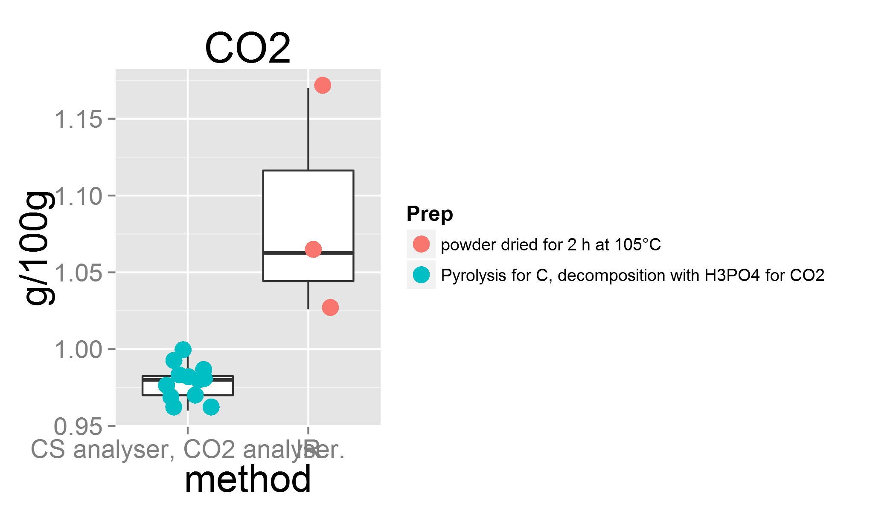

plot of chunk unnamed-chunk-3

## Lab 0 was removed

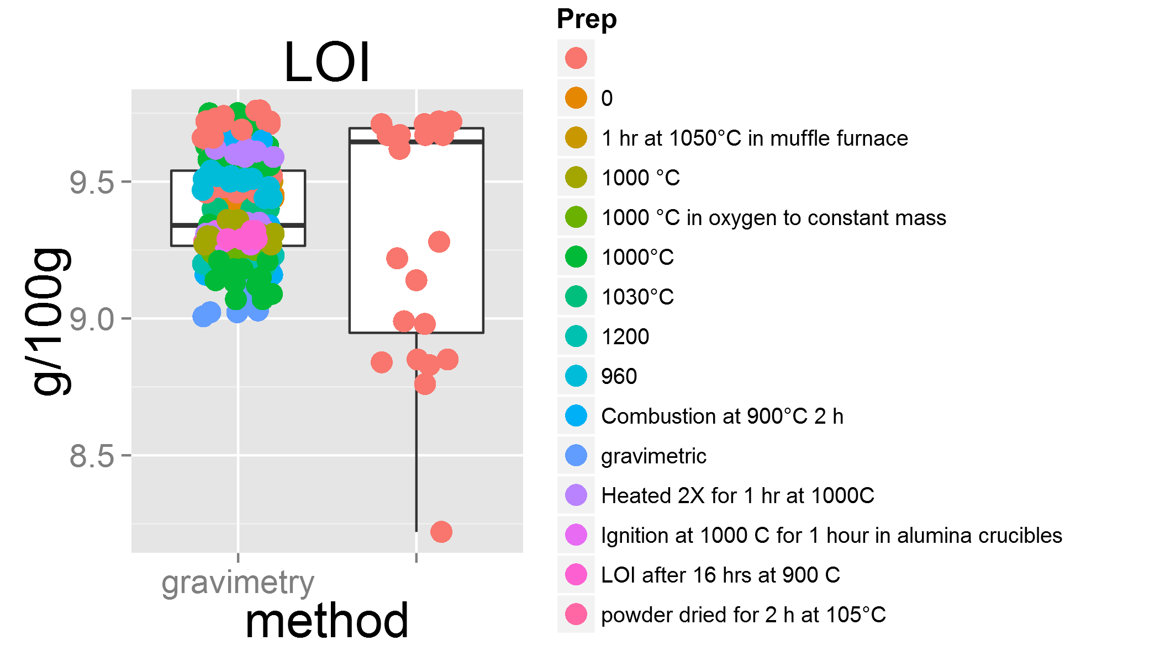

plot of chunk unnamed-chunk-3

## Warning: Removed 1 rows containing missing values (geom_point).

## Lab 0 was removed

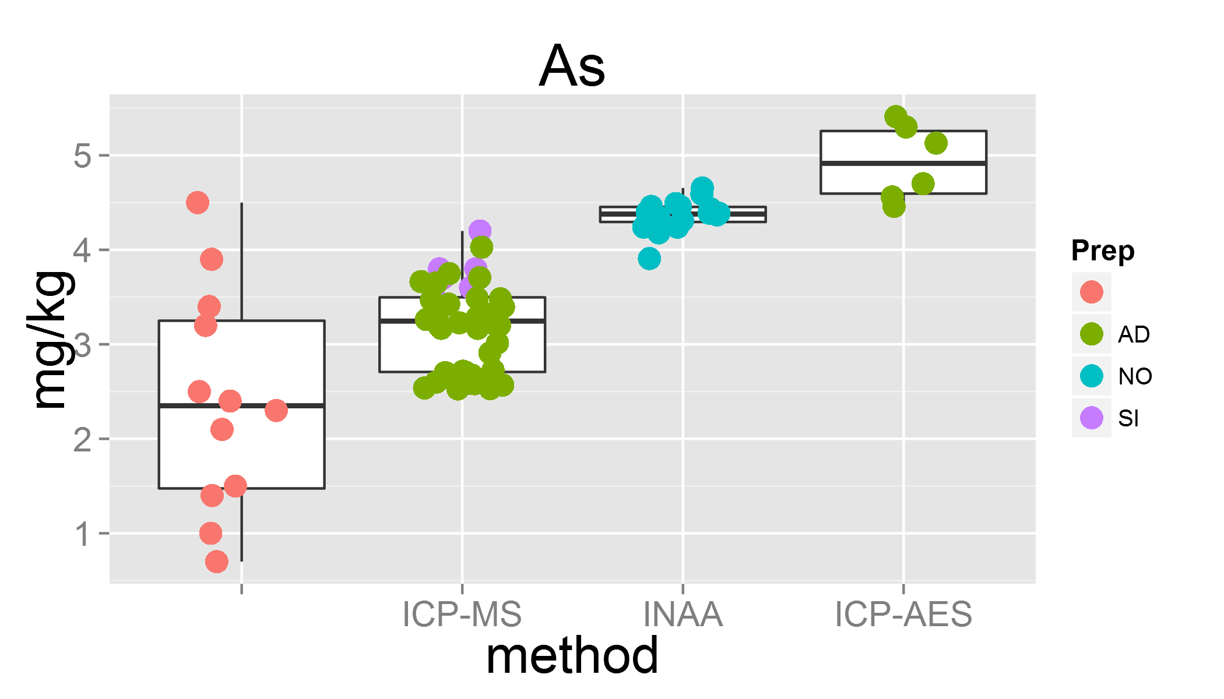

plot of chunk unnamed-chunk-3

## Warning: Removed 4 rows containing missing values (geom_point).

## Lab 14 was removed  
## Lab 26 was removed

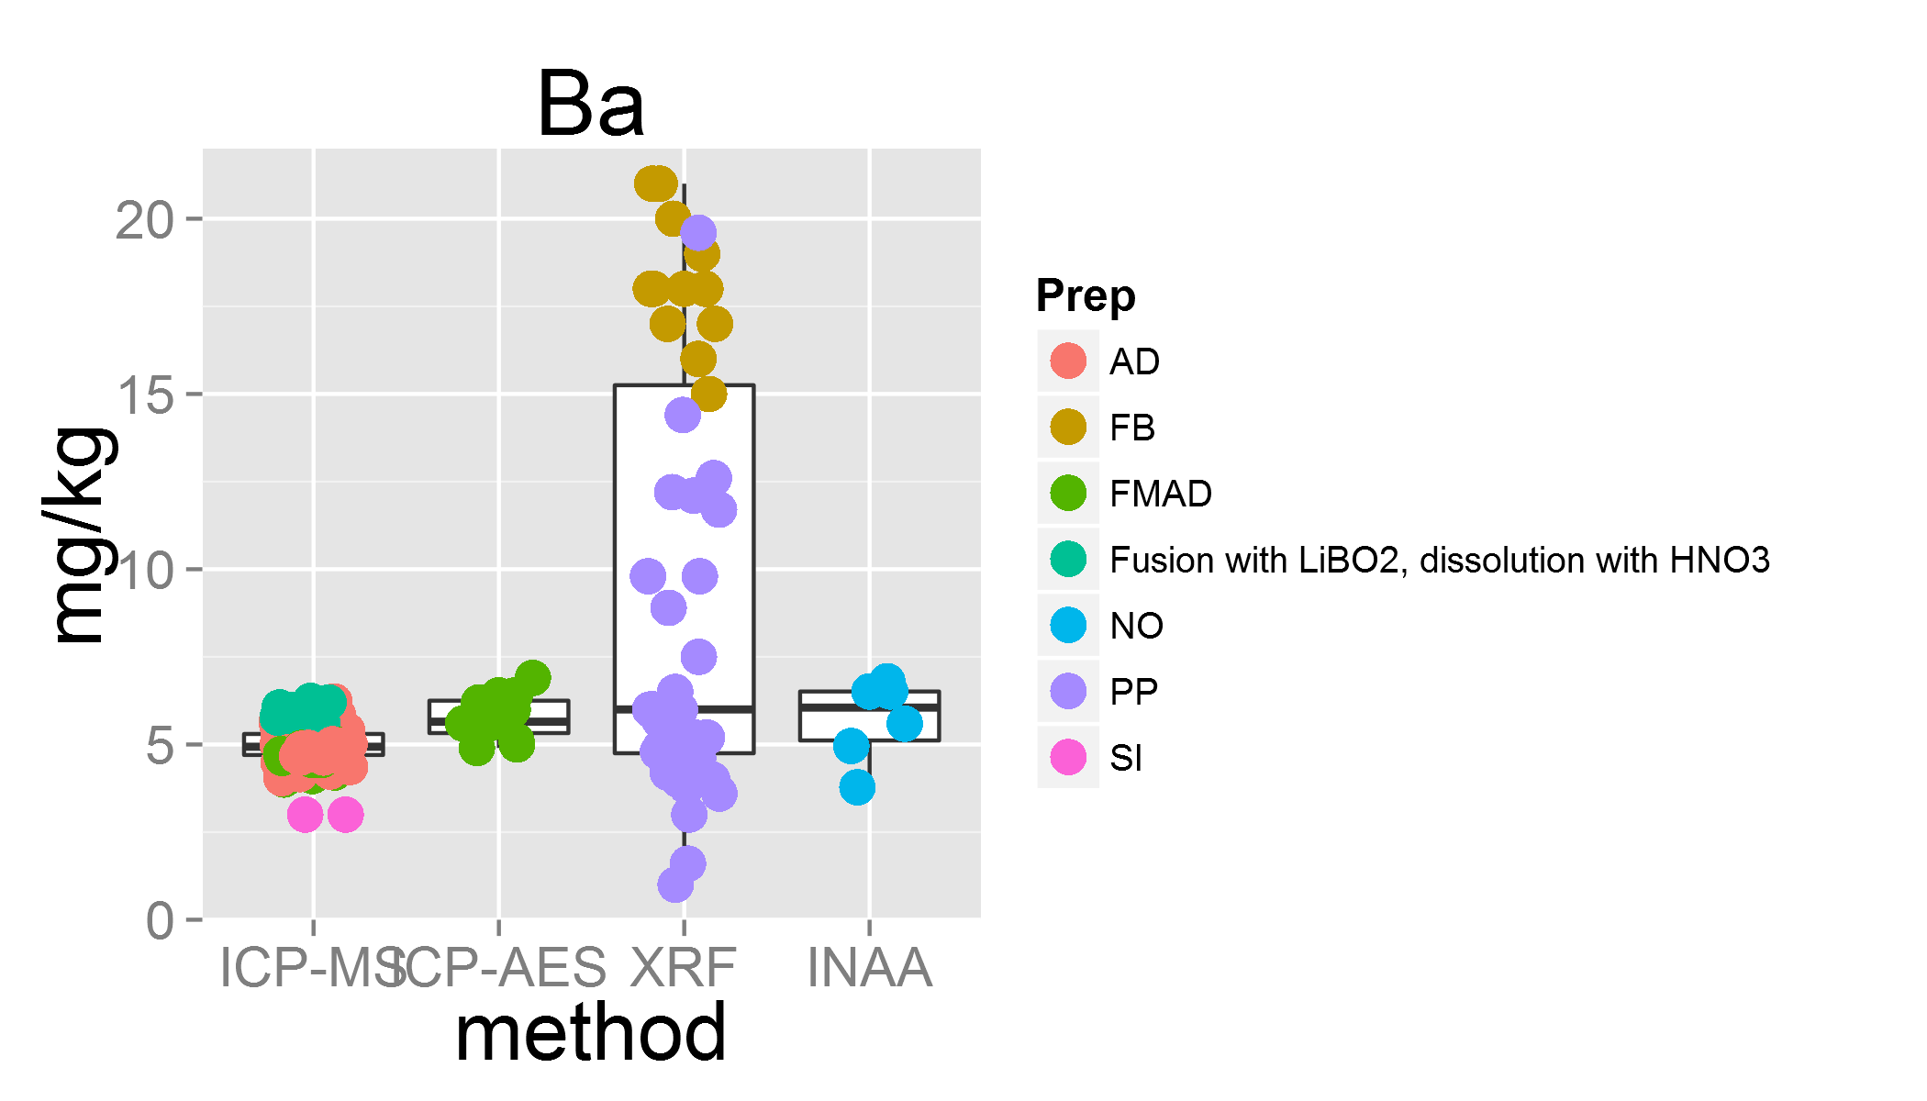

plot of chunk unnamed-chunk-3

## Warning: Removed 1 rows containing missing values (geom_point).

## Lab 0 was removed

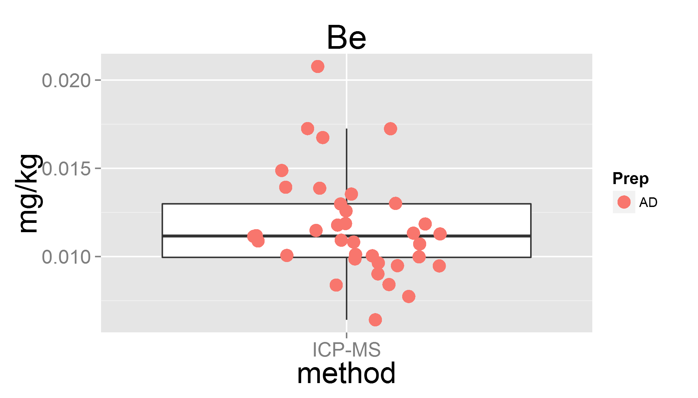

plot of chunk unnamed-chunk-3

## Warning: Removed 9 rows containing missing values (geom_point).  
## Warning: Removed 3 rows containing missing values (geom_point).

## Lab 29 was removed

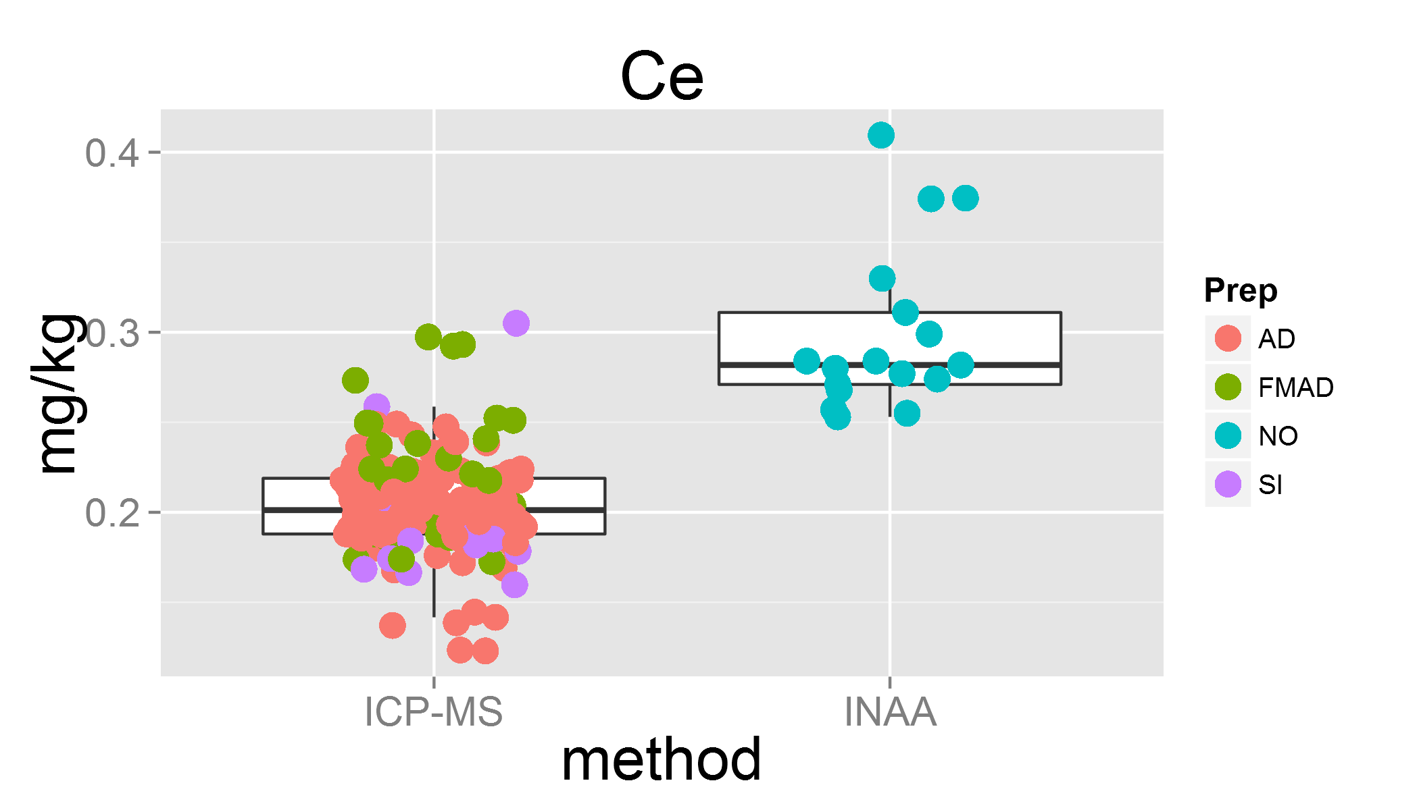

plot of chunk unnamed-chunk-3

## Warning: Removed 2 rows containing missing values (geom_point).

## Lab 12 was removed  
## Lab 16 was removed  
## Lab 5 was removed

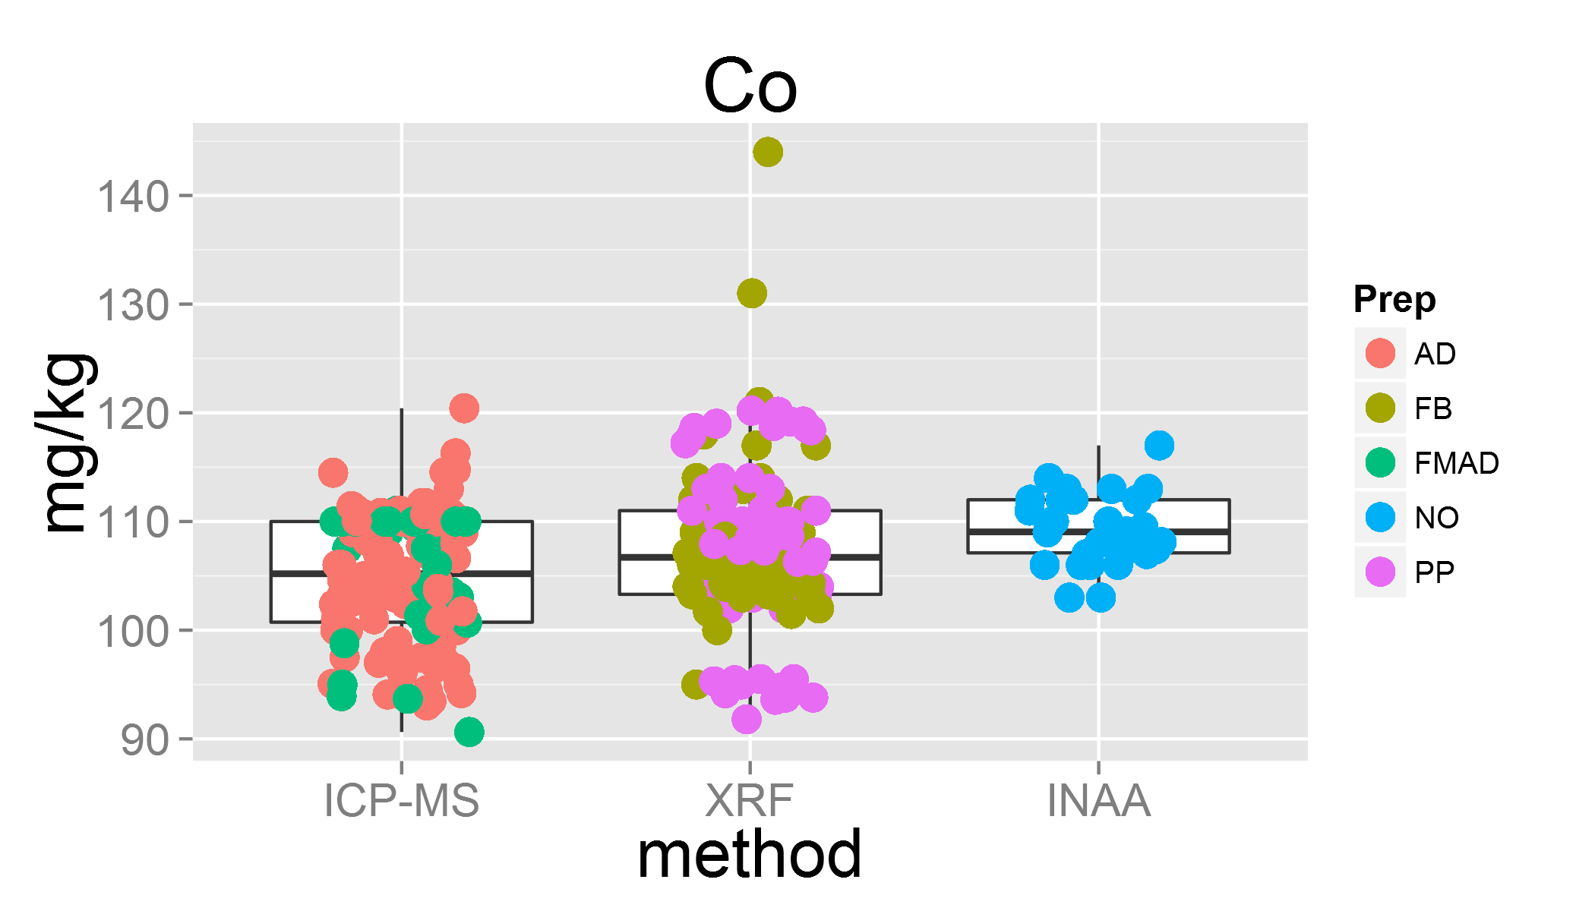

plot of chunk unnamed-chunk-3

## Warning: Removed 24 rows containing missing values (geom_point).  
## Warning: Removed 1 rows containing missing values (geom_point).

## Lab 8 was removed  
## Lab 12 was removed  
## Lab 18 was removed

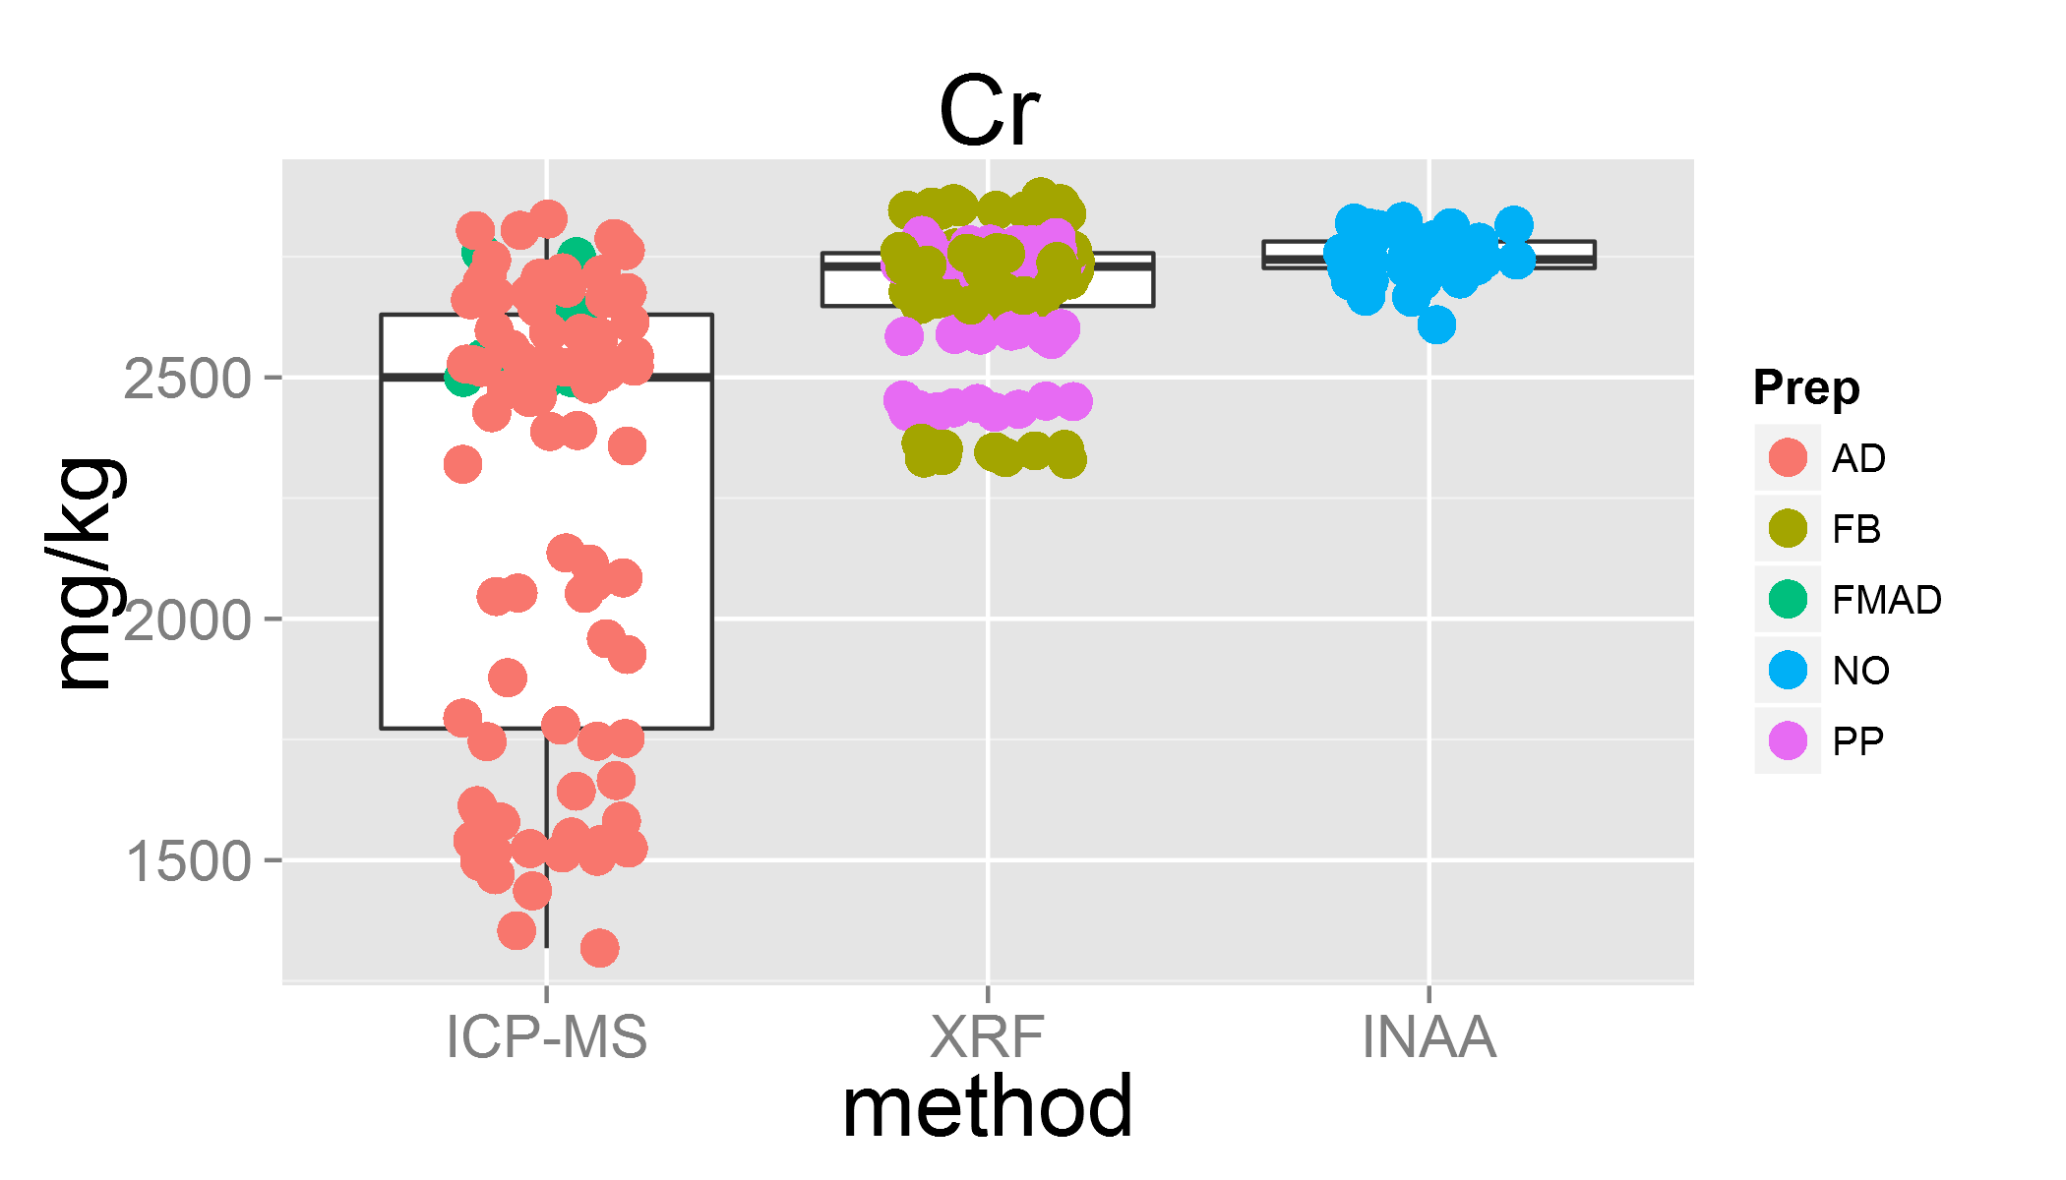

plot of chunk unnamed-chunk-3

## Warning: Removed 13 rows containing missing values (geom_point).  
## Warning: Removed 3 rows containing missing values (geom_point).

## Lab 33 was removed

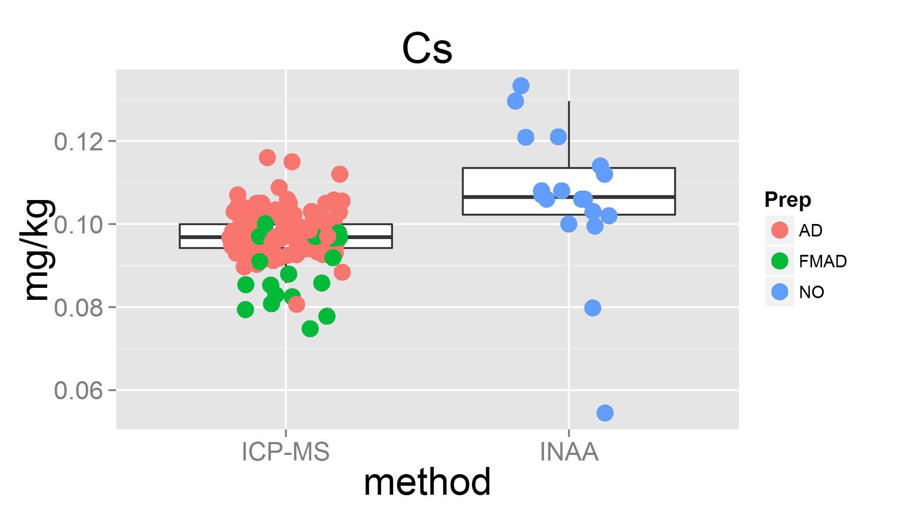

plot of chunk unnamed-chunk-3

## Warning: Removed 15 rows containing missing values (geom_point).  
## Warning: Removed 12 rows containing missing values (geom_point).

## Lab 4 was removed  
## Lab 14 was removed  
## Lab 33 was removed

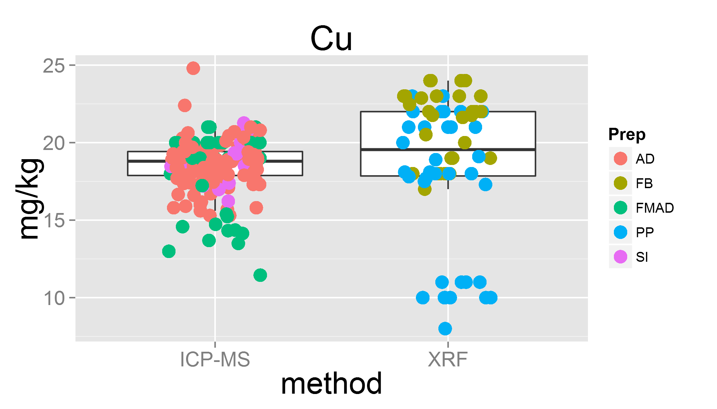

plot of chunk unnamed-chunk-3

## Warning: Removed 19 rows containing missing values (geom_point).

## Lab 31 was removed

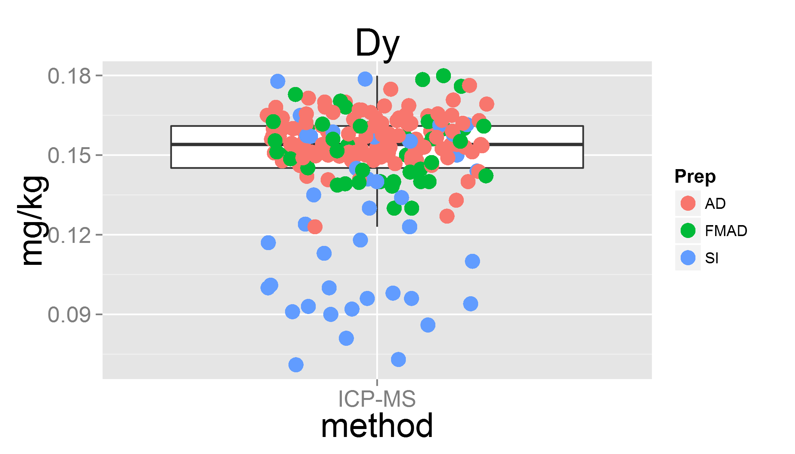

plot of chunk unnamed-chunk-3

## Warning: Removed 20 rows containing missing values (geom_point).

## Lab 31 was removed

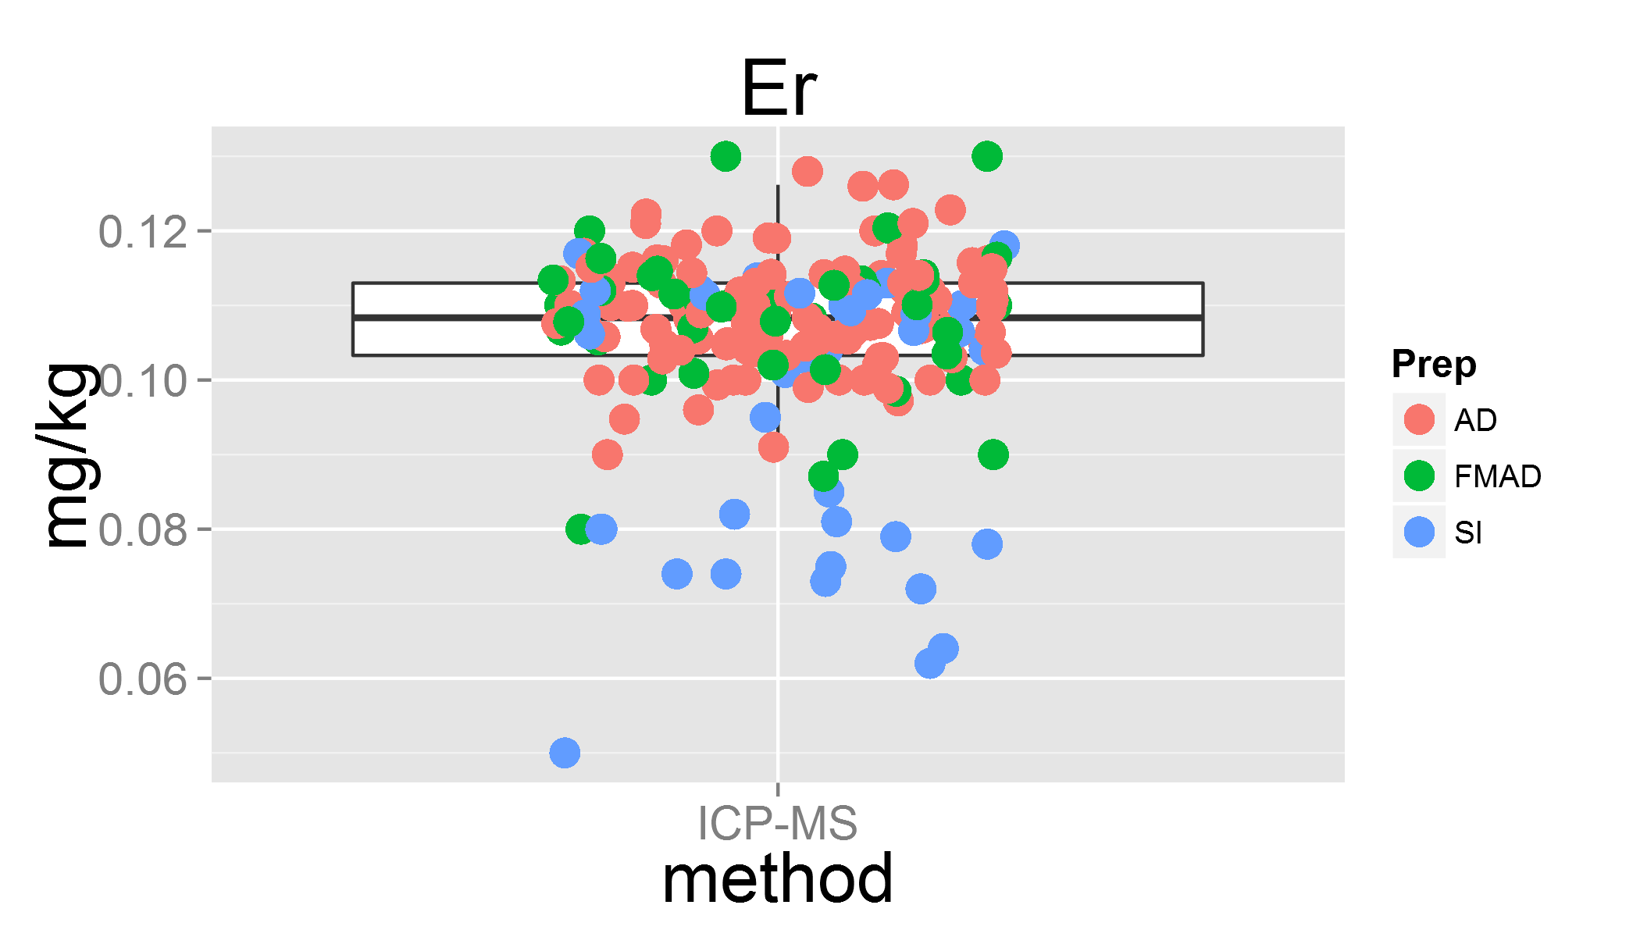

plot of chunk unnamed-chunk-3

## Warning: Removed 8 rows containing missing values (geom_point).

## Lab 31 was removed

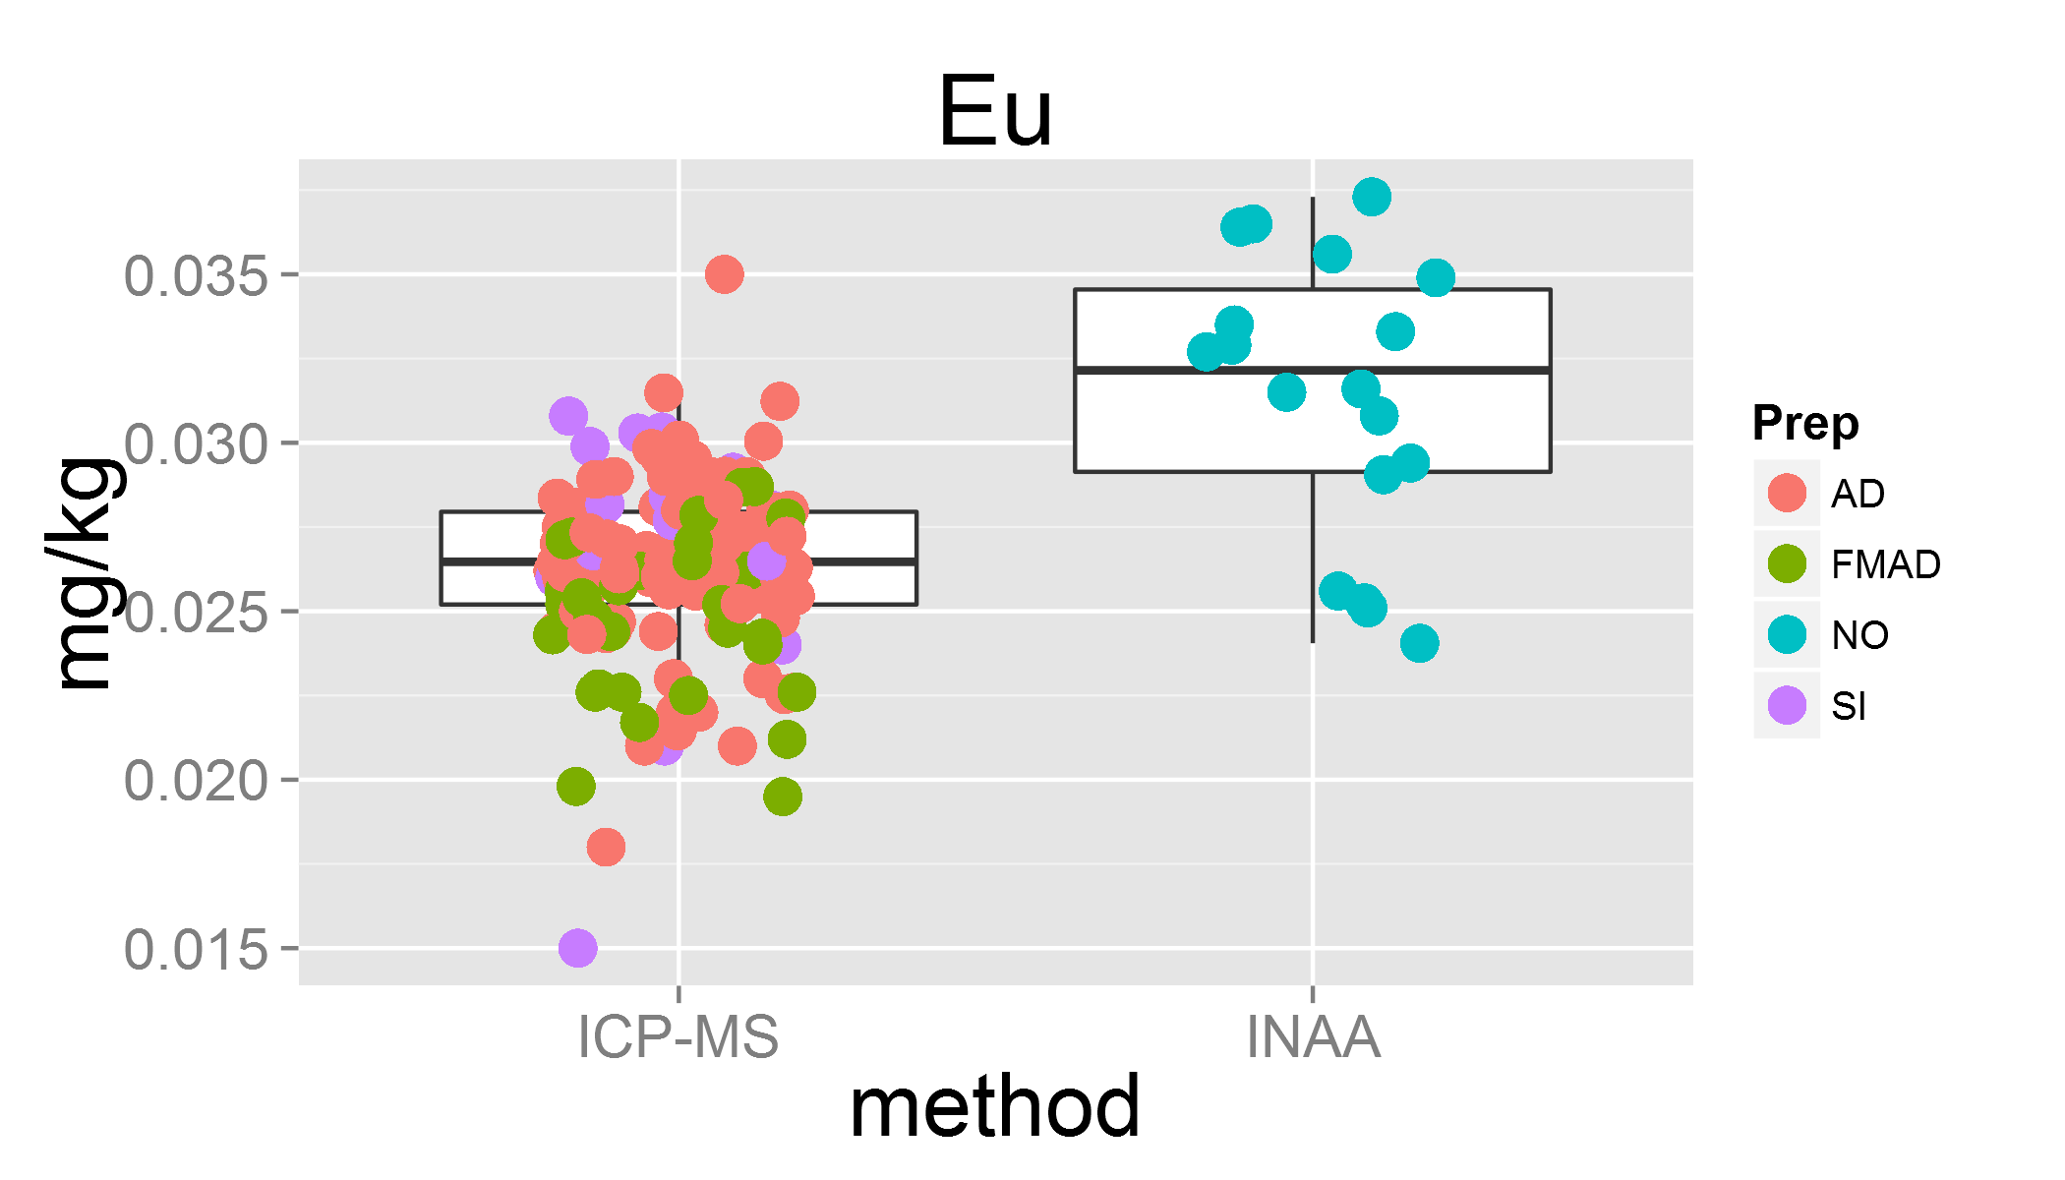

plot of chunk unnamed-chunk-3

## Lab 4 was removed  
## Lab 35 was removed

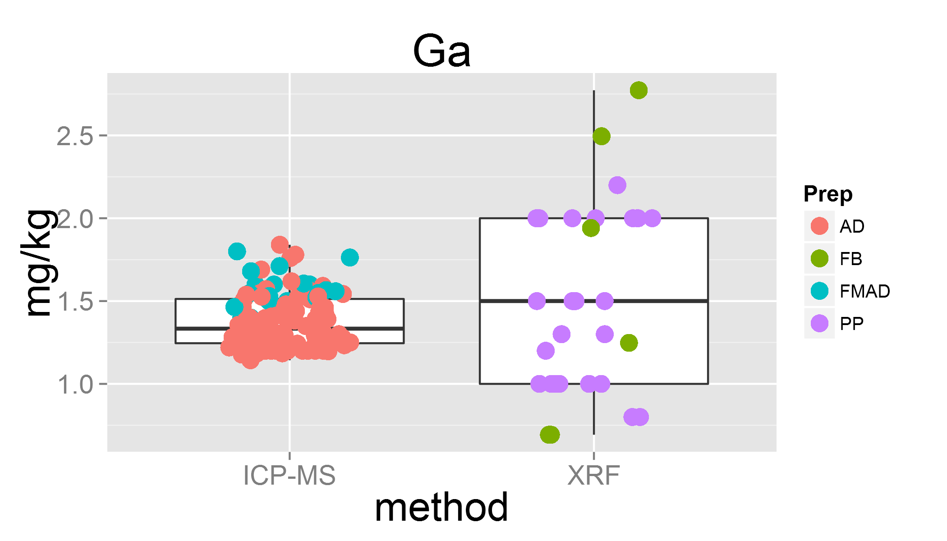

plot of chunk unnamed-chunk-3

## Warning: Removed 10 rows containing missing values (geom_point).

## Lab 8 was removed  
## Lab 31 was removed

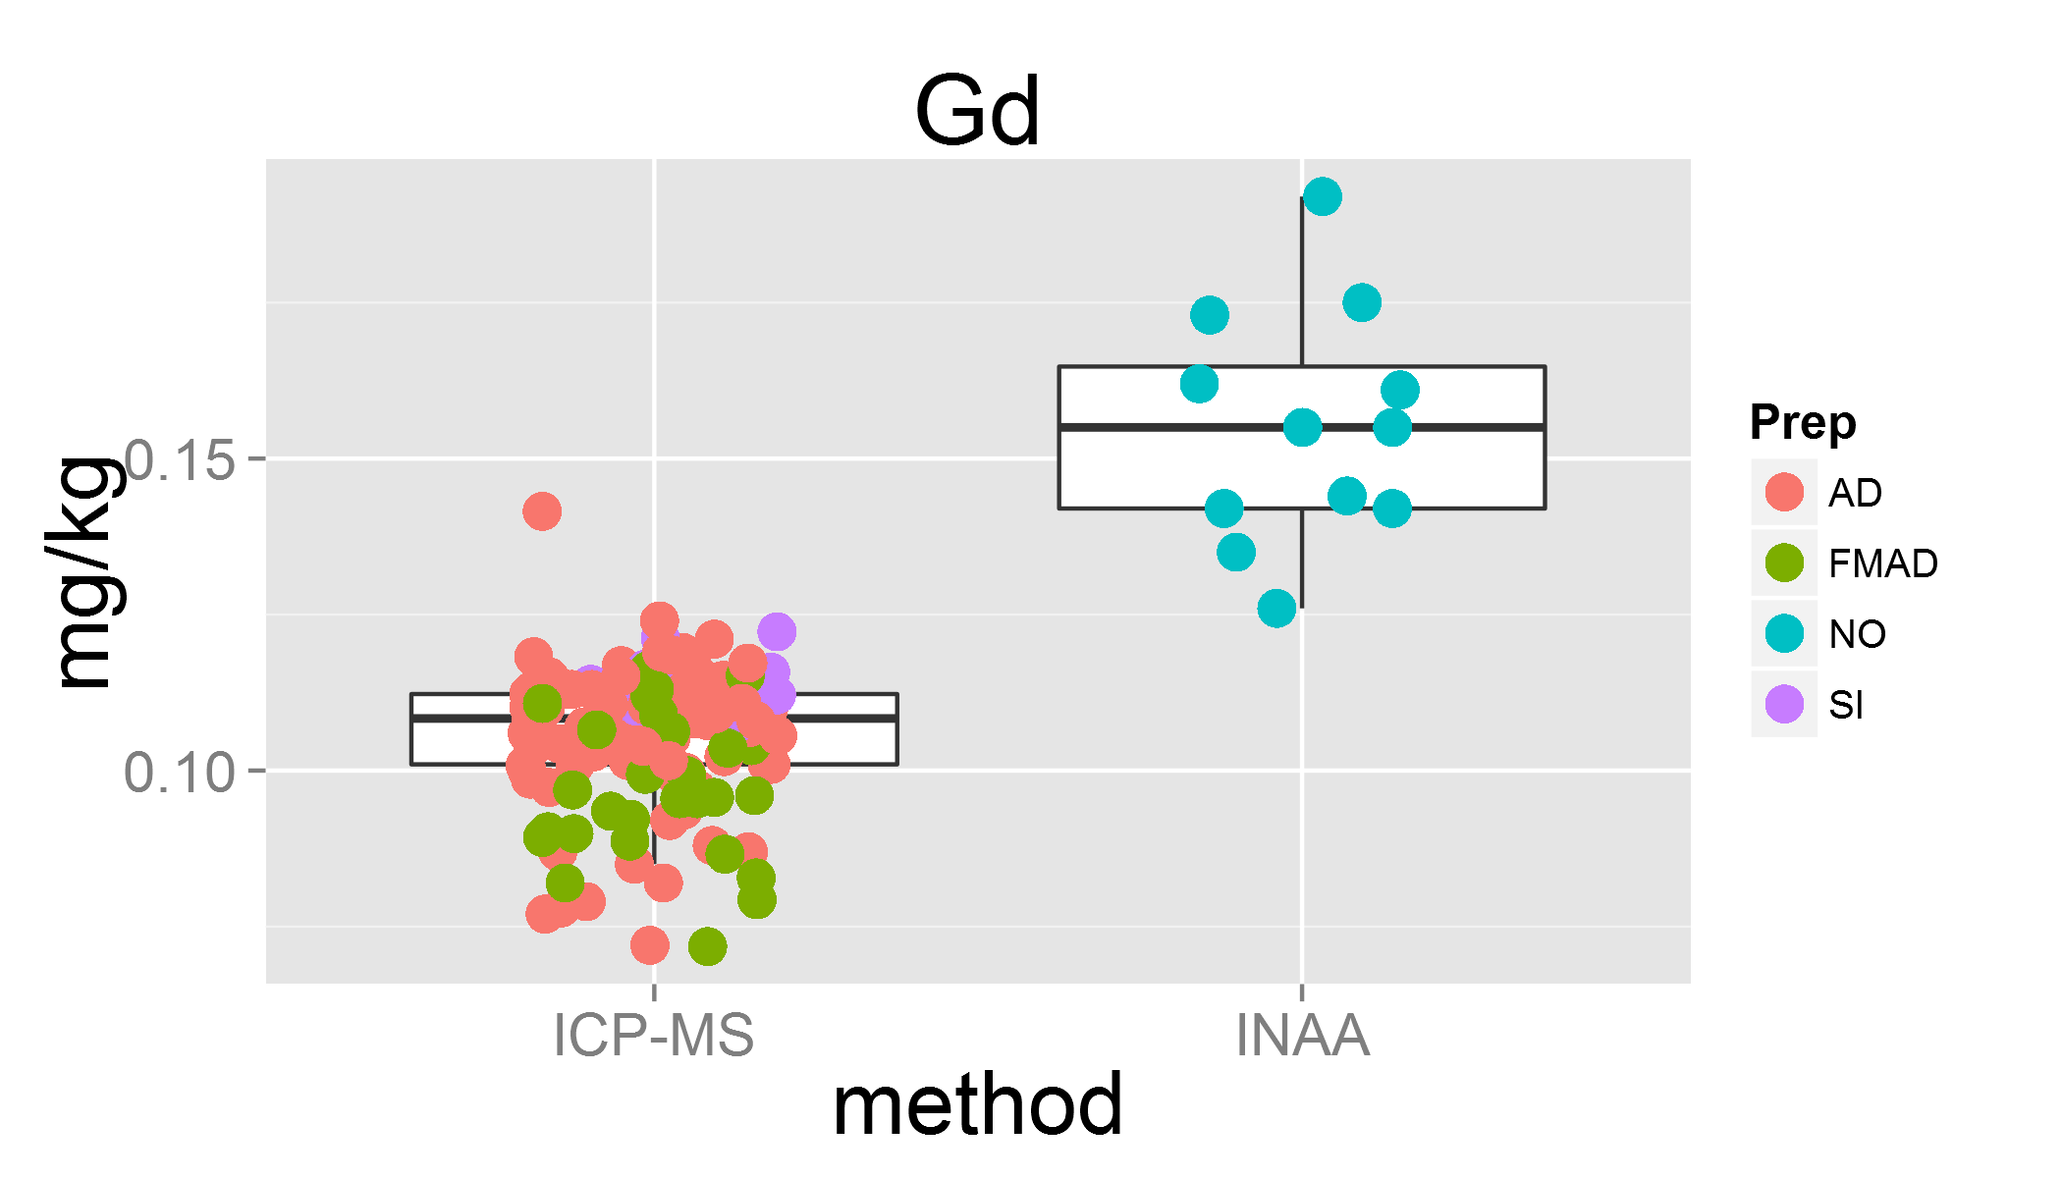

plot of chunk unnamed-chunk-3

## Warning: Removed 18 rows containing missing values (geom_point).

## Lab 14 was removed

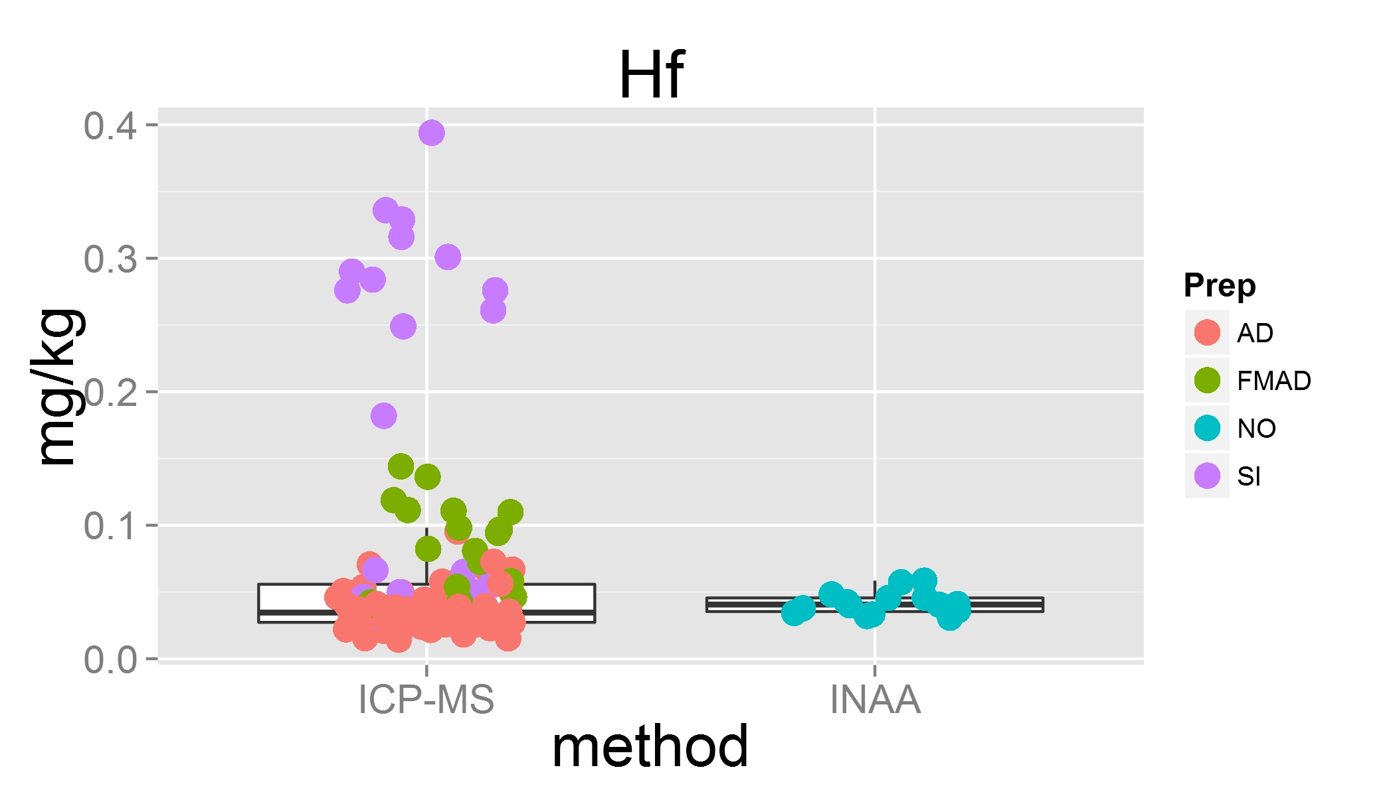

plot of chunk unnamed-chunk-3

## Warning: Removed 11 rows containing missing values (geom_point).

## Lab 31 was removed  
## Lab 33 was removed

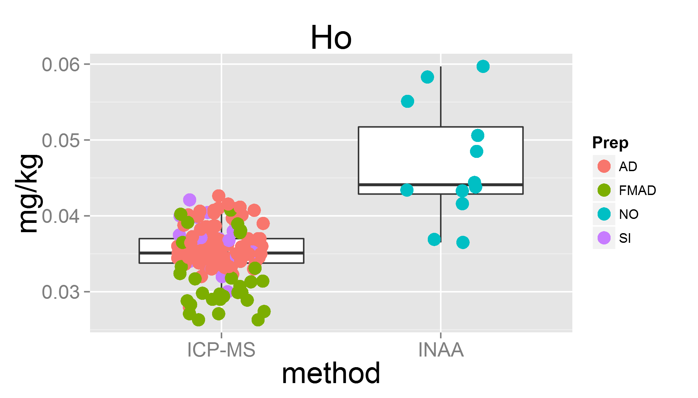

plot of chunk unnamed-chunk-3

## Warning: Removed 9 rows containing missing values (geom_point).  
## Warning: Removed 4 rows containing missing values (geom_point).

## Lab 16 was removed  
## Lab 12 was removed

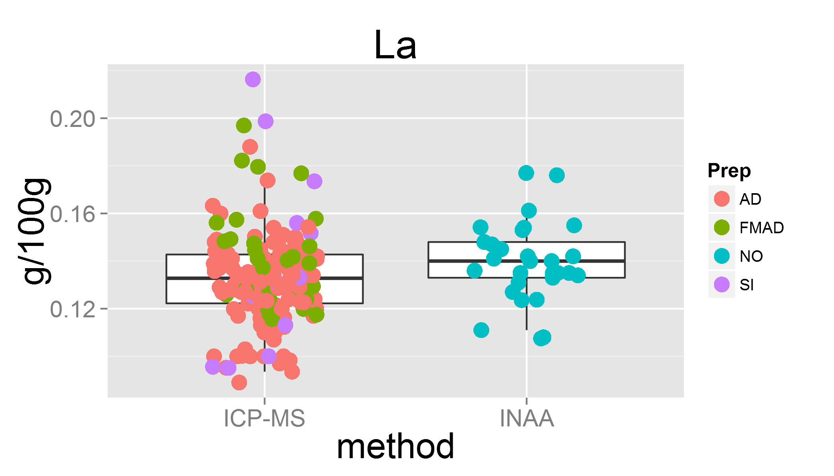

plot of chunk unnamed-chunk-3

## Warning: Removed 19 rows containing missing values (geom_point).

## Lab 31 was removed

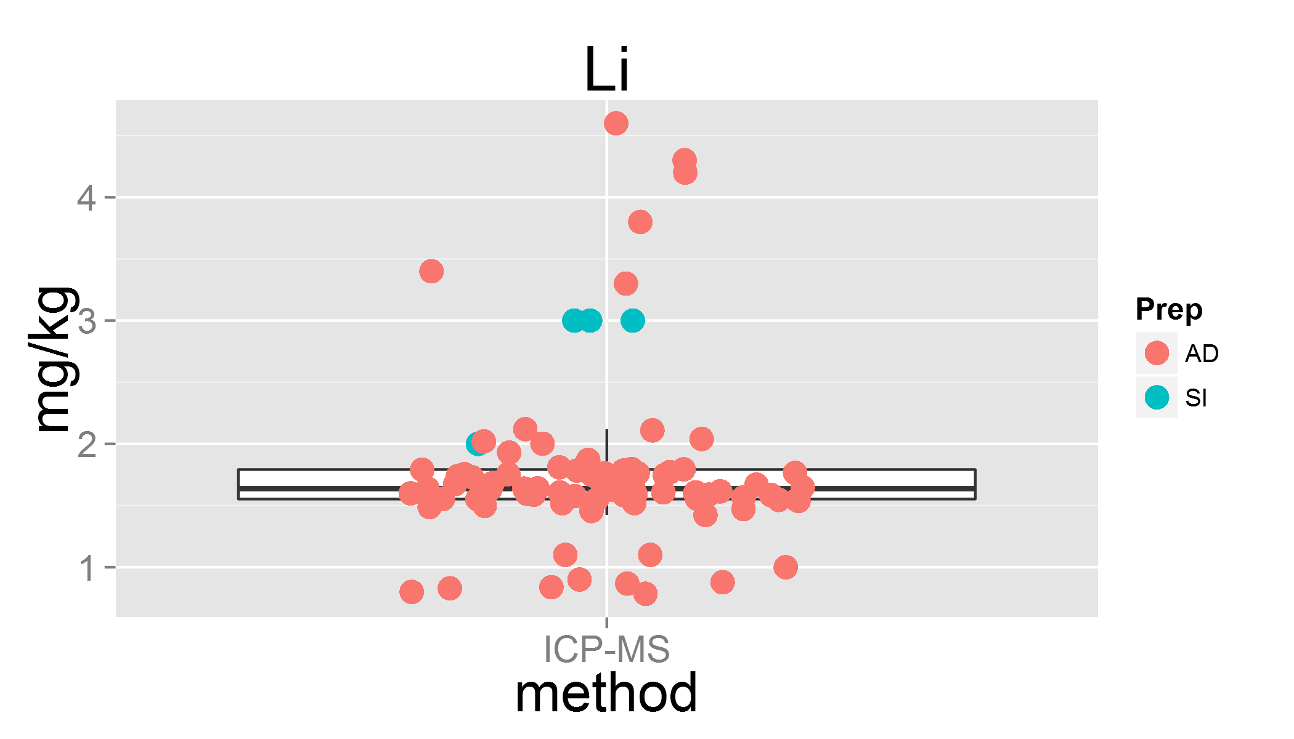

plot of chunk unnamed-chunk-3

## Warning: Removed 12 rows containing missing values (geom_point).  
## Warning: Removed 3 rows containing missing values (geom_point).

## Lab 4 was removed

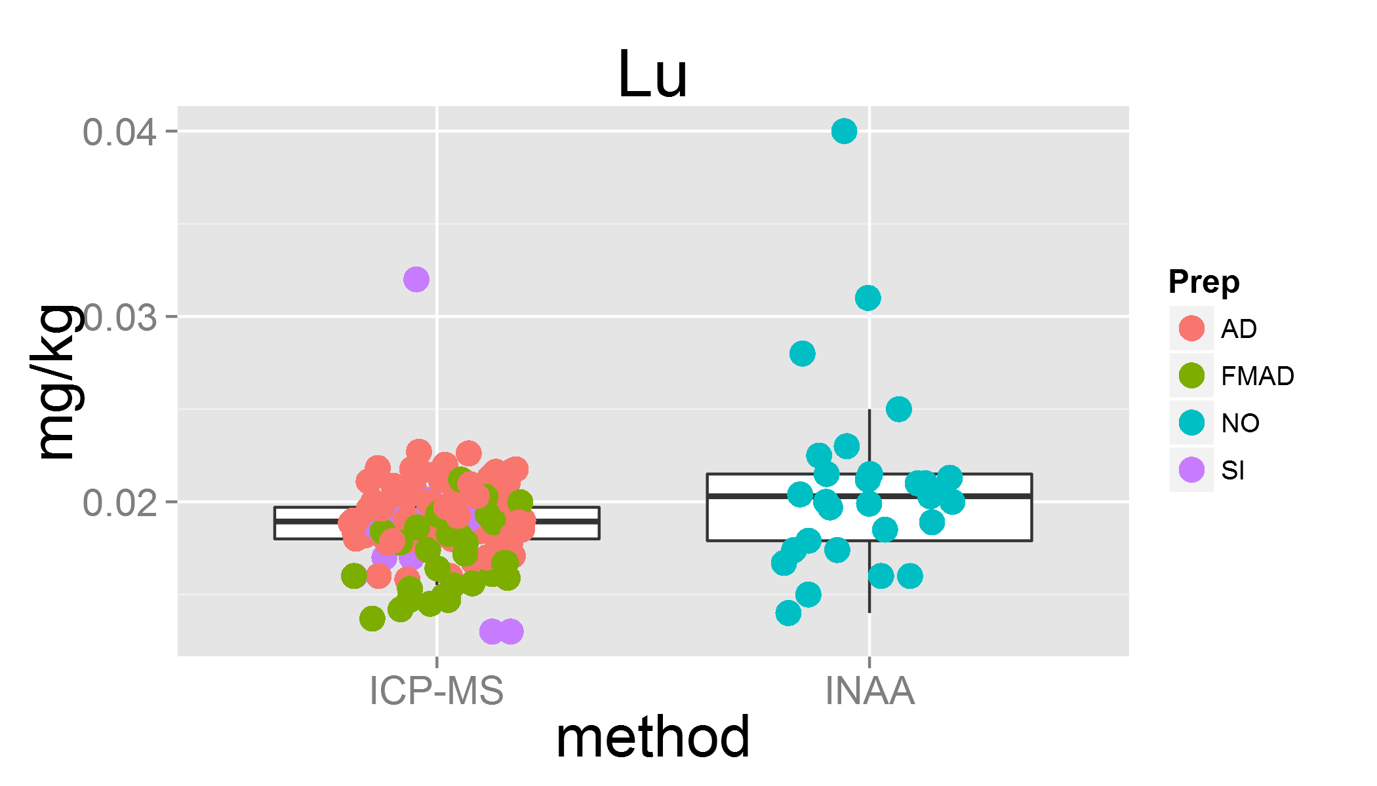

plot of chunk unnamed-chunk-3

## Warning: Removed 17 rows containing missing values (geom_point).

## Lab 26 was removed  
## Lab 33 was removed

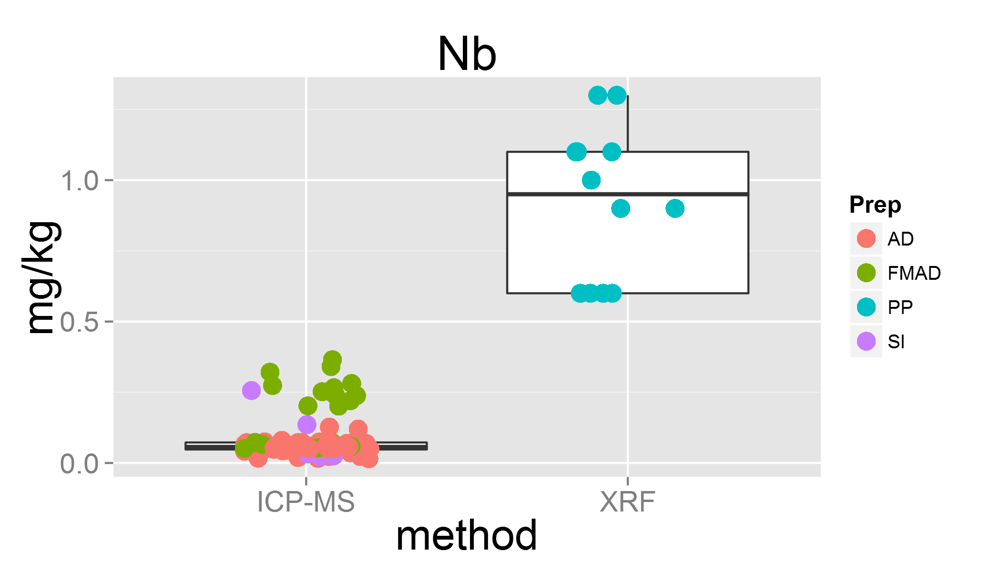

plot of chunk unnamed-chunk-3

## Warning: Removed 12 rows containing missing values (geom_point).

## Lab 29 was removed  
## Lab 31 was removed

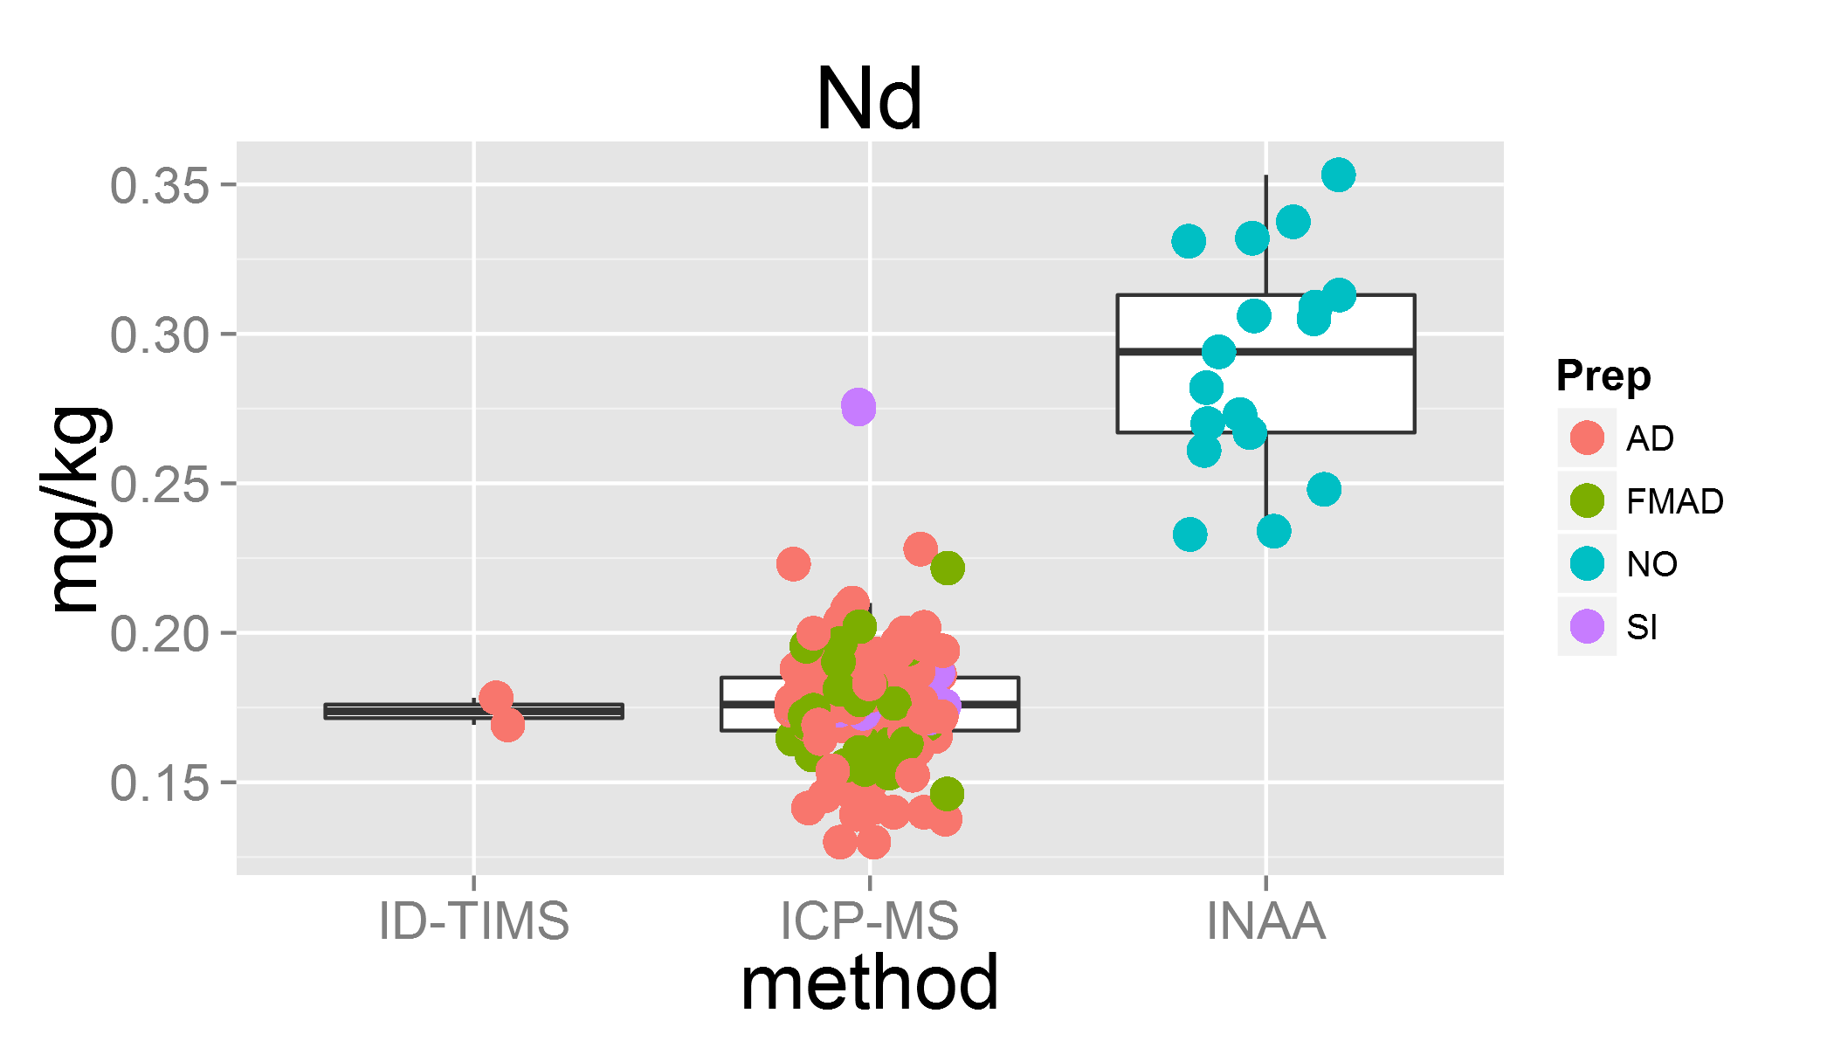

plot of chunk unnamed-chunk-3

## Warning: Removed 3 rows containing missing values (geom_point).  
## Warning: Removed 2 rows containing missing values (geom_point).  
## Warning: Removed 2 rows containing missing values (geom_point).

## Lab 12 was removed  
## Lab 18 was removed  
## Lab 22 was removed

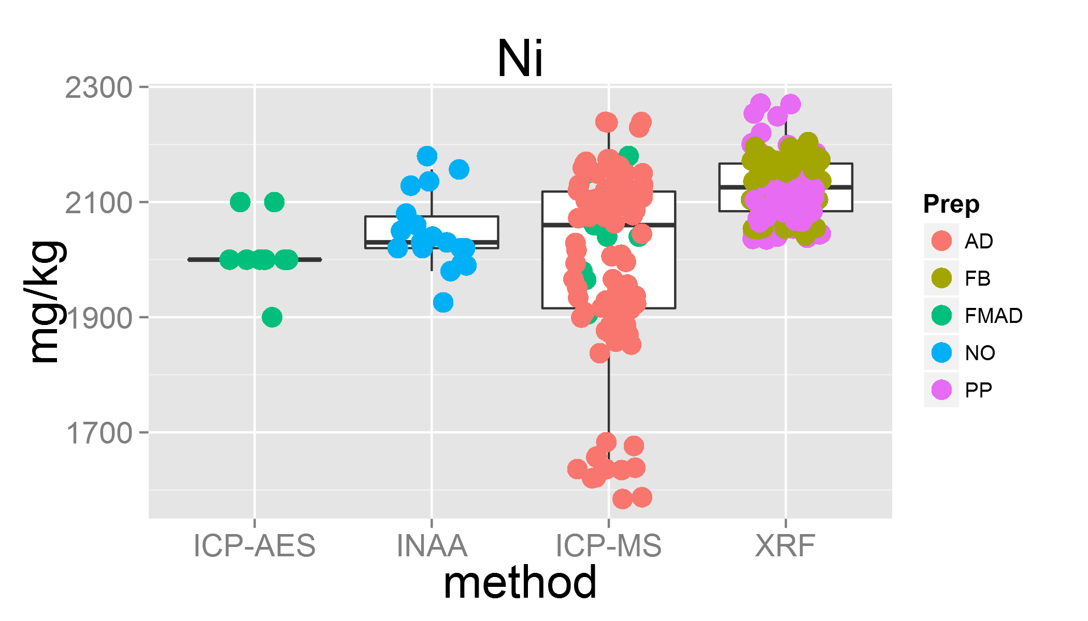

plot of chunk unnamed-chunk-3

## Warning: Removed 10 rows containing missing values (geom_point).

## Lab 0 was removed

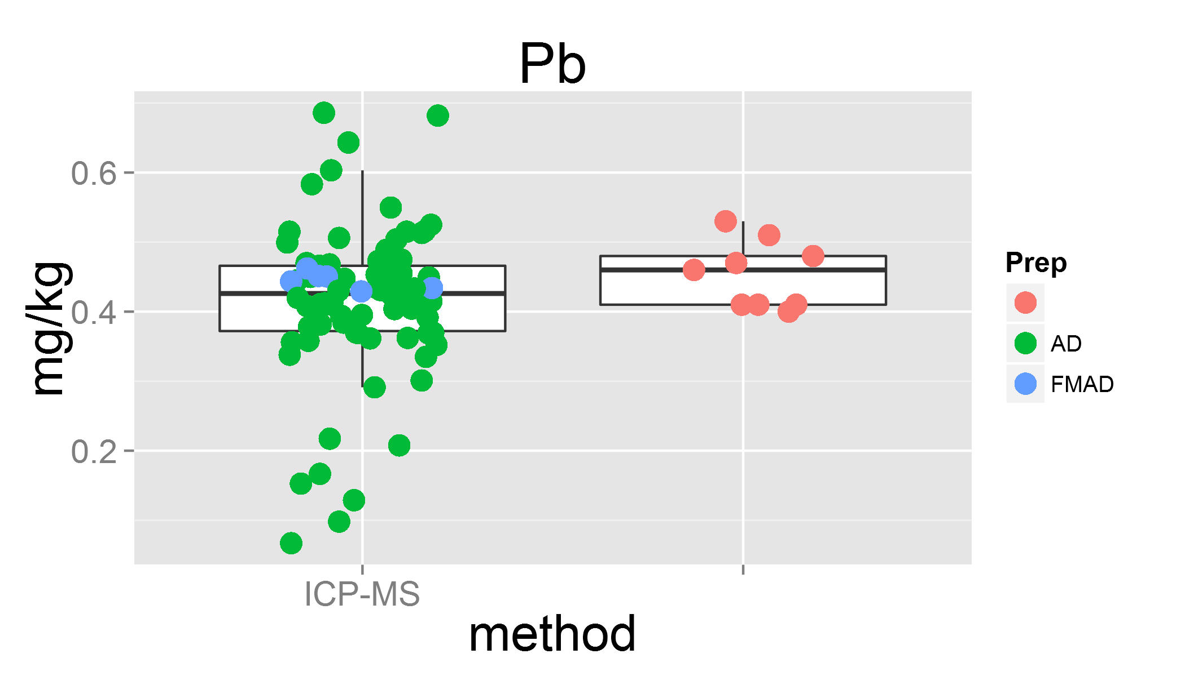

plot of chunk unnamed-chunk-3

## Warning: Removed 20 rows containing missing values (geom_point).

## Lab 14 was removed  
## Lab 31 was removed

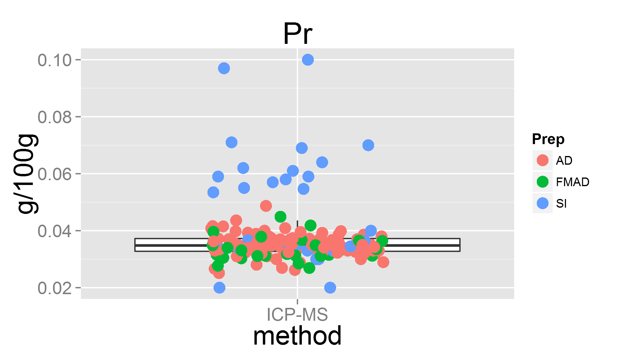

plot of chunk unnamed-chunk-3

## Warning: Removed 11 rows containing missing values (geom_point).

## Lab 31 was removed  
## Lab 26 was removed  
## Lab 33 was removed

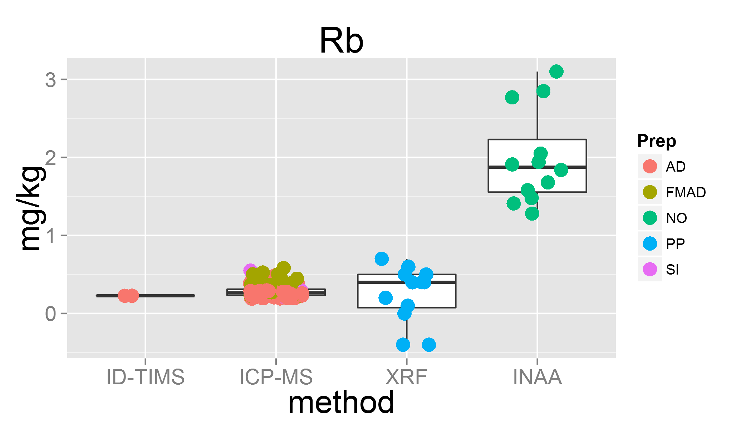

plot of chunk unnamed-chunk-3

## Warning: Removed 4 rows containing missing values (geom_point).

## Lab 0 was removed

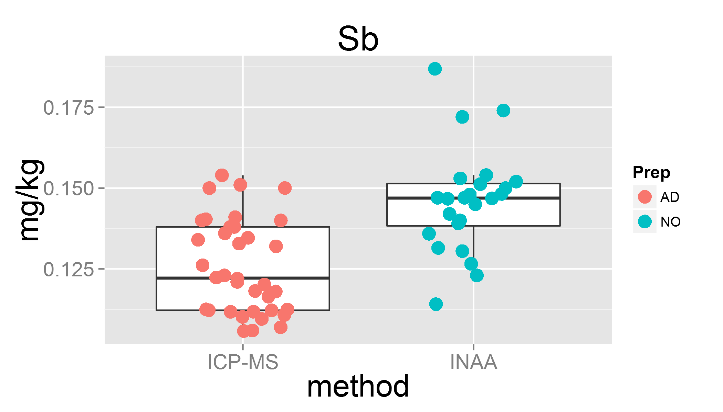

plot of chunk unnamed-chunk-3

## Warning: Removed 5 rows containing missing values (geom_point).

## Lab 8 was removed

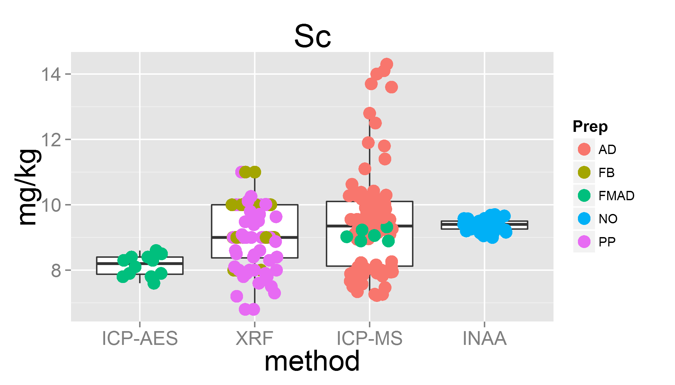

plot of chunk unnamed-chunk-3

## Warning: Removed 12 rows containing missing values (geom_point).  
## Warning: Removed 1 rows containing missing values (geom_point).

## Lab 14 was removed  
## Lab 33 was removed

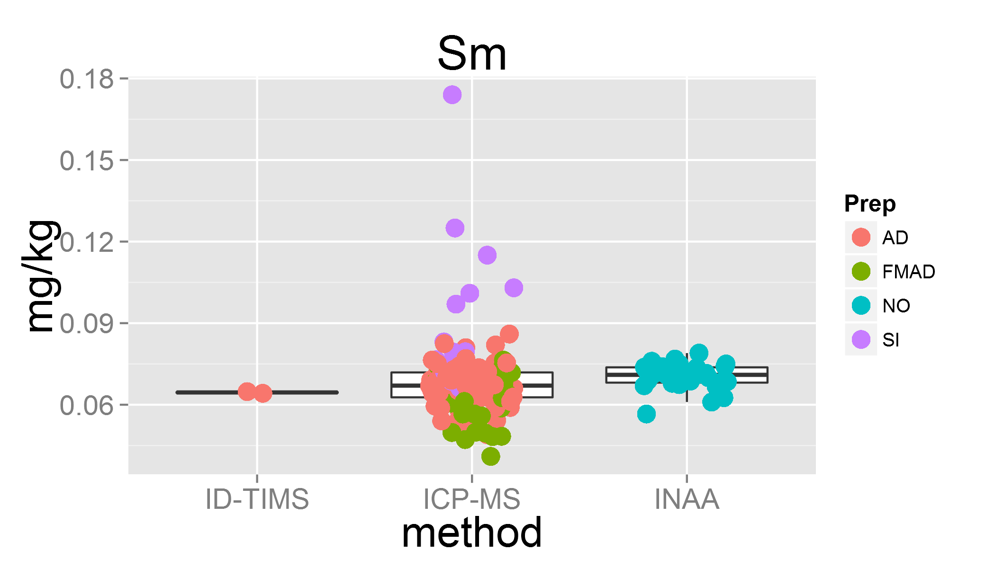

plot of chunk unnamed-chunk-3

## Warning: Removed 2 rows containing missing values (geom_point).

## Lab 0 was removed

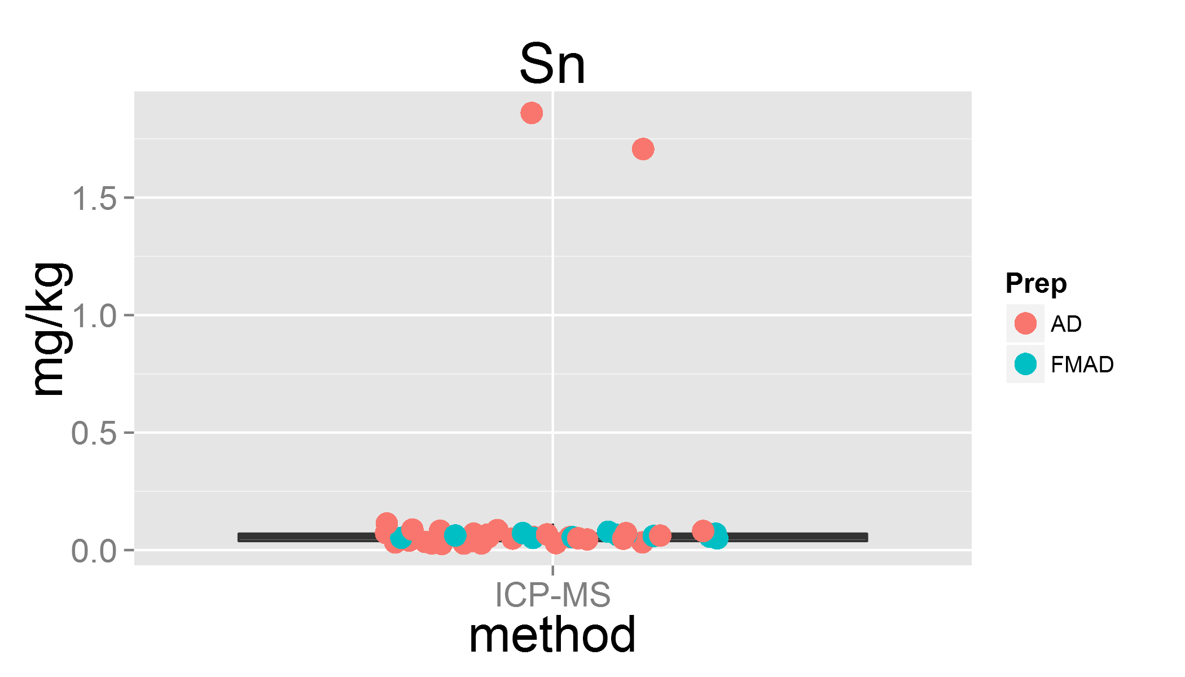

plot of chunk unnamed-chunk-3

## Warning: Removed 14 rows containing missing values (geom_point).  
## Warning: Removed 12 rows containing missing values (geom_point).

## Lab 7 was removed  
## Lab 7 was removed

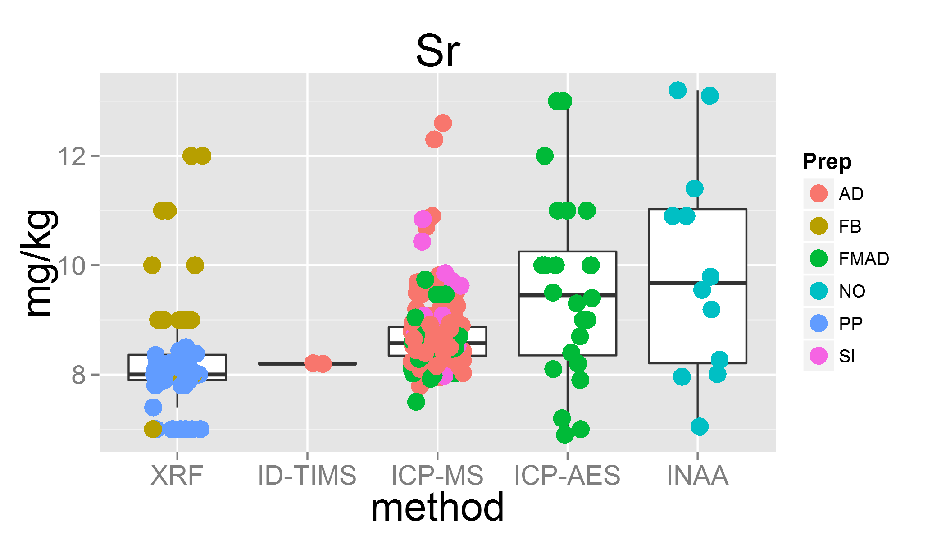

plot of chunk unnamed-chunk-3

## Warning: Removed 1 rows containing missing values (geom_point).  
## Warning: Removed 13 rows containing missing values (geom_point).

## Lab 8 was removed

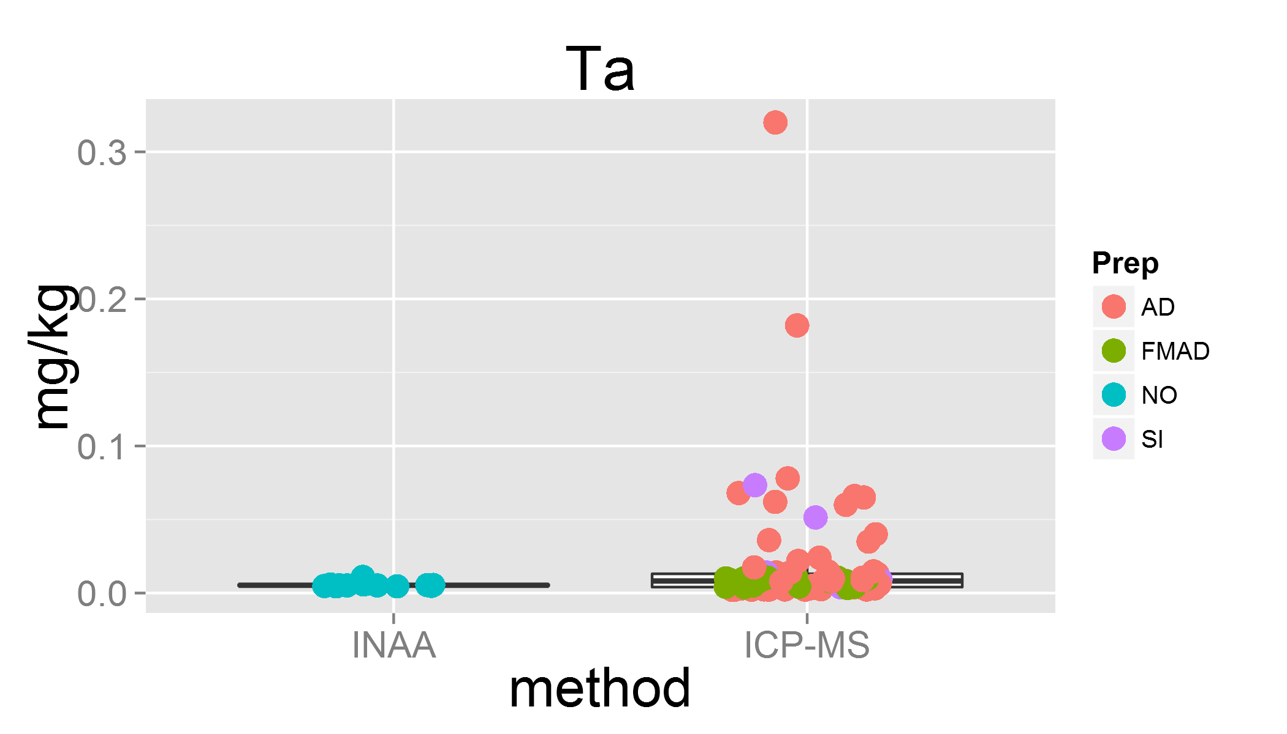

plot of chunk unnamed-chunk-3

## Warning: Removed 15 rows containing missing values (geom_point).

## Lab 32 was removed  
## Lab 31 was removed

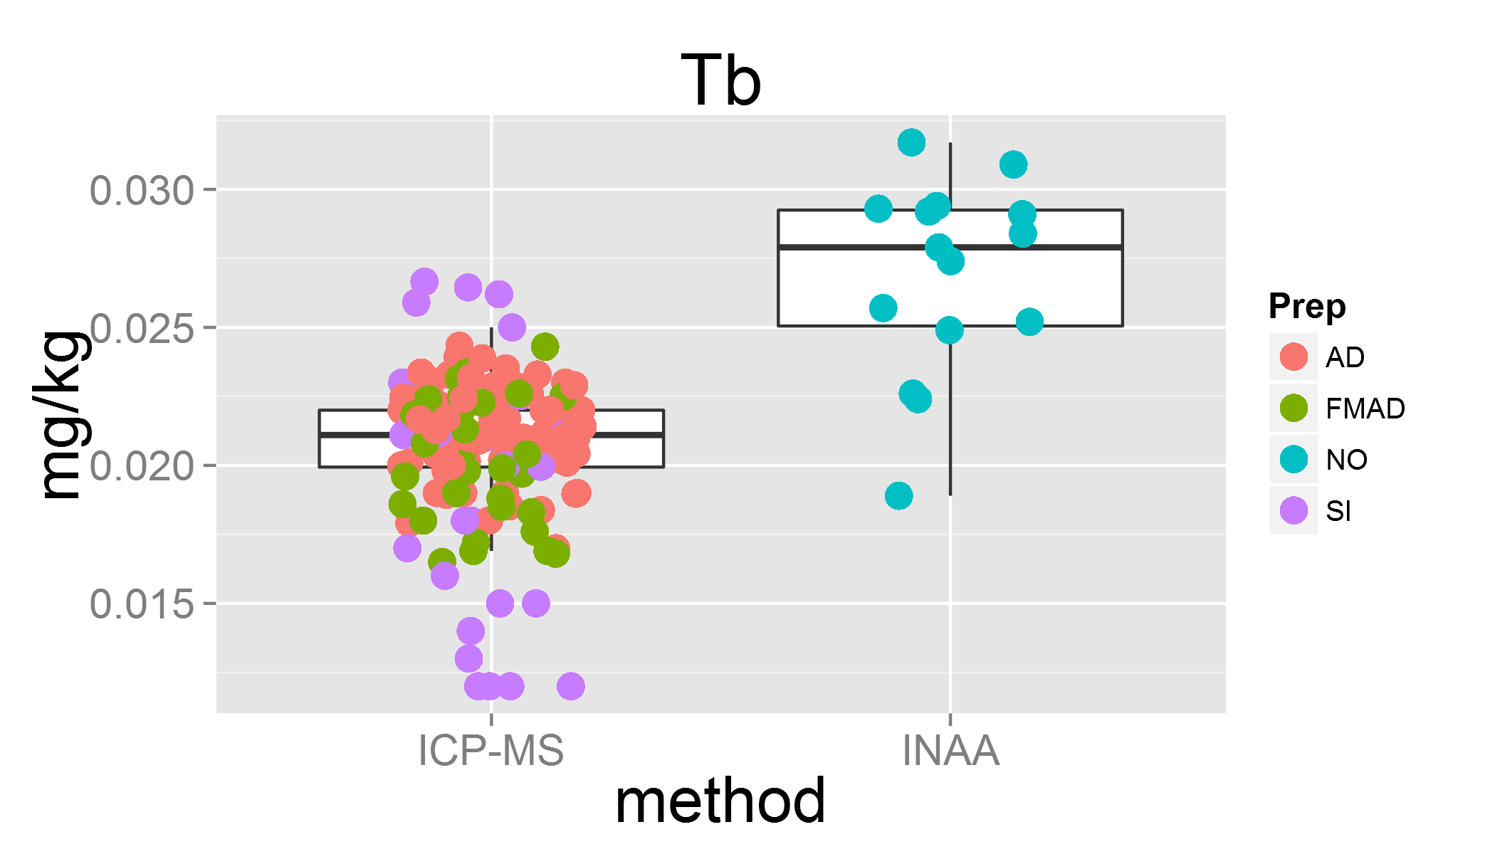

plot of chunk unnamed-chunk-3

## Warning: Removed 10 rows containing missing values (geom_point).

## Lab 14 was removed

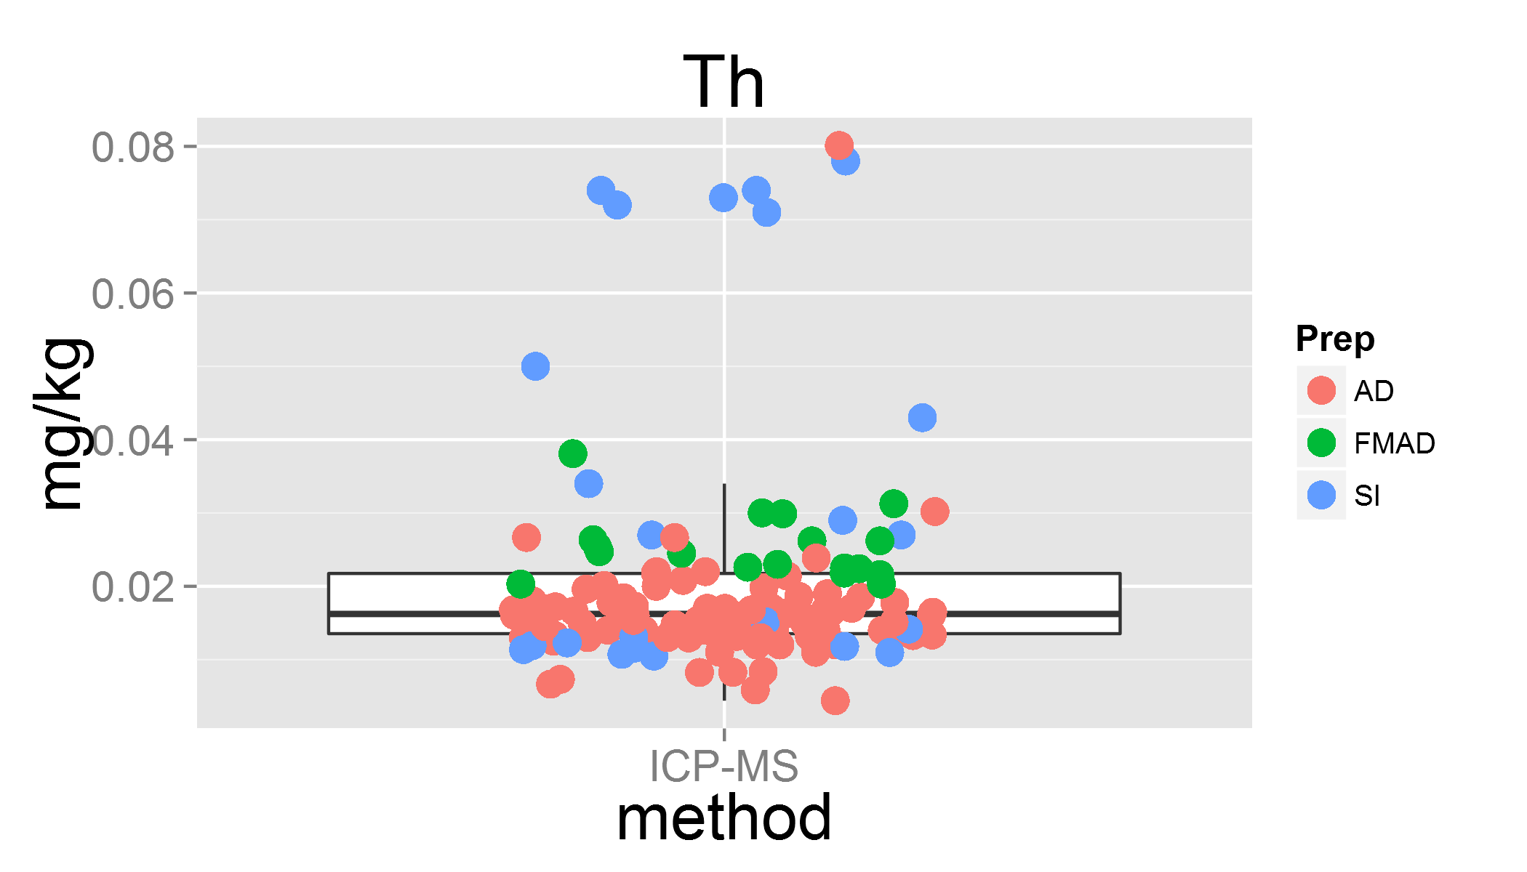

plot of chunk unnamed-chunk-3

## Warning: Removed 4 rows containing missing values (geom_point).

## Lab 0 was removed

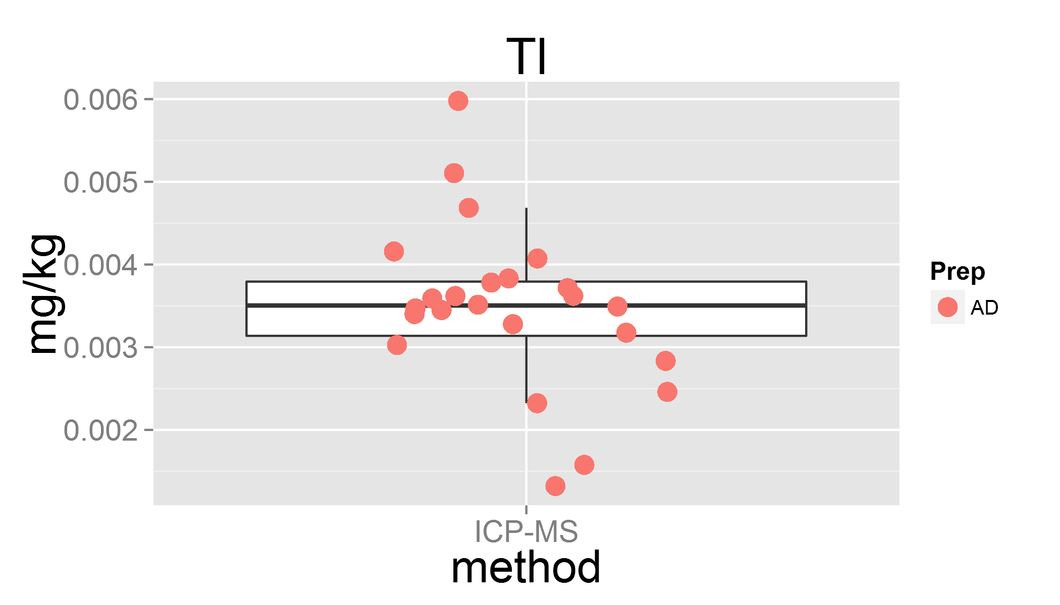

plot of chunk unnamed-chunk-3

## Warning: Removed 9 rows containing missing values (geom_point).

## Lab 31 was removed

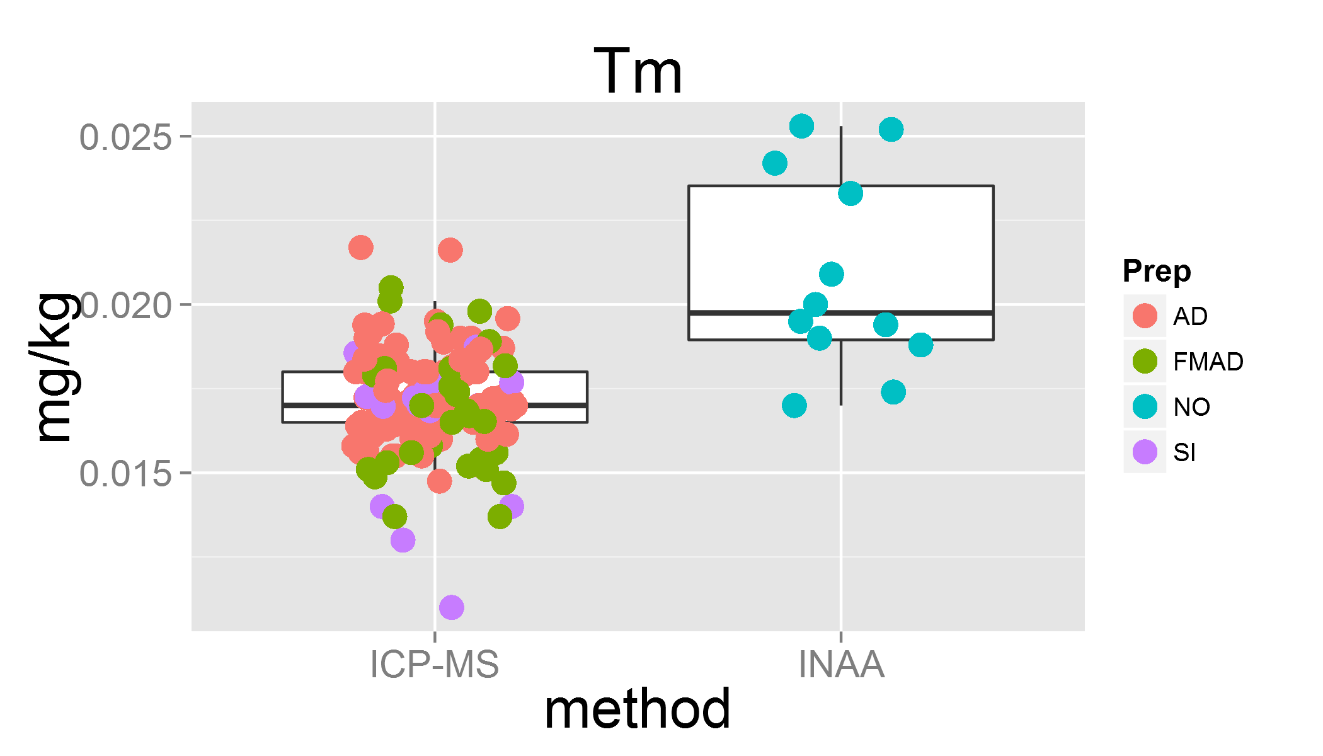

plot of chunk unnamed-chunk-3

## Warning: Removed 18 rows containing missing values (geom_point).

## Lab 14 was removed  
## Lab 29 was removed  
## Lab 31 was removed

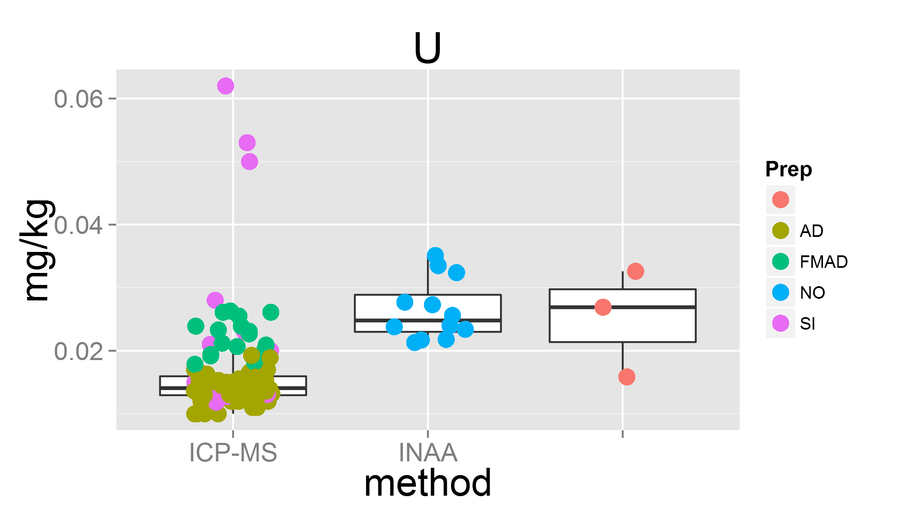

plot of chunk unnamed-chunk-3

## Warning: Removed 4 rows containing missing values (geom_point).  
## Warning: Removed 1 rows containing missing values (geom_point).

## Lab 31 was removed  
## Lab 32 was removed

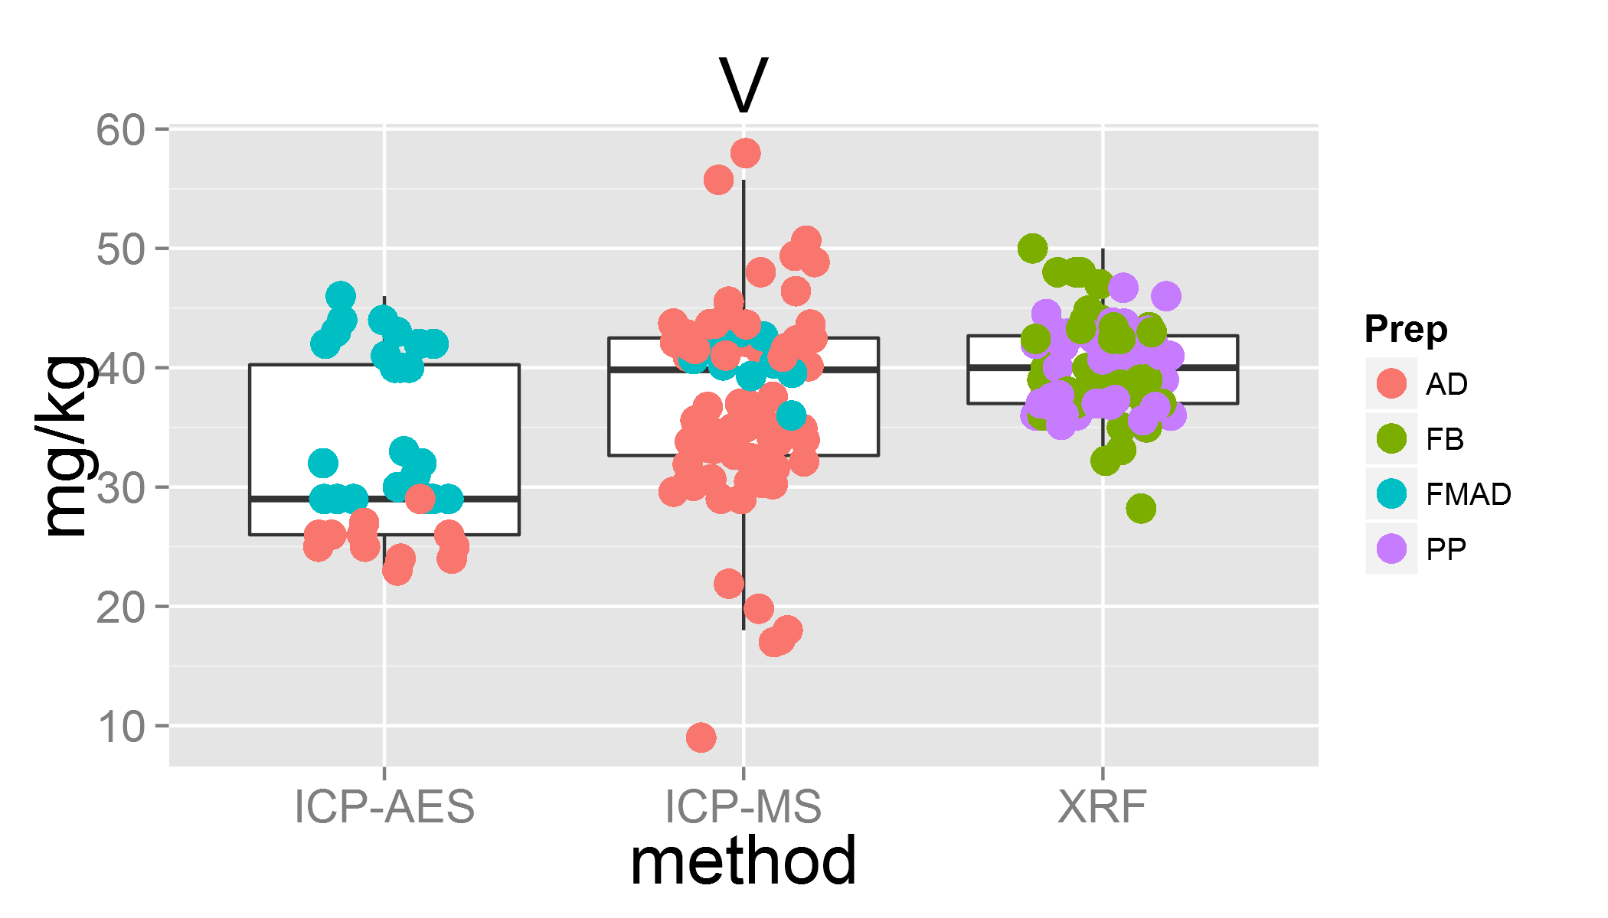

plot of chunk unnamed-chunk-3

## Warning: Removed 12 rows containing missing values (geom_point).  
## Warning: Removed 3 rows containing missing values (geom_point).

## Lab 26 was removed  
## Lab 31 was removed  
## Lab 32 was removed

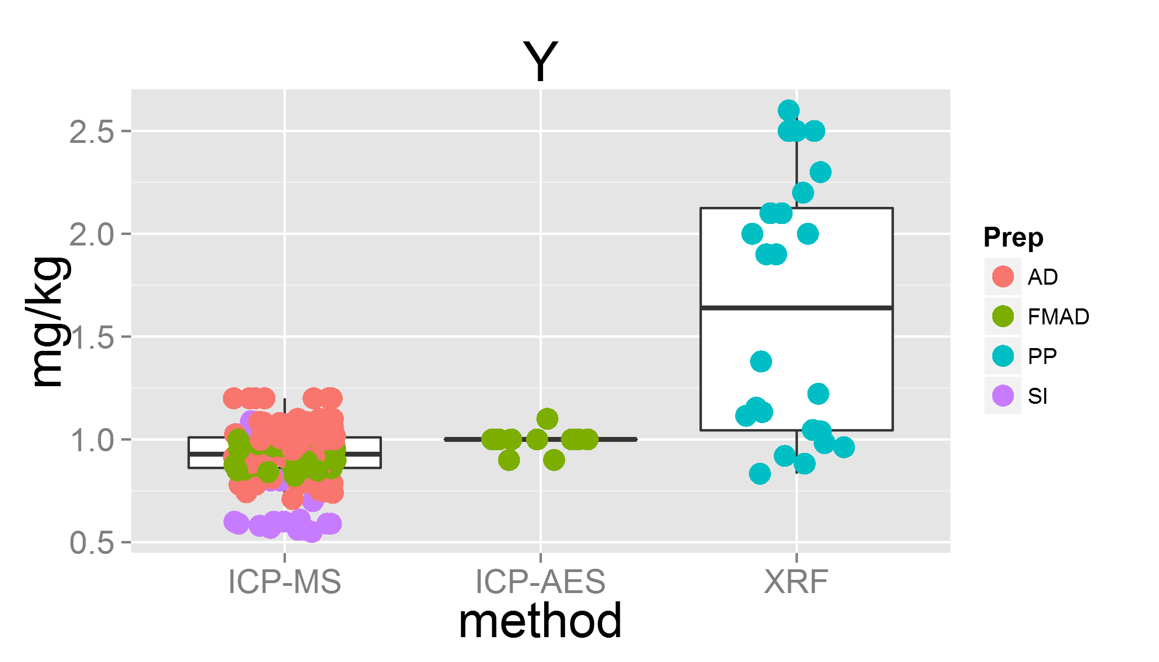

plot of chunk unnamed-chunk-3

## Warning: Removed 14 rows containing missing values (geom_point).  
## Warning: Removed 5 rows containing missing values (geom_point).

## Lab 14 was removed

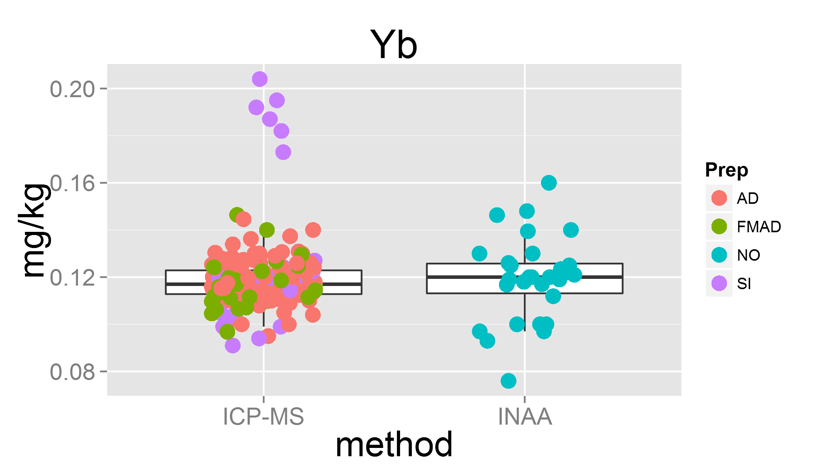

plot of chunk unnamed-chunk-3

## Warning: Removed 2 rows containing missing values (geom_point).  
## Warning: Removed 2 rows containing missing values (geom_point).

## Lab 0 was removed

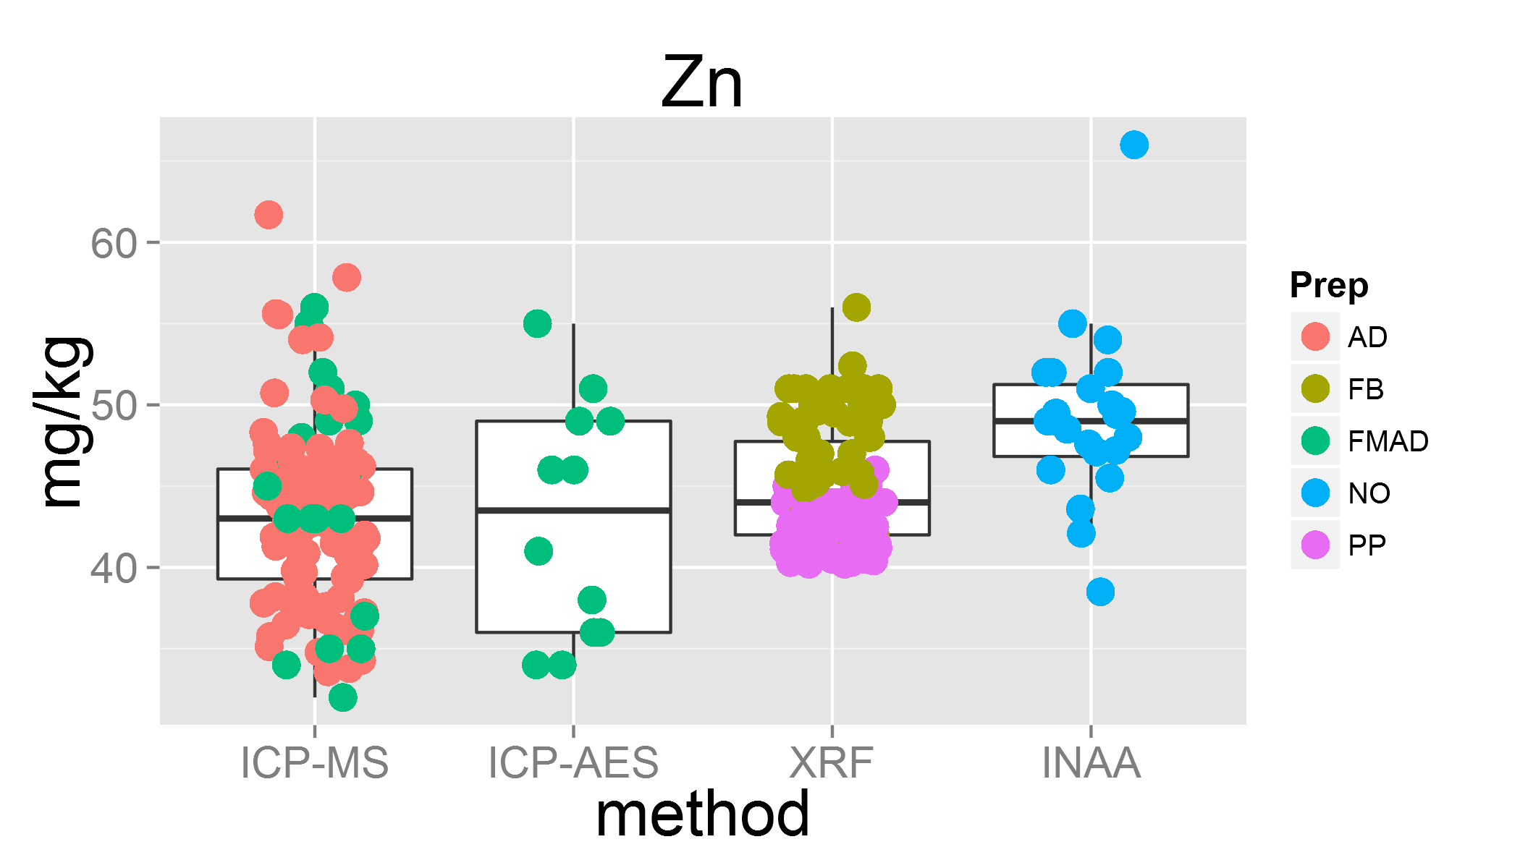

plot of chunk unnamed-chunk-3

## Warning: Removed 16 rows containing missing values (geom_point).  
## Warning: Removed 1 rows containing missing values (geom_point).

## Lab 10 was removed  
## Lab 6 was removed  
## Lab 26 was removed  
## Lab 33 was removed  
## Lab 31 was removed  
## Lab 24 was removed

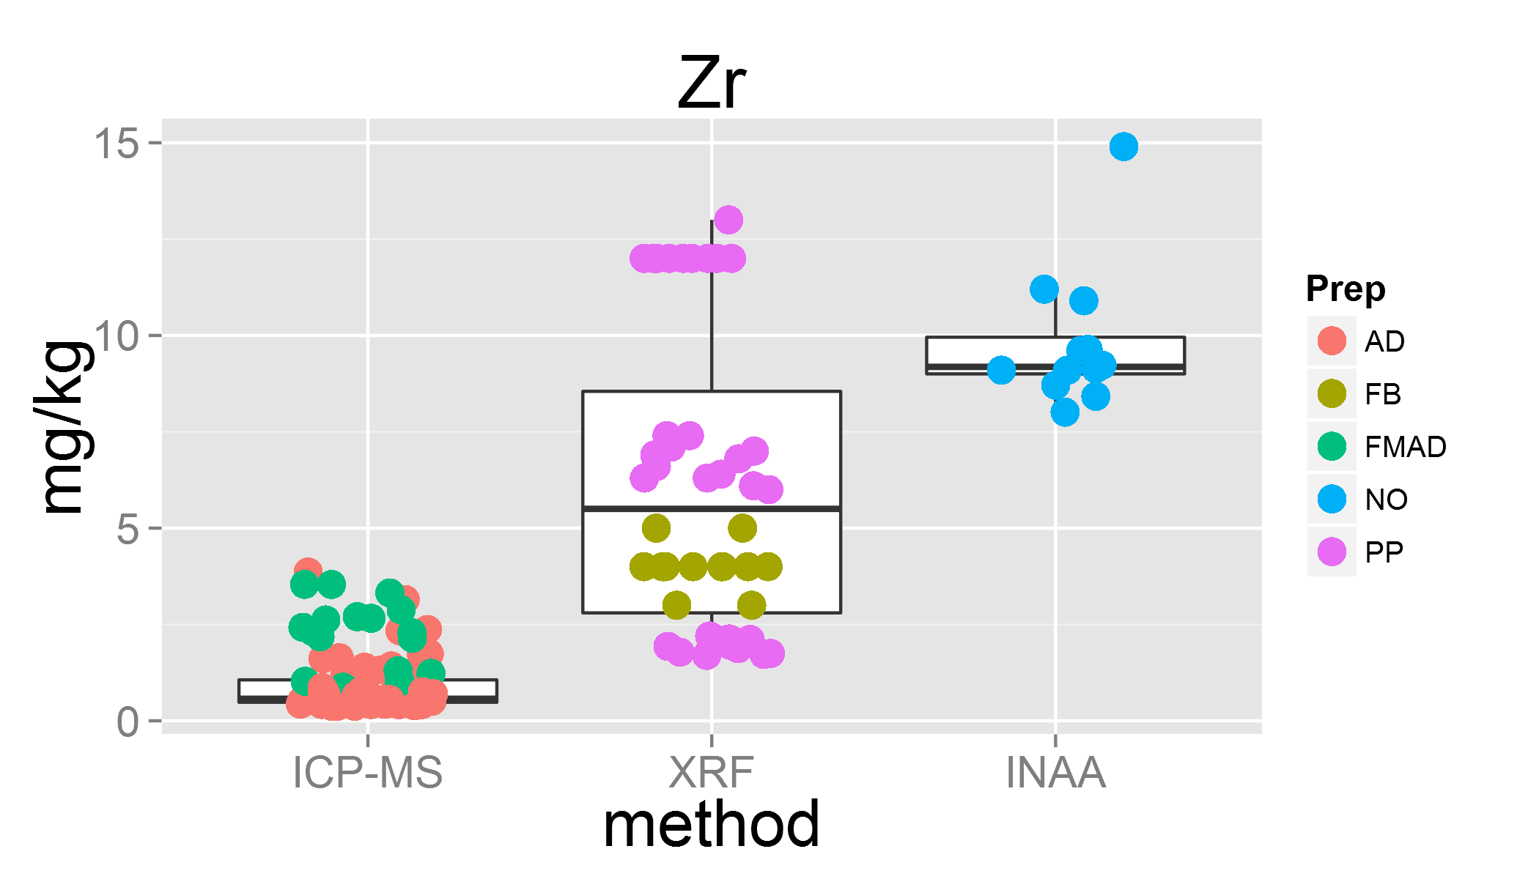

plot of chunk unnamed-chunk-3

medianGOM.packet.after <- ddply(GOM, c("Lab", "Packet"), numcolwise(medianGOM)) # median Lab and Packets after outlier removal  
## median over median of packets within lab  
GOM.median.after <- ddply(medianGOM.packet.after, c("Lab"), numcolwise(medianGOM)) # creating a new table of median of labs after outlier removal for measurand but for entire table (all measurands)  
GOM.median.after <- merge(GOM.median.after, OKUM.methods, by="Lab")  
GOM.median.after.df <- data.frame(apply(GOM.median.after[2:56], 2, median, na.rm=TRUE)) # creating a new table with final property values based on median  
names(GOM.median.after.df) <- c("mass fraction")  
meanGOM.packet <- ddply(GOM, c("Lab", "Packet"), numcolwise(meanGOM))  
meanGOM.packet.after <- ddply(GOM, c("Lab", "Packet"), numcolwise(meanGOM)) # mean Lab and Packets after outlier removal  
## mean over mean of packets within lab  
GOM.mean.after <- ddply(meanGOM.packet.after, c("Lab"), numcolwise(meanGOM)) # creating a new table of mean of labs after outlier removal for measurand but for entire table (all measurands)  
GOM.mean.after <- merge(GOM.mean.after, OKUM.methods, by="Lab")  
GOM.mean.after.df <- data.frame(apply(GOM.mean.after[2:56], 2, mean, na.rm=TRUE)) # creating a new table with final property values based on mean  
names(GOM.mean.after.df) <- c("mass fraction")

### Nested random effects in data analysis: two way ANOVA

This model can be used when the results of the interlaboratory study are used to confirm the homogeneity of the material as well as to characterise it. The experimental scheme is illustrated in Fig X for the particular case of the IAG protocol. When the ILC consists of different methos, the result can be expressed by the equation

$x_{ijk}=μ+A_{i}+Bij+ε_{ijk}$

where

$x_{ijk}$ is the $k$ th result of sample unit j reported from method/laboratory $i$, $A_{i}$ 
 is the error due to method/laboratory $i$, $Bij$ 
 is the error due to the $j$ th sample unit within method/laboratory $i$, $ε_{ijk}$ is the measurement error.

The parameters to be estimated are the grand mean, the between-laboratory standard deviation $s_{L}$, the between-bottle standard deviation $s_{bb}$ and the repeatability standard deviation $s_{r}$. The are related as follows

$s_{L}=\sqrt{Var(A_{i})}$ $s_{bb}=\sqrt{Var(B_{ij})}$ $s_{r}=\sqrt{Var(ε_{ijk})}$

The formulae for computing the above-mentioned estimates read as follows. The grand mean is computed using

$\overline{x}=\frac{1}{\sum_{i=1}^{p}{\sum_{j=1}^{b_{i}}{n_{ij}}}}\sum_{i=1}^{p}{\sum_{j=1}^{b_{i}}{\sum_{k=1}^{n_{i}j}{x_{ijk}}}}$

where $p$ denotes the number of laboratories, $b_{i}$ the number of bottles used by method/laboratory $i$, and $n_{ij}$ is the number of replicates measured on bottle ${}_{ij}$. The variances are computed as follows

$Var(ε_{ijk})=MS_{within}=s_{r}^{2}$ $Var(B_{ij})=\frac{MS_{B⊂A}−MS_{within}}{n_{0}}=s_{b}^{2}b$ $Var(A_{i})=\frac{MS_{among}−nʹ_{0}Var(B_{ij})−Var(ε_{ijk})}{(nb)_{0}}=s_{L}^{2}$

where

$MS_{among}=\frac{\sum_{i=1}^{p}{n_{i}}({\overline{x}}_{A}−\overline{x})^{2}}{p−1}$

$MS_{B⊂A}=\frac{\sum_{i=1}^{p}{\sum_{j=1}^{b_{i}}{n_{ij}}}({\overline{x}}_{B}−{\overline{x}}_{A})^{2}}{\sum_{i=1}^{p}{b_{i}}−p}$

$MS_{within}=\frac{\sum_{i=1}^{p}{\sum_{j=1}^{b_{i}}{\sum_{k=1}^{n_{i}j}{(}}}x_{ijk}−{\overline{x}}_{B})^{2}}{\sum_{i=1}^{p}{\sum_{j=1}^{b_{i}}{n_{ij}}}−\sum_{i=1}^{p}{b_{i}}}$

and

$nʹ_{0}=\frac{\sum_{i=1}^{p}{\left(\frac{\sum_{j=1}^{b_{i}}{n_{ij}^{2}}}{\sum_{j=1}^{b_{i}}{n_{ij}}}\right)}−\frac{\sum_{i=1}^{p}{\sum_{j=1}^{b_{i}}{n_{ij}^{2}}}}{\sum_{i=1}^{p}{\sum_{j=1}^{b_{i}}{n_{ij}}}}}{p−1}$

$n_{0}=\frac{\sum_{i=1}^{p}{\sum_{j=1}^{b_{i}}{n_{ij}}}−\sum_{i=1}^{p}{\left(\frac{\sum_{j=1}^{b_{i}}{n_{ij}^{2}}}{\sum_{j=1}^{b_{i}}{n_{ij}}}\right)}}{\sum_{i=1}^{p}{b_{i}}−p}$

$(nb)_{0}=\frac{\sum_{i=1}^{p}{\sum_{j=1}^{b_{i}}{n_{ij}}}−\frac{\sum_{i=1}^{p}{(}\sum_{j=1}^{b_{i}}{n_{ij}})^{2}}{\sum_{i=1}^{p}{\sum_{j=1}^{b_{i}}{n_{ij}}}}}{p−1}$

### solutions of the above equations in $R$

ANOVA is calculated based on a linear model using the using "linear mixed effects models" of package nlme (lme {nlme})

GOM.lme <- lme(measurand ~ 1, random = ~ 1|Lab/Packet, data=DF.lme) # linear model with random effects

the variance components are extrated with package ape (varcomp {ape})

$s_{L}^{2}$ = sL2 <- varcomp(GOM.lme, FALSE, FALSE)[[1]] # between-laboratory variance $s_{bb}^{2}$ 
 = sbb2 <- varcomp(GOM.lme, FALSE, FALSE)[[2]] # between bottle variance $s_{r}^{2}$ 
 = sr2 <- varcomp(GOM.lme, FALSE, FALSE)[[3]] # repeatability standard deviation

The characterisation uncertainty $u_{char}$ is calculated

u1 <- sqrt(sL2/p+sbb2/p/r+sr2/p/r/4)

which is equivalent to

$u_{1}=\sqrt{\frac{s_{L}^{2}}{p}−\frac{s_{r}^{2}}{np}−\frac{s_{bb}^{2}}{npr}}$

This approach is not completly correct as it assumes 4 replicates per bottle

u2 <- attr(GOM.lme$fixDF,"varFixFact") # this approach takes unbalanced data into account and is used for all further calculations.

The between day variance is neglected here but the uncertainty component due to inhomogeneity is taken into account through the $s_{bb}^{2}$ component.

for (m in col.names) {  
 measurand.name <- m  
 switch(  
 refmat,  
 GAS = rm1 <- 2,  
 MUH = rm1 <- 1,  
 OKUM = rm1 <- 0  
 )   
 if(rm1 > 0)   
 {measurand <- measurand.name %p% '.' %p% rm1  
 } else   
 {  
 measurand <- measurand.name  
 }  
 MorT <- grep(measurand.name, colnames(GOM), fixed=TRUE) # finding the position of the measurand.name in the Columnheaders of data frame GOM  
 ifelse(MorT[1]< 21, MorT <- 'M', MorT<-'T') # testing if measurand is a major or trace element/compound (col:5-20 majors)  
 ifelse(MorT == "T", unit <- 'mg/kg', unit <- 'g/100g') # testing which unit is needed   
 ## calculating method parameters  
# '%p%' <- function(x, y) {as.character(paste (x, y, sep =""))}  
mean <- mean(tapply(GOM[[measurand]], GOM$Lab, mean, na.rm=TRUE), na.rm=TRUE)  
mean.before <- mean(GOM.mean[[measurand]], na.rm=TRUE)  
median.before <- median(GOM.median[[measurand]], na.rm=TRUE)  
median.after <- median(GOM.median.after[[measurand]], na.rm=TRUE) # median of the individual measurand after outlier removal  
prep <- 'Prep.'  
method <- 'Method.'  
anal.prep <- prep %p% measurand.name  
anal.method <- method %p% measurand.name  
anal <- GOM.median.after[[measurand]]  
anal.prep <- GOM.median.after[[anal.prep]]  
anal.method <- GOM.median.after[[anal.method]]  
analyte <- data.frame(GOM.median.after$Lab, GOM.median.after$names, anal, anal.prep, anal.method )  
analyte <- na.omit(analyte)  
  
 bymethod.n <- ddply(analyte, c("anal.method"), summarise,   
 N=length(anal),   
 mean = round(mean(anal), 3),   
 median = round(median(anal), 3),   
 sd = round(sd(anal),3),   
 se = round(sd/sqrt(N),3))  
  
meanGOM.packet.after$Lab <- as.factor(meanGOM.packet$Lab) # using only the median of the 3 packages per lab  
meanGOM.packet.after$Packet <- as.factor(meanGOM.packet$Packet)  
anal <- meanGOM.packet.after[[measurand]]  
DF.lme <- data.frame(meanGOM.packet.after$Lab, meanGOM.packet.after$Packet, meanGOM.packet.after[[measurand]])  
DF.lme <- na.omit(DF.lme)  
names(DF.lme) <- c("Lab", "Packet", "measurand")  
GOM.lme <- lme(measurand ~ 1, random = ~ 1|Lab/Packet, data=DF.lme) # linear model with random effects  
sL2.a <- varcomp(GOM.lme, FALSE, FALSE)[[1]] # between-laboratory variance  
sbb2.a <- varcomp(GOM.lme, FALSE, FALSE)[[2]] # between bottle standard deviation  
sr2.a <- varcomp(GOM.lme, FALSE, FALSE)[[3]] # repeatability standard deviation  
n.p <- dim(DF.lme)[1] # number of obervations  
p <- length(unique(DF.lme$Lab)) # haven't found a better way how to extract the number of labs (number of groups)  
r <- length(unique(DF.lme$Packet))  
t.value <- qt(0.975,df=p-1)  
u1.a <- sqrt(sL2.a/p+sbb2.a/p/r+sr2.a/p/r/4) # calculating the standard uncertainty of characterization  
u2.a <- attr(GOM.lme$fixDF,"varFixFact") # gives the same results as u1, amazing!  
# plot(DF.lme)  
analyte.noPP <- subset(analyte, analyte$anal.prep!="PP") # Removing all PP preparations for comparison reasons  
median.after.noPP <- median(analyte.noPP$anal)  
outlier <- ifelse(outlier=="0", "X", outlier)  
print(measurand)  
qqnorm(GOM.median.after[[measurand]])  
qqline(GOM.median.after[[measurand]])  
reference.line <- median.after  
u.Ulim <- median.after + u2.a*t.value  
l.Ulim <- median.after - u2.a*t.value  
bymethod <- ggplot(bymethod.n, aes(x=anal.method, y=median))+geom_point(size=4)+geom_errorbar(aes(ymin=median-se, ymax=median+se), width=0.05)+ geom_abline(intercept = reference.line, slope = 0) + geom_abline(intercept = u.Ulim, slope = 0, linetype ="dotted") + geom_abline(intercept = l.Ulim, slope = 0, linetype = "dotted") + mytheme  
plot.lab <- plot_lab(measurand, MorT, horw = FALSE, u = TRUE)  
# grid.arrange(bymethod, plot.lab, ncol=2)  
print(plot.lab)  
# print(bymethod.n)  
outlier.type.name <- measurand.name %p% ".outlier.type" # defining if outlier is selected ("Y" or NA)  
outlier.dist.type <- measurand.name %p% ".dist.type" # defining if outlier is based on Y = Youden plot, M = Madel's k, P = pressed powder pellet, D = detection limit   
out.measurand <- data.frame(MUH.outlier[[measurand.name]], MUH.outlier[[outlier.type.name]], MUH.outlier[[outlier.dist.type]])  
# out.measurand <- cbind(MUH.outlier[[measurand.name]], MUH.outlier[[outlier.type.name]])  
names(out.measurand) <- c("outlier.lab","outlier.type", "outlier.dist" )  
property.value.dist.type <- out.measurand[1,3]  
property.value <- ifelse(property.value.dist.type == "median", median.after, mean)  
df <- data.frame(Sys.Date(), refmat, measurand.name, signif(mean.before, 4), signif(mean,4), signif(median.before,4), signif(median.after,4), signif(median.after.noPP,4), unit, signif(sL2.a,3), signif(sbb2.a,3), signif(sr2.a,4), signif(u1.a,3), signif(u2.a,3), round(t.value,2), signif(outlier,2), signif(p,2), property.value.dist.type, signif(property.value,4), signif(u2.a*t.value,3))  
write.table(df, "df1.txt", row.names=FALSE, append=TRUE, col.names=FALSE)  
 }

## [1] "SiO2.1"

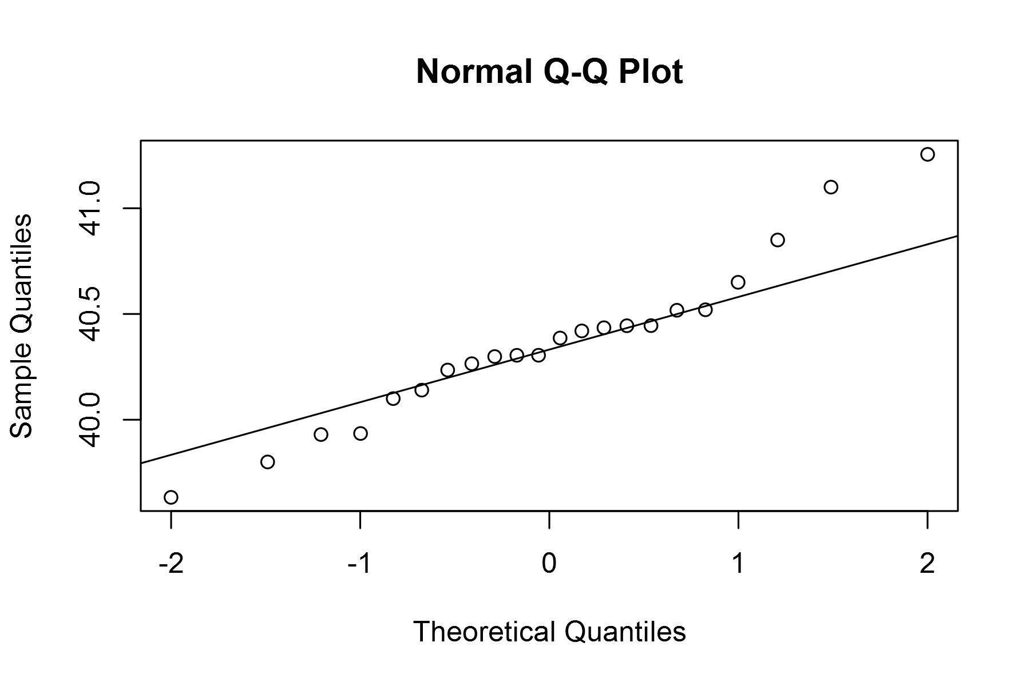

plot of chunk unnamed-chunk-4

## geom_smooth: method="auto" and size of largest group is <1000, so using loess. Use 'method = x' to change the smoothing method.

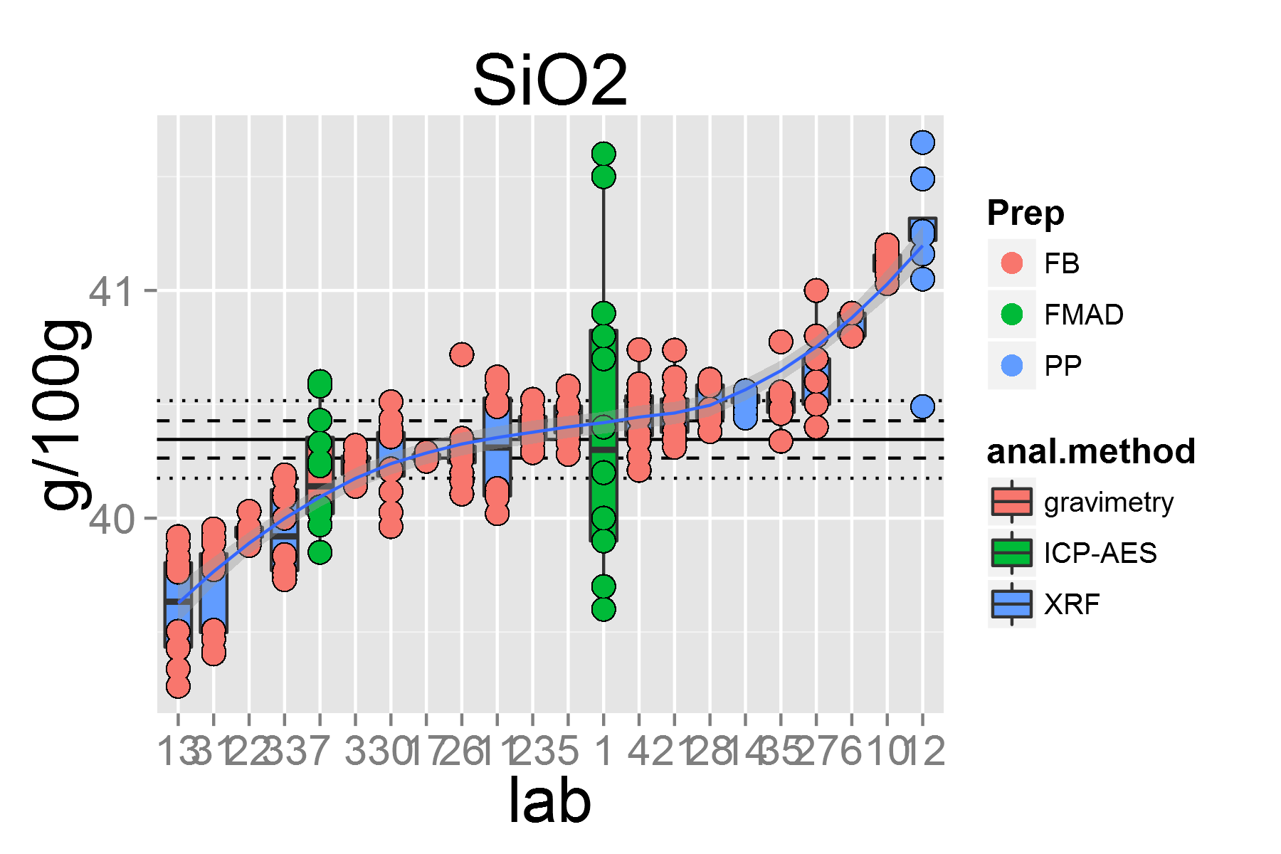

plot of chunk unnamed-chunk-4

## [1] "TiO2.1"

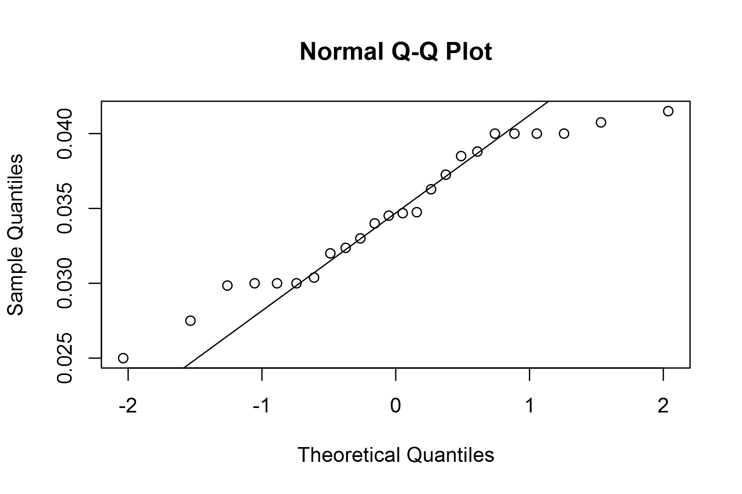

plot of chunk unnamed-chunk-4

## geom_smooth: method="auto" and size of largest group is <1000, so using loess. Use 'method = x' to change the smoothing method.

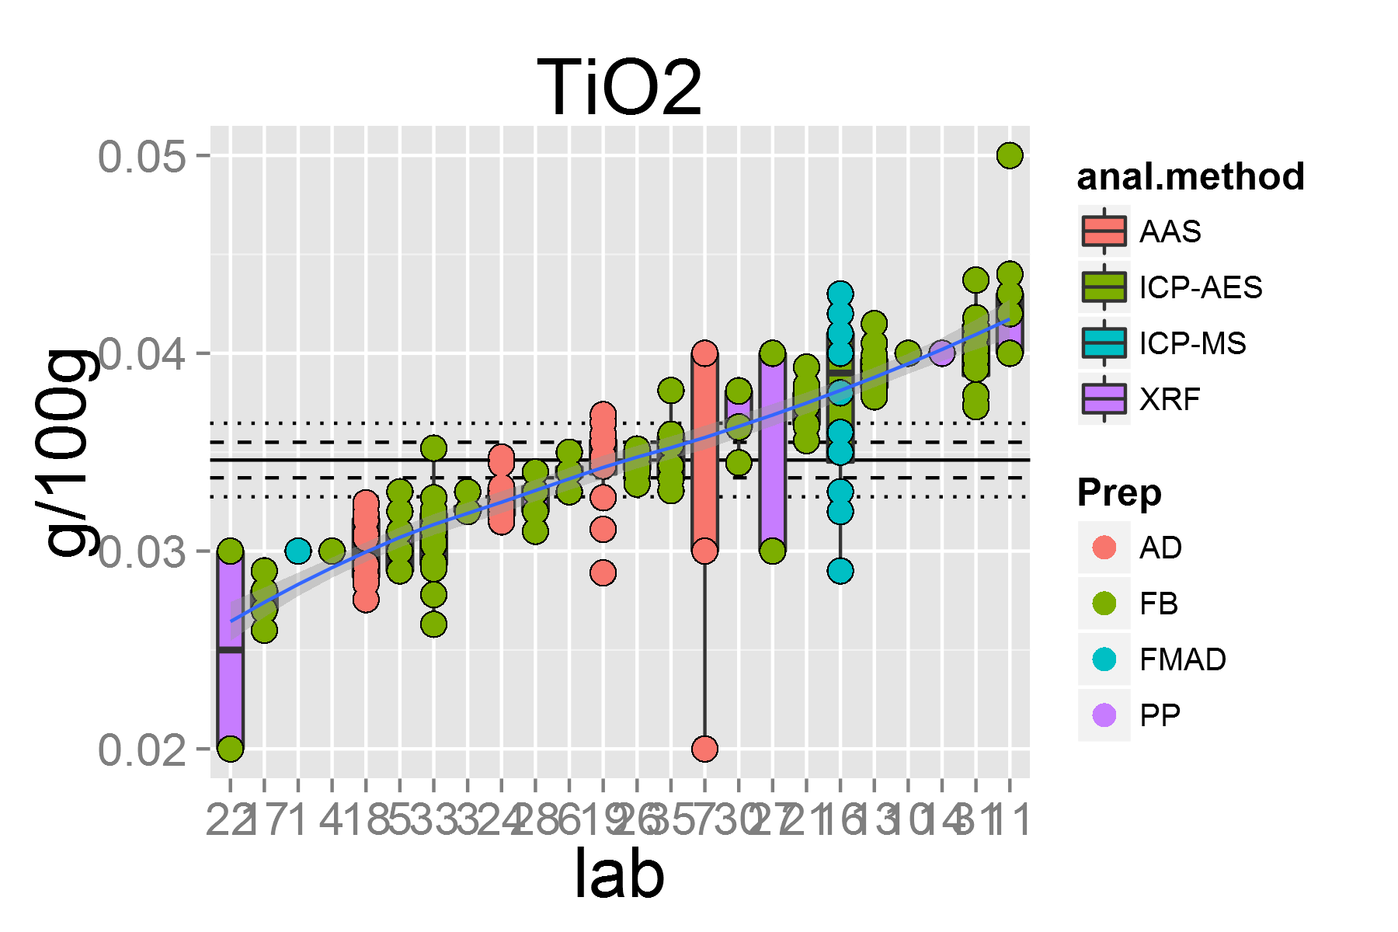

plot of chunk unnamed-chunk-4

## [1] "Al2O3.1"

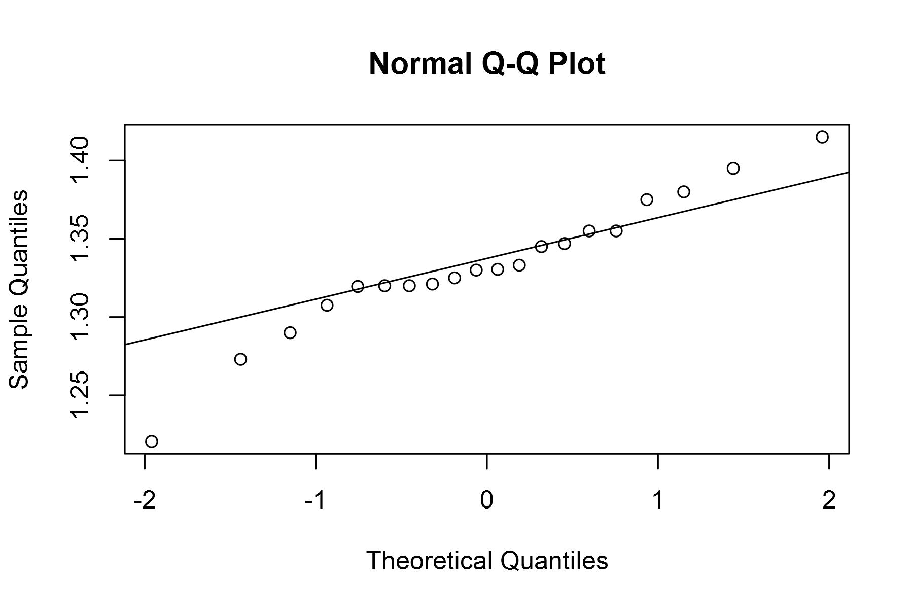

plot of chunk unnamed-chunk-4

## geom_smooth: method="auto" and size of largest group is <1000, so using loess. Use 'method = x' to change the smoothing method.

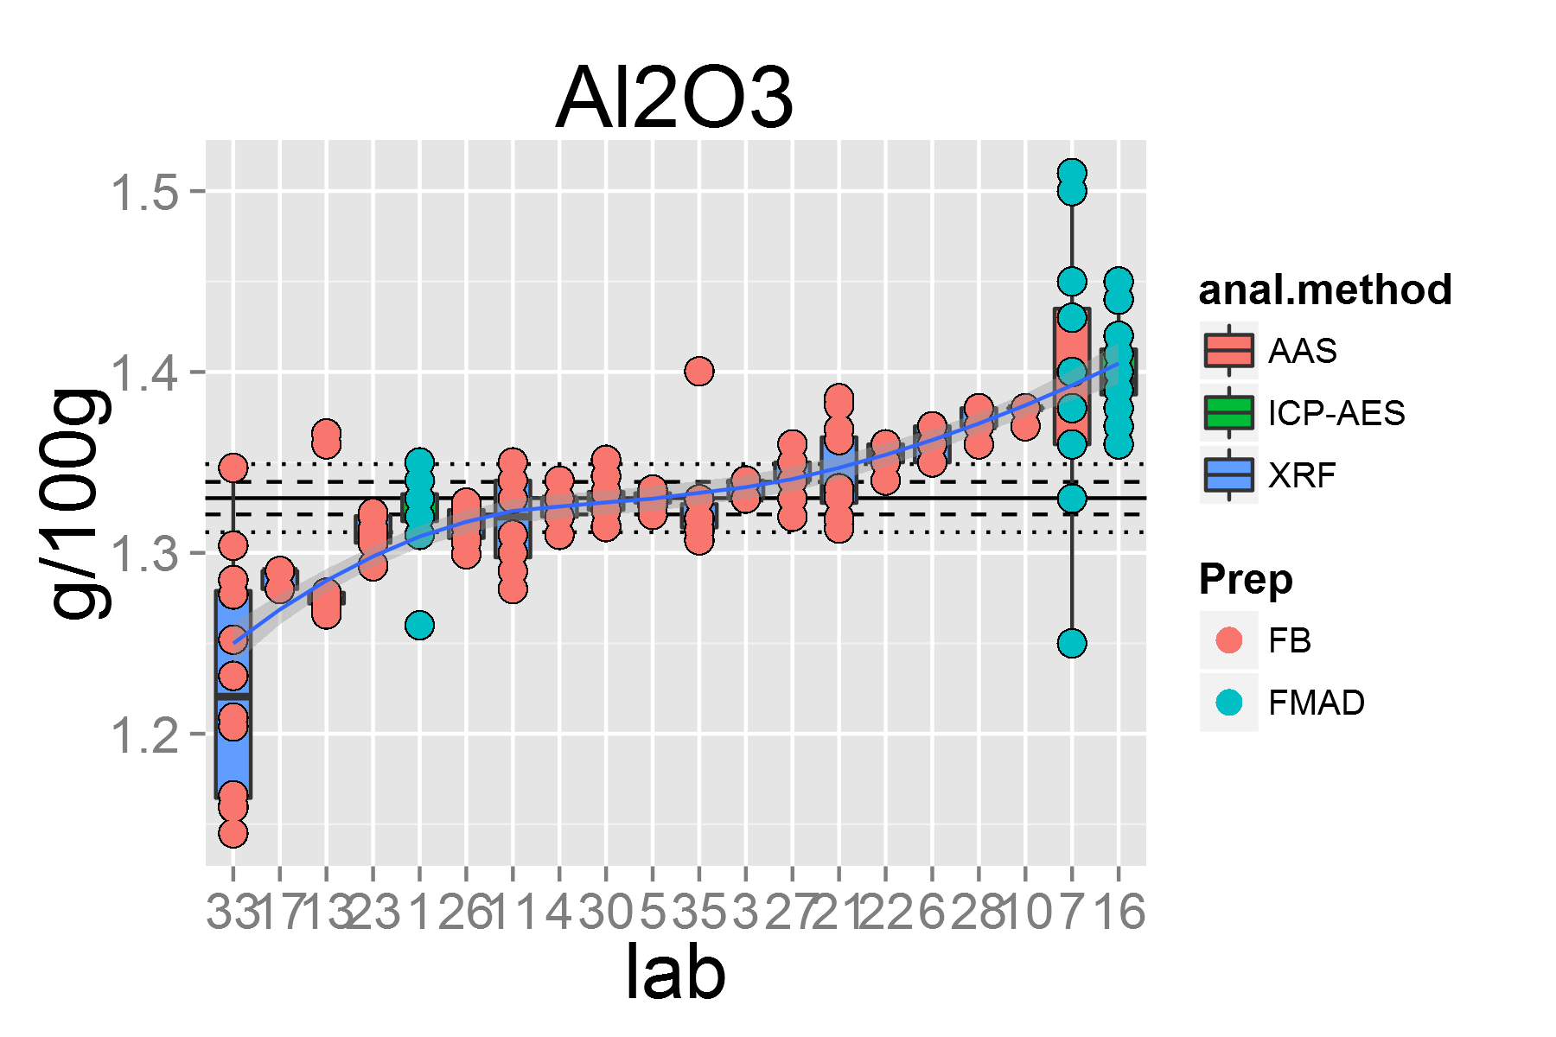

plot of chunk unnamed-chunk-4

## [1] "Fe2O3T.1"

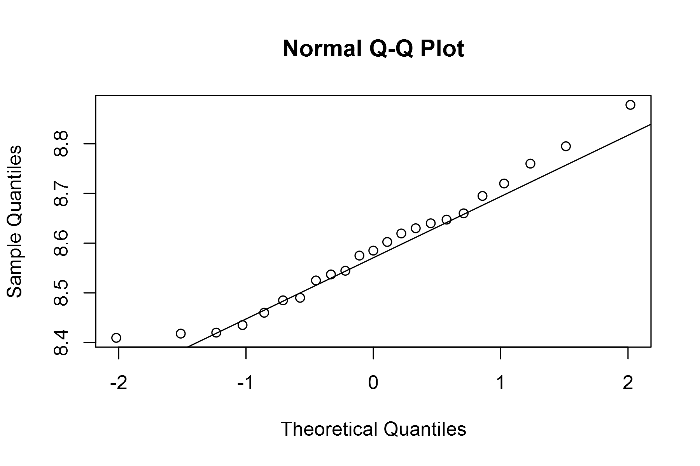

plot of chunk unnamed-chunk-4

## geom_smooth: method="auto" and size of largest group is <1000, so using loess. Use 'method = x' to change the smoothing method.

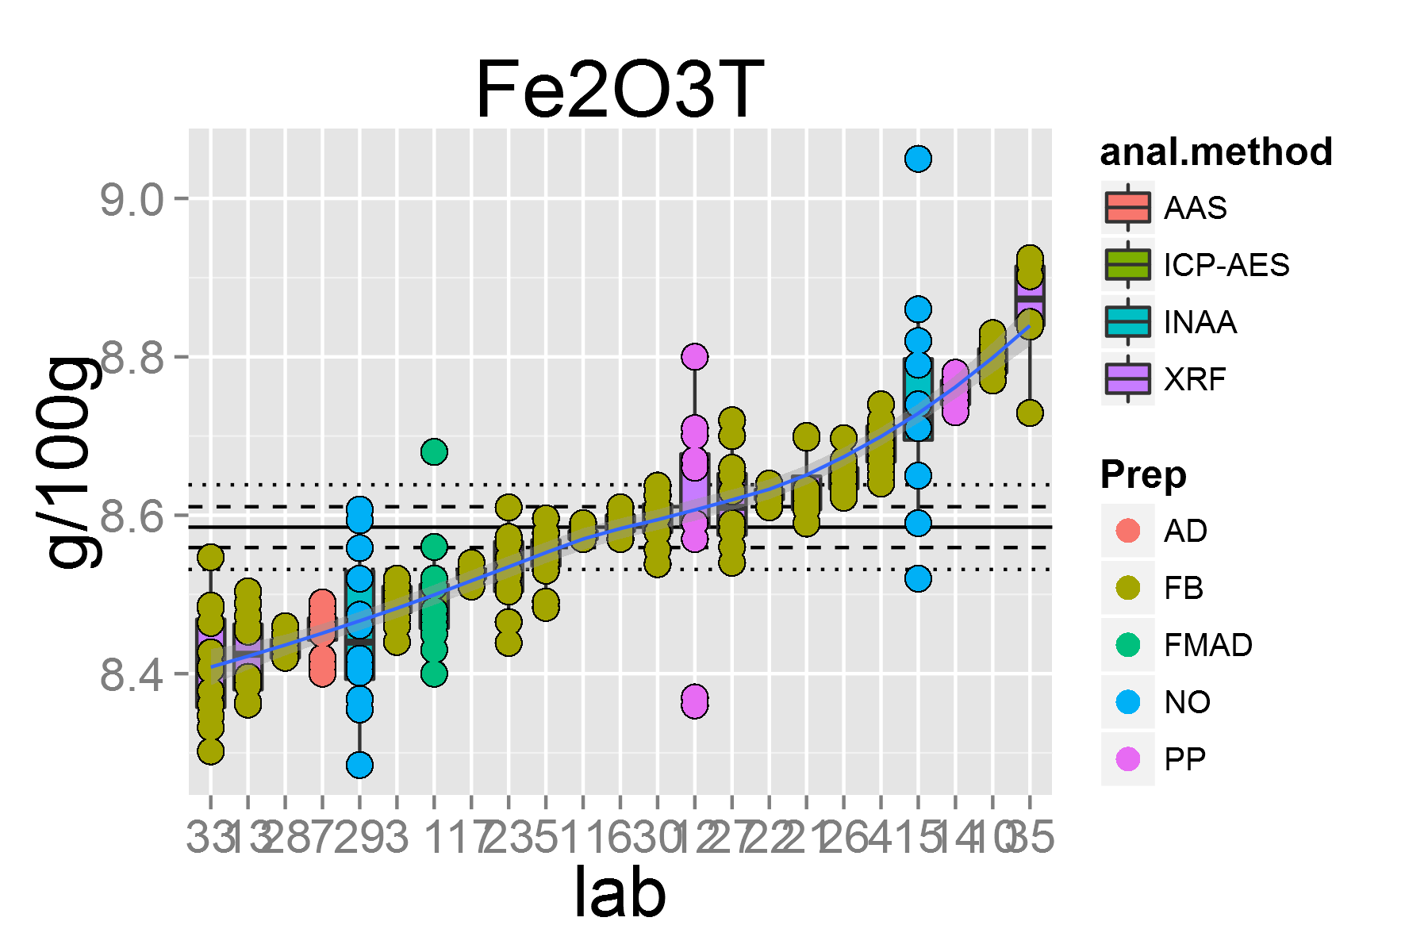

plot of chunk unnamed-chunk-4

## [1] "FeO.1"

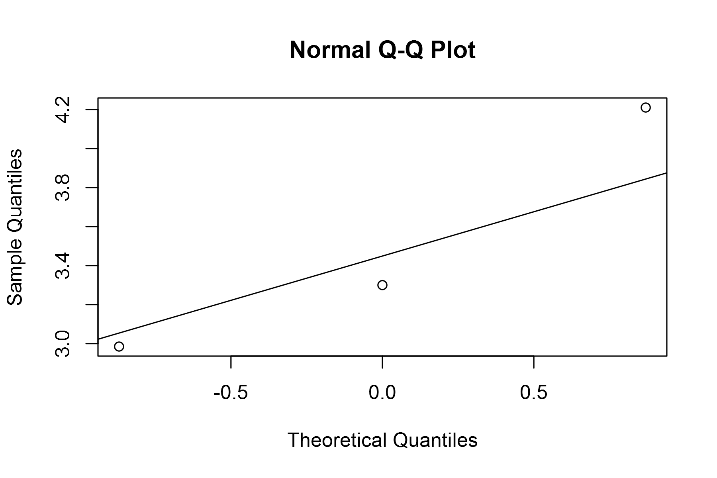

plot of chunk unnamed-chunk-4

## geom_smooth: method="auto" and size of largest group is <1000, so using loess. Use 'method = x' to change the smoothing method.

## Warning: pseudoinverse used at 0.99  
## Warning: neighborhood radius 1.01  
## Warning: reciprocal condition number 0  
## Warning: There are other near singularities as well. 4.0401  
## Warning: pseudoinverse used at 0.99  
## Warning: neighborhood radius 1.01  
## Warning: reciprocal condition number 0  
## Warning: There are other near singularities as well. 4.0401

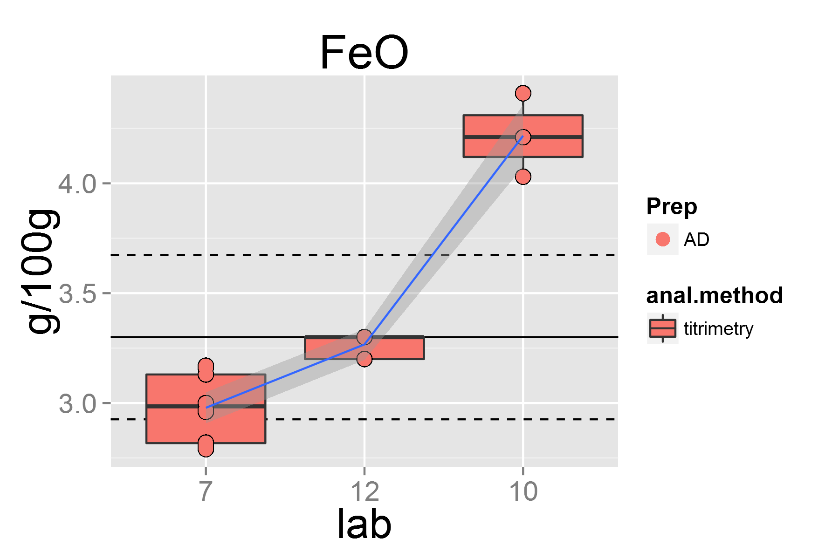

plot of chunk unnamed-chunk-4

## [1] "MnO.1"

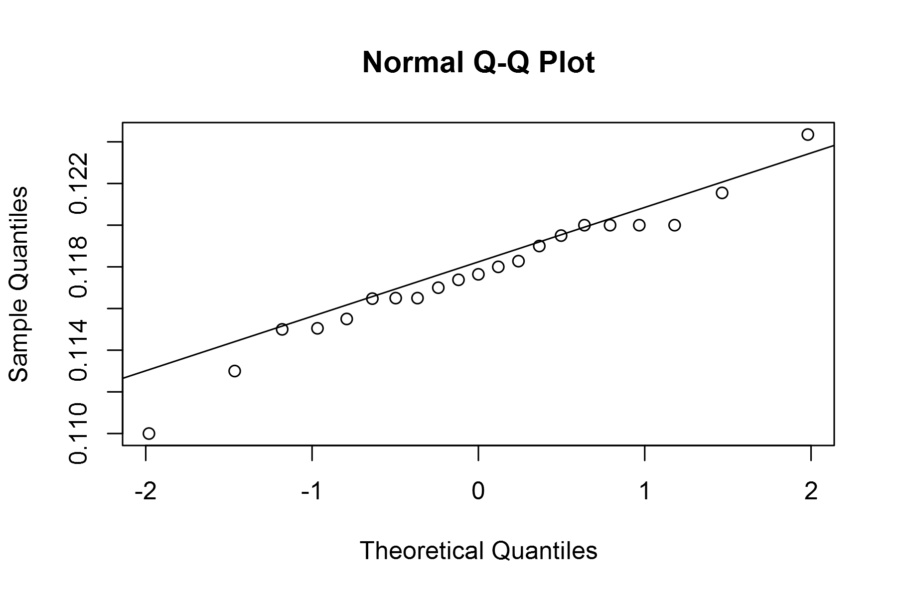

plot of chunk unnamed-chunk-4

## geom_smooth: method="auto" and size of largest group is <1000, so using loess. Use 'method = x' to change the smoothing method.

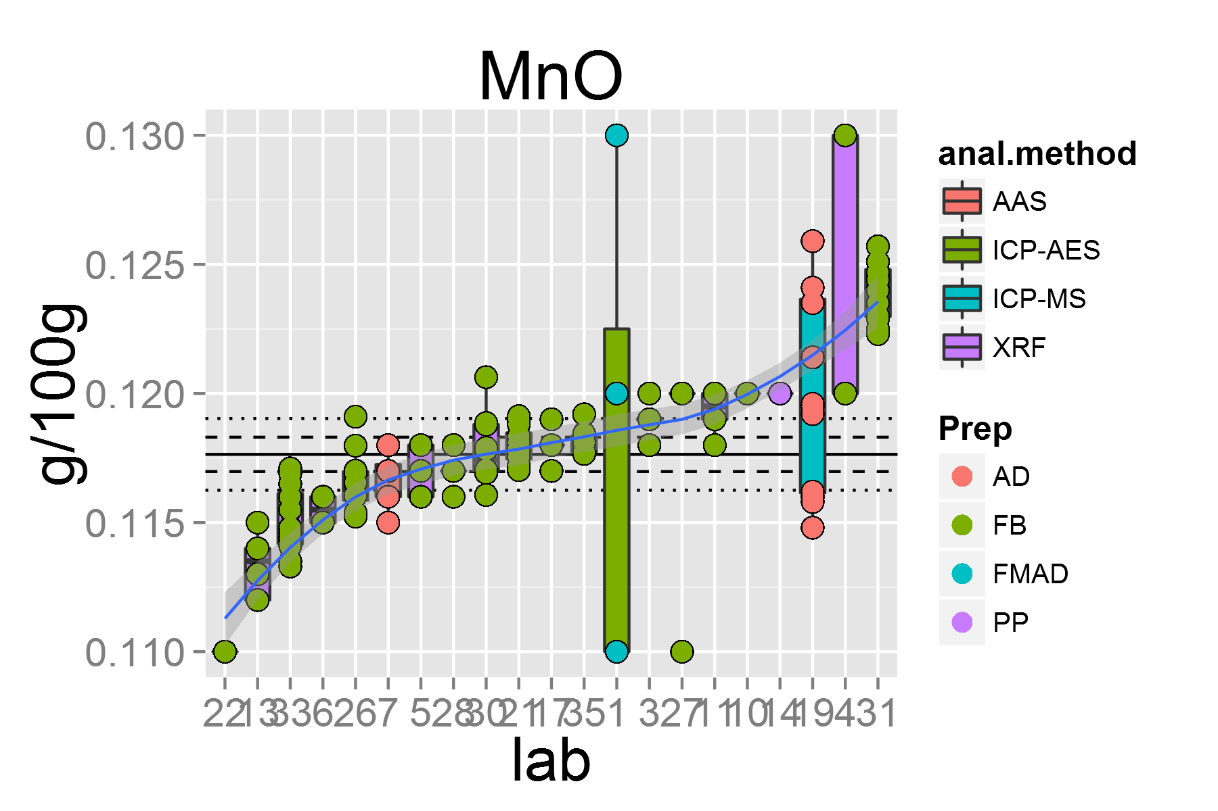

plot of chunk unnamed-chunk-4

## [1] "MgO.1"

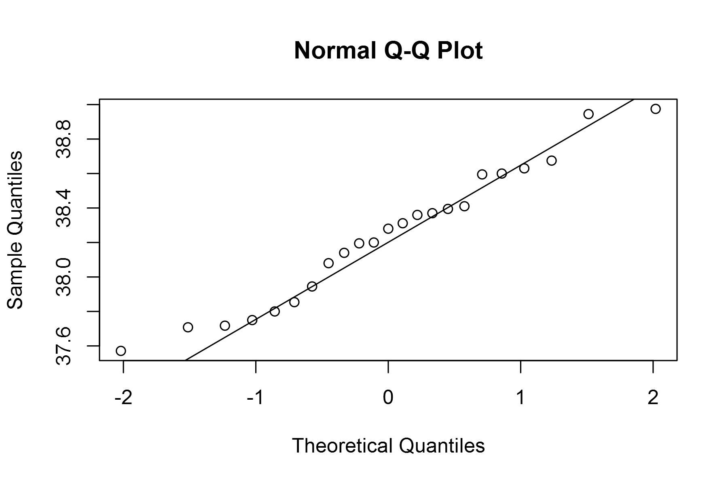

plot of chunk unnamed-chunk-4

## geom_smooth: method="auto" and size of largest group is <1000, so using loess. Use 'method = x' to change the smoothing method.

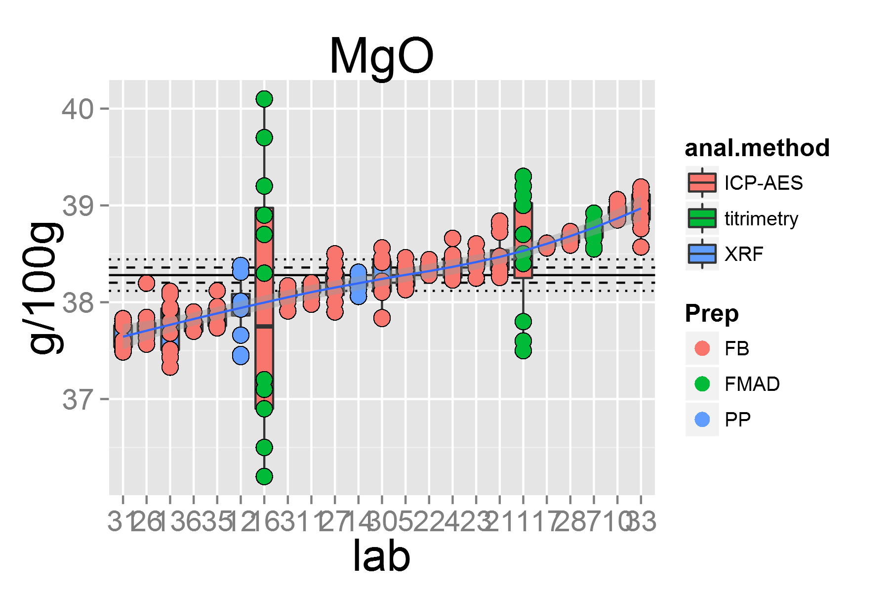

plot of chunk unnamed-chunk-4

## [1] "CaO.1"

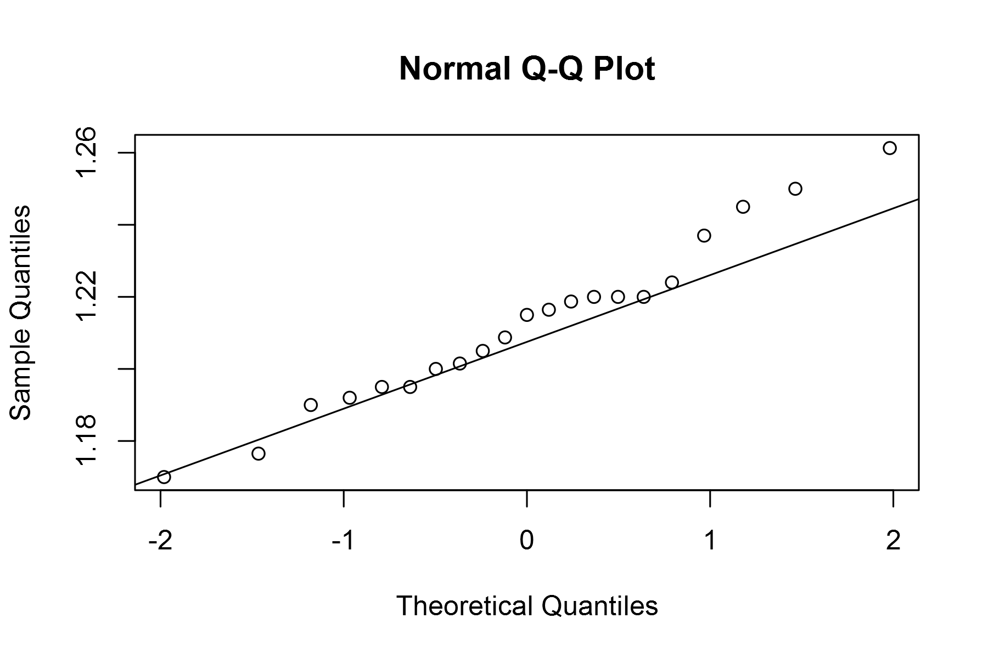

plot of chunk unnamed-chunk-4

## geom_smooth: method="auto" and size of largest group is <1000, so using loess. Use 'method = x' to change the smoothing method.

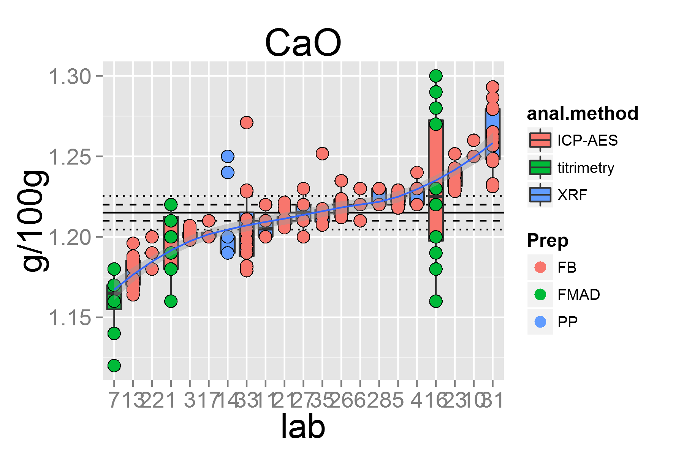

plot of chunk unnamed-chunk-4

## [1] "Na2O.1"

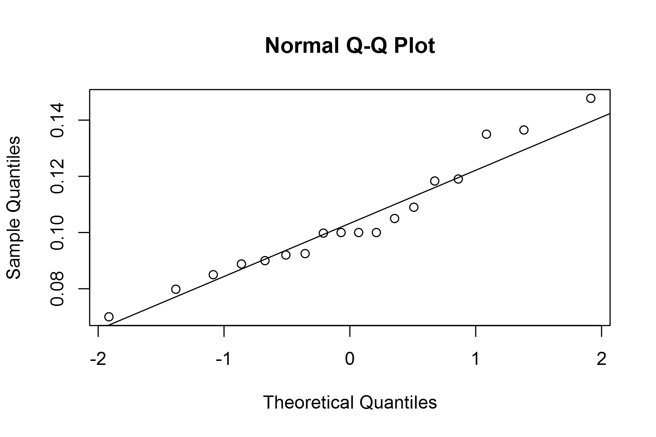

plot of chunk unnamed-chunk-4

## geom_smooth: method="auto" and size of largest group is <1000, so using loess. Use 'method = x' to change the smoothing method.

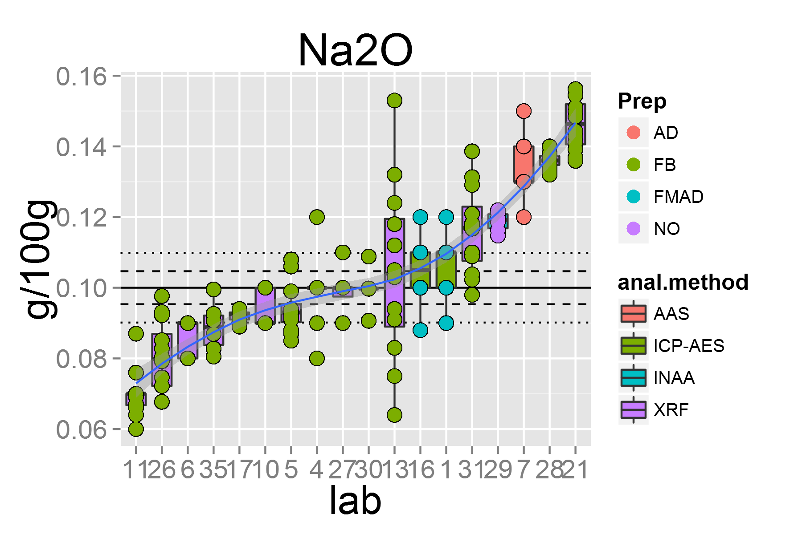

plot of chunk unnamed-chunk-4

## [1] "K2O.1"

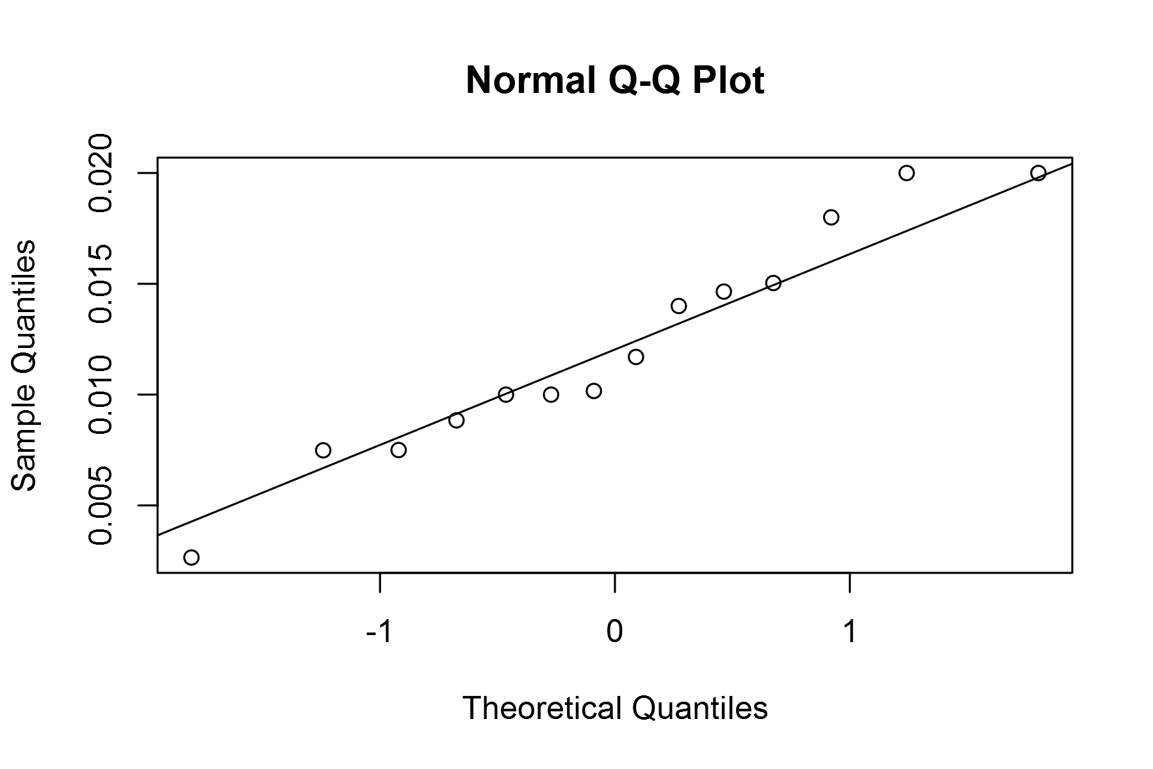

plot of chunk unnamed-chunk-4

## geom_smooth: method="auto" and size of largest group is <1000, so using loess. Use 'method = x' to change the smoothing method.

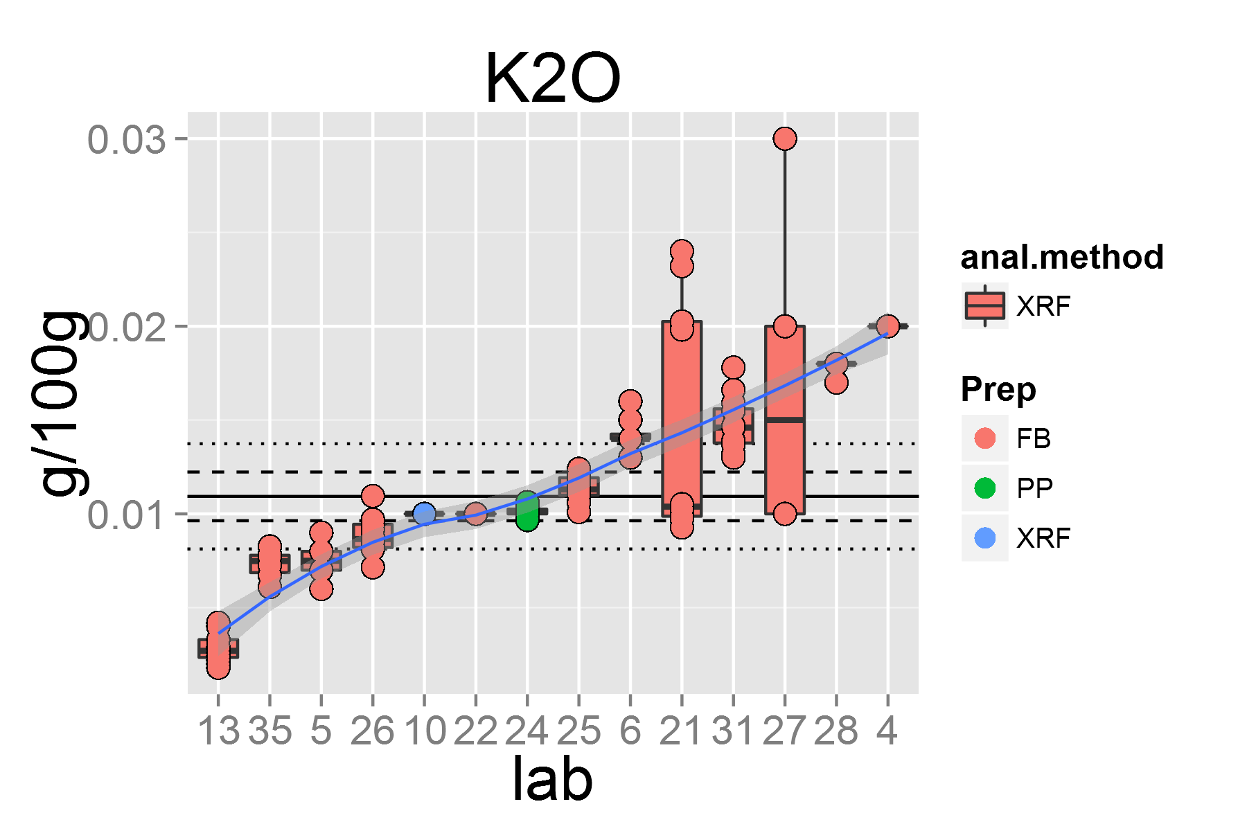

plot of chunk unnamed-chunk-4

## [1] "P2O5.1"

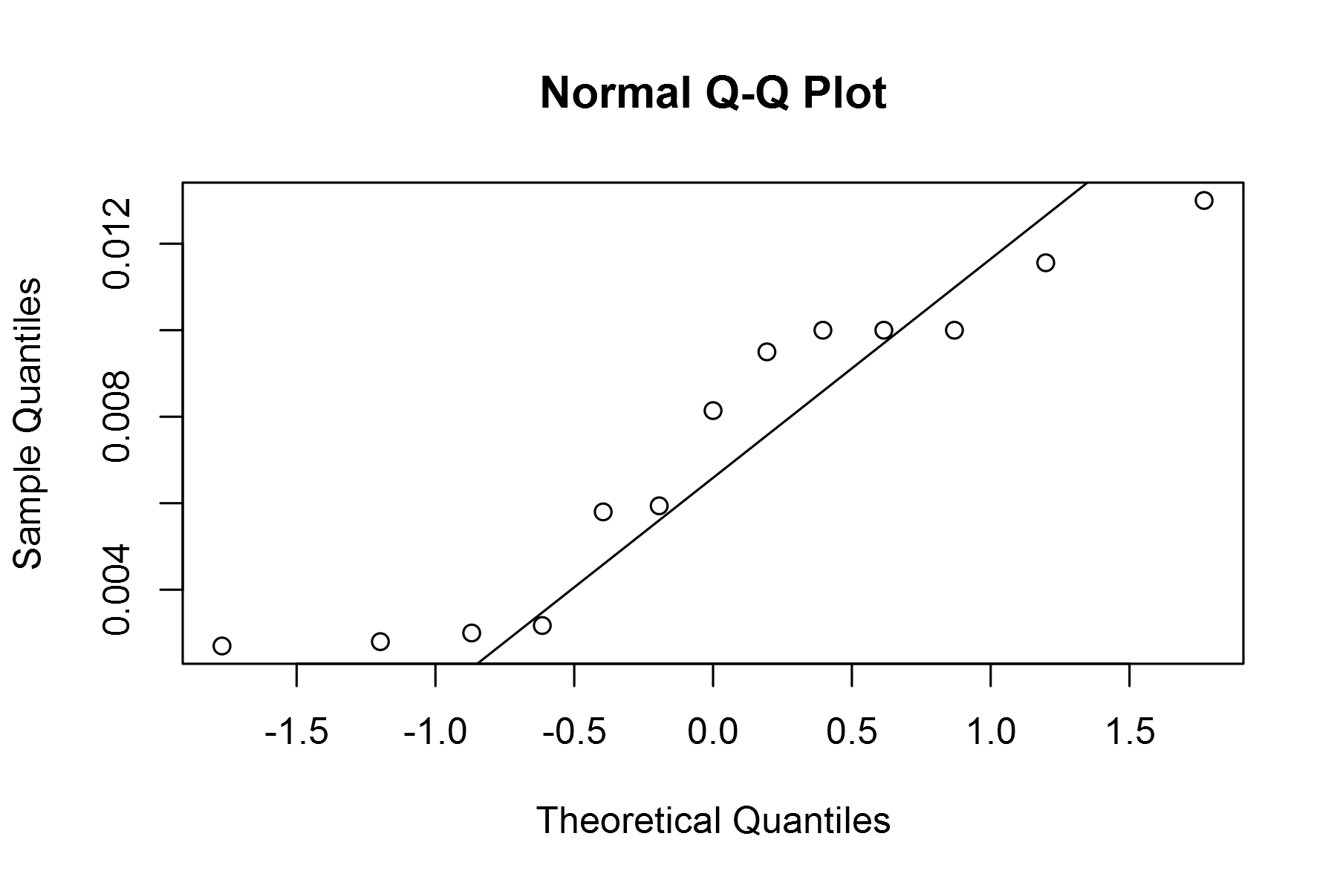

plot of chunk unnamed-chunk-4

## geom_smooth: method="auto" and size of largest group is <1000, so using loess. Use 'method = x' to change the smoothing method.

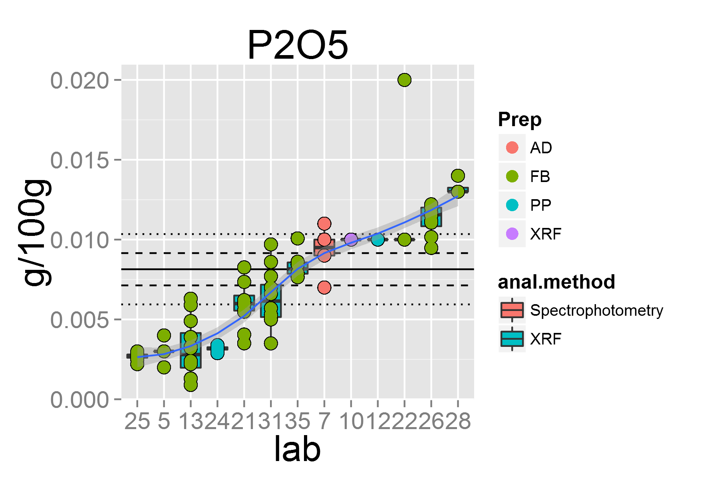

plot of chunk unnamed-chunk-4

## [1] "H2O..1"

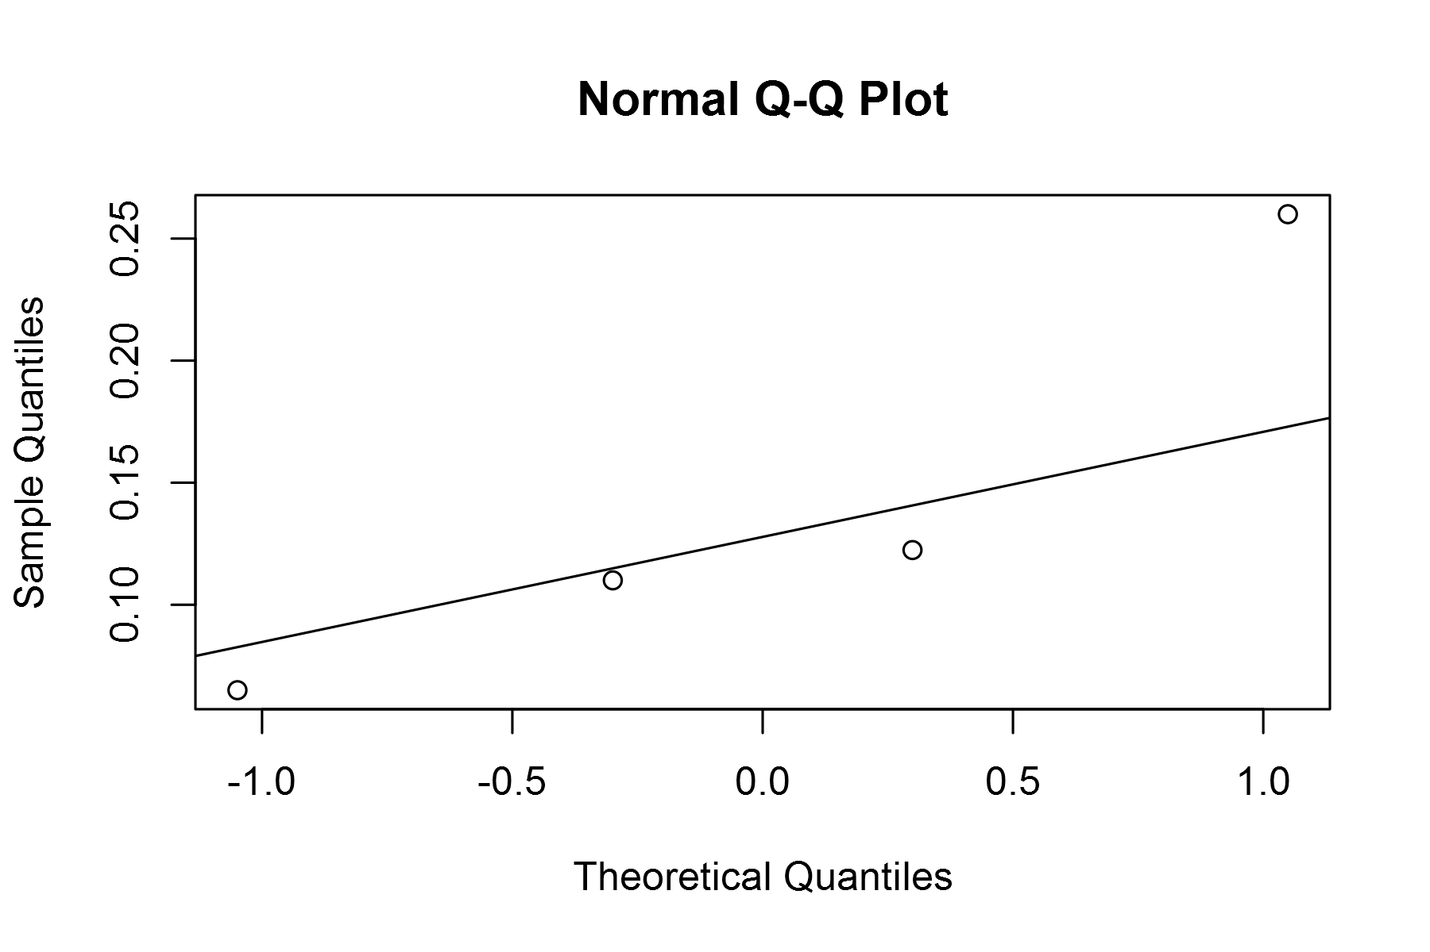

plot of chunk unnamed-chunk-4

## geom_smooth: method="auto" and size of largest group is <1000, so using loess. Use 'method = x' to change the smoothing method.

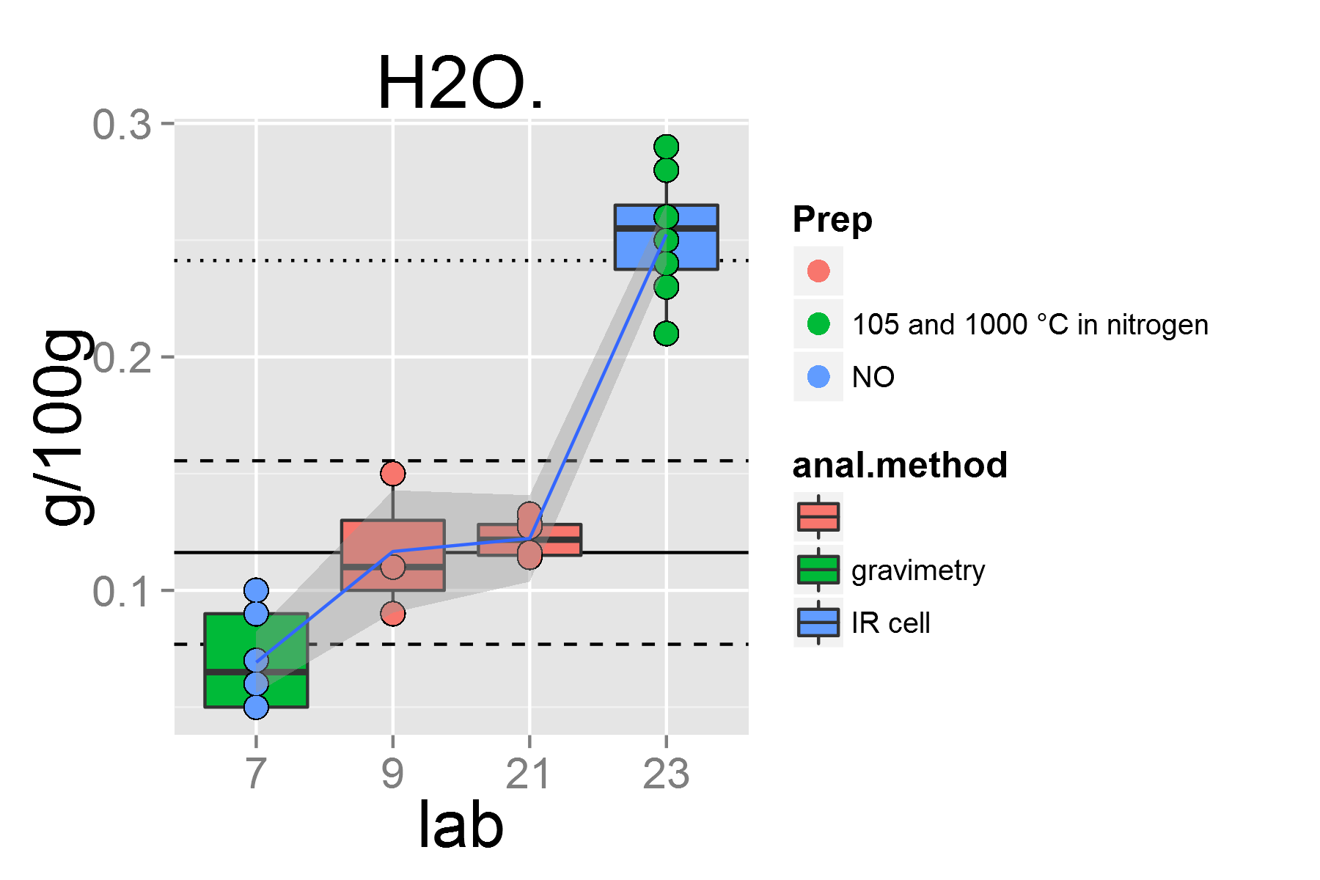

plot of chunk unnamed-chunk-4

## [1] "CO2.1"

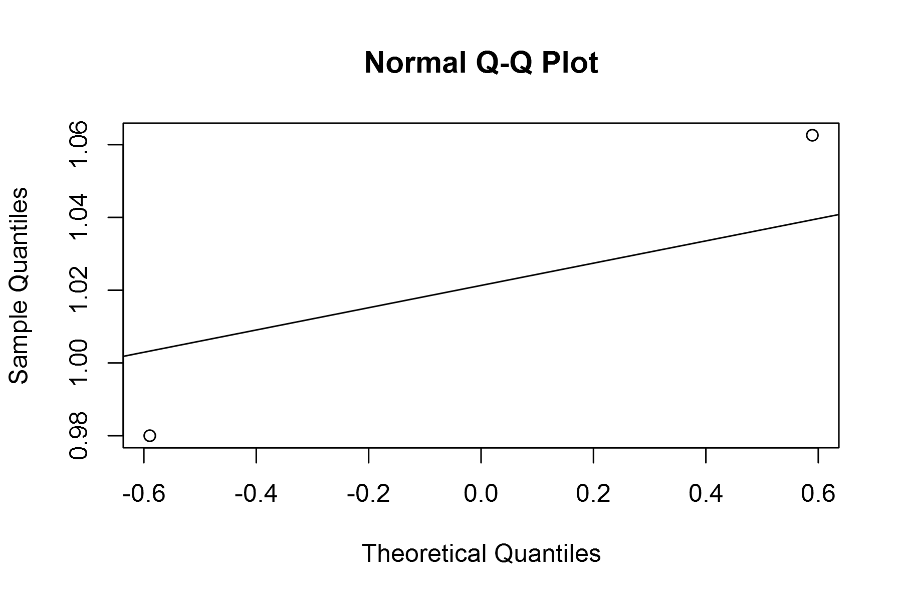

plot of chunk unnamed-chunk-4

## geom_smooth: method="auto" and size of largest group is <1000, so using loess. Use 'method = x' to change the smoothing method.

## Warning: at 0.995  
## Warning: radius 2.5e-005  
## Warning: all data on boundary of neighborhood. make span bigger  
## Warning: pseudoinverse used at 0.995  
## Warning: neighborhood radius 0.005  
## Warning: reciprocal condition number 1  
## Warning: There are other near singularities as well. 1.01  
## Warning: zero-width neighborhood. make span bigger

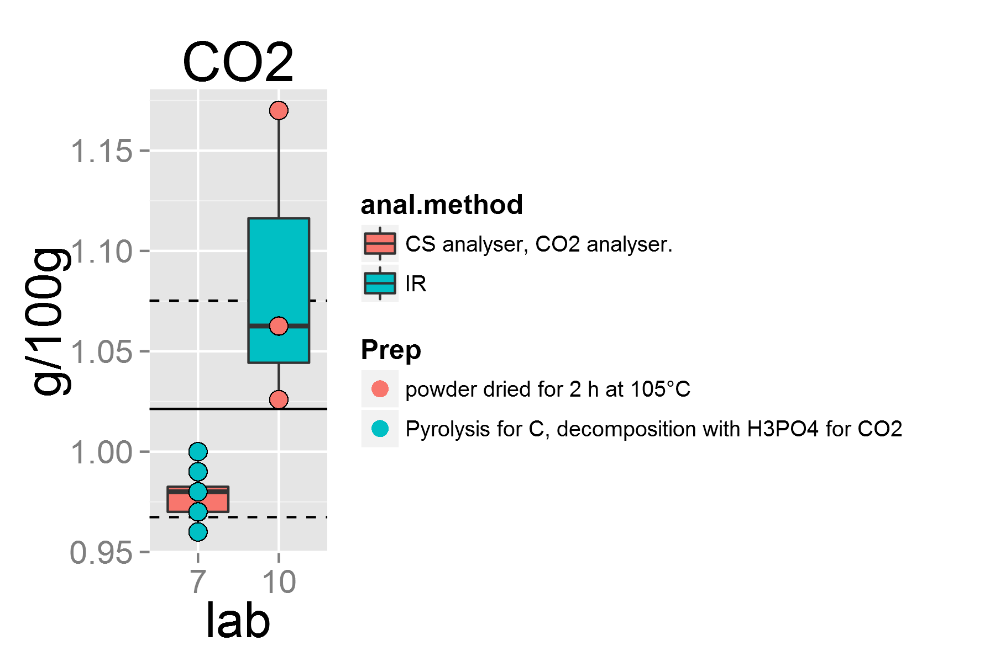

plot of chunk unnamed-chunk-4

## [1] "LOI.1"

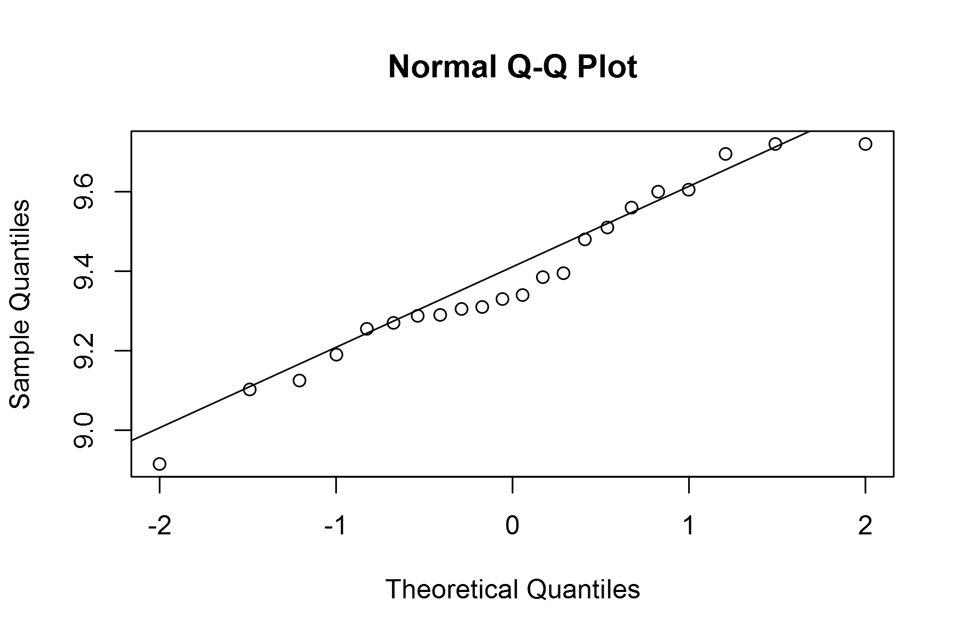

plot of chunk unnamed-chunk-4

## geom_smooth: method="auto" and size of largest group is <1000, so using loess. Use 'method = x' to change the smoothing method.

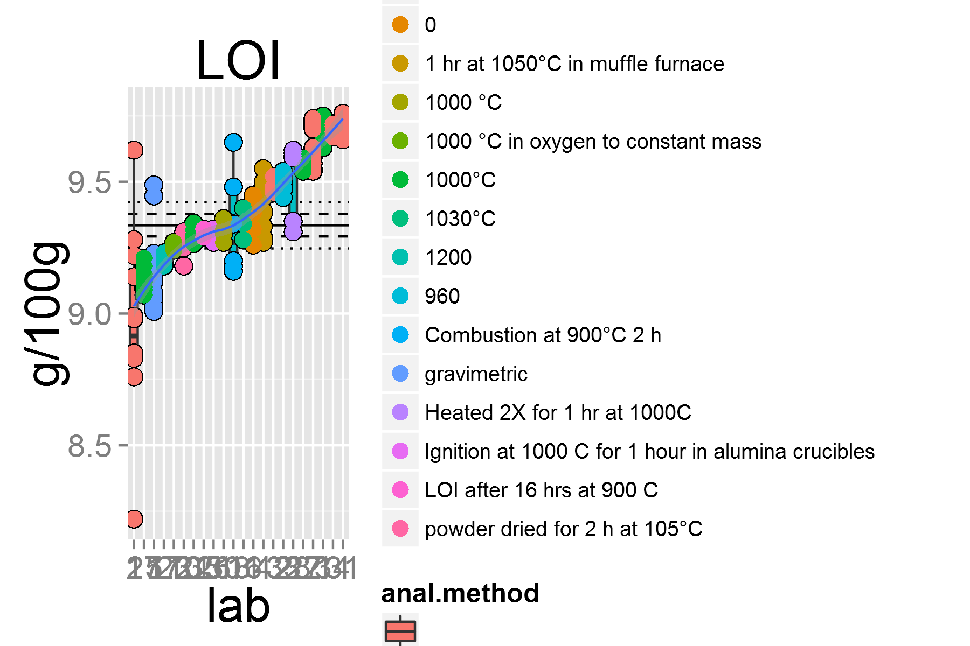

plot of chunk unnamed-chunk-4

## [1] "As.1"

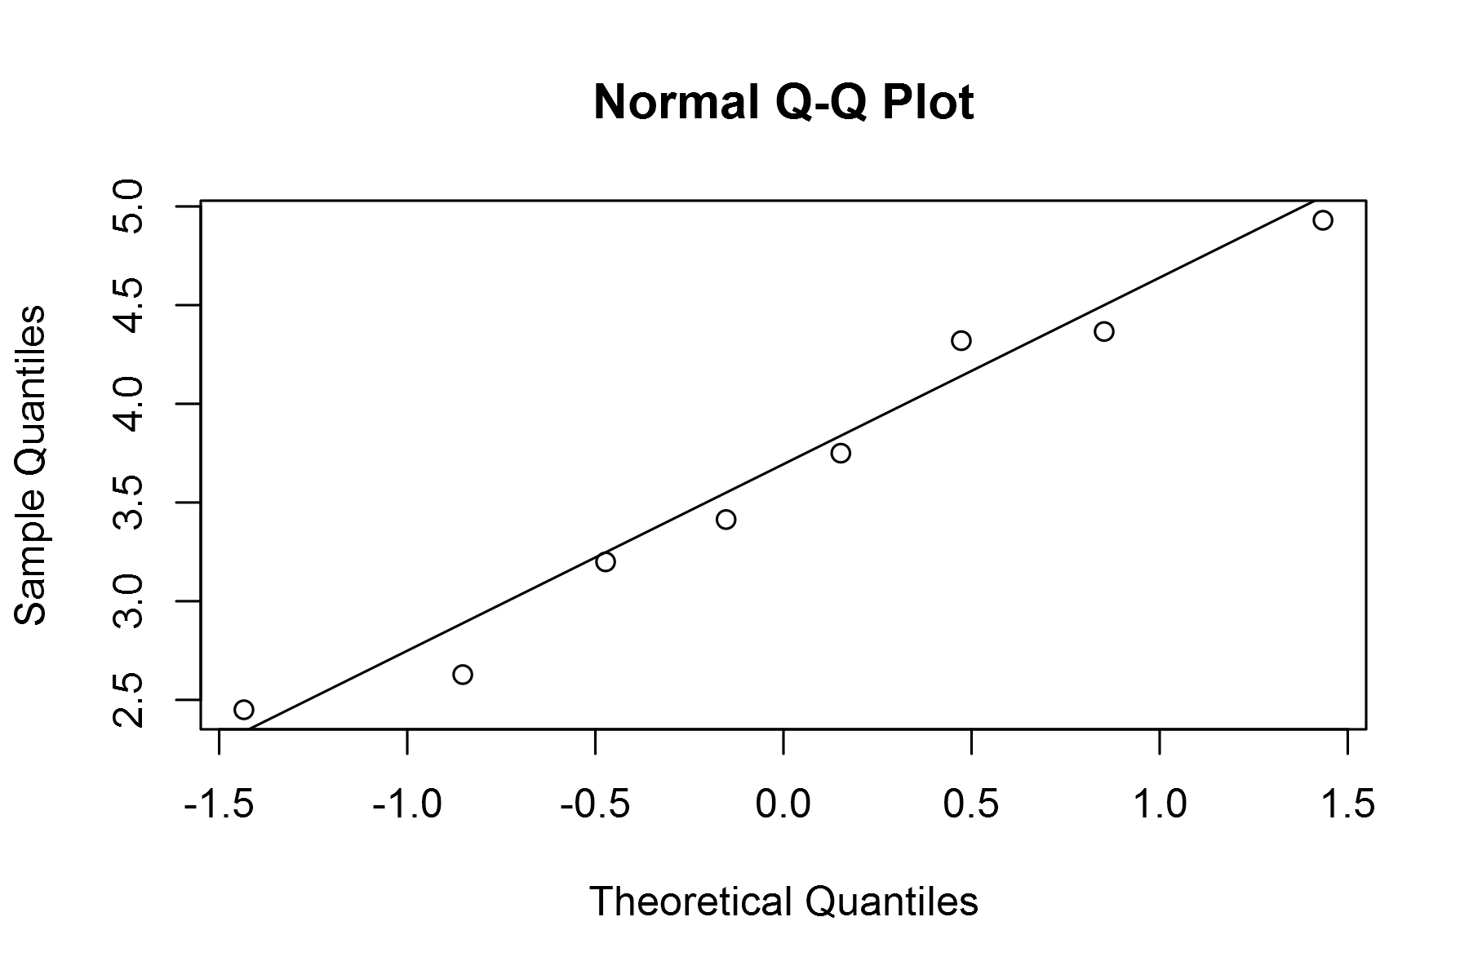

plot of chunk unnamed-chunk-4

## geom_smooth: method="auto" and size of largest group is <1000, so using loess. Use 'method = x' to change the smoothing method.

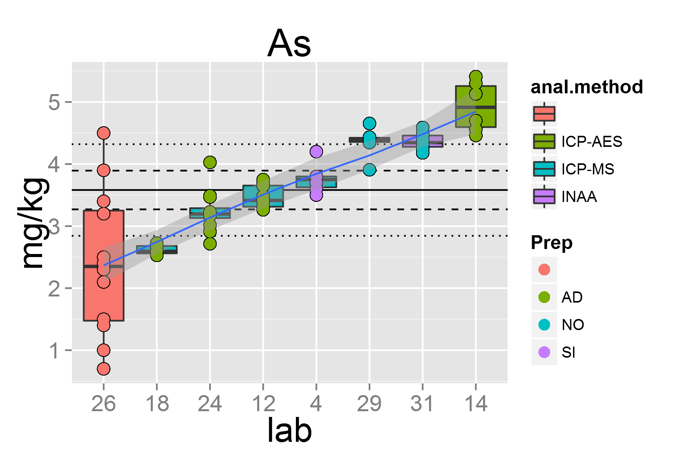

plot of chunk unnamed-chunk-4

## [1] "Ba.1"

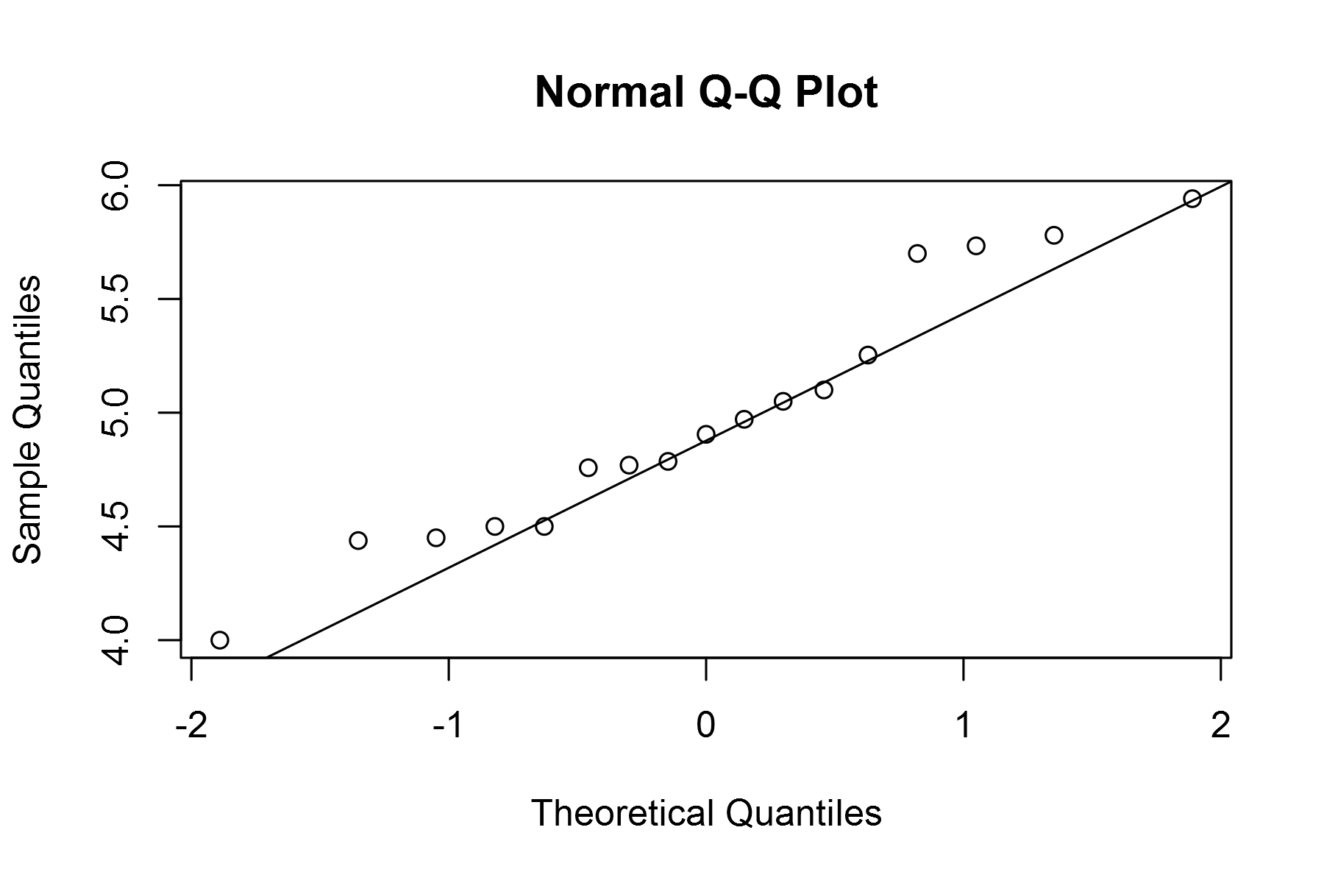

plot of chunk unnamed-chunk-4

## geom_smooth: method="auto" and size of largest group is <1000, so using loess. Use 'method = x' to change the smoothing method.

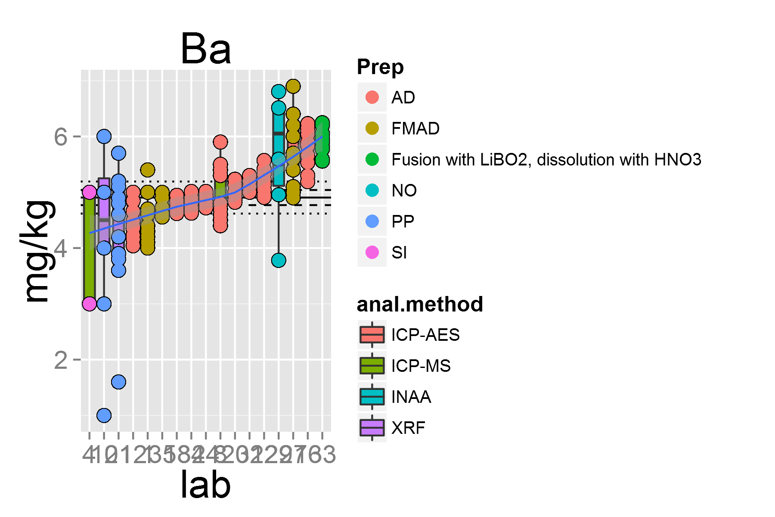

plot of chunk unnamed-chunk-4

## [1] "Be.1"

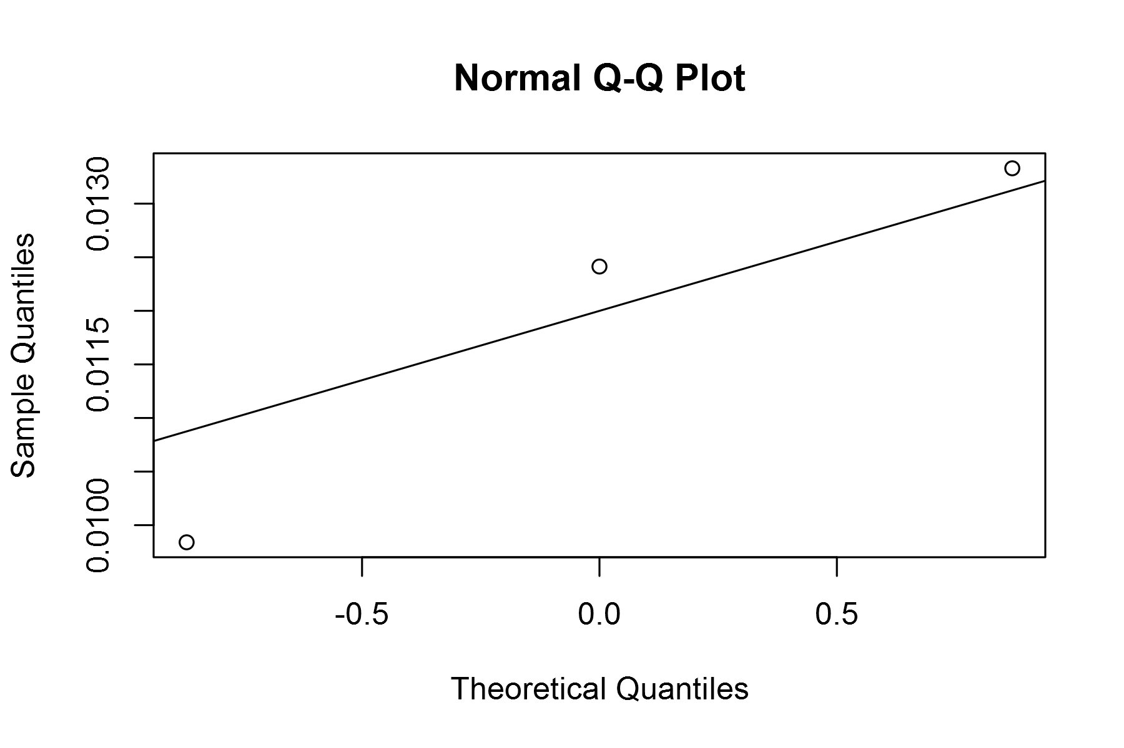

plot of chunk unnamed-chunk-4

## geom_smooth: method="auto" and size of largest group is <1000, so using loess. Use 'method = x' to change the smoothing method.

## Warning: pseudoinverse used at 0.99  
## Warning: neighborhood radius 2.01  
## Warning: reciprocal condition number 2.581e-016  
## Warning: There are other near singularities as well. 4.0401  
## Warning: pseudoinverse used at 0.99  
## Warning: neighborhood radius 2.01  
## Warning: reciprocal condition number 2.581e-016  
## Warning: There are other near singularities as well. 4.0401

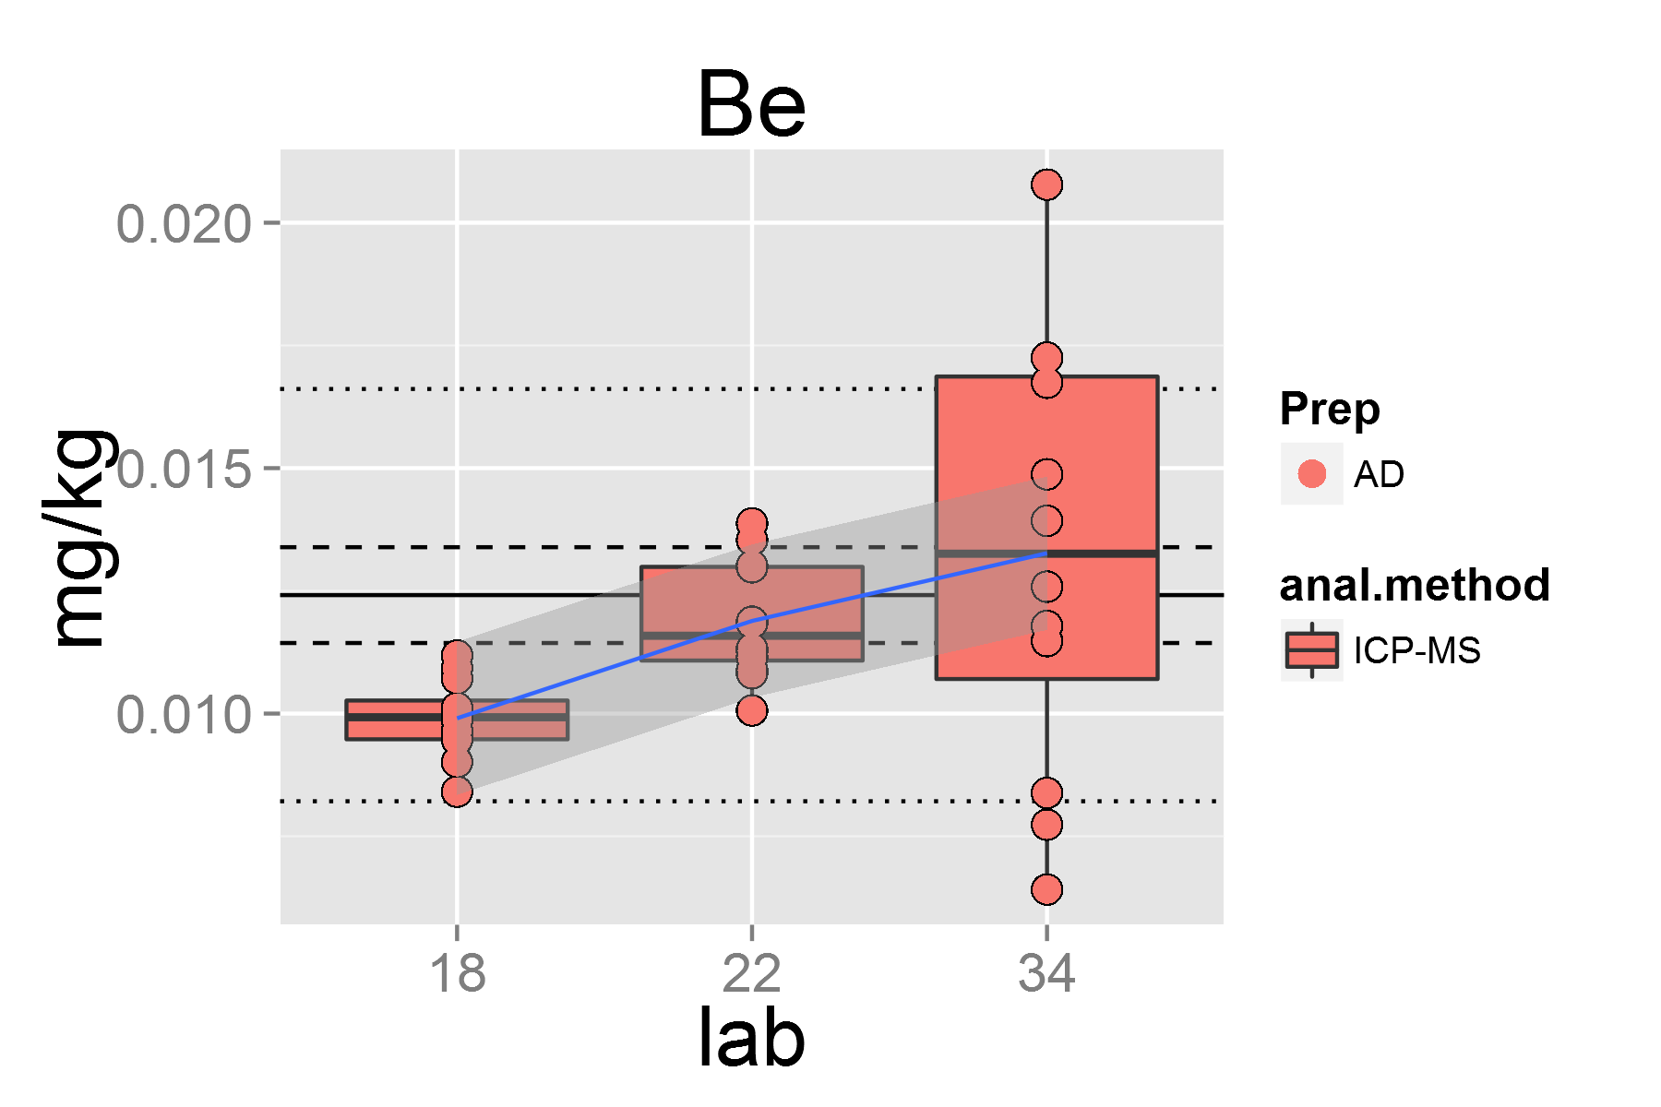

plot of chunk unnamed-chunk-4

## [1] "Ce.1"

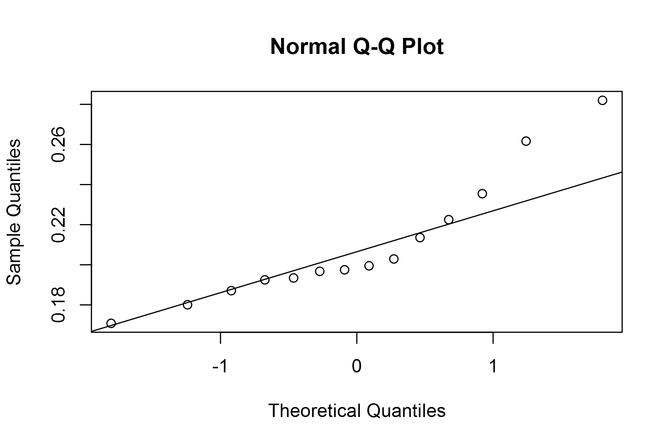

plot of chunk unnamed-chunk-4

## geom_smooth: method="auto" and size of largest group is <1000, so using loess. Use 'method = x' to change the smoothing method.

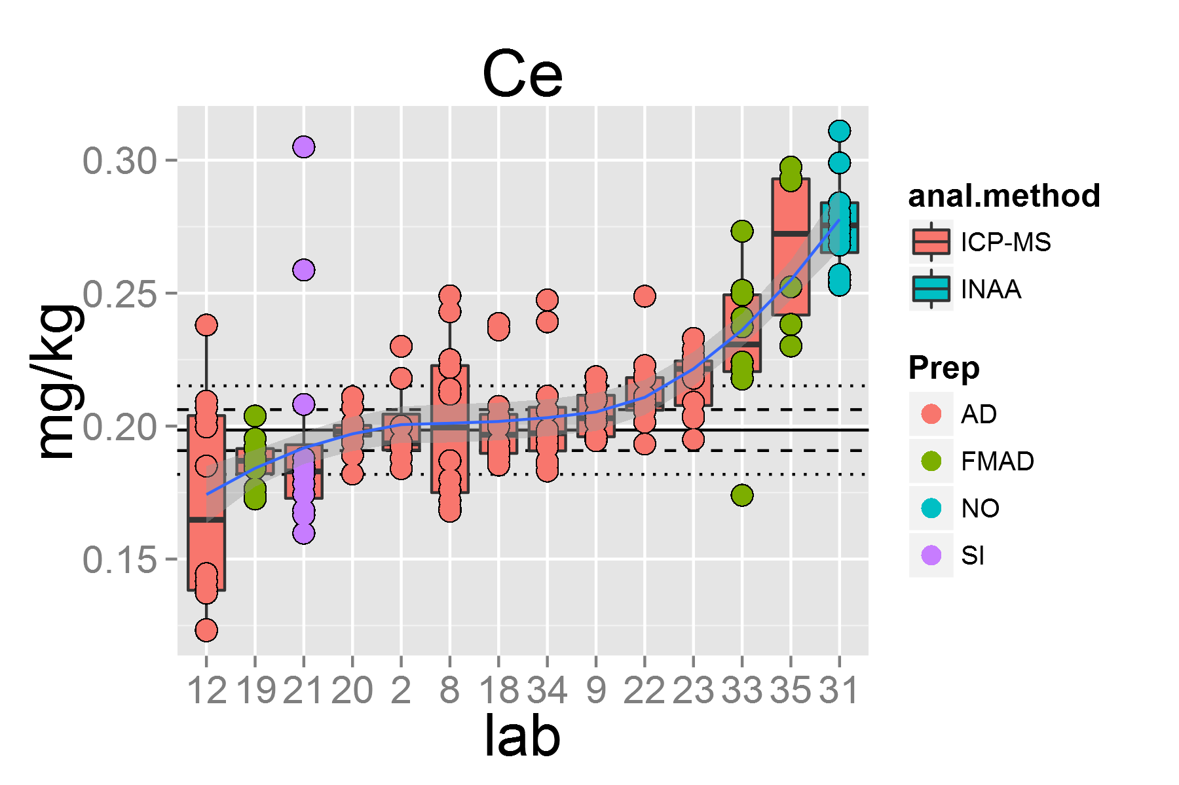

plot of chunk unnamed-chunk-4

## [1] "Co.1"

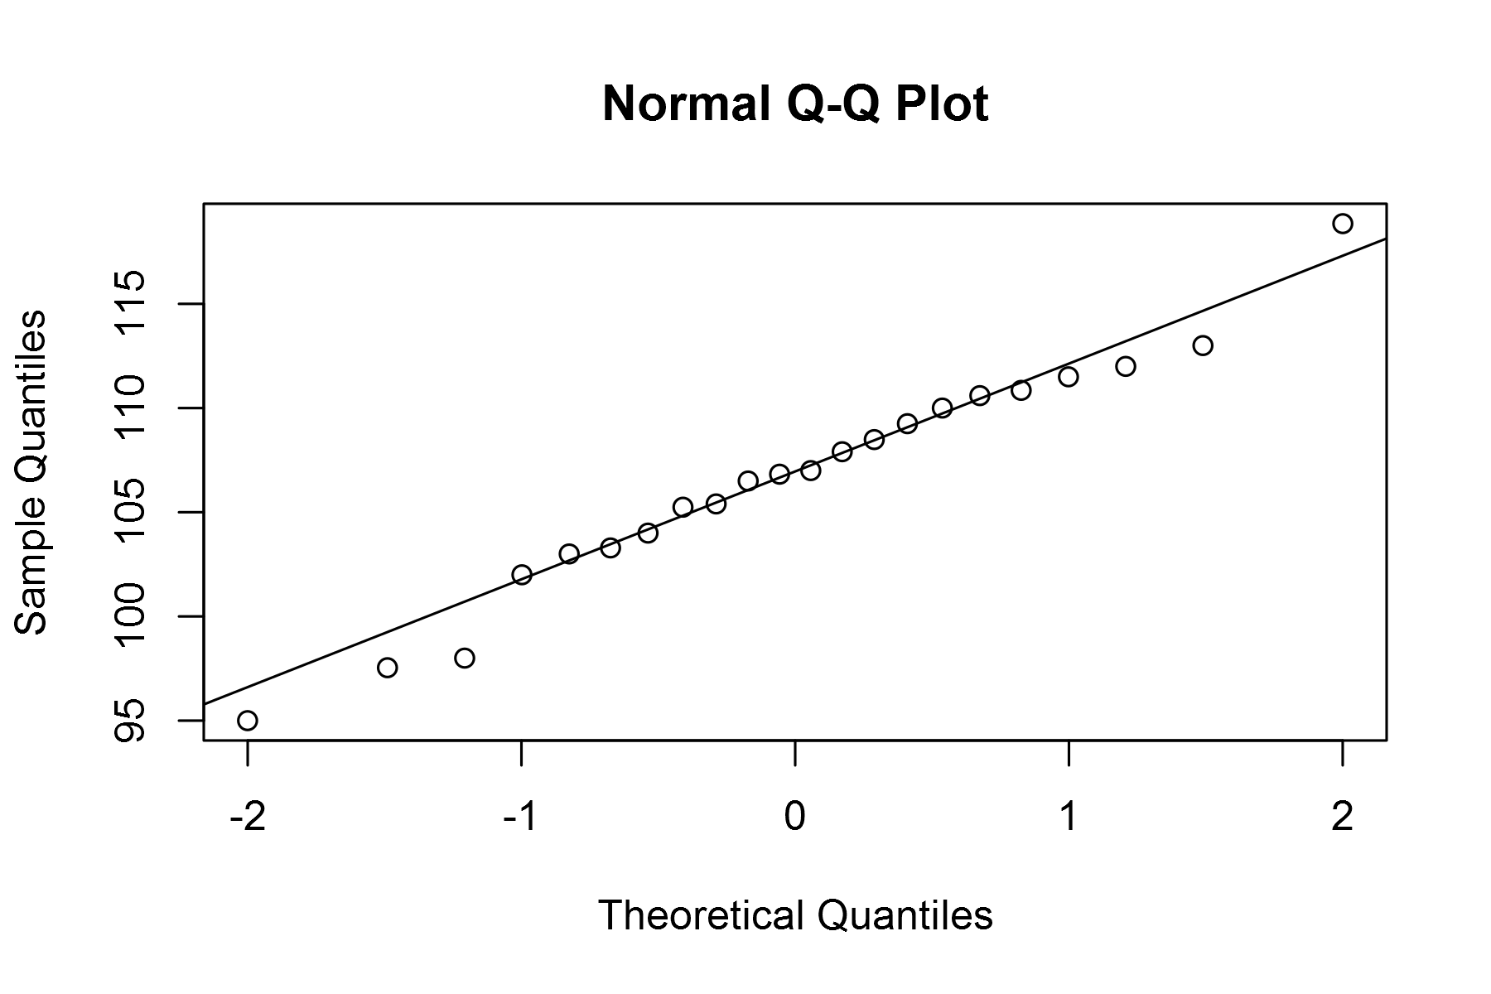

plot of chunk unnamed-chunk-4

## geom_smooth: method="auto" and size of largest group is <1000, so using loess. Use 'method = x' to change the smoothing method.

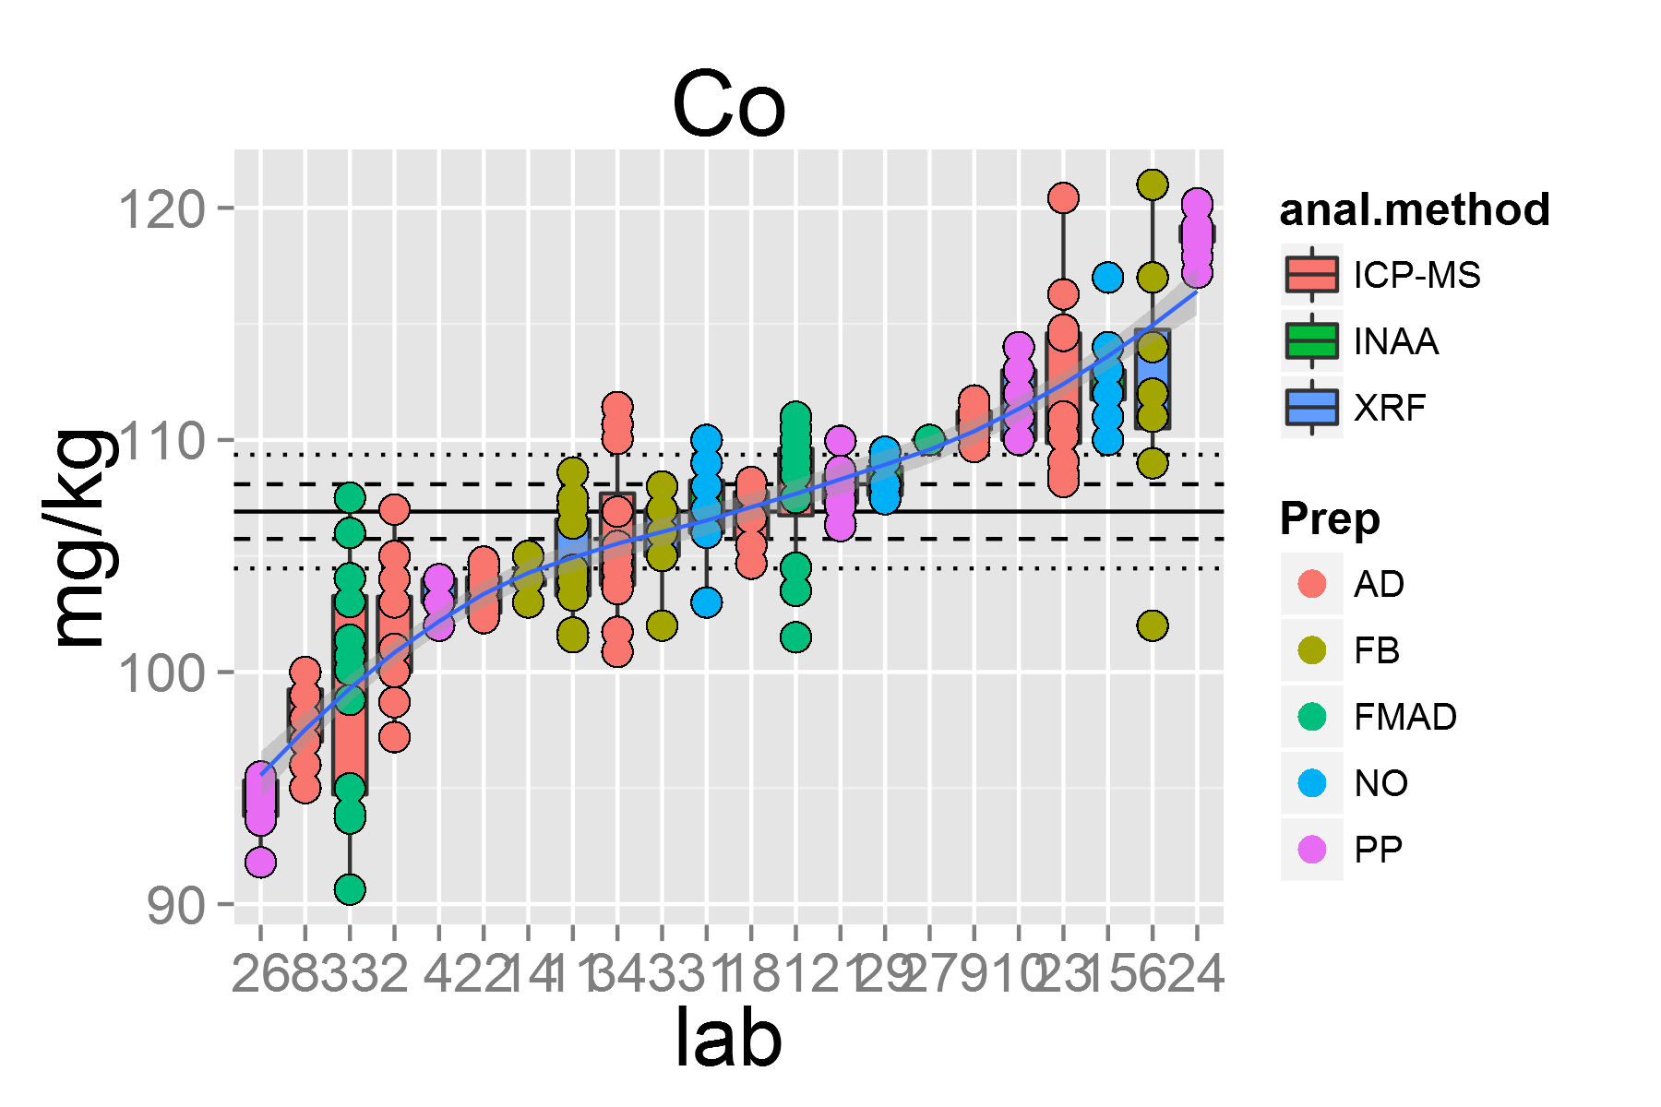

plot of chunk unnamed-chunk-4

## [1] "Cr.1"

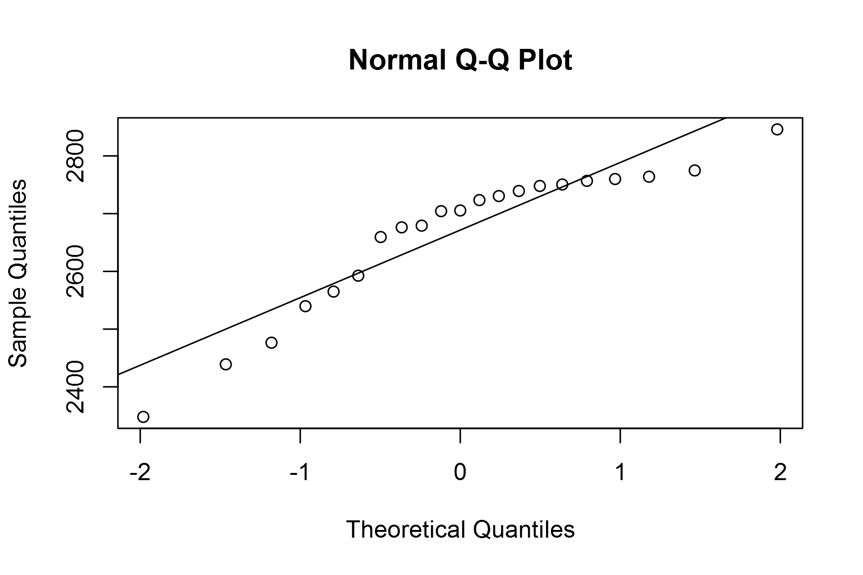

plot of chunk unnamed-chunk-4

## geom_smooth: method="auto" and size of largest group is <1000, so using loess. Use 'method = x' to change the smoothing method.

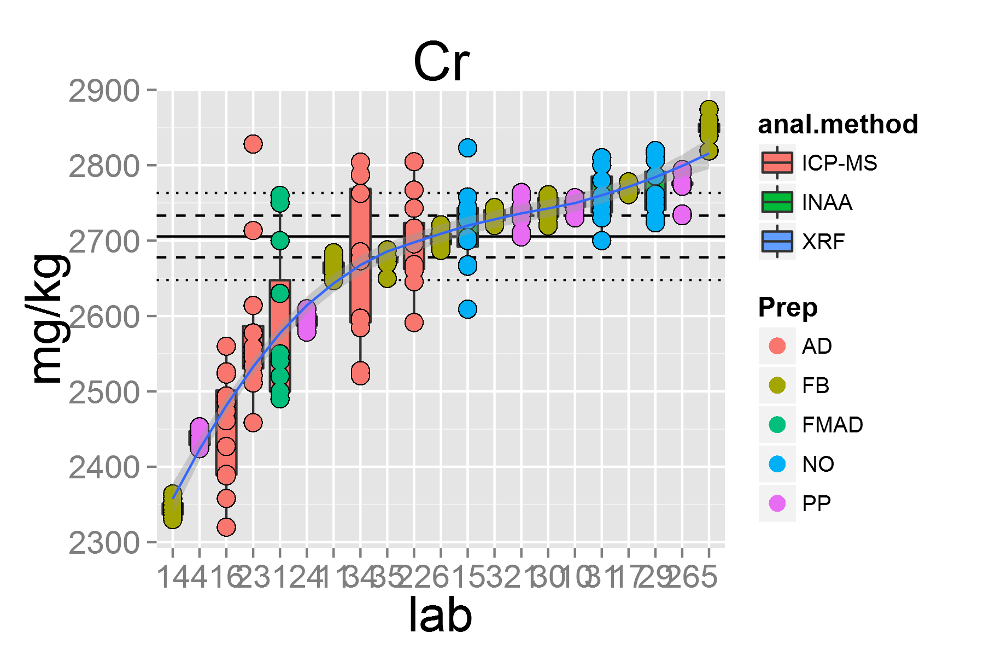

plot of chunk unnamed-chunk-4

## [1] "Cs.1"

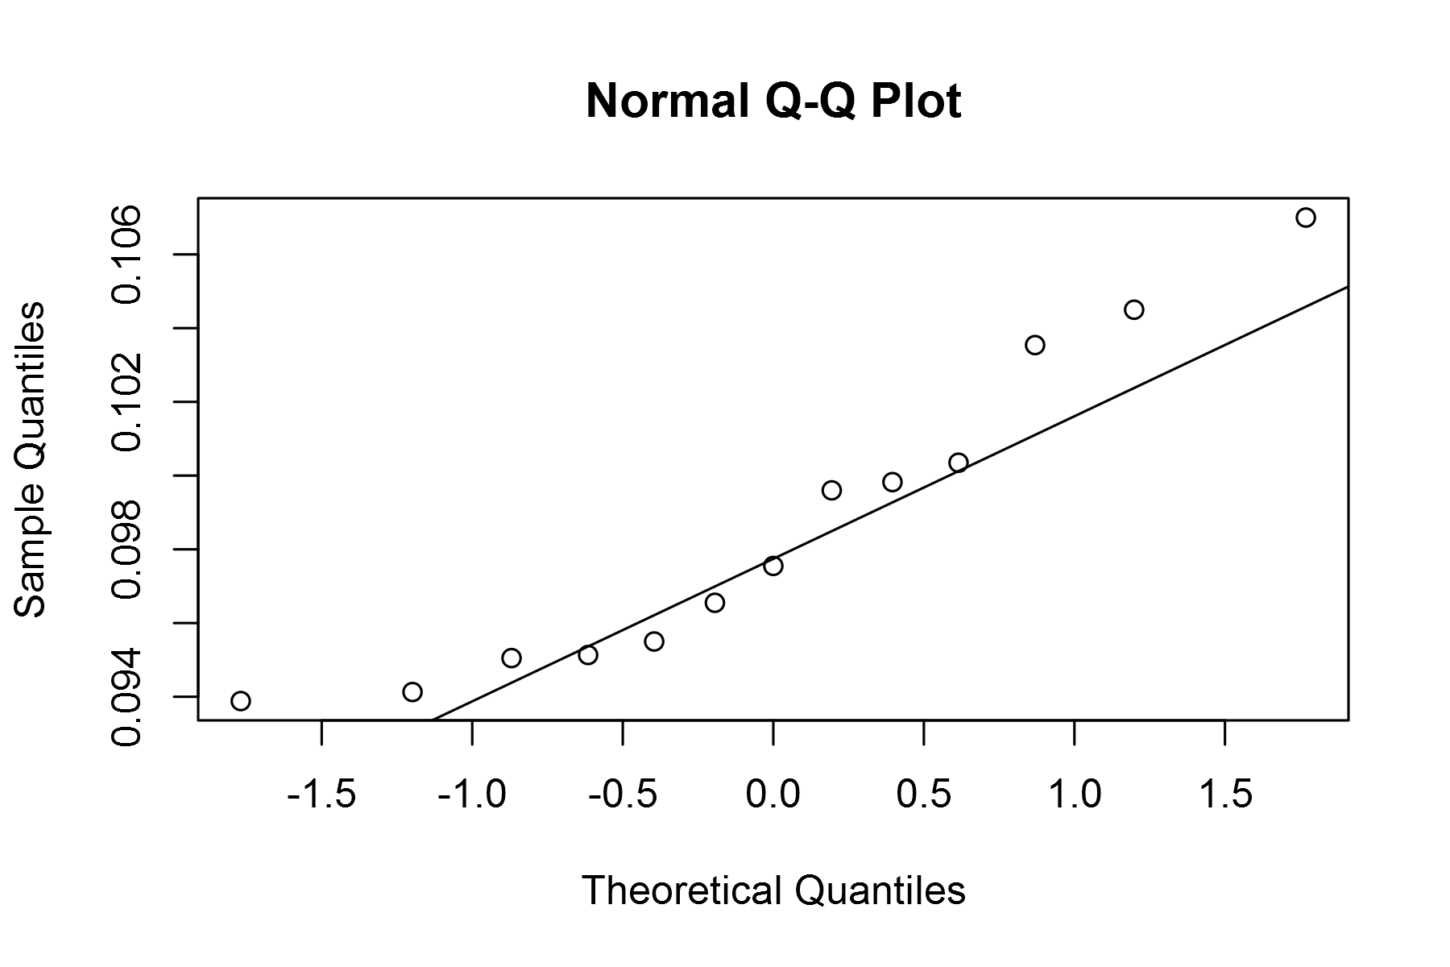

plot of chunk unnamed-chunk-4

## geom_smooth: method="auto" and size of largest group is <1000, so using loess. Use 'method = x' to change the smoothing method.

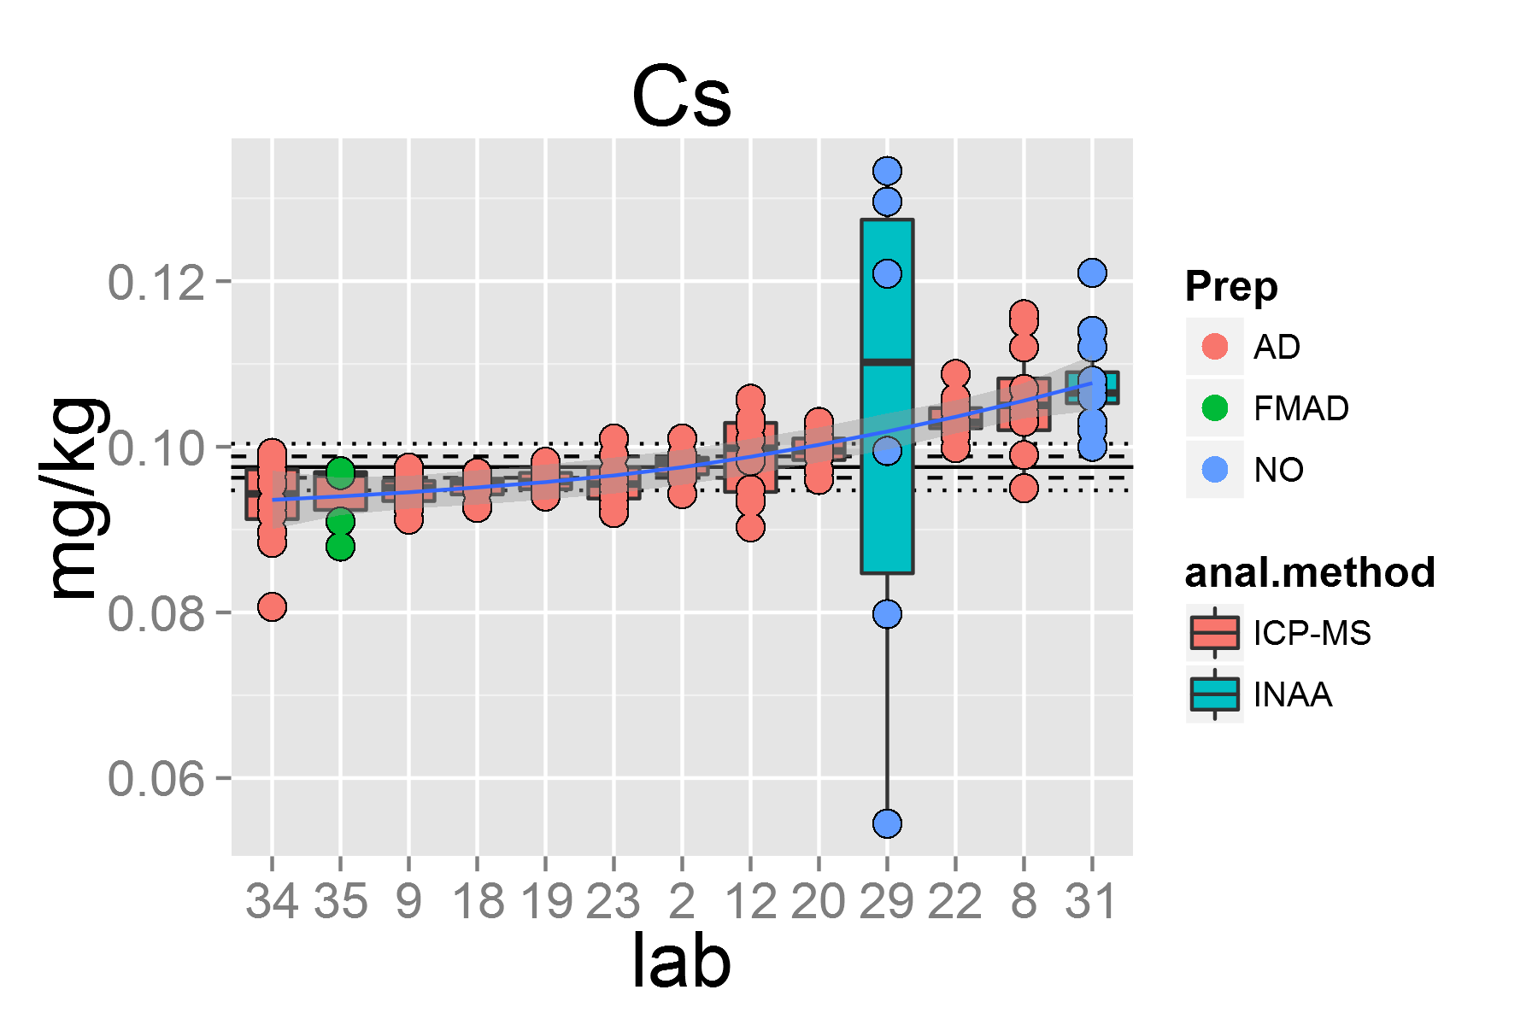

plot of chunk unnamed-chunk-4

## [1] "Cu.1"

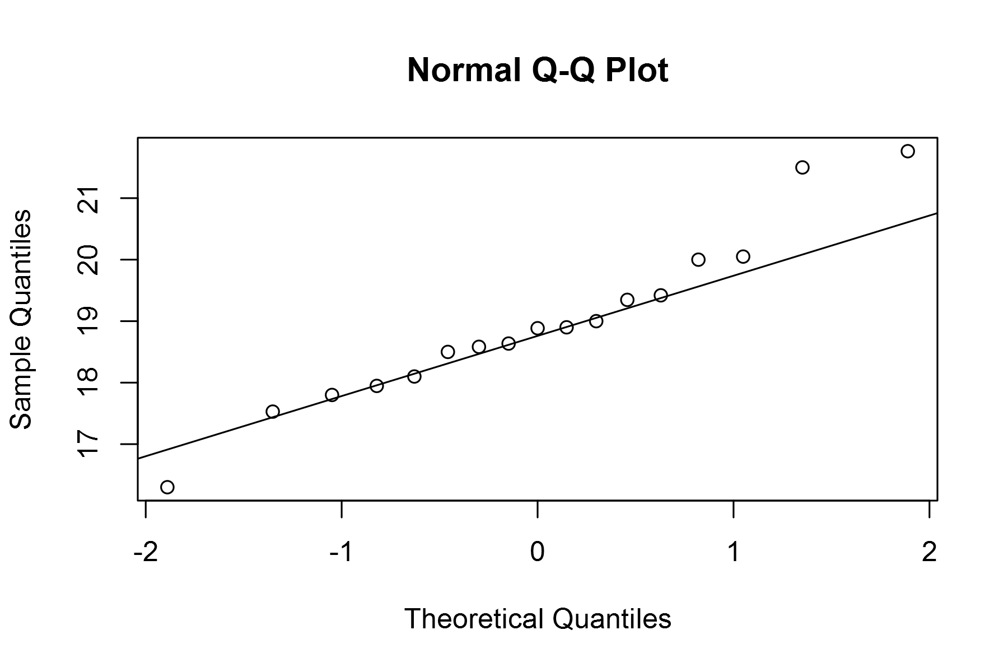

plot of chunk unnamed-chunk-4

## geom_smooth: method="auto" and size of largest group is <1000, so using loess. Use 'method = x' to change the smoothing method.

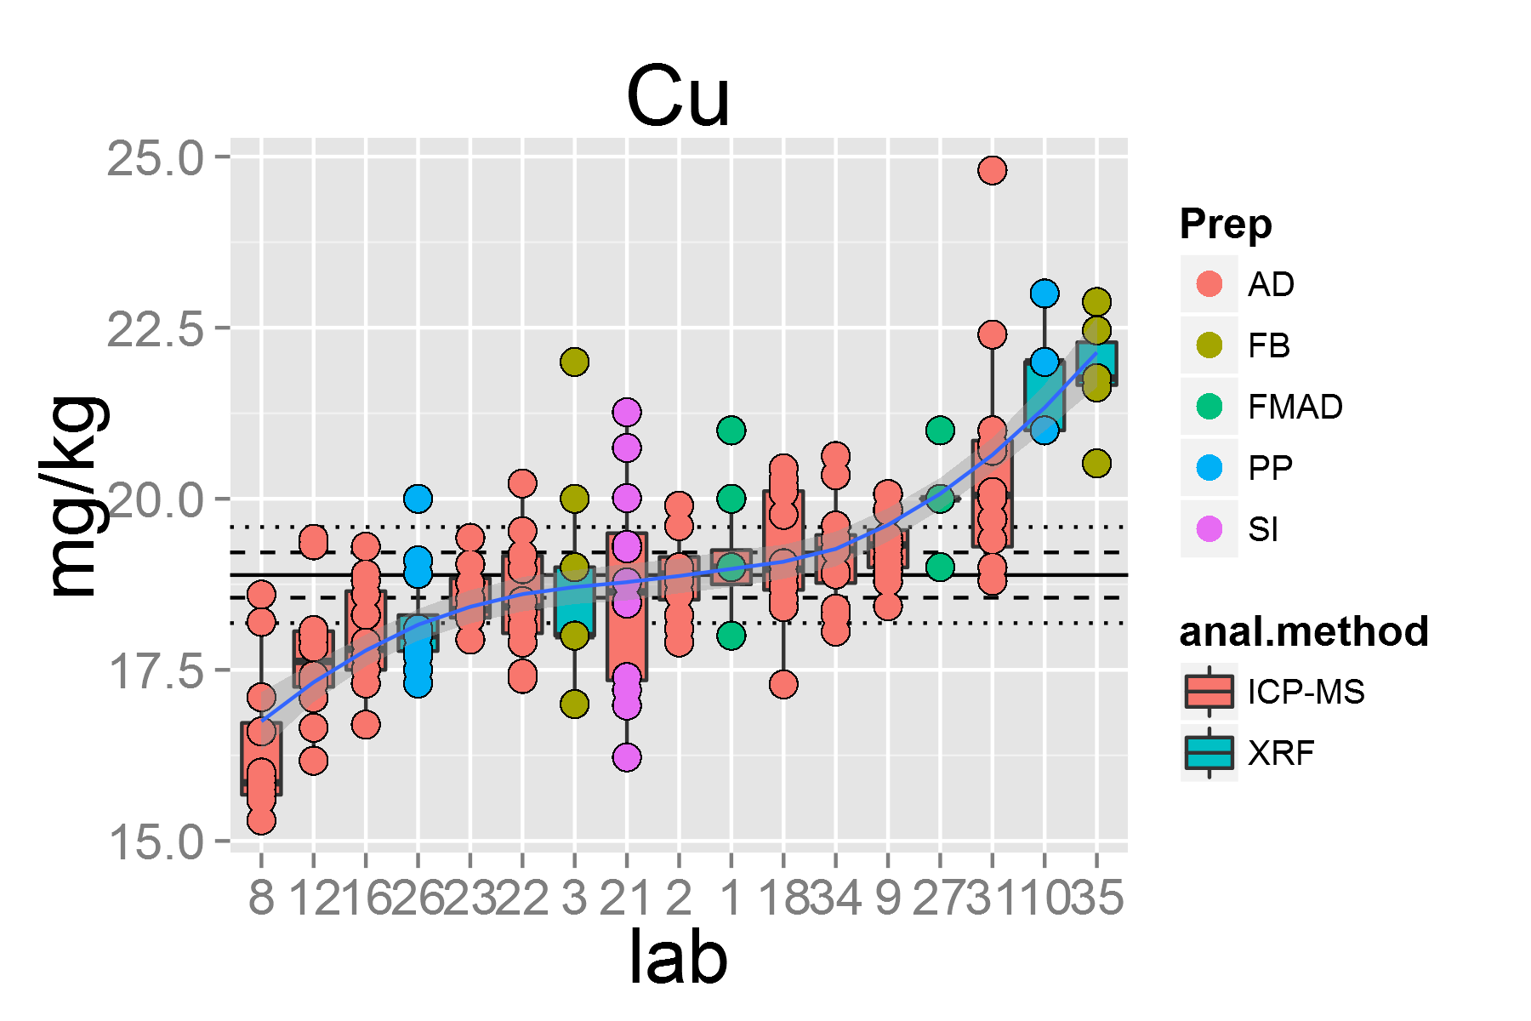

plot of chunk unnamed-chunk-4

## [1] "Dy.1"

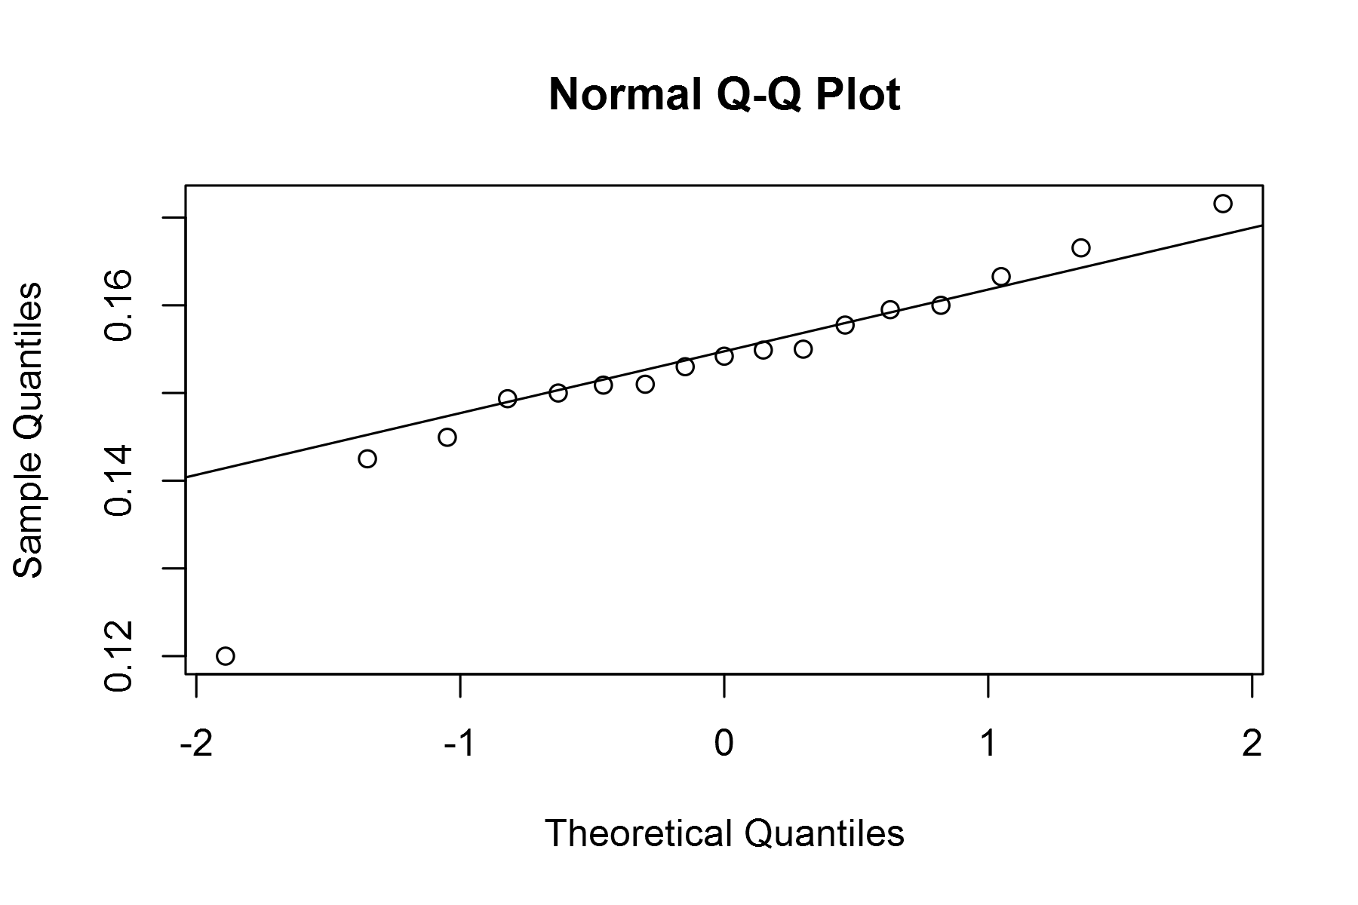

plot of chunk unnamed-chunk-4

## geom_smooth: method="auto" and size of largest group is <1000, so using loess. Use 'method = x' to change the smoothing method.

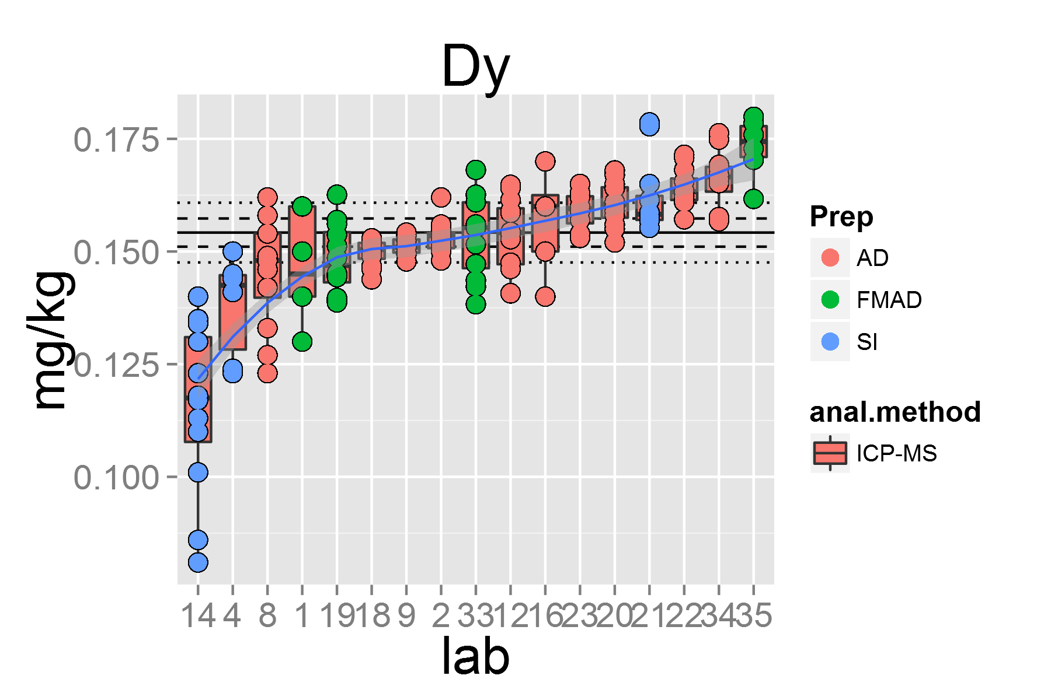

plot of chunk unnamed-chunk-4

## [1] "Er.1"

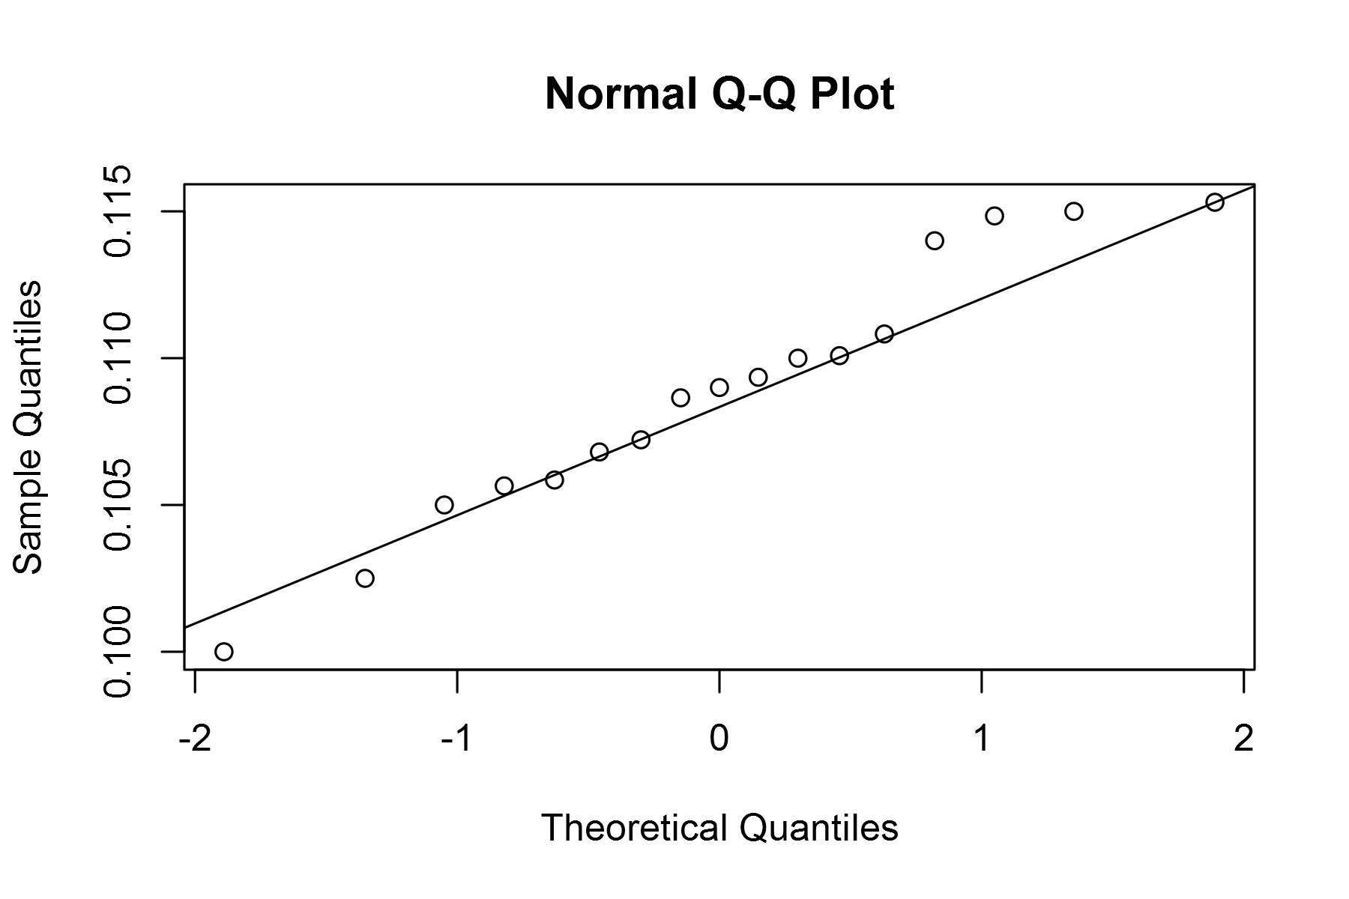

plot of chunk unnamed-chunk-4

## geom_smooth: method="auto" and size of largest group is <1000, so using loess. Use 'method = x' to change the smoothing method.

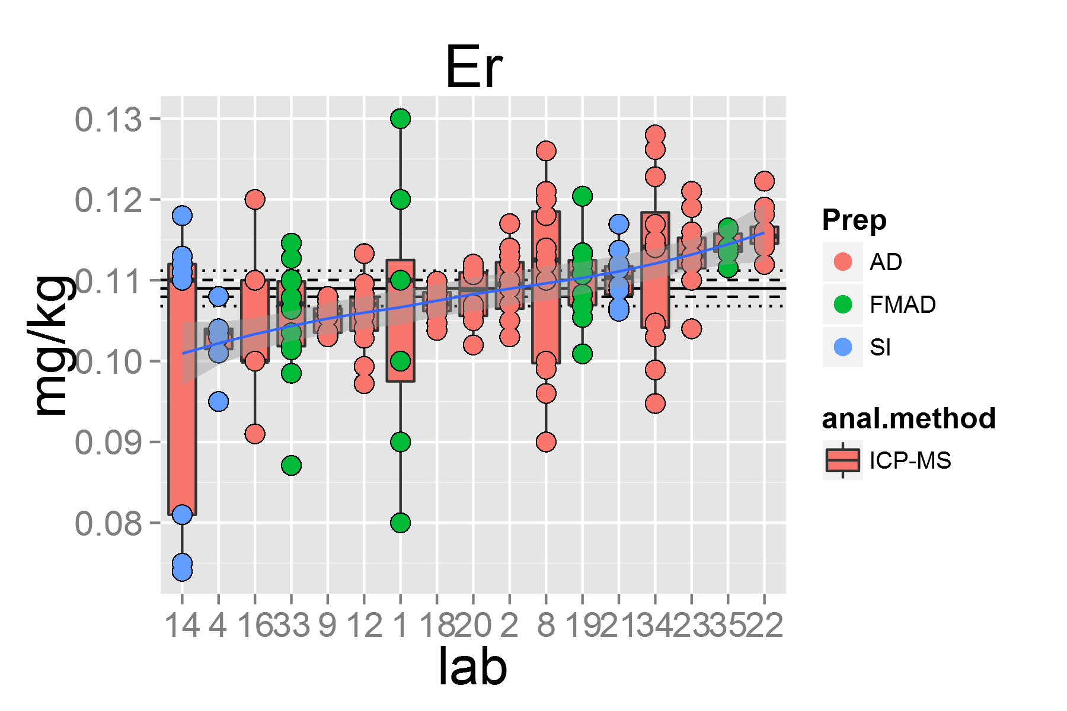

plot of chunk unnamed-chunk-4

## [1] "Eu.1"

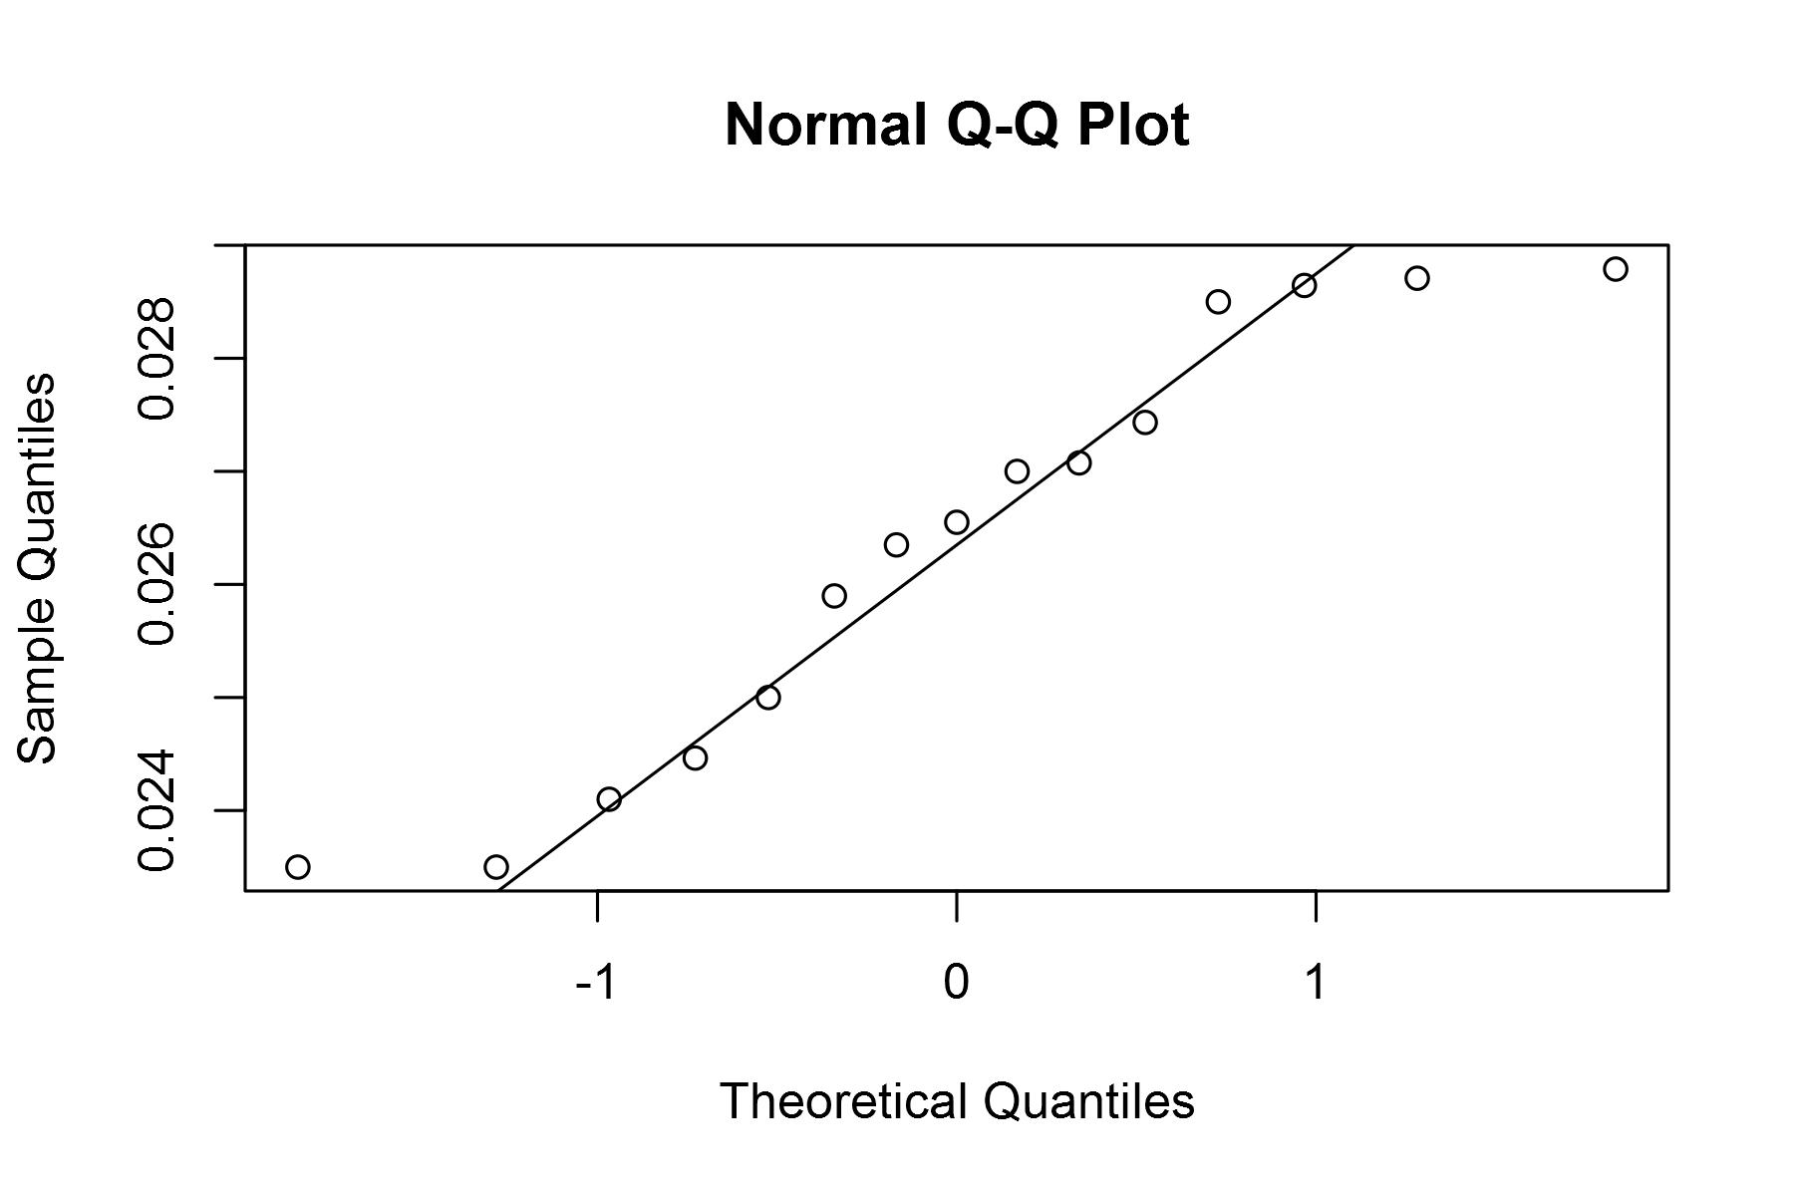

plot of chunk unnamed-chunk-4

## geom_smooth: method="auto" and size of largest group is <1000, so using loess. Use 'method = x' to change the smoothing method.

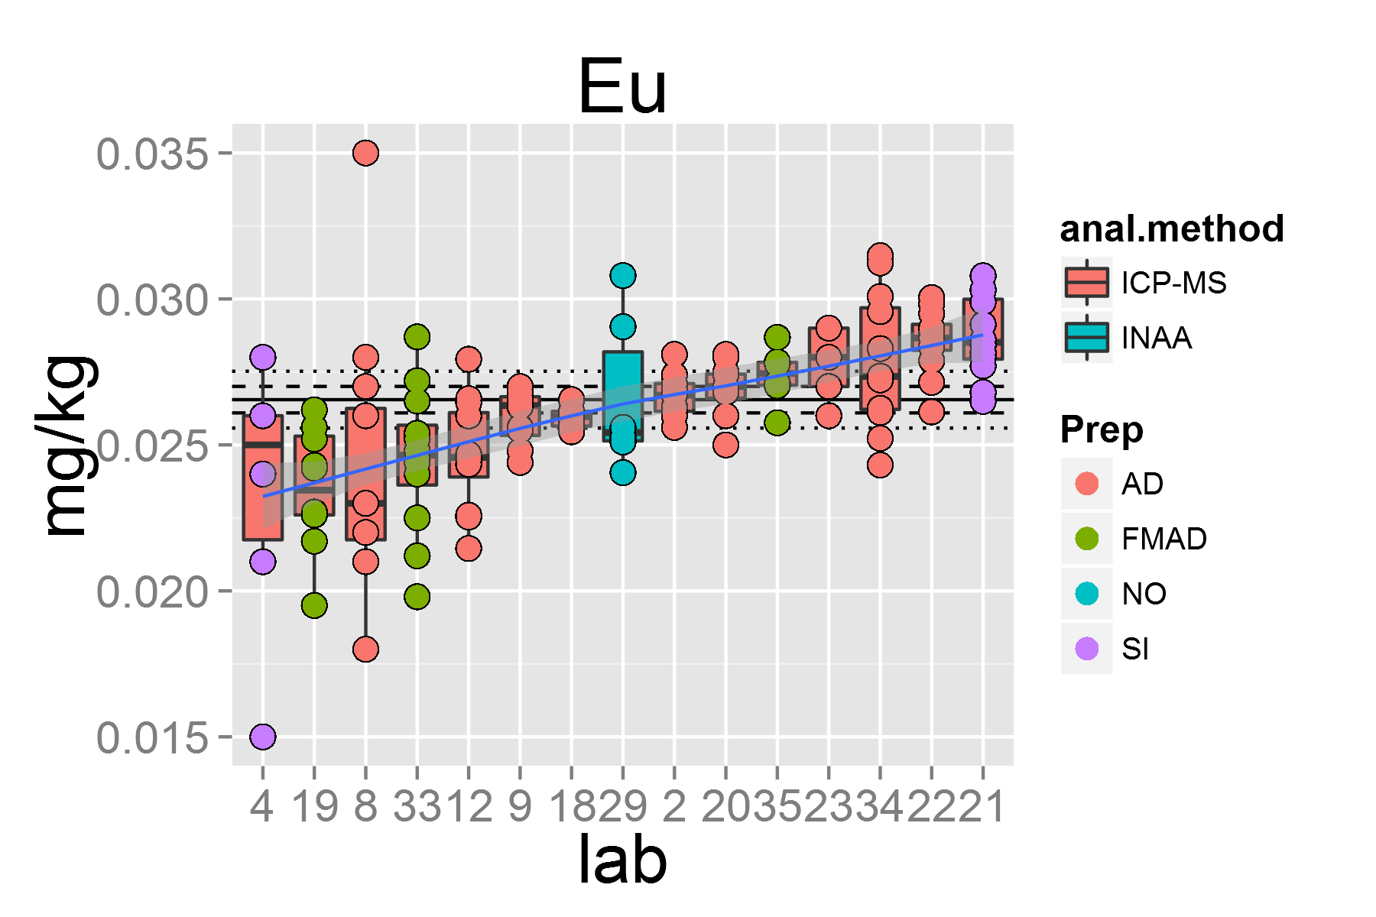

plot of chunk unnamed-chunk-4

## [1] "Ga.1"

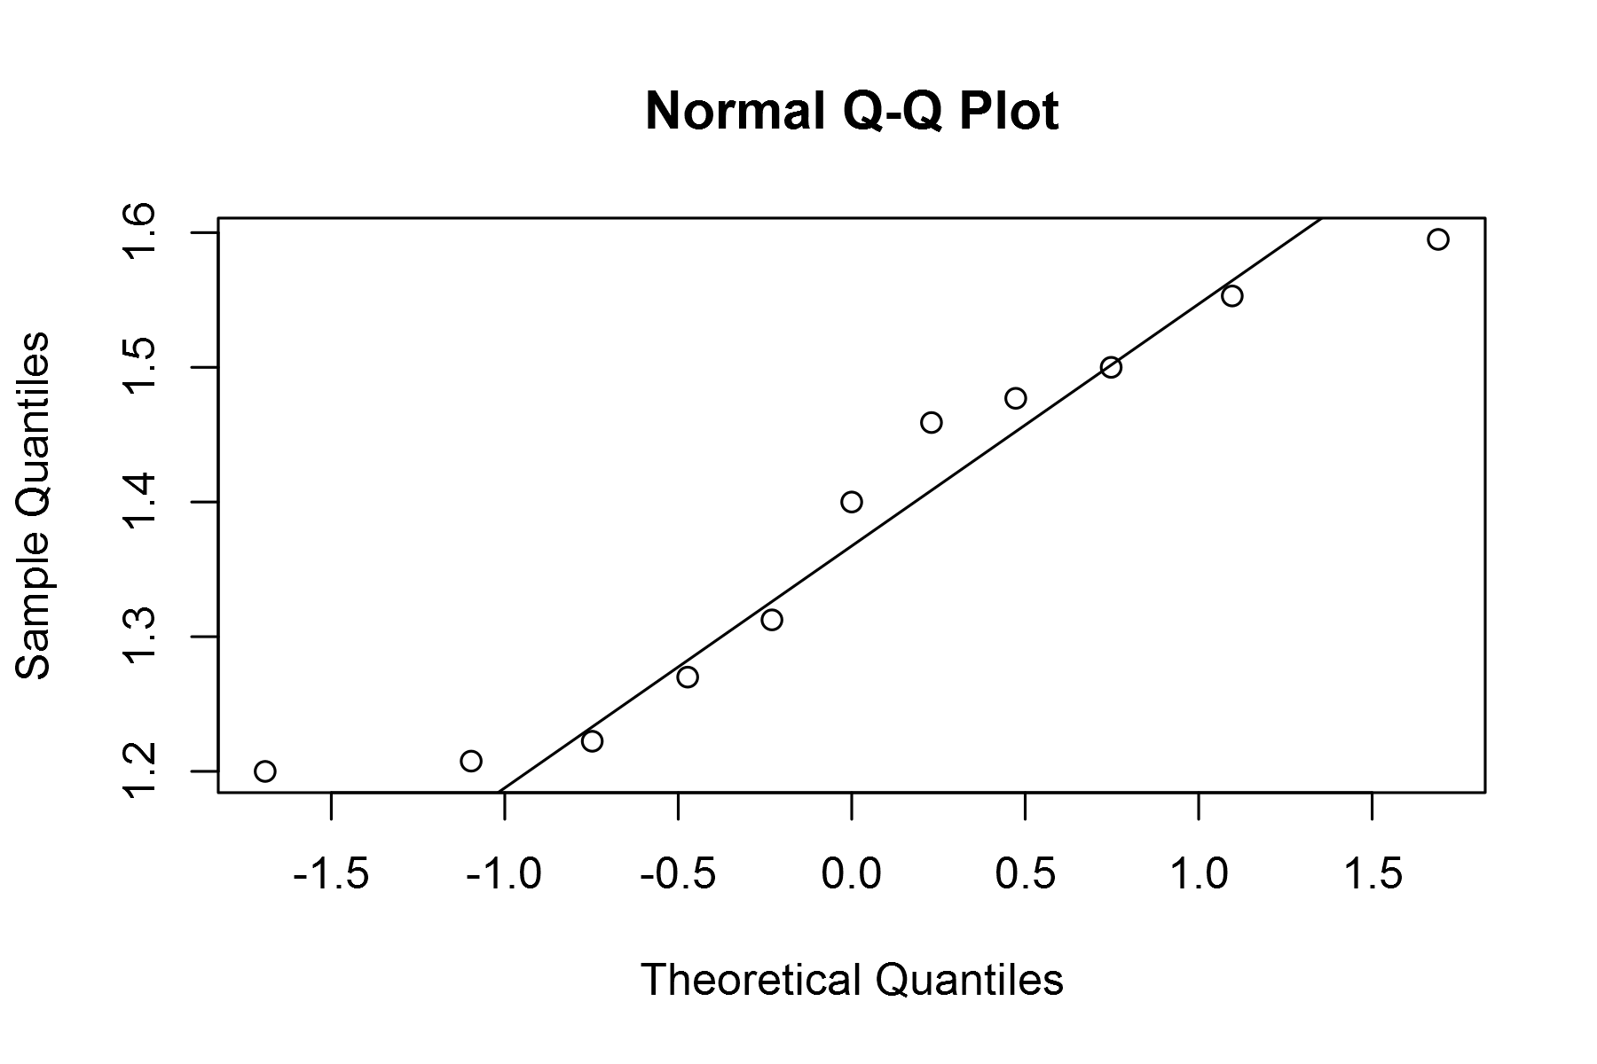

plot of chunk unnamed-chunk-4

## geom_smooth: method="auto" and size of largest group is <1000, so using loess. Use 'method = x' to change the smoothing method.

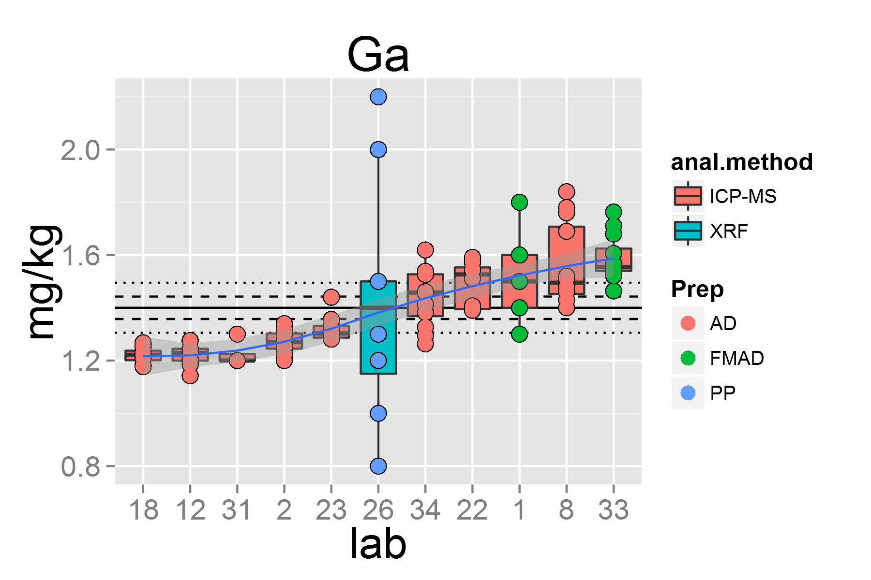

plot of chunk unnamed-chunk-4

## [1] "Gd.1"

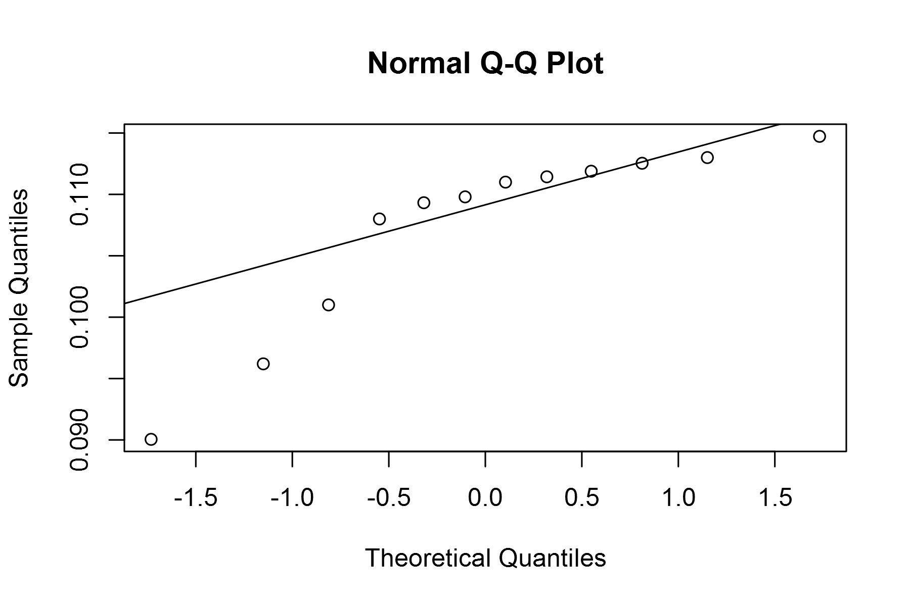

plot of chunk unnamed-chunk-4

## geom_smooth: method="auto" and size of largest group is <1000, so using loess. Use 'method = x' to change the smoothing method.

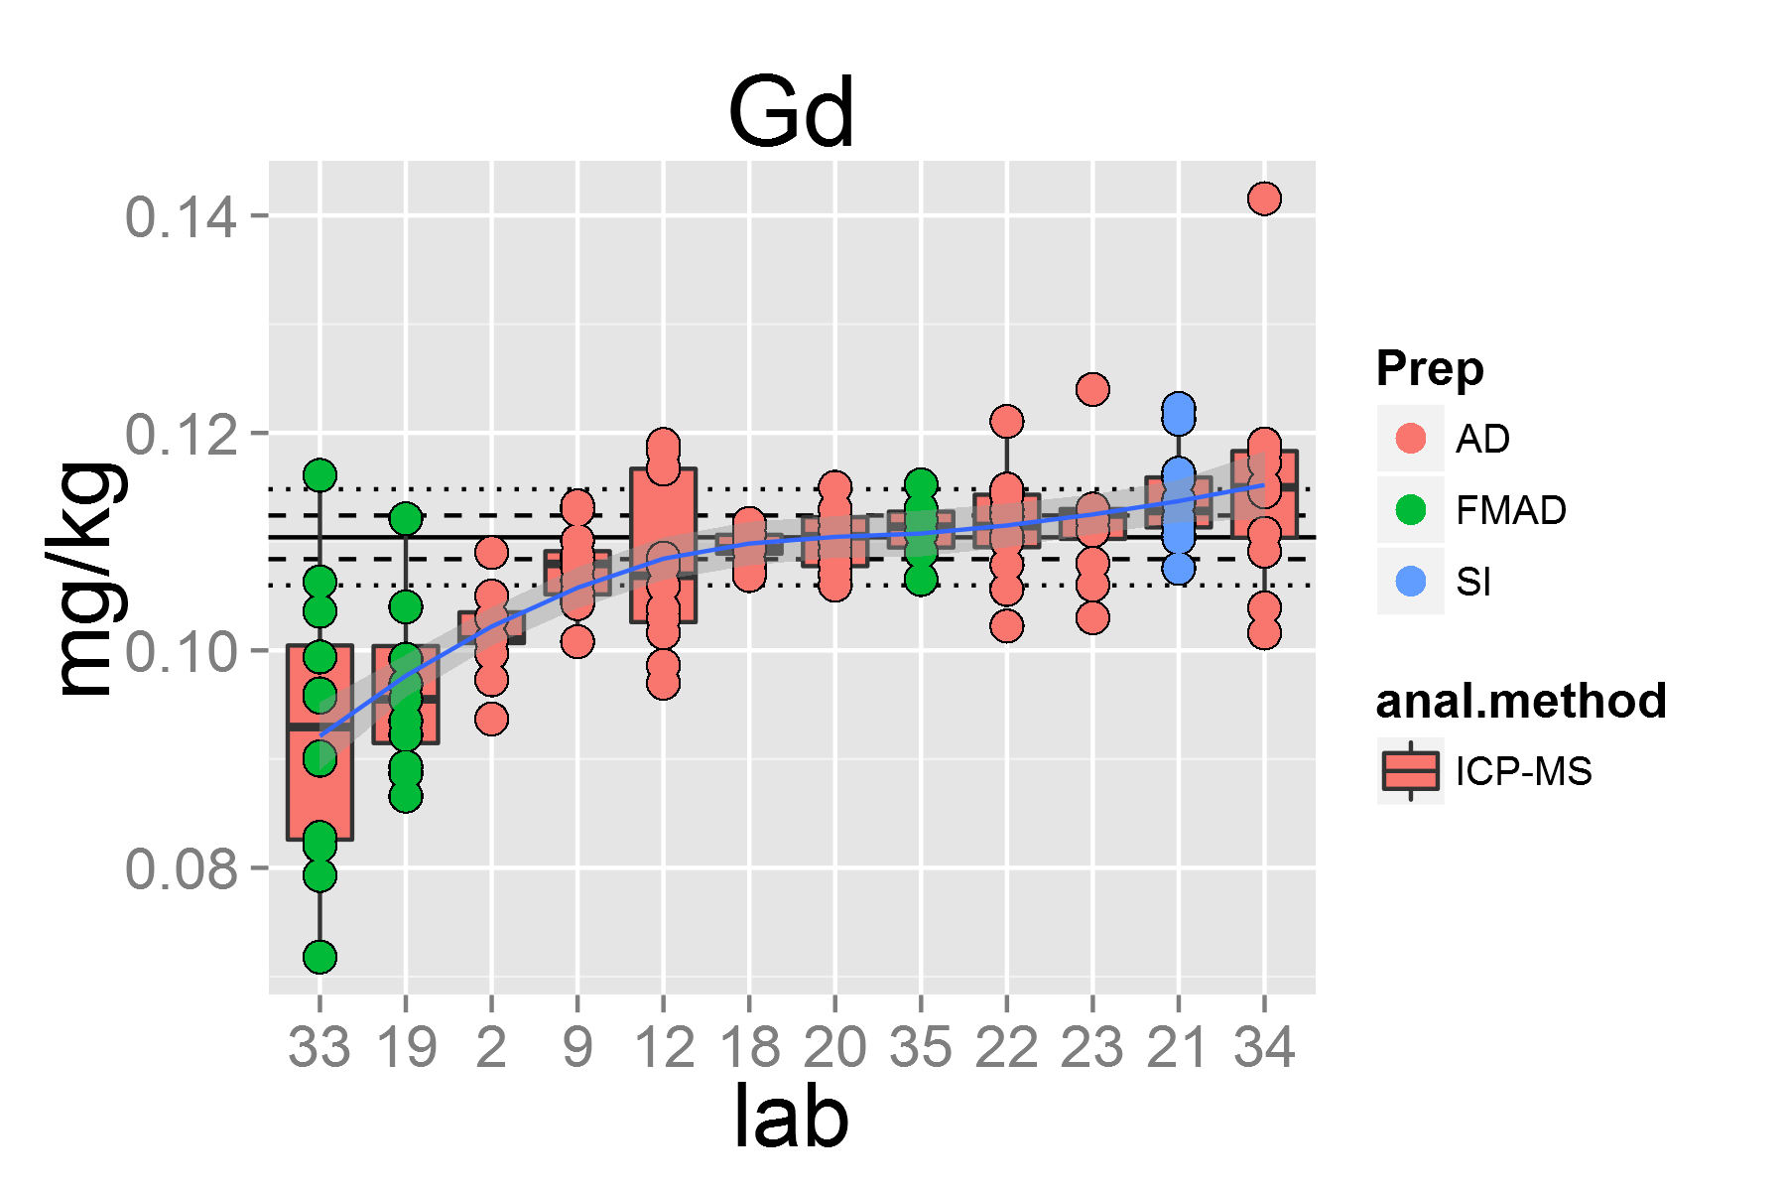

plot of chunk unnamed-chunk-4

## [1] "Hf.1"

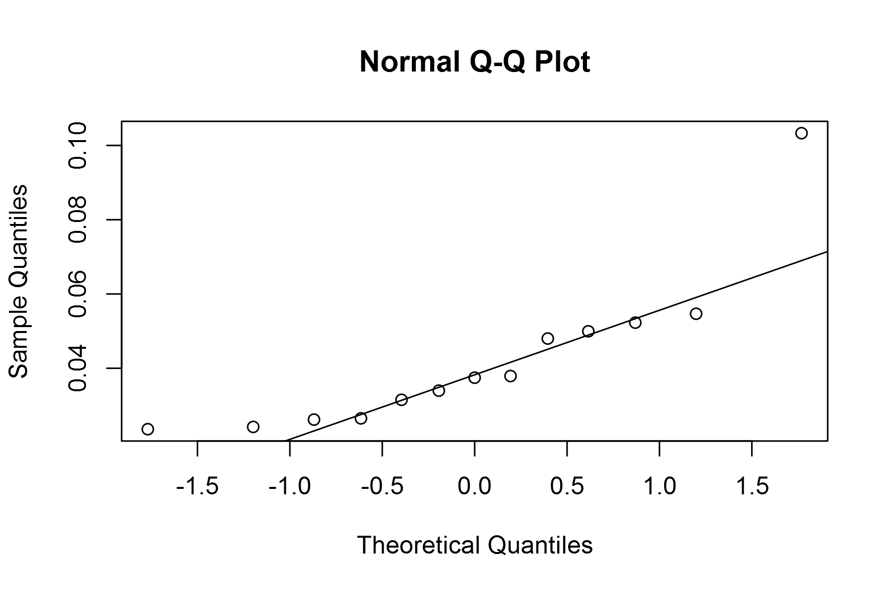

plot of chunk unnamed-chunk-4

## geom_smooth: method="auto" and size of largest group is <1000, so using loess. Use 'method = x' to change the smoothing method.

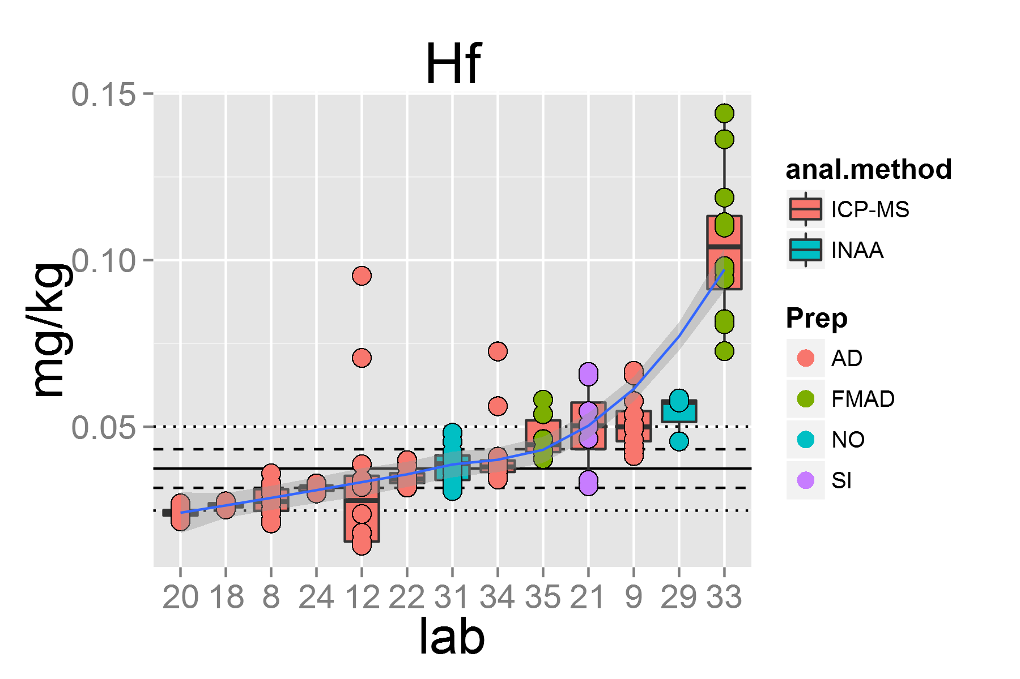

plot of chunk unnamed-chunk-4

## [1] "Ho.1"

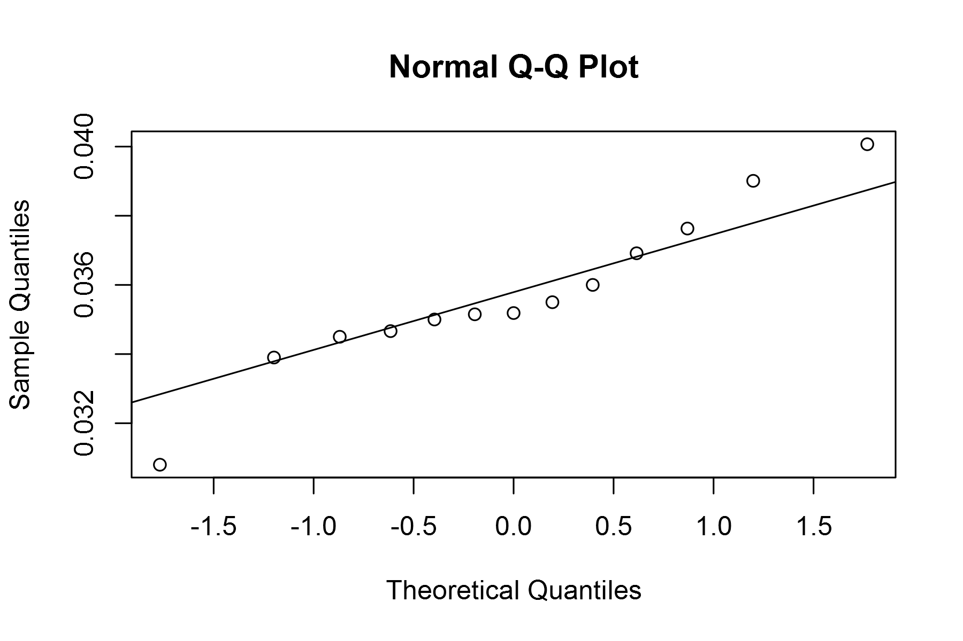

plot of chunk unnamed-chunk-4

## geom_smooth: method="auto" and size of largest group is <1000, so using loess. Use 'method = x' to change the smoothing method.

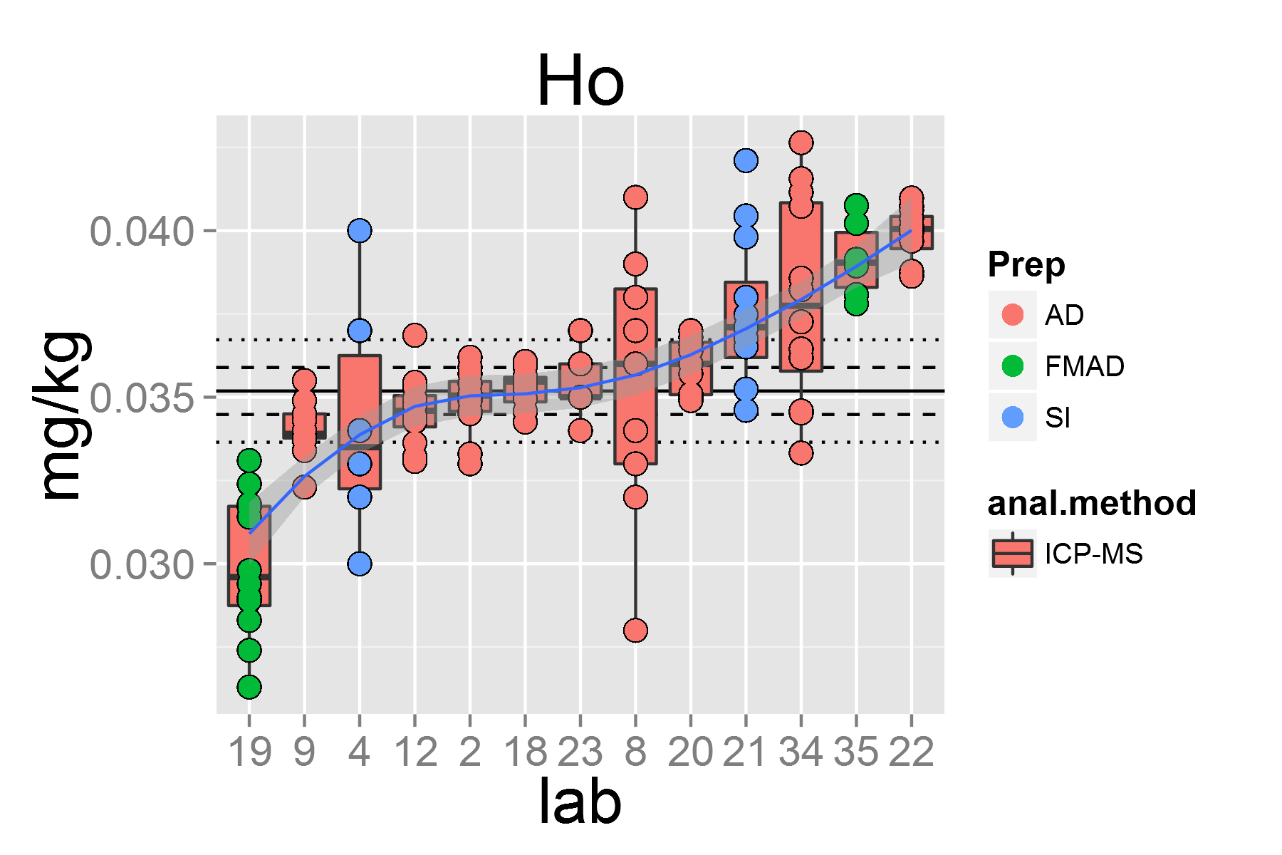

plot of chunk unnamed-chunk-4

## [1] "La.1"

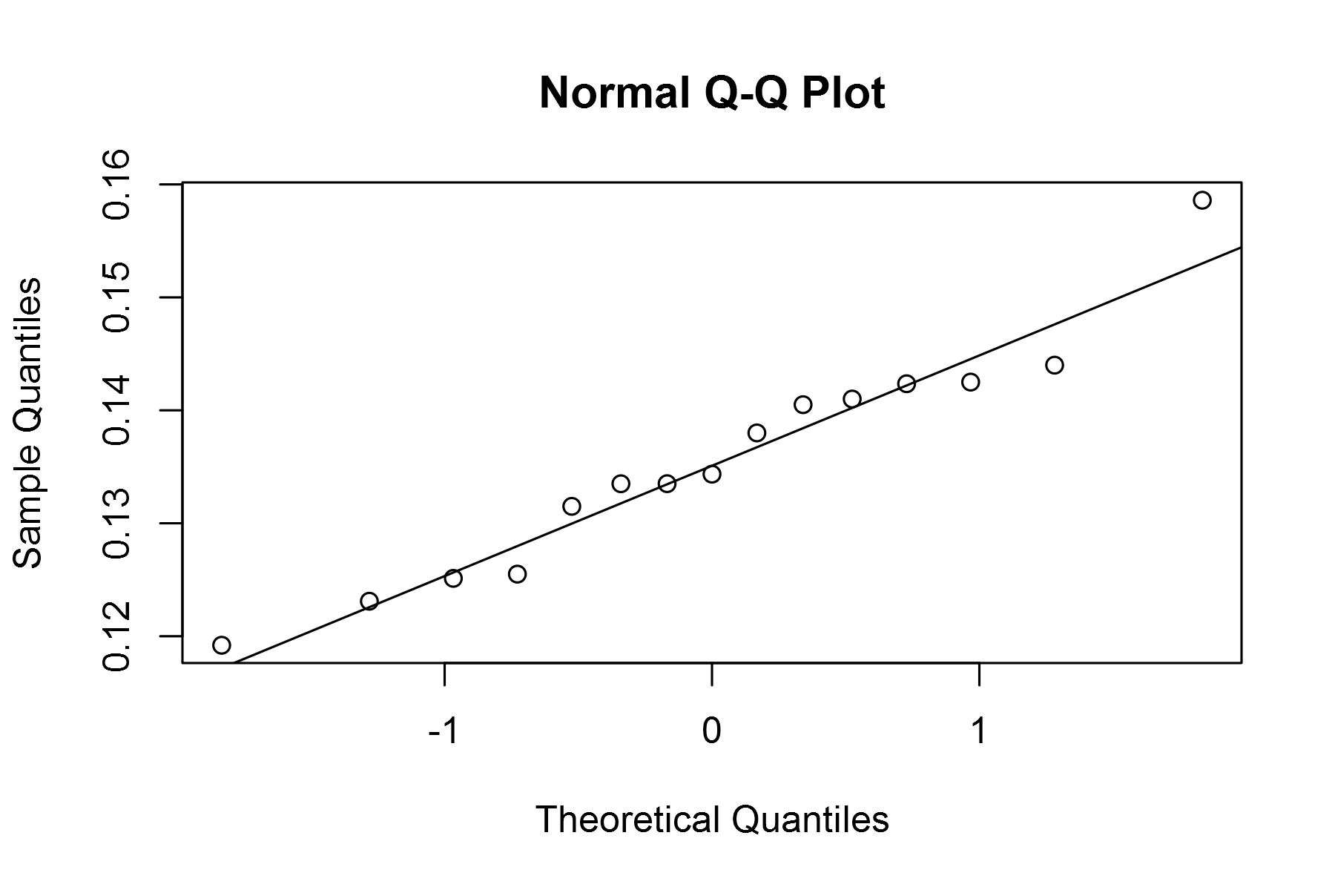

plot of chunk unnamed-chunk-4

## geom_smooth: method="auto" and size of largest group is <1000, so using loess. Use 'method = x' to change the smoothing method.

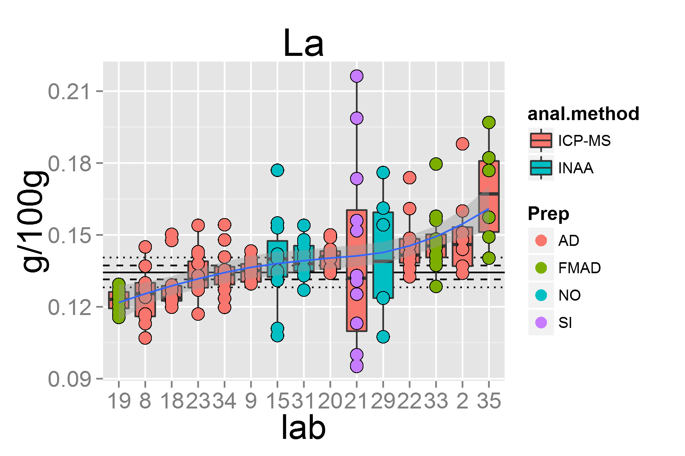

plot of chunk unnamed-chunk-4

## [1] "Li.1"

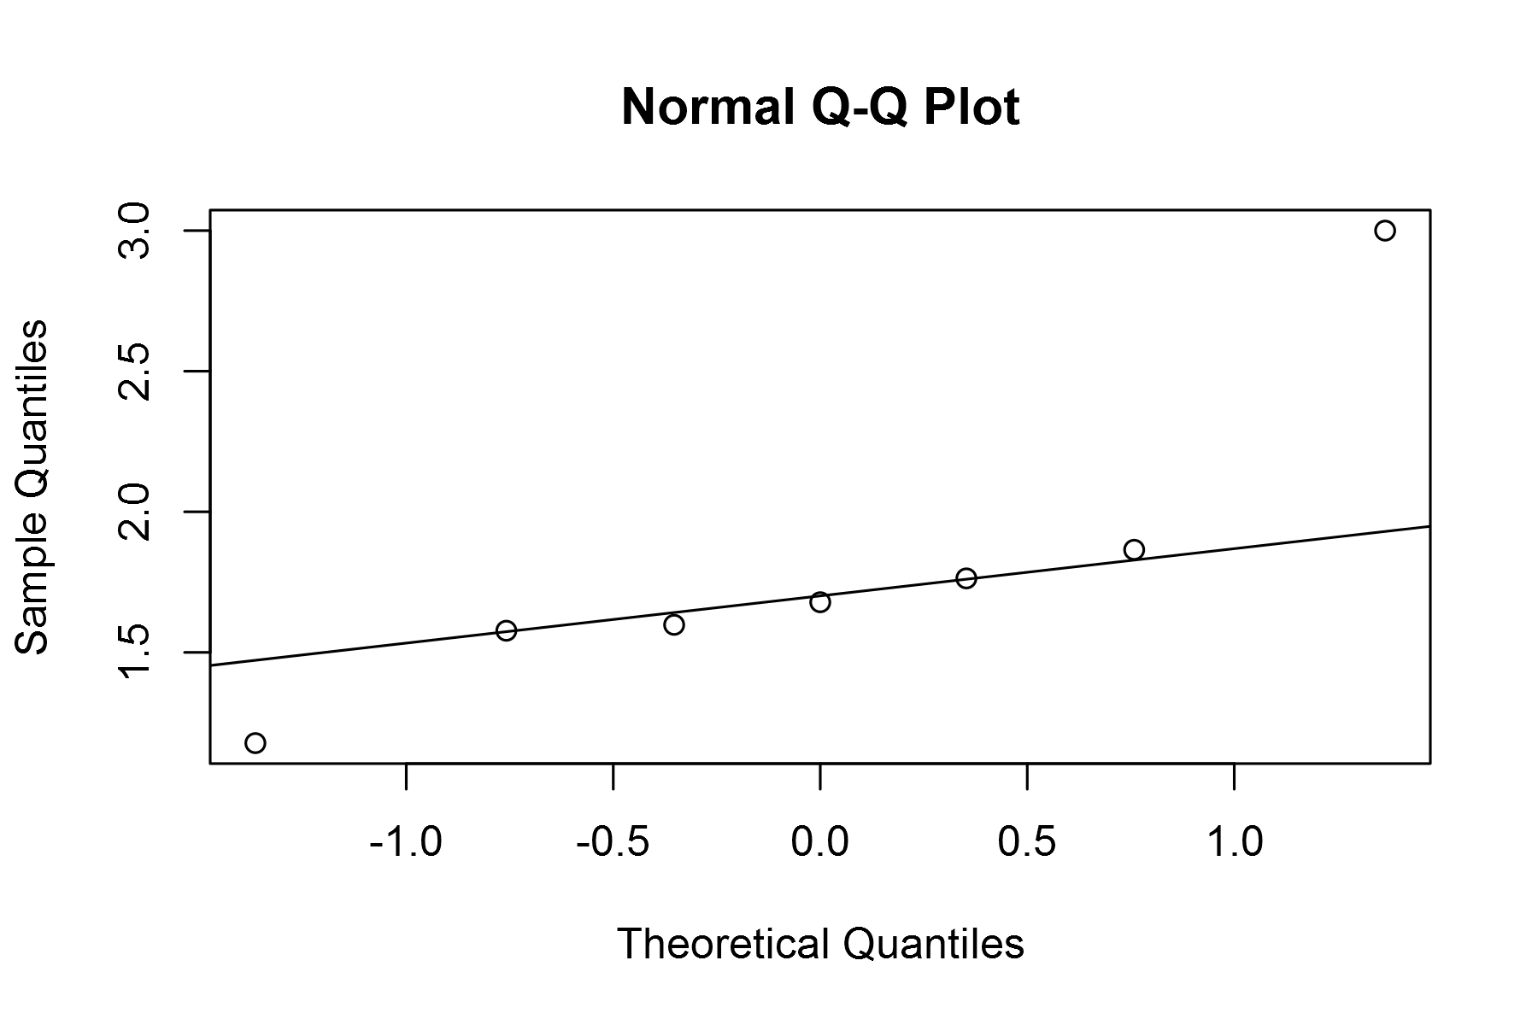

plot of chunk unnamed-chunk-4

## geom_smooth: method="auto" and size of largest group is <1000, so using loess. Use 'method = x' to change the smoothing method.

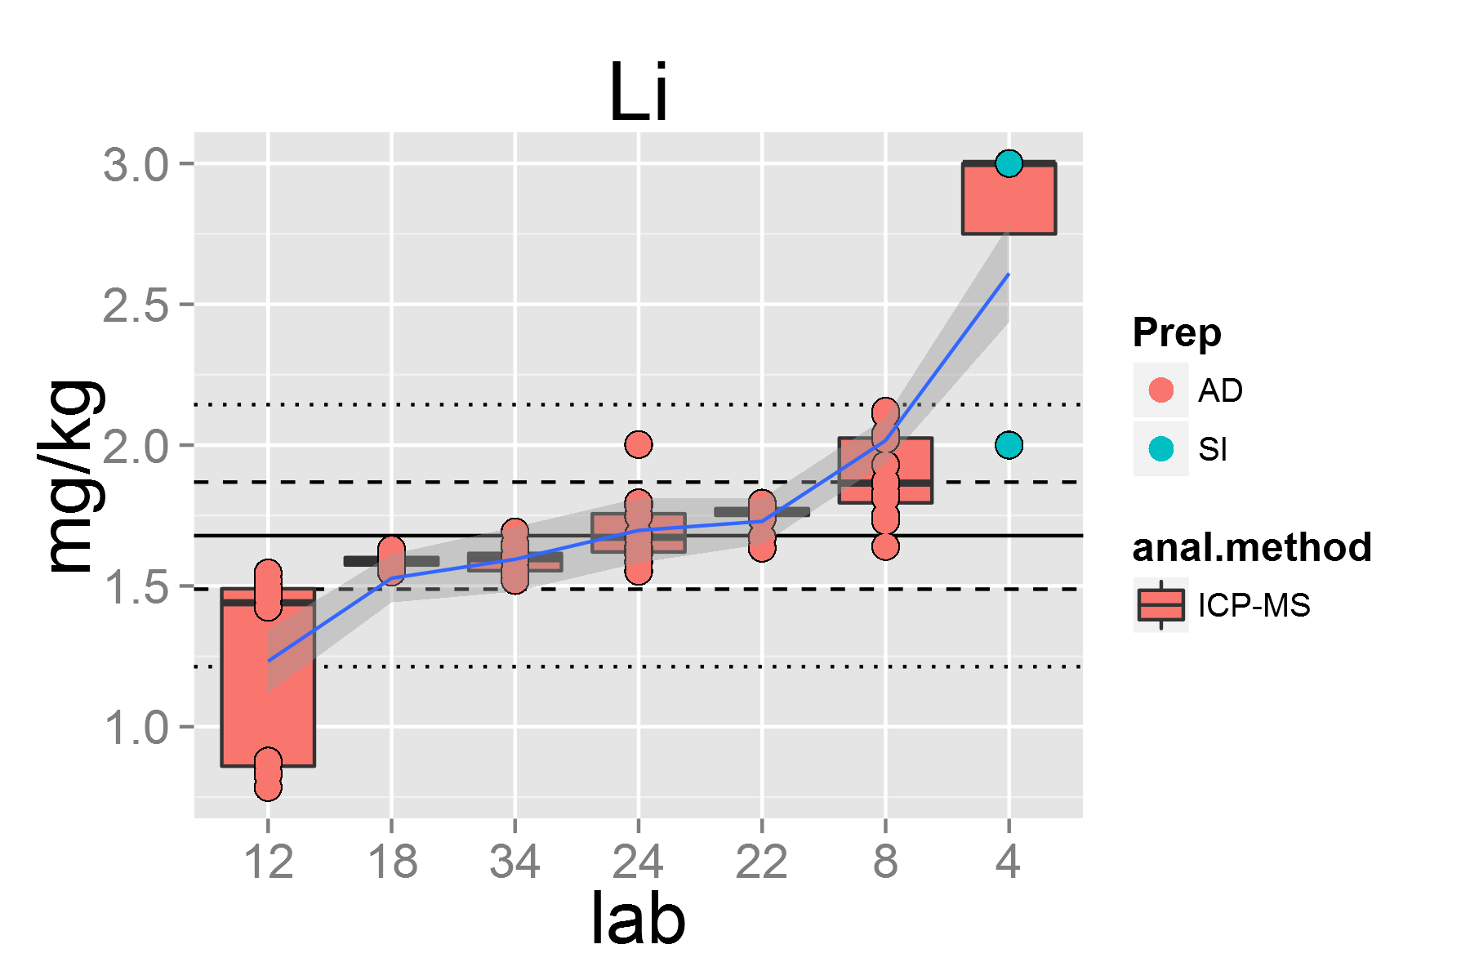

plot of chunk unnamed-chunk-4

## [1] "Lu.1"

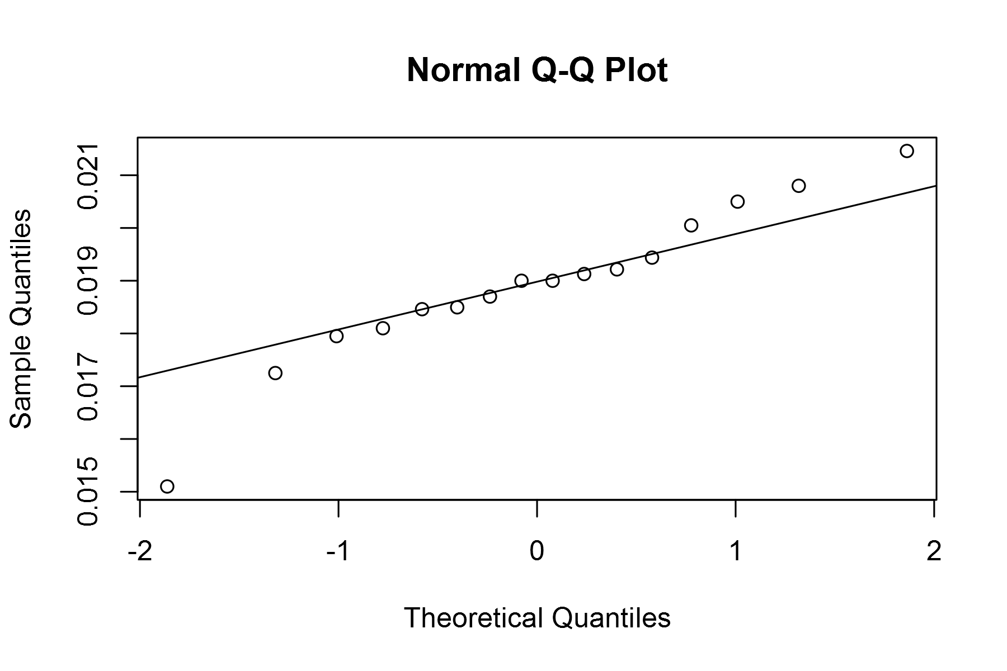

plot of chunk unnamed-chunk-4

## geom_smooth: method="auto" and size of largest group is <1000, so using loess. Use 'method = x' to change the smoothing method.

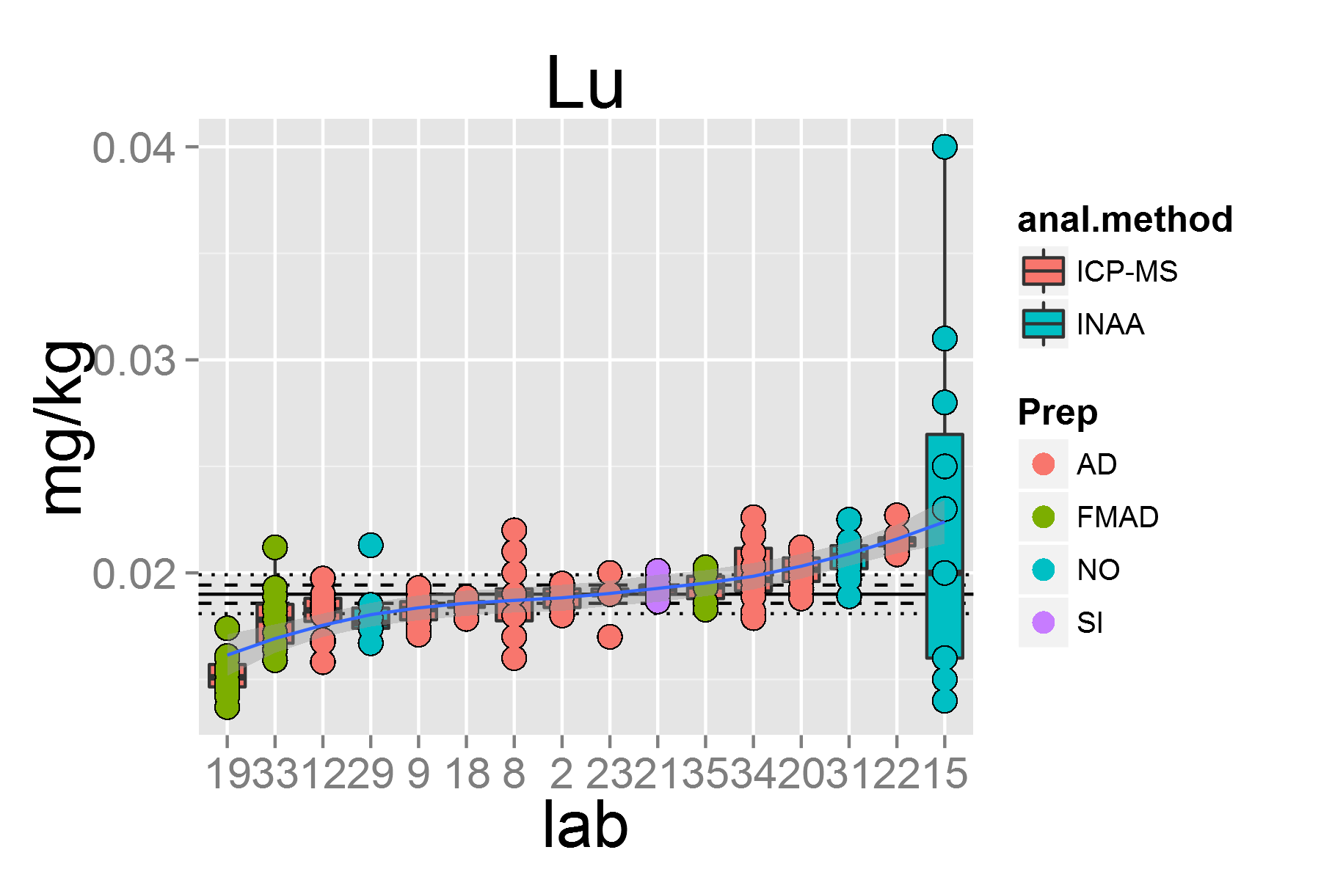

plot of chunk unnamed-chunk-4

## [1] "Nb.1"

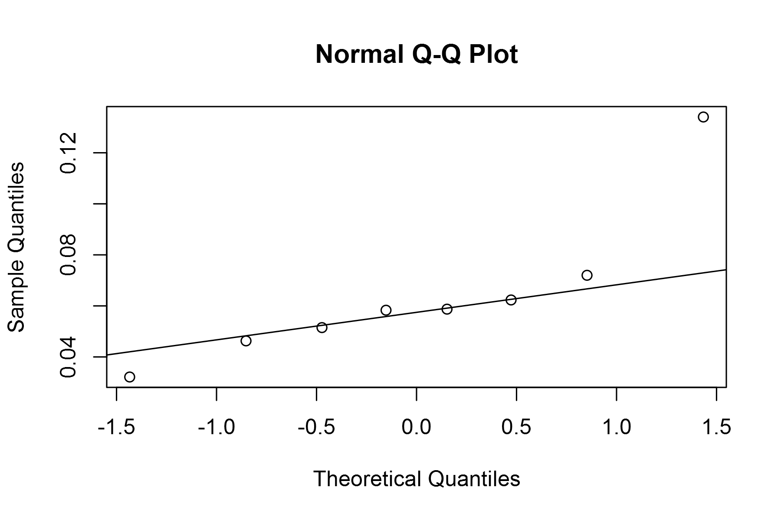

plot of chunk unnamed-chunk-4

## geom_smooth: method="auto" and size of largest group is <1000, so using loess. Use 'method = x' to change the smoothing method.

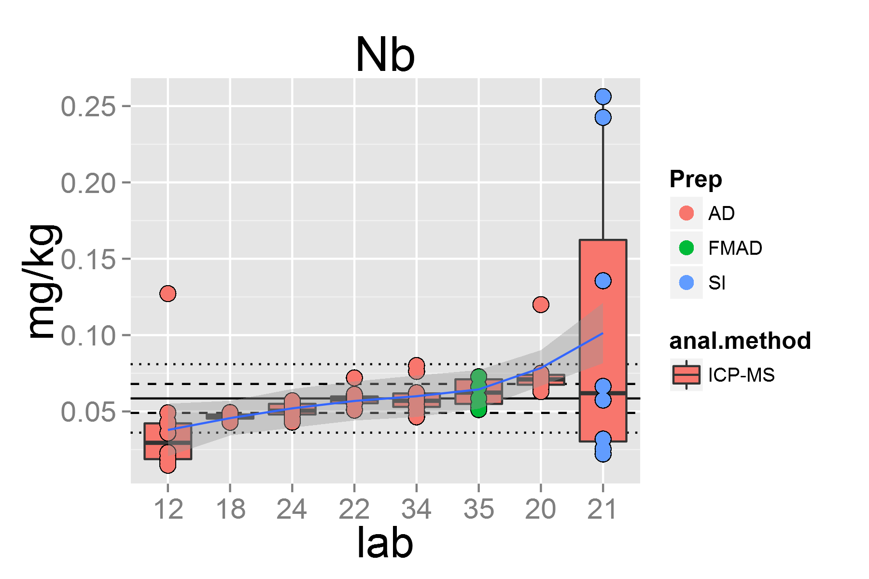

plot of chunk unnamed-chunk-4

## [1] "Nd.1"

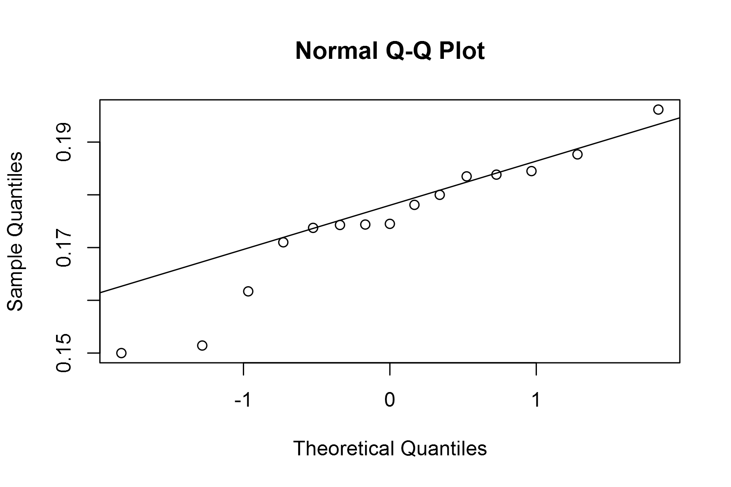

plot of chunk unnamed-chunk-4

## geom_smooth: method="auto" and size of largest group is <1000, so using loess. Use 'method = x' to change the smoothing method.

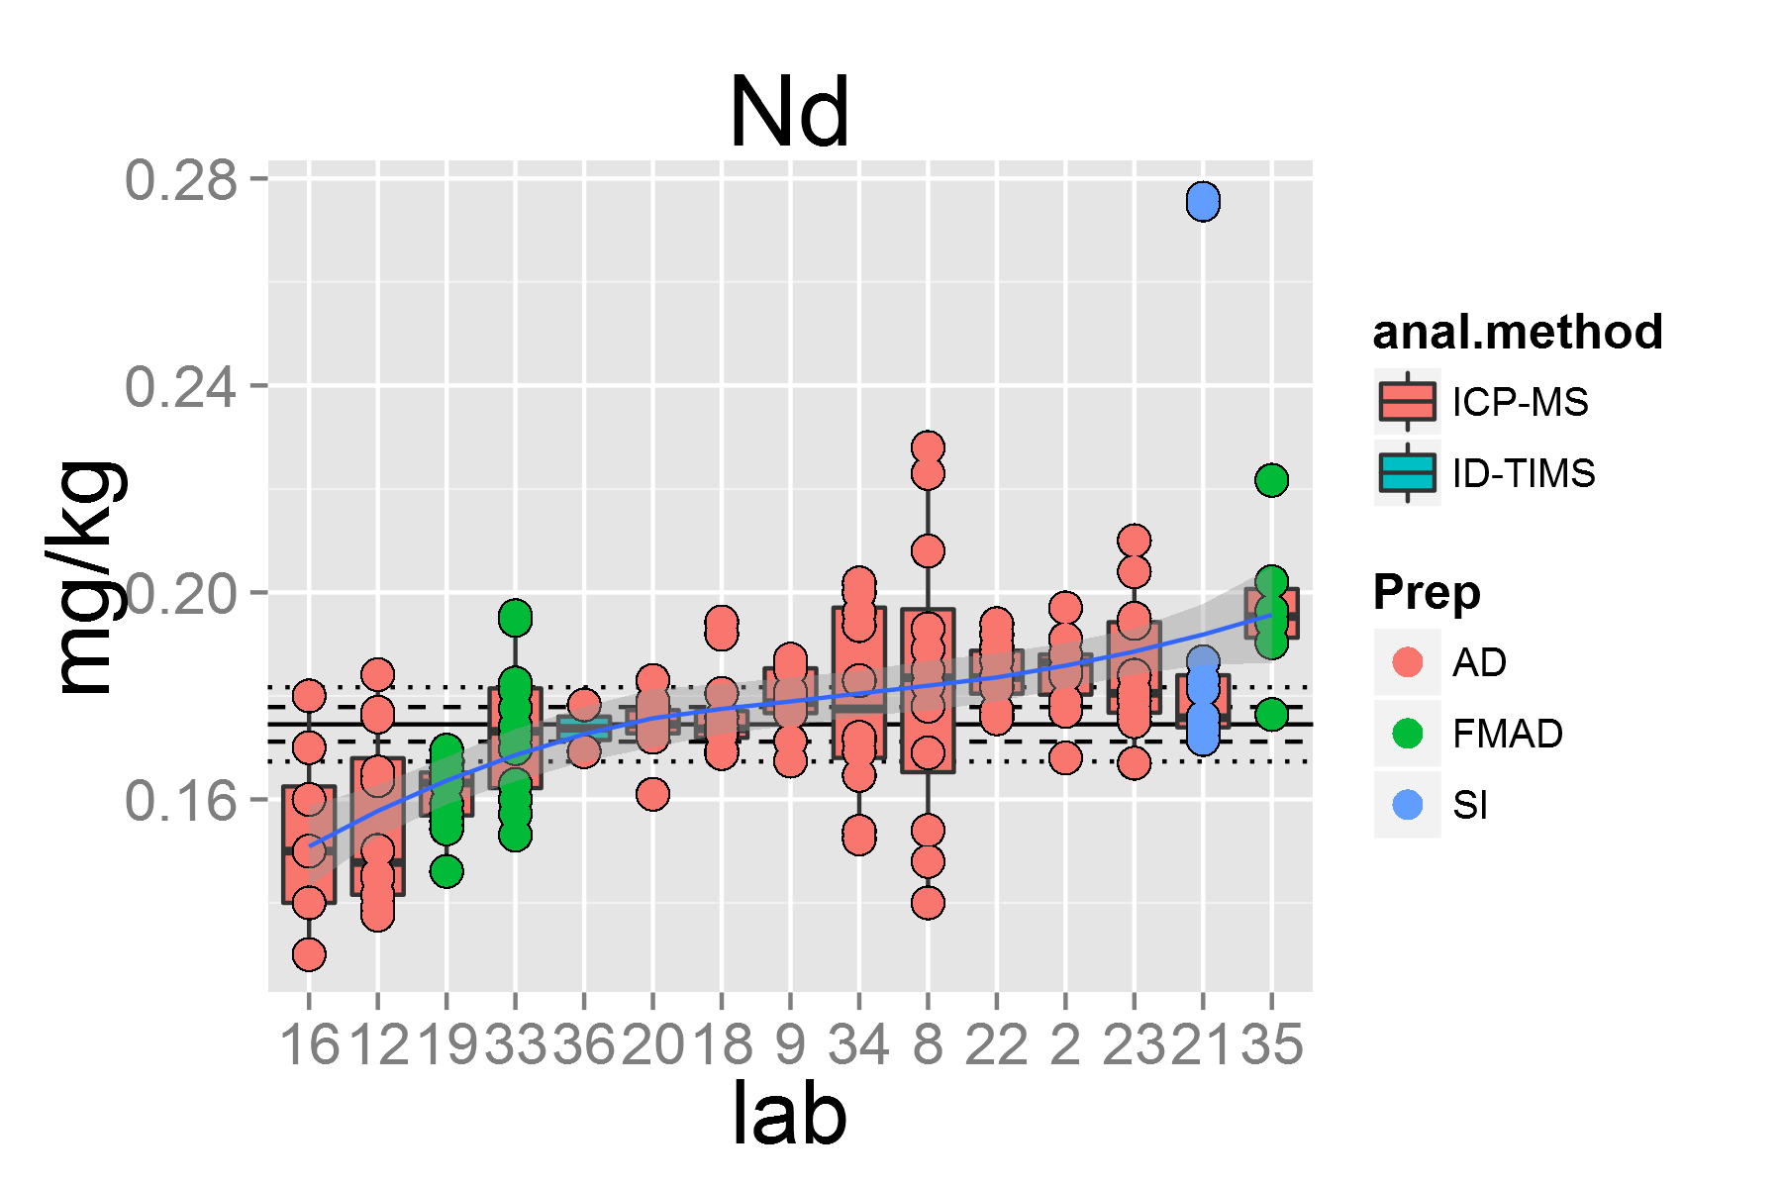

plot of chunk unnamed-chunk-4

## [1] "Ni.1"

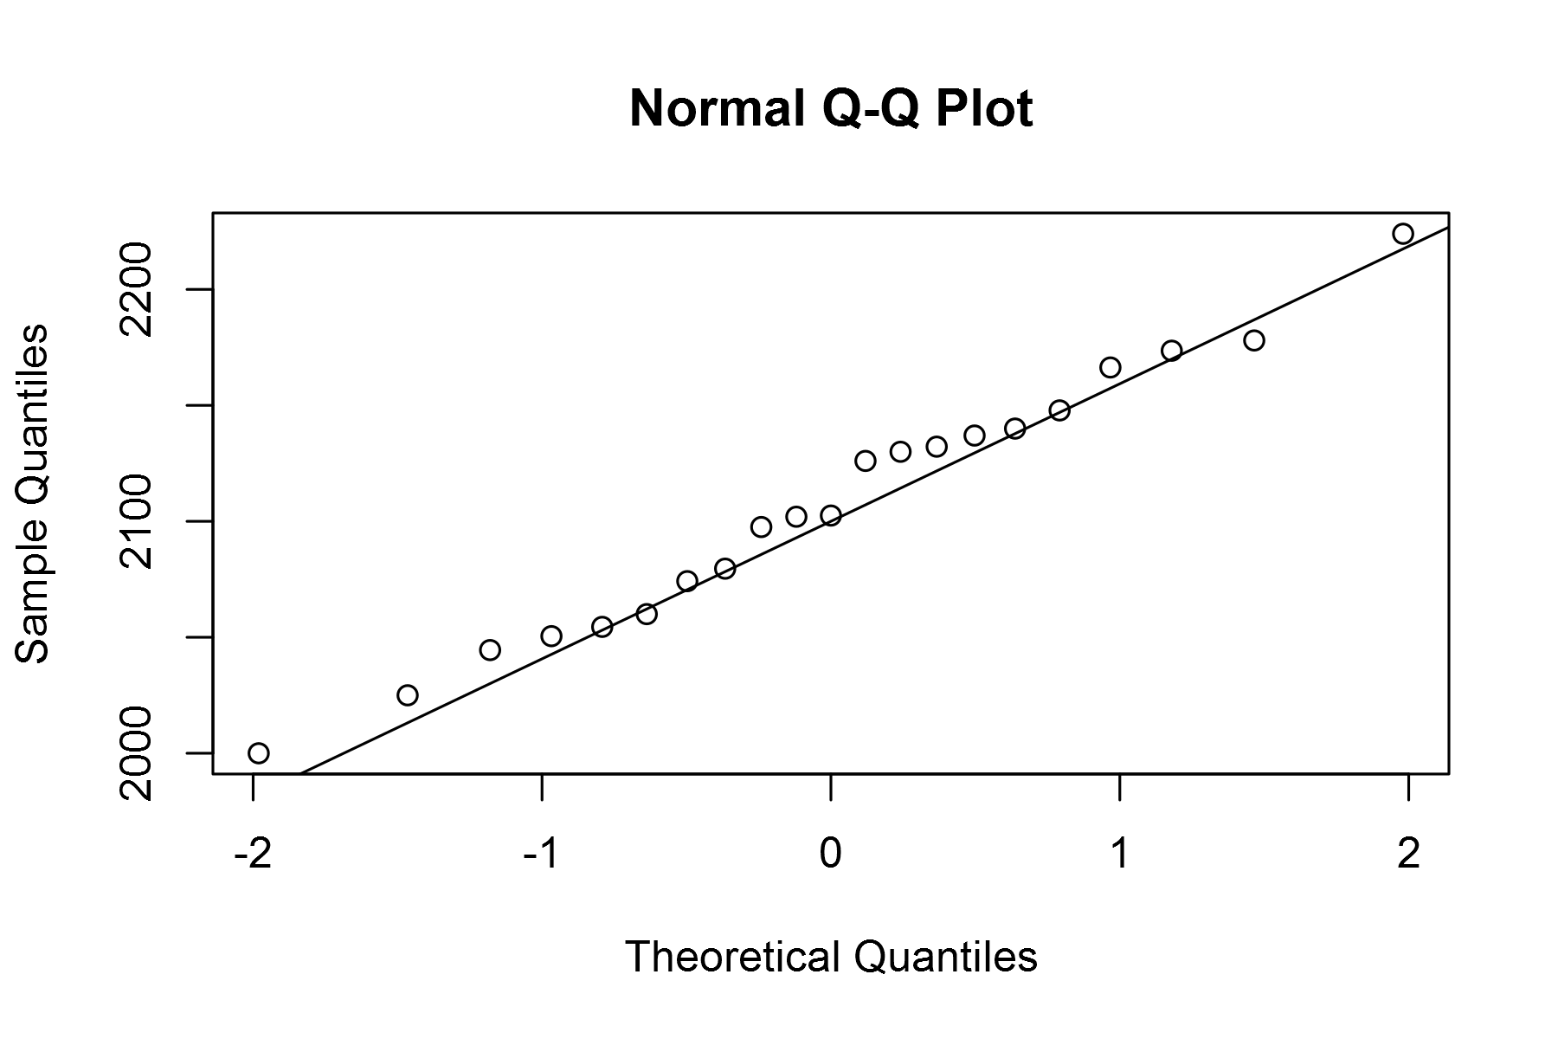

plot of chunk unnamed-chunk-4

## geom_smooth: method="auto" and size of largest group is <1000, so using loess. Use 'method = x' to change the smoothing method.

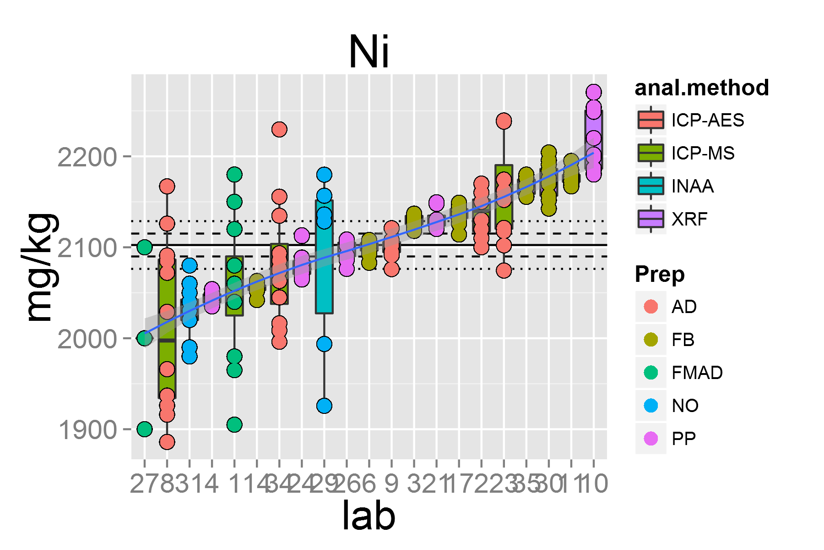

plot of chunk unnamed-chunk-4

## [1] "Pb.1"

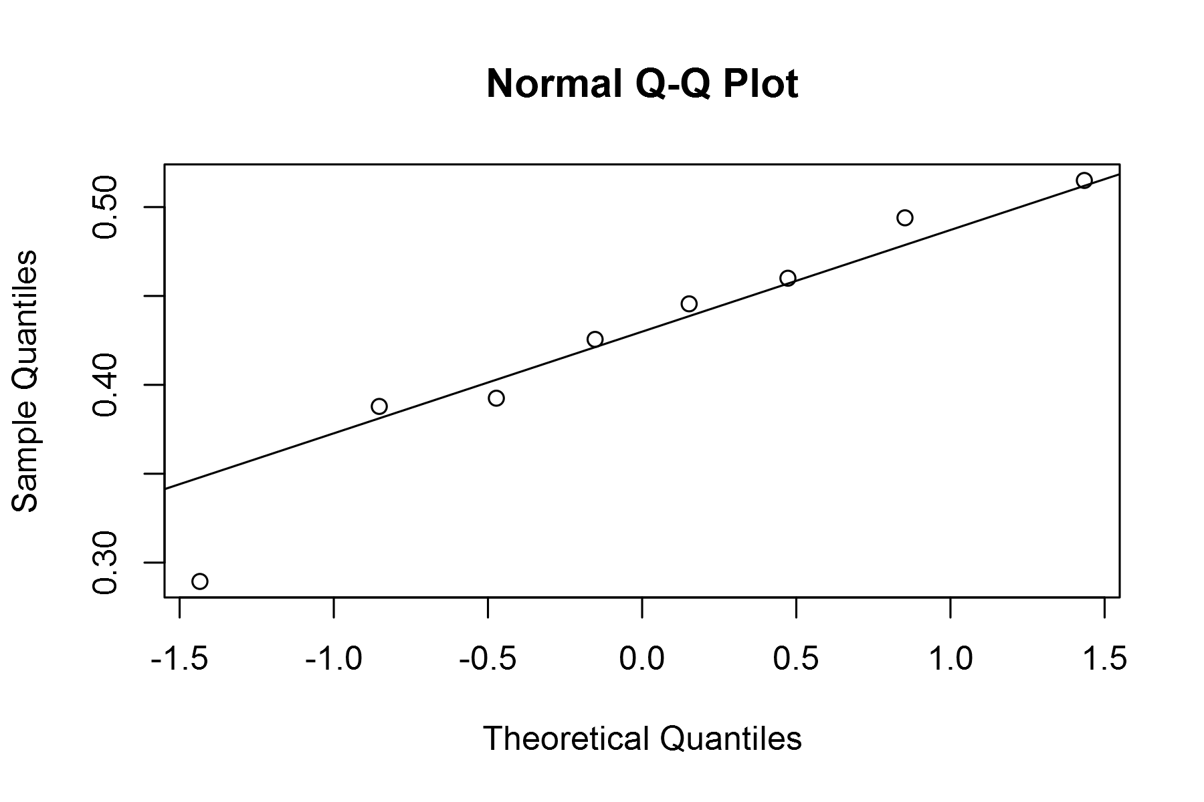

plot of chunk unnamed-chunk-4

## geom_smooth: method="auto" and size of largest group is <1000, so using loess. Use 'method = x' to change the smoothing method.

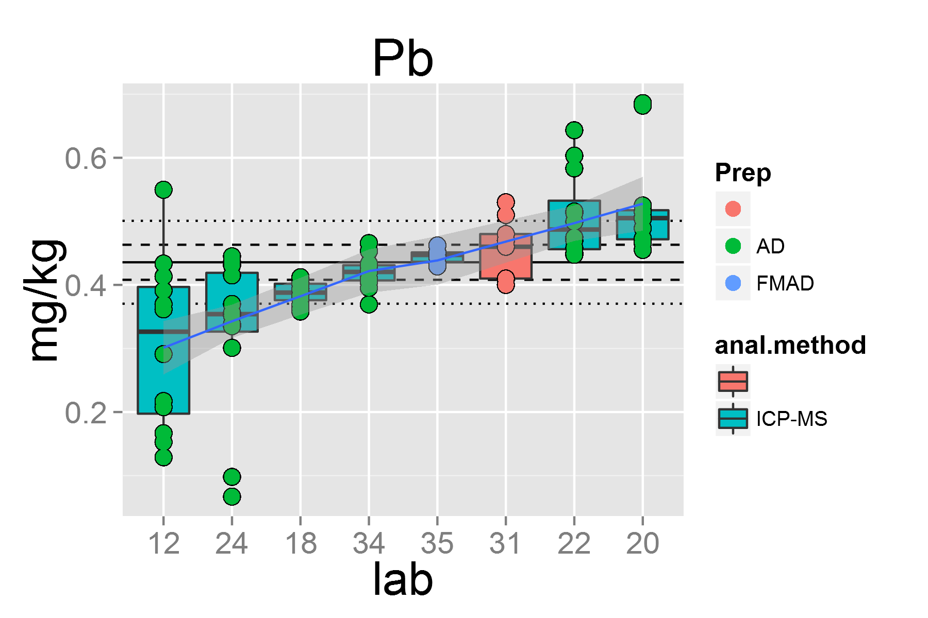

plot of chunk unnamed-chunk-4

## [1] "Pr.1"

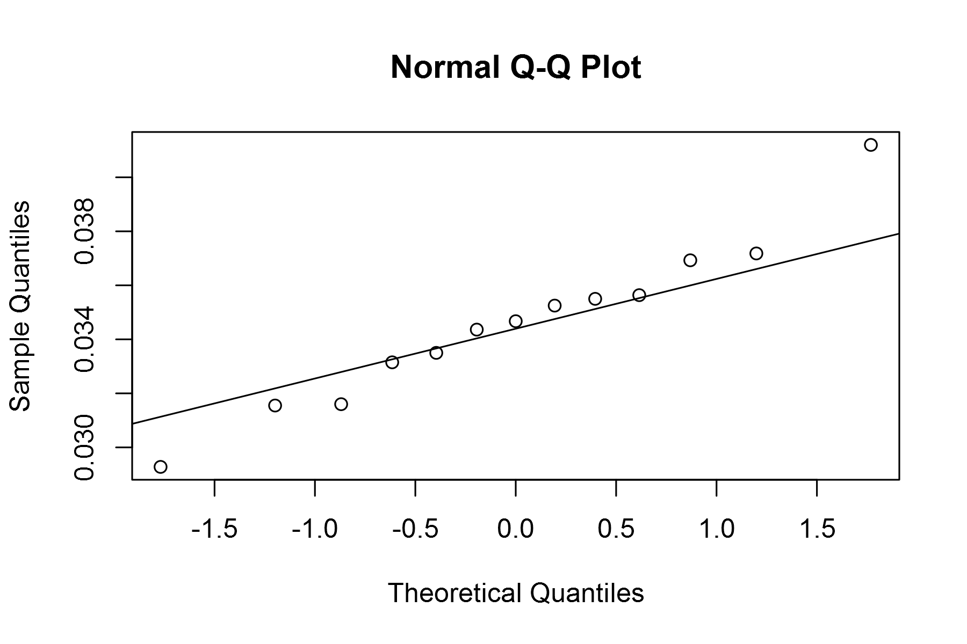

plot of chunk unnamed-chunk-4

## geom_smooth: method="auto" and size of largest group is <1000, so using loess. Use 'method = x' to change the smoothing method.

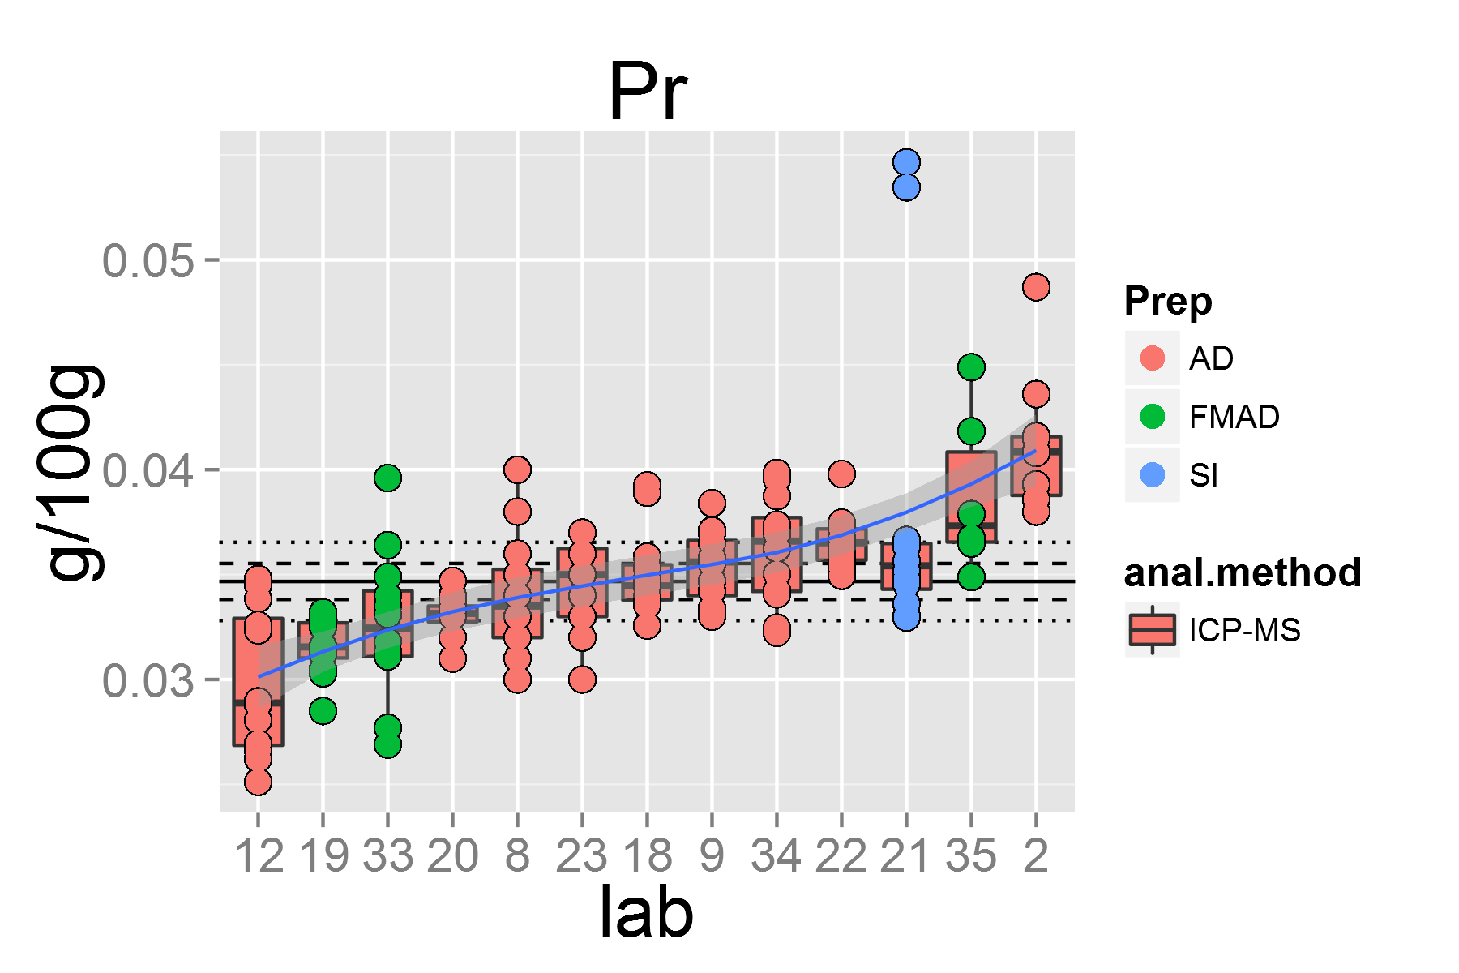

plot of chunk unnamed-chunk-4

## [1] "Rb.1"

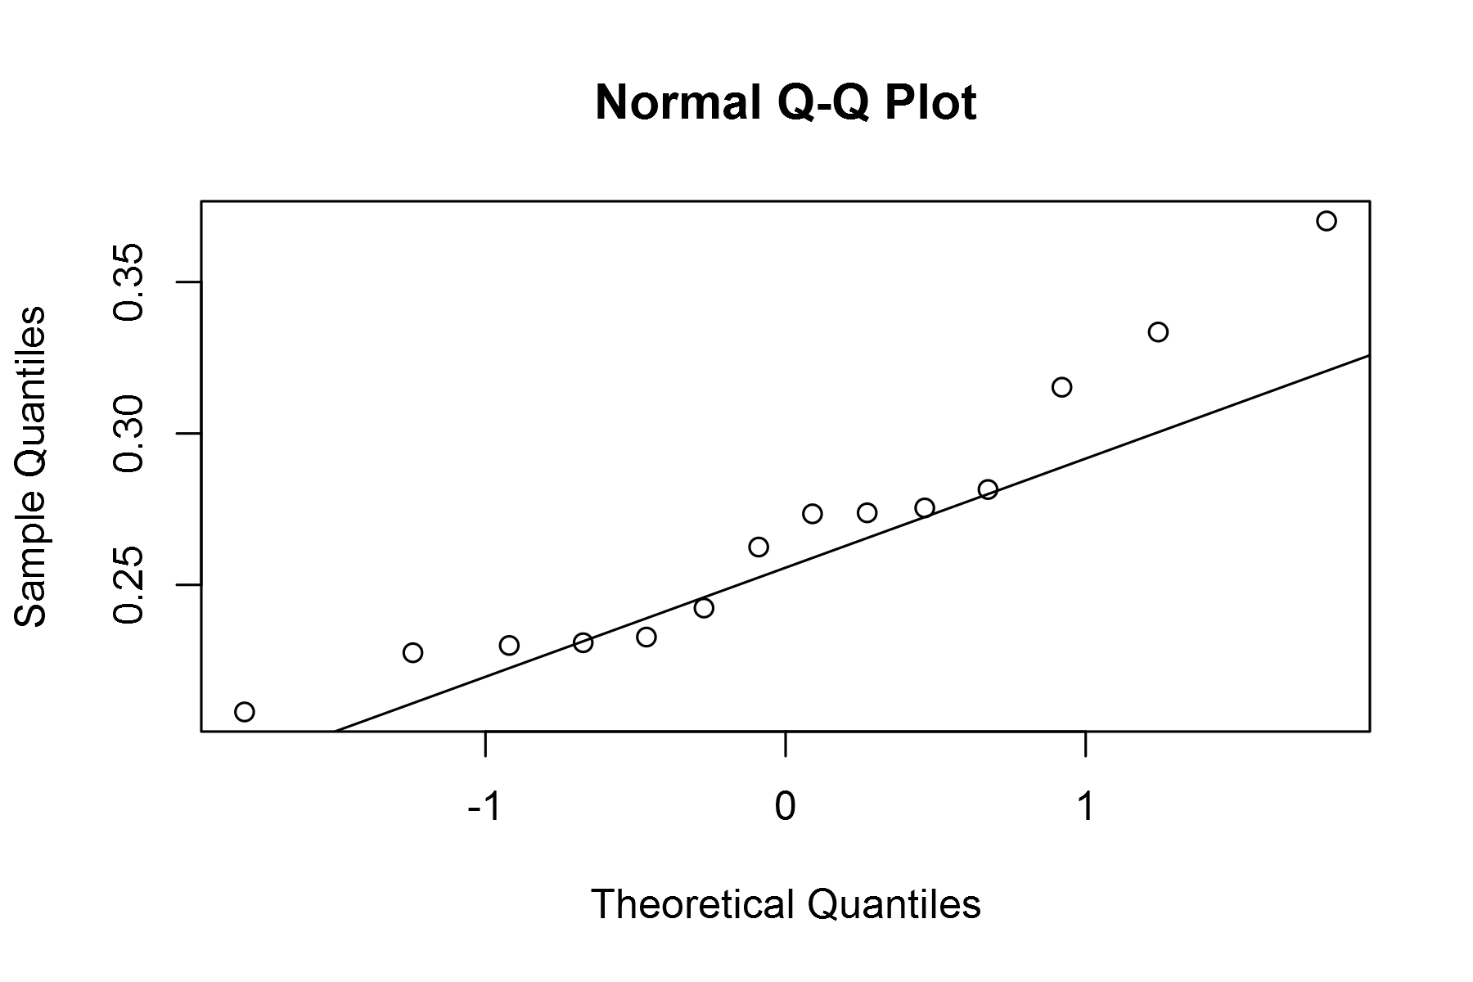

plot of chunk unnamed-chunk-4

## geom_smooth: method="auto" and size of largest group is <1000, so using loess. Use 'method = x' to change the smoothing method.

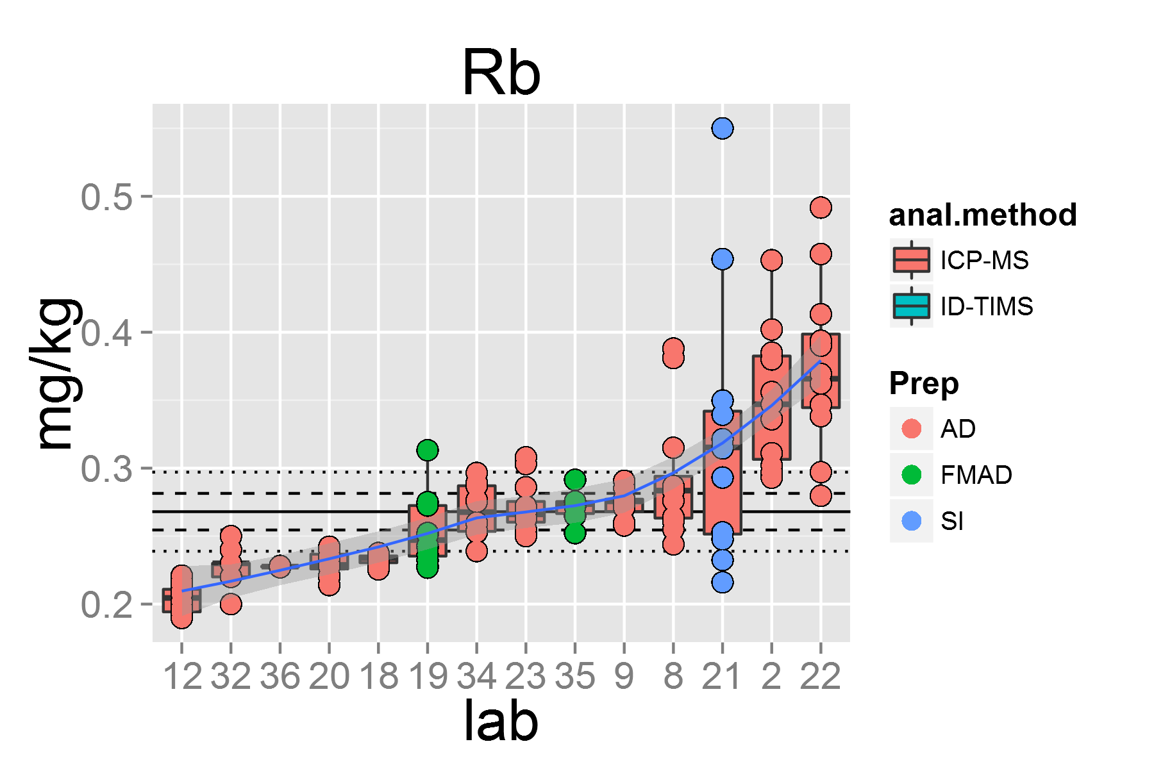

plot of chunk unnamed-chunk-4

## [1] "Sb.1"

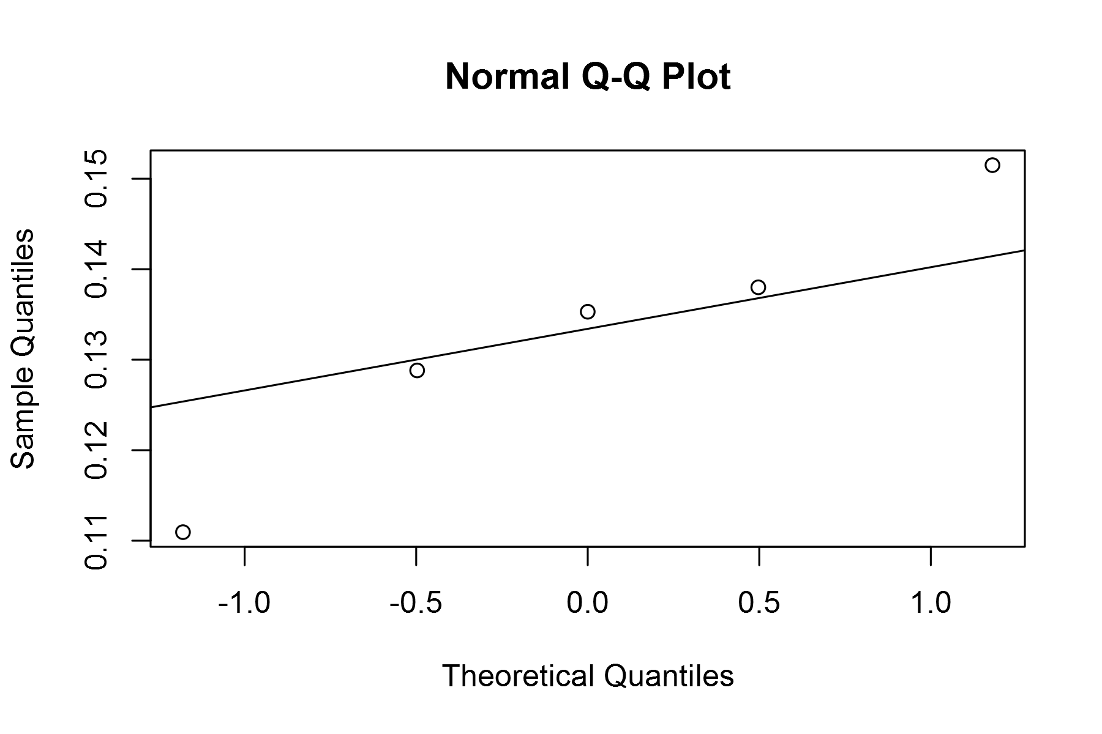

plot of chunk unnamed-chunk-4

## geom_smooth: method="auto" and size of largest group is <1000, so using loess. Use 'method = x' to change the smoothing method.

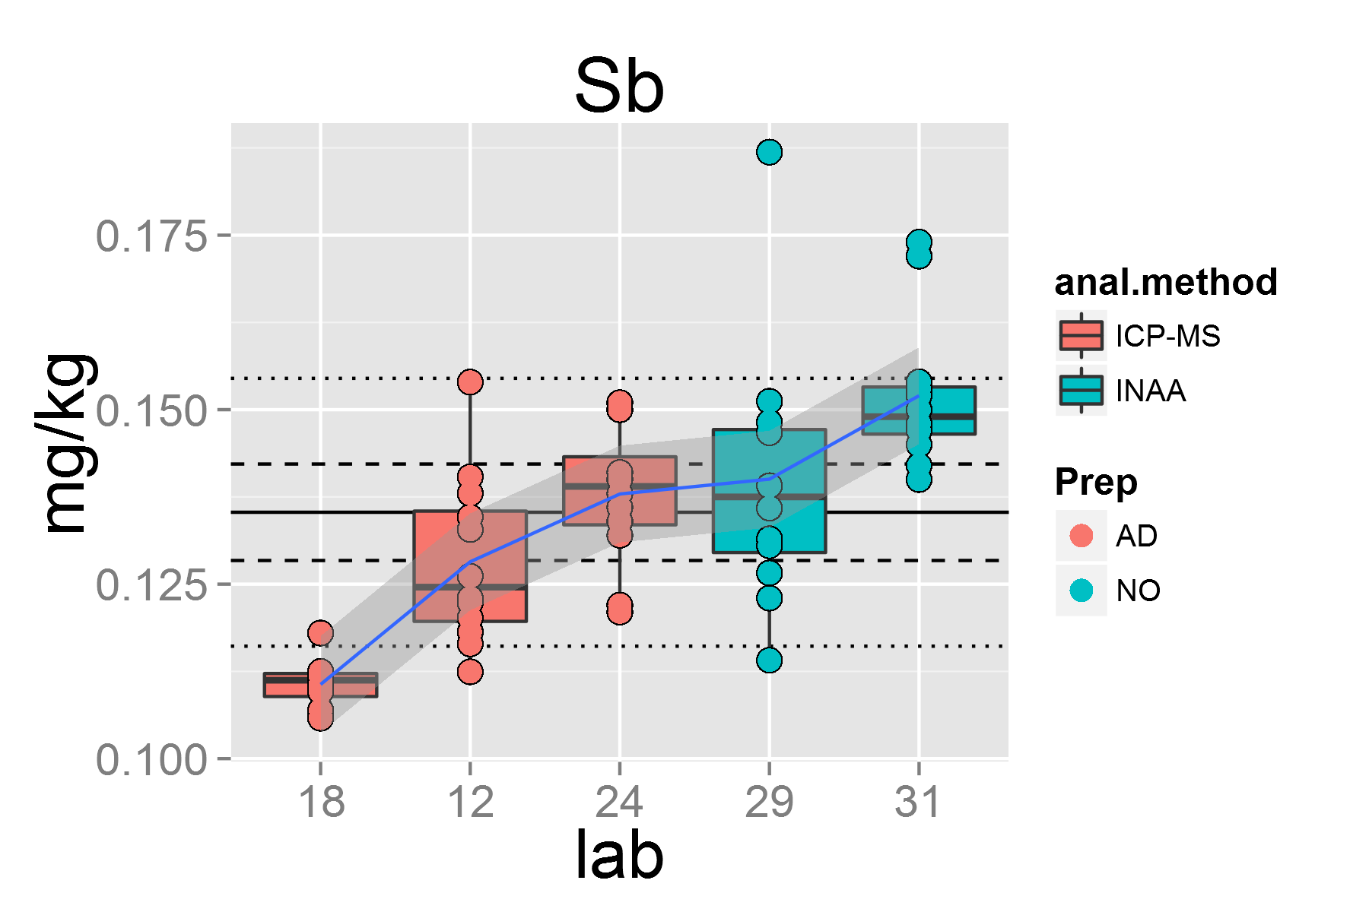

plot of chunk unnamed-chunk-4

## [1] "Sc.1"

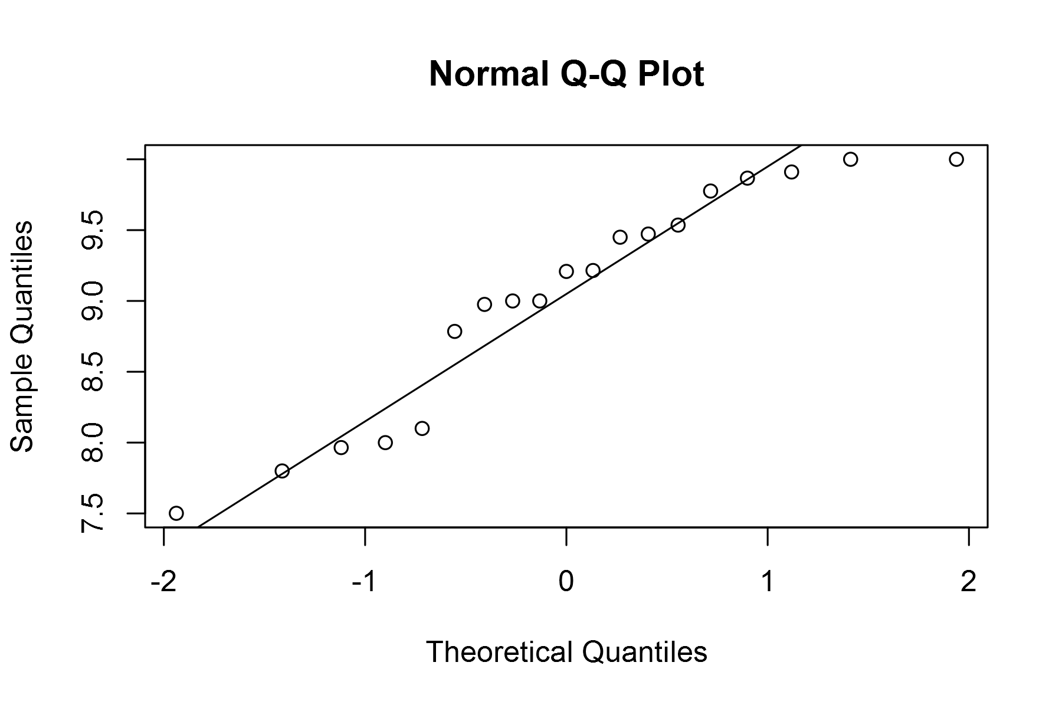

plot of chunk unnamed-chunk-4

## geom_smooth: method="auto" and size of largest group is <1000, so using loess. Use 'method = x' to change the smoothing method.

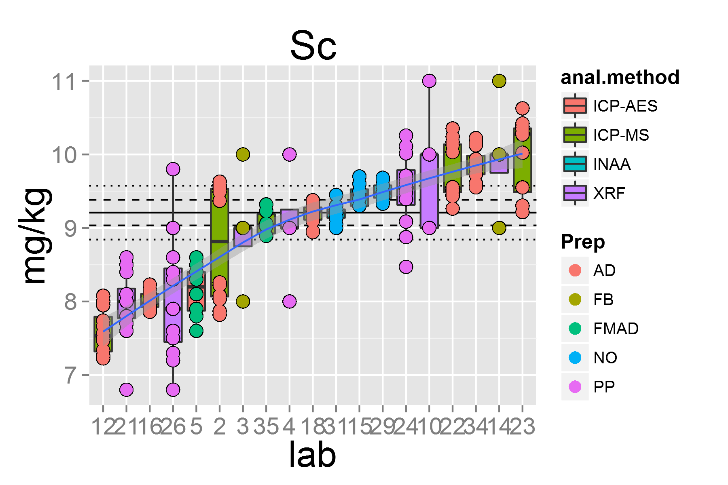

plot of chunk unnamed-chunk-4

## [1] "Sm.1"

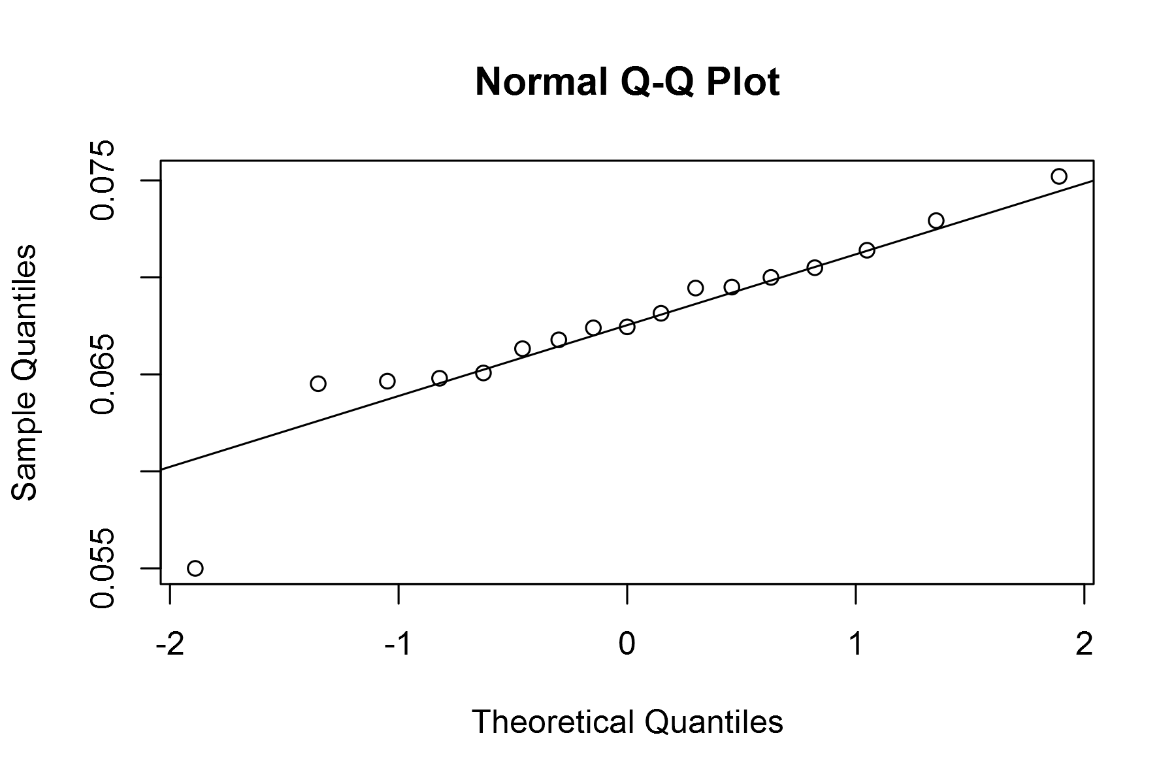

plot of chunk unnamed-chunk-4

## geom_smooth: method="auto" and size of largest group is <1000, so using loess. Use 'method = x' to change the smoothing method.

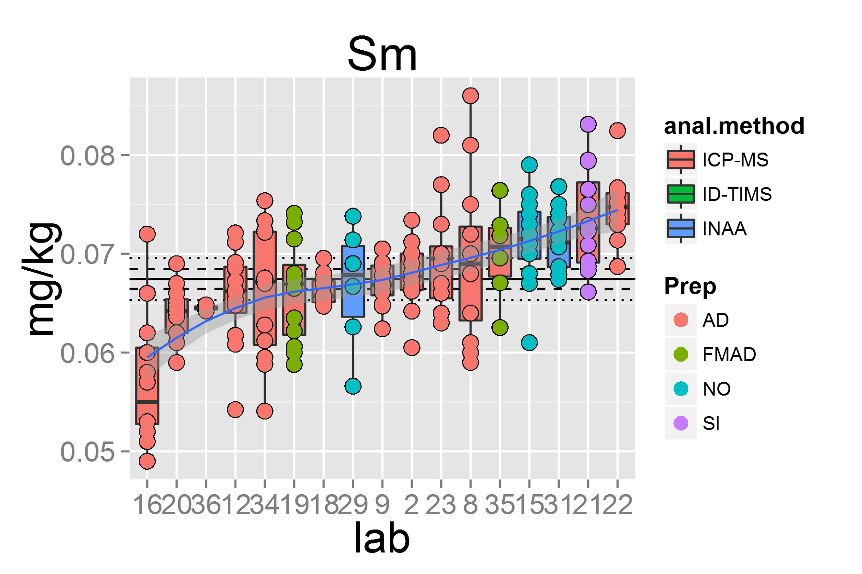

plot of chunk unnamed-chunk-4

## [1] "Sn.1"

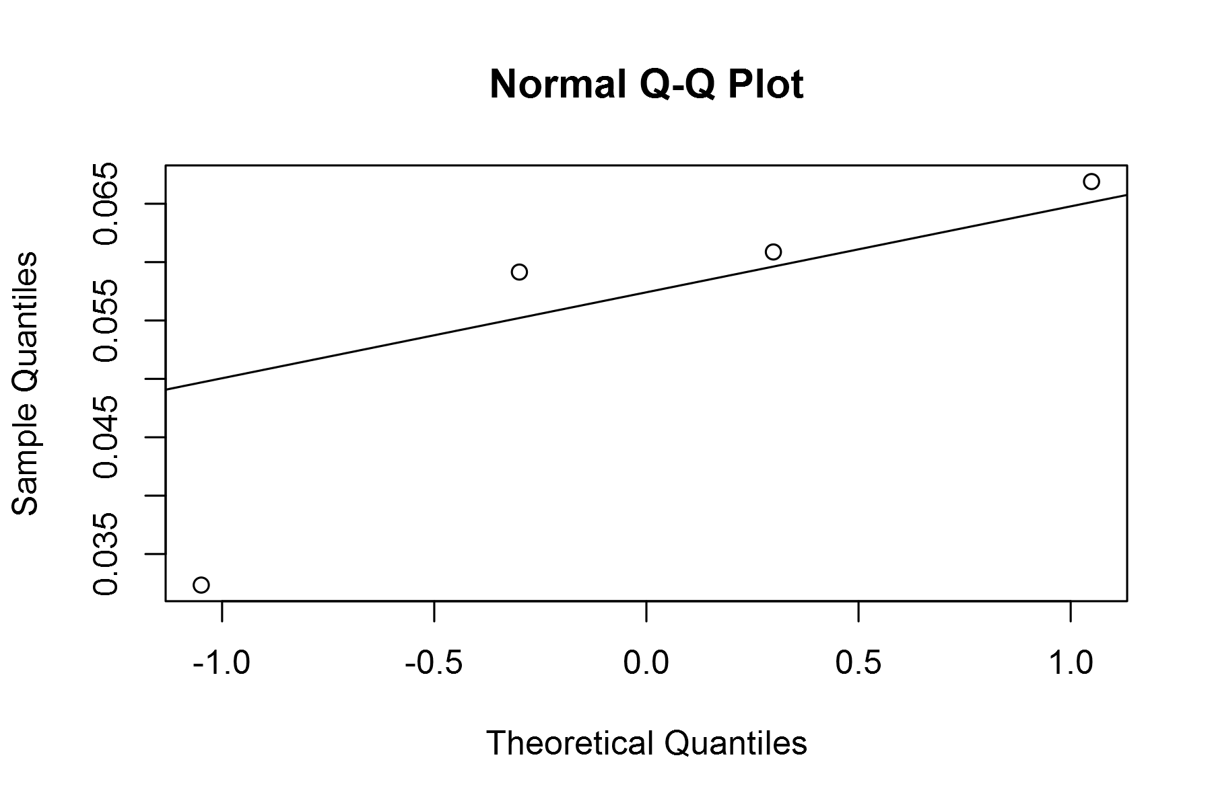

plot of chunk unnamed-chunk-4

## geom_smooth: method="auto" and size of largest group is <1000, so using loess. Use 'method = x' to change the smoothing method.

## Warning: pseudoinverse used at 0.985  
## Warning: neighborhood radius 2.015  
## Warning: reciprocal condition number 3.0447e-016  
## Warning: There are other near singularities as well. 4.0602  
## Warning: pseudoinverse used at 0.985  
## Warning: neighborhood radius 2.015  
## Warning: reciprocal condition number 3.0447e-016  
## Warning: There are other near singularities as well. 4.0602

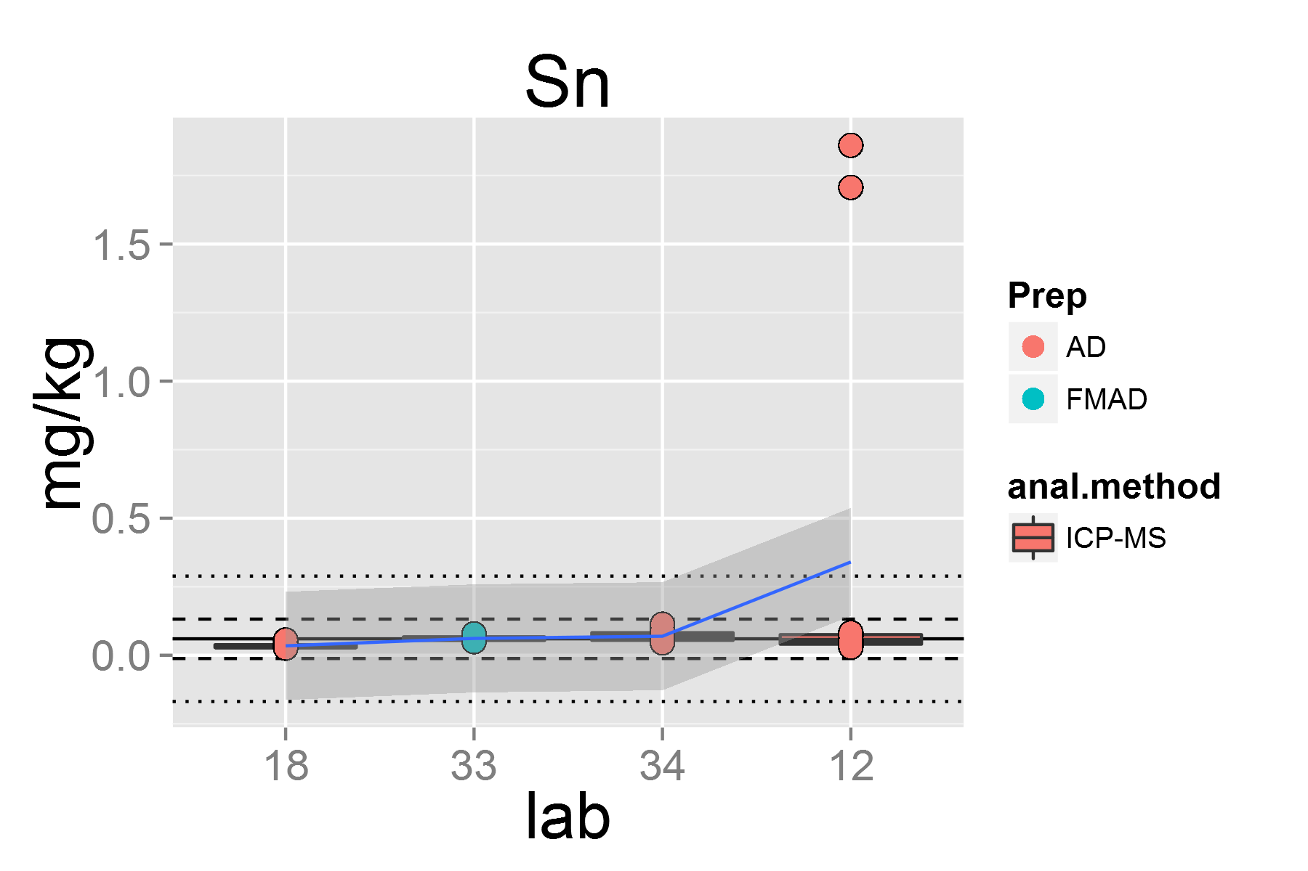

plot of chunk unnamed-chunk-4

## [1] "Sr.1"

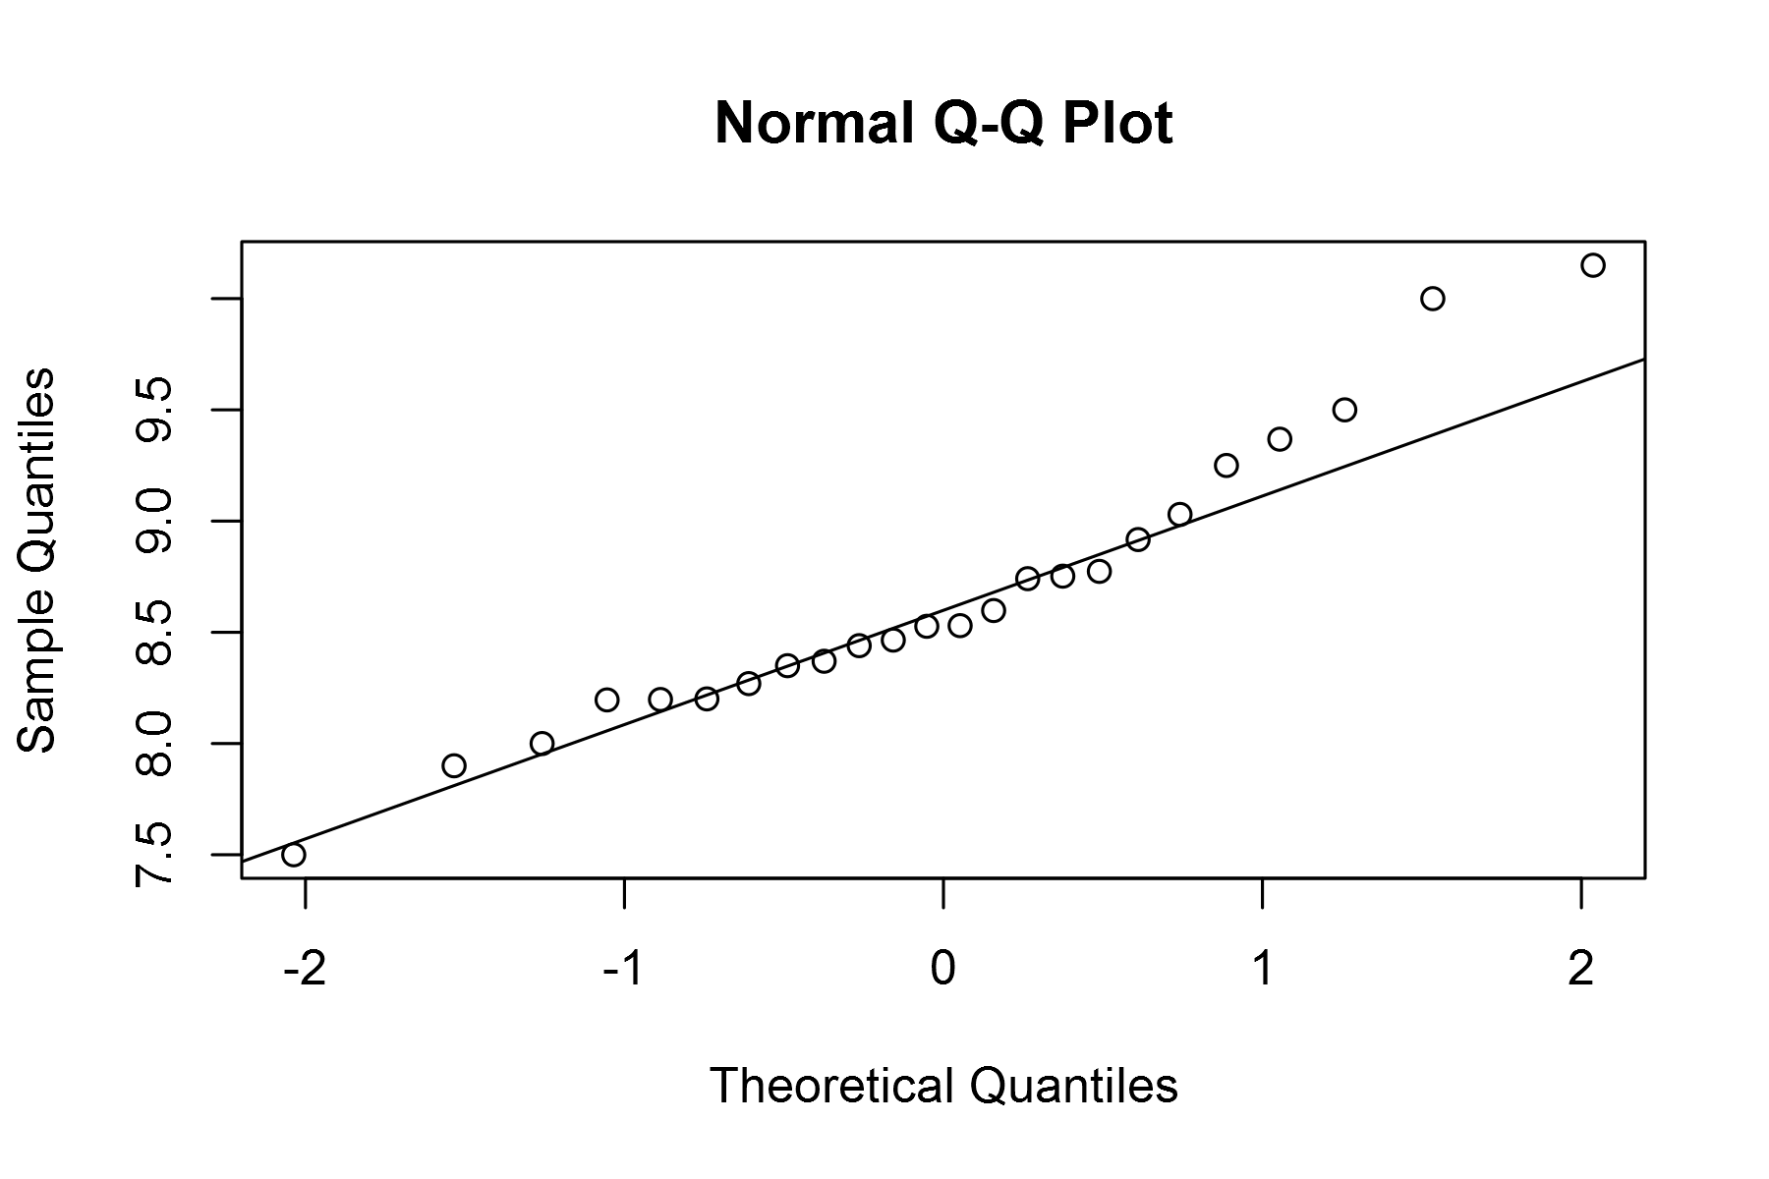

plot of chunk unnamed-chunk-4

## geom_smooth: method="auto" and size of largest group is <1000, so using loess. Use 'method = x' to change the smoothing method.

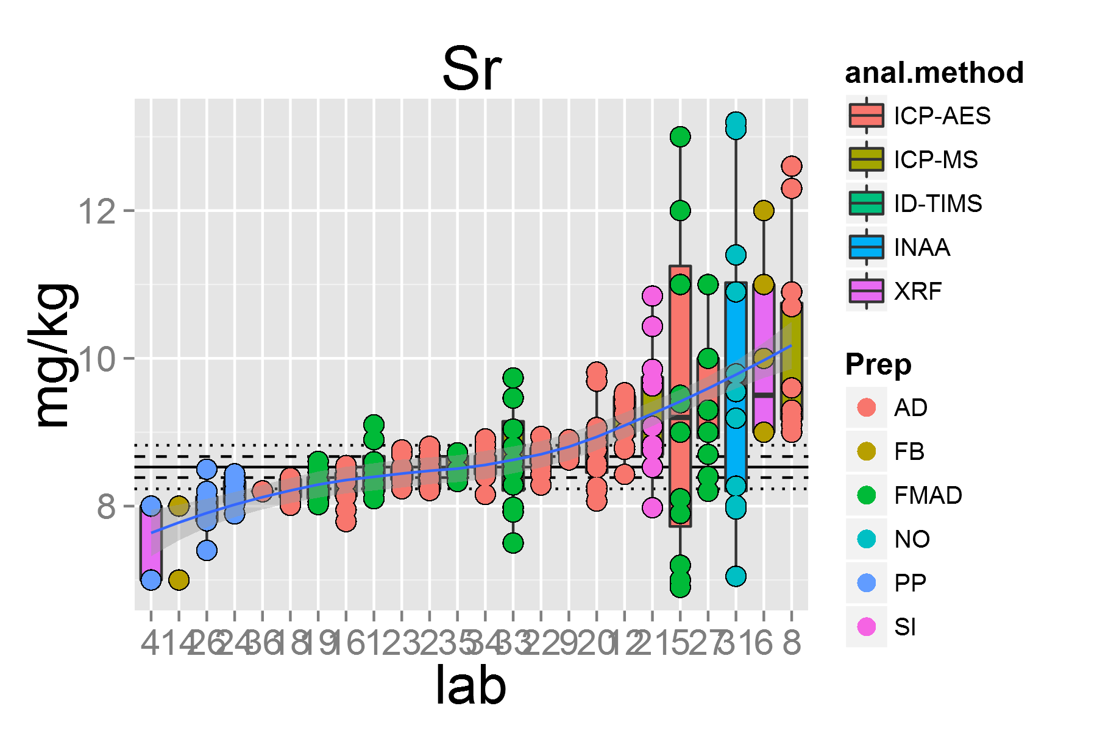

plot of chunk unnamed-chunk-4

## [1] "Ta.1"

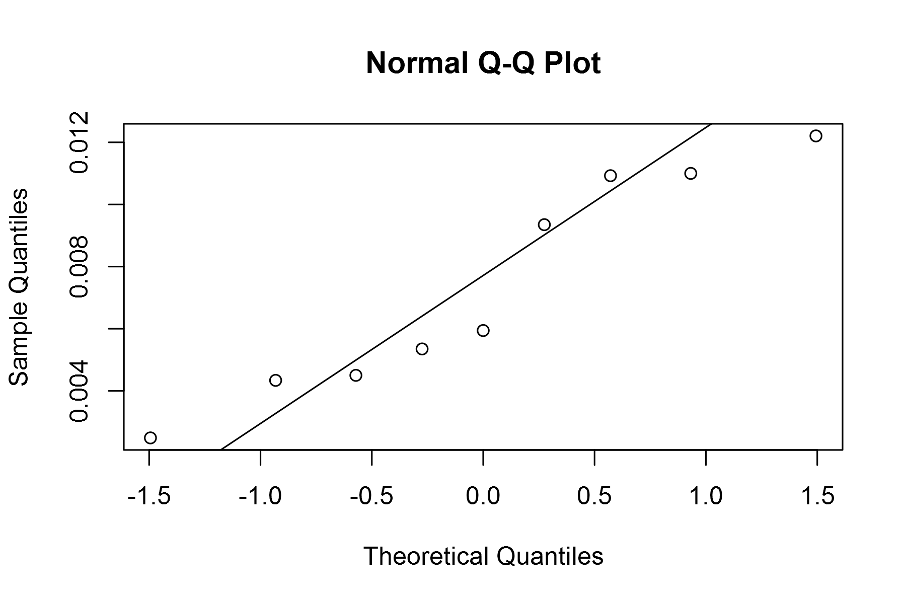

plot of chunk unnamed-chunk-4

## geom_smooth: method="auto" and size of largest group is <1000, so using loess. Use 'method = x' to change the smoothing method.

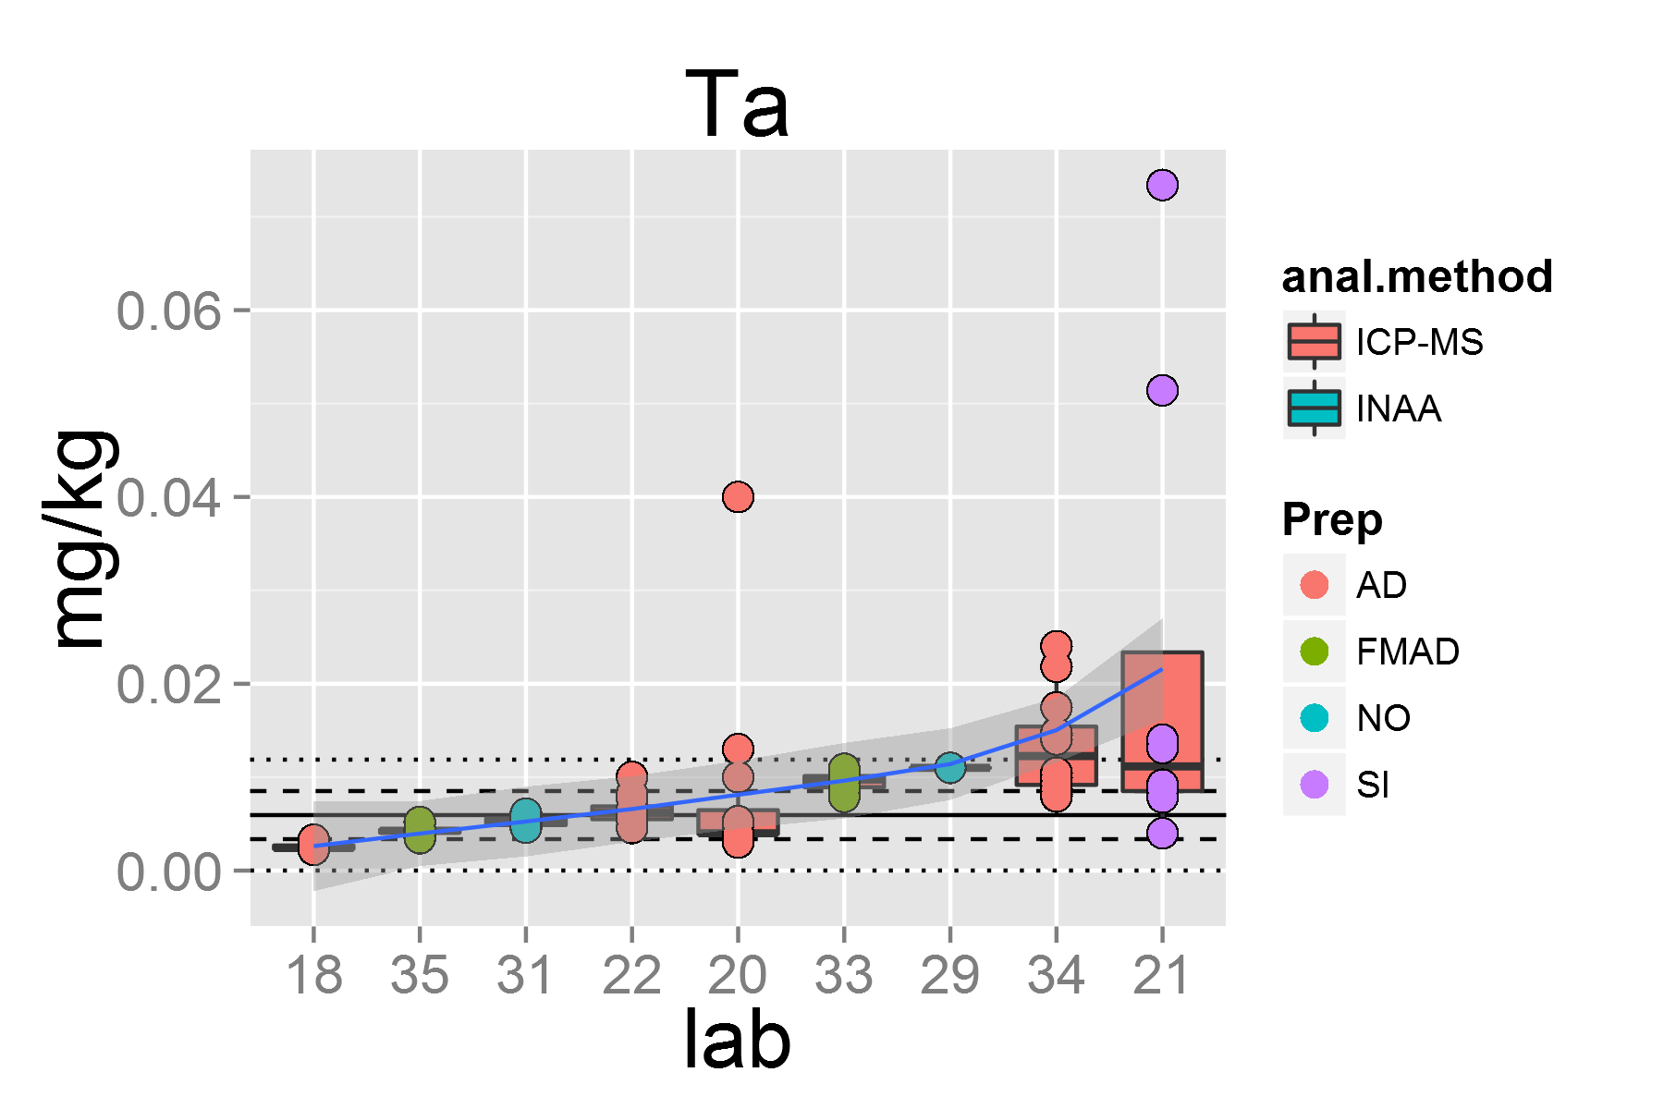

plot of chunk unnamed-chunk-4

## [1] "Tb.1"

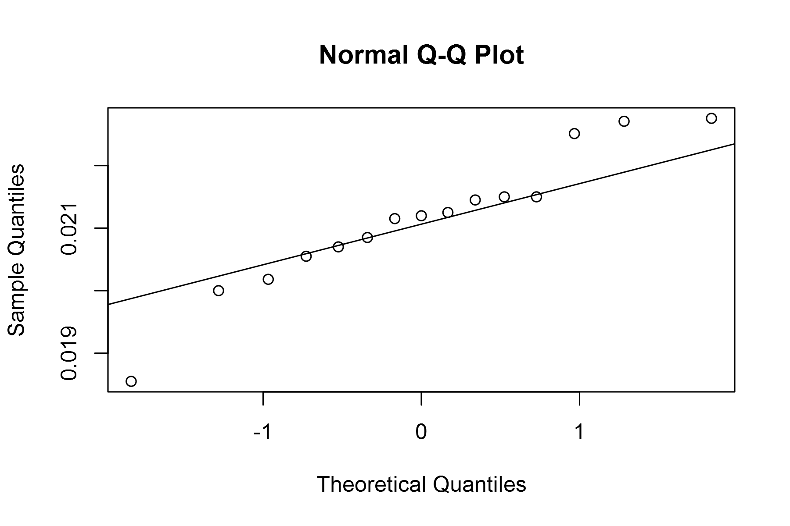

plot of chunk unnamed-chunk-4

## geom_smooth: method="auto" and size of largest group is <1000, so using loess. Use 'method = x' to change the smoothing method.

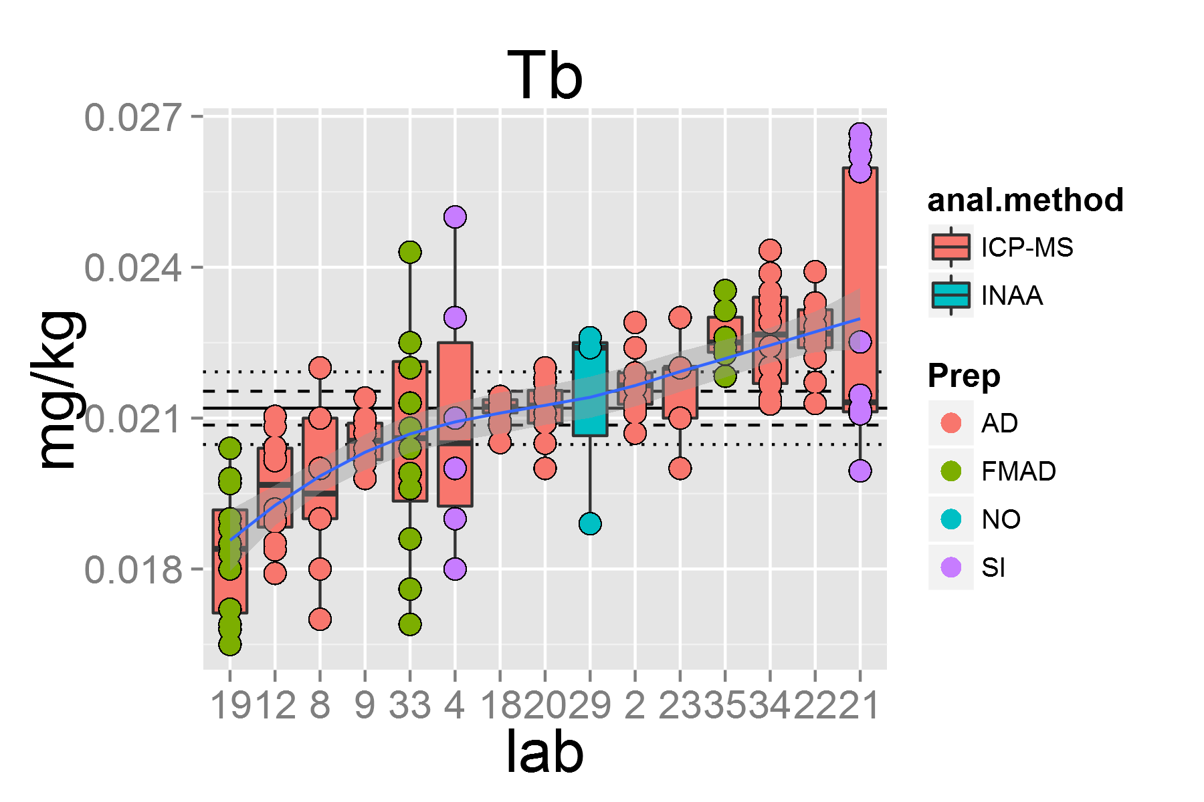

plot of chunk unnamed-chunk-4

## [1] "Th.1"

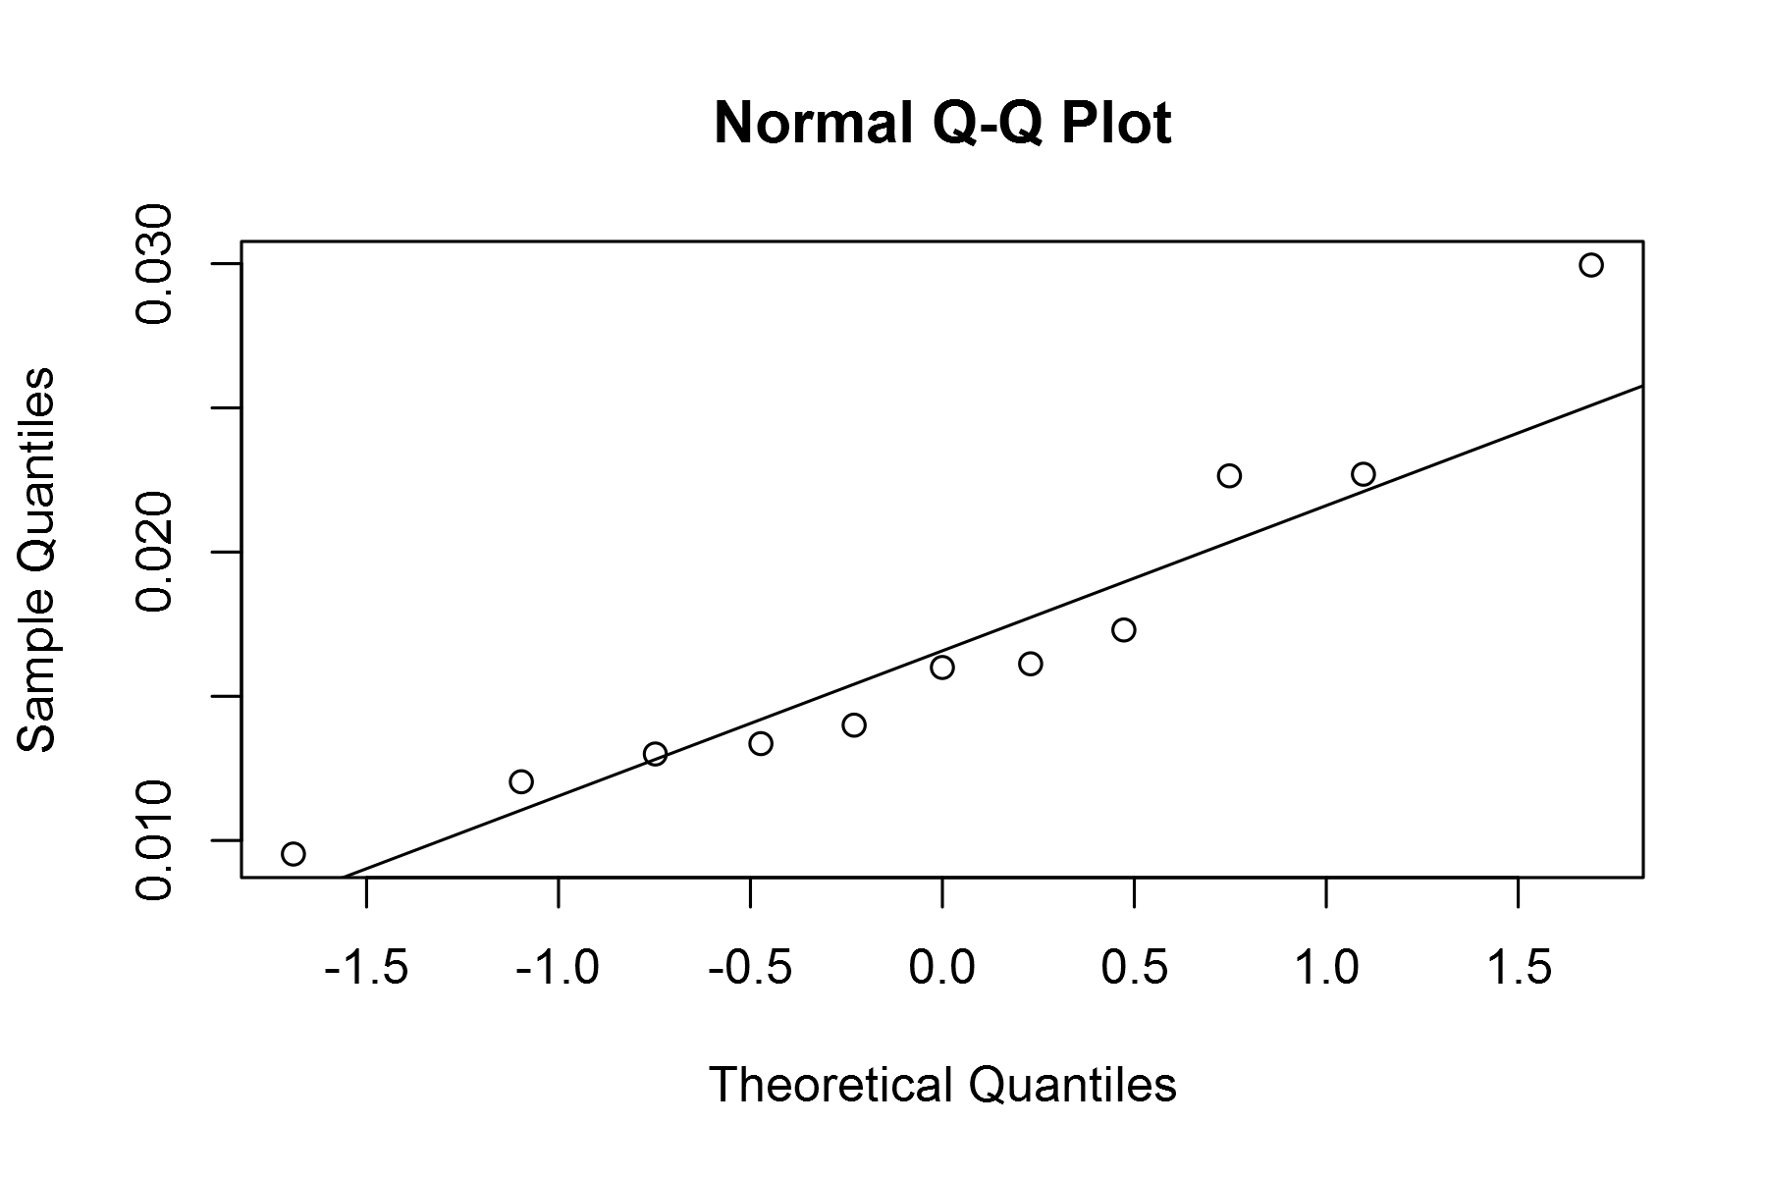

plot of chunk unnamed-chunk-4

## geom_smooth: method="auto" and size of largest group is <1000, so using loess. Use 'method = x' to change the smoothing method.

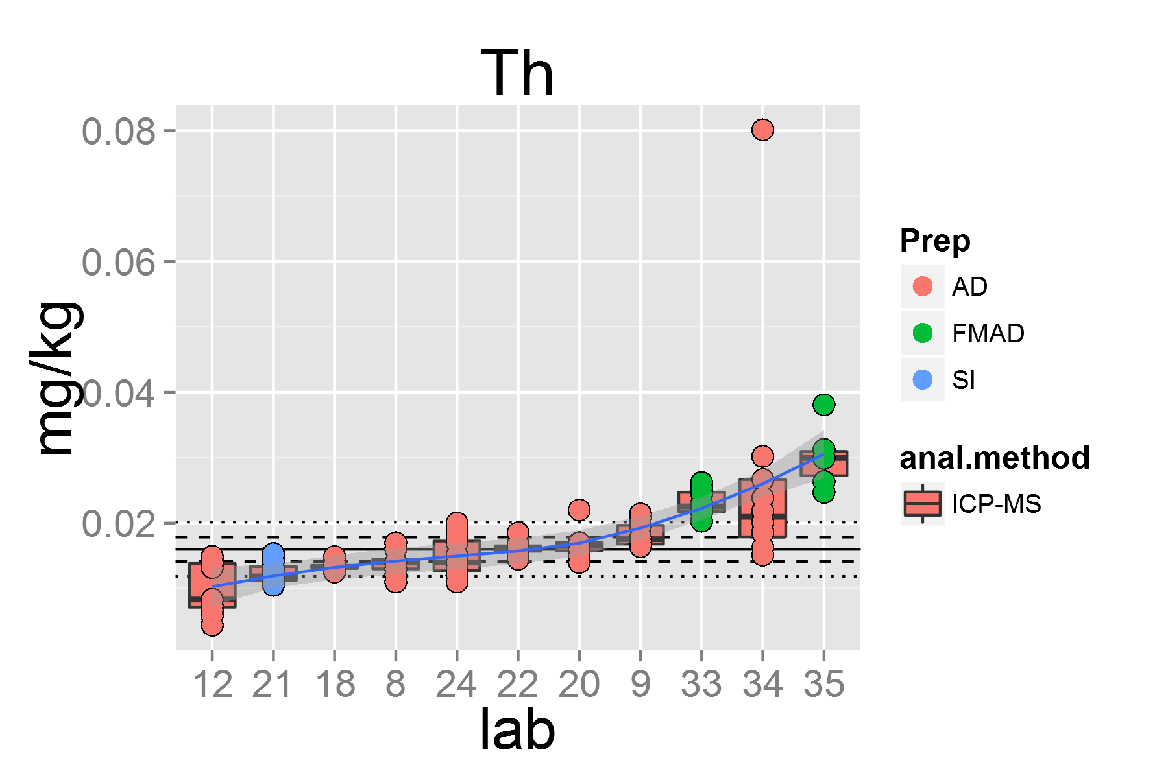

plot of chunk unnamed-chunk-4

## [1] "Tl.1"

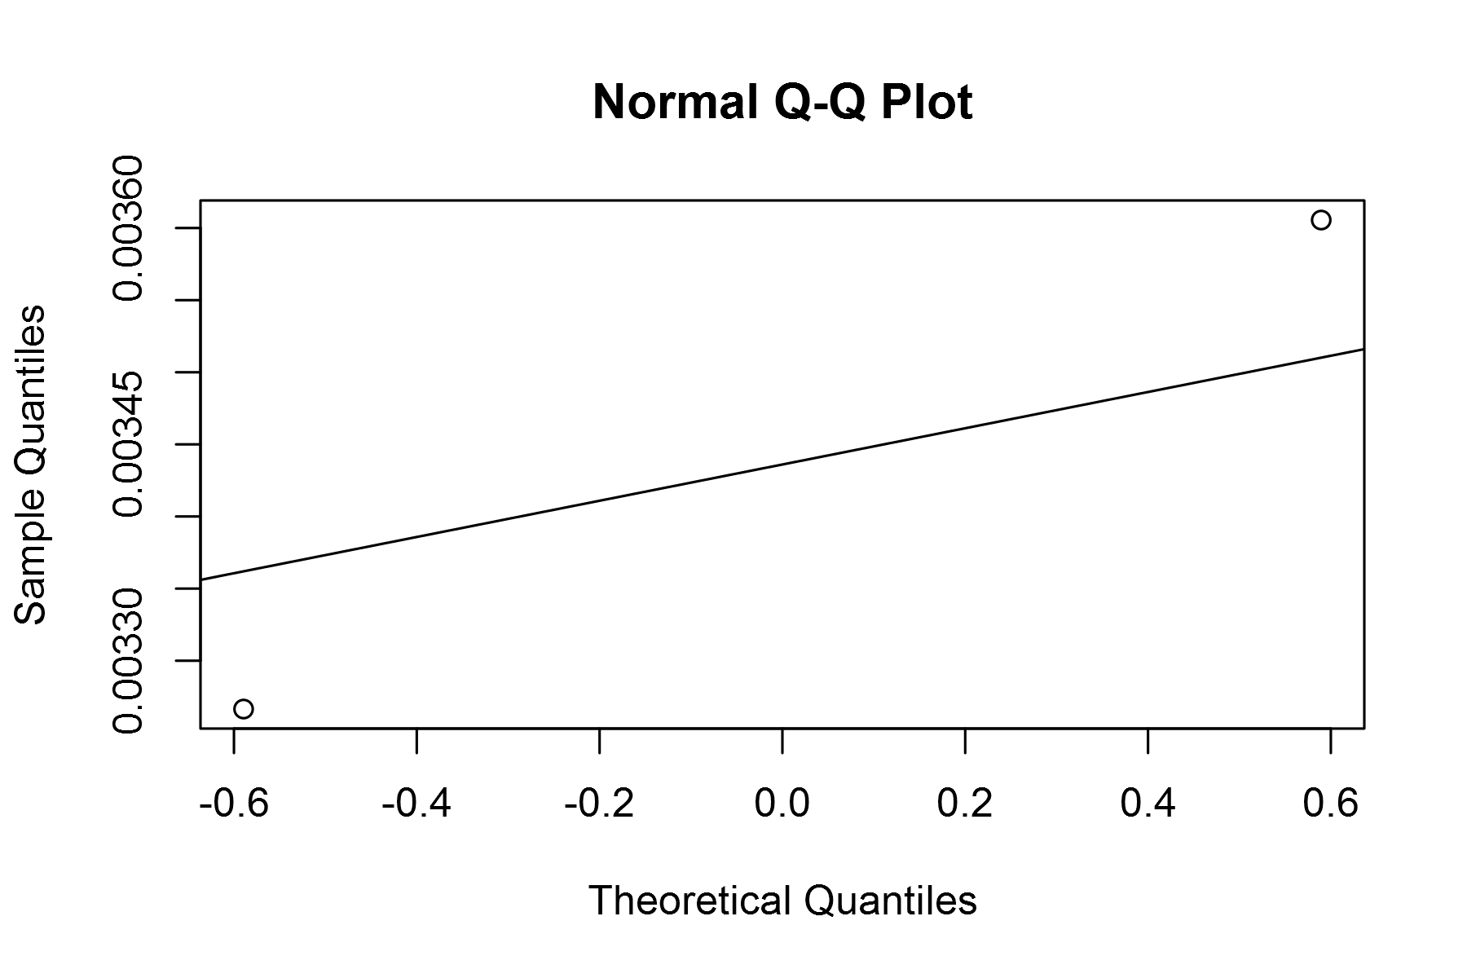

plot of chunk unnamed-chunk-4

## geom_smooth: method="auto" and size of largest group is <1000, so using loess. Use 'method = x' to change the smoothing method.

## Warning: pseudoinverse used at 0.995  
## Warning: neighborhood radius 1.005  
## Warning: reciprocal condition number 0  
## Warning: There are other near singularities as well. 1.01  
## Warning: pseudoinverse used at 0.995  
## Warning: neighborhood radius 1.005  
## Warning: reciprocal condition number 0  
## Warning: There are other near singularities as well. 1.01

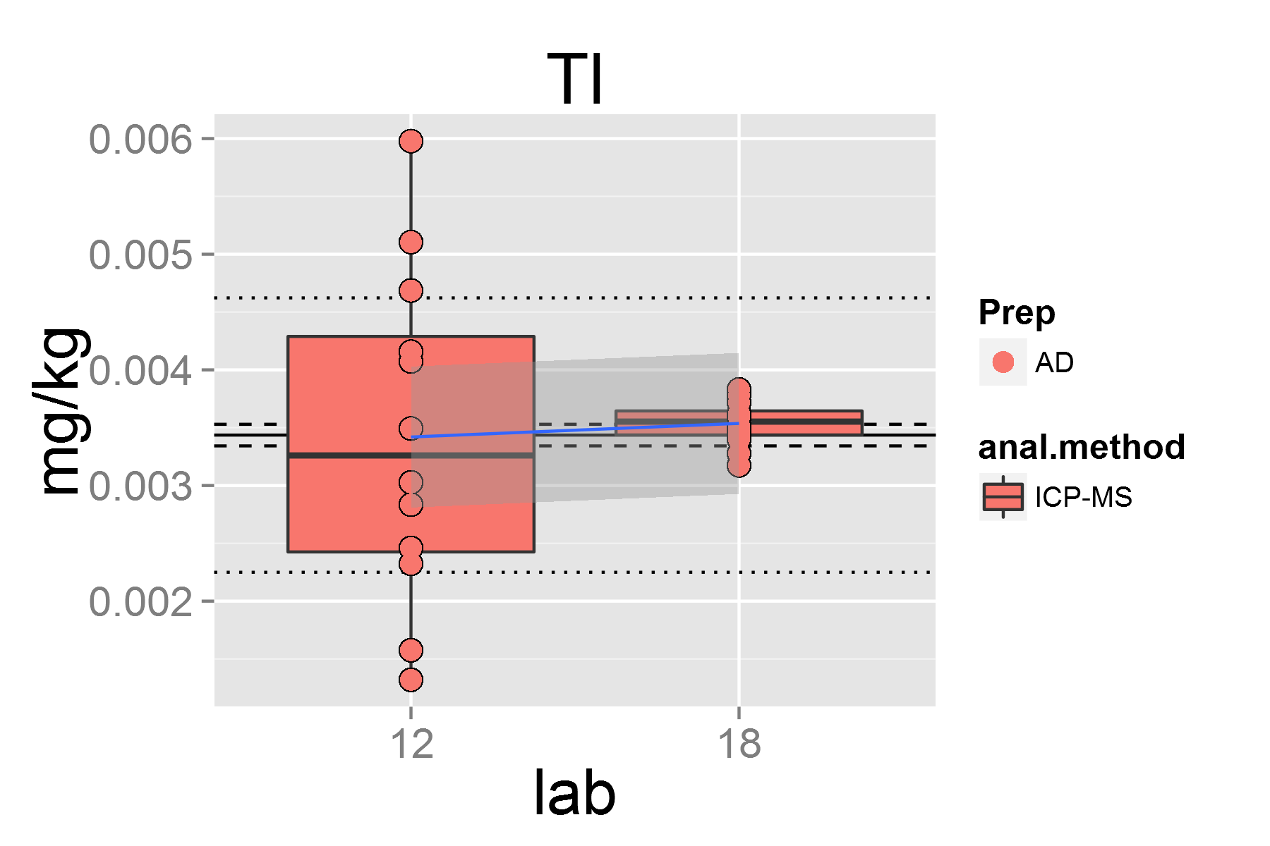

plot of chunk unnamed-chunk-4

## [1] "Tm.1"

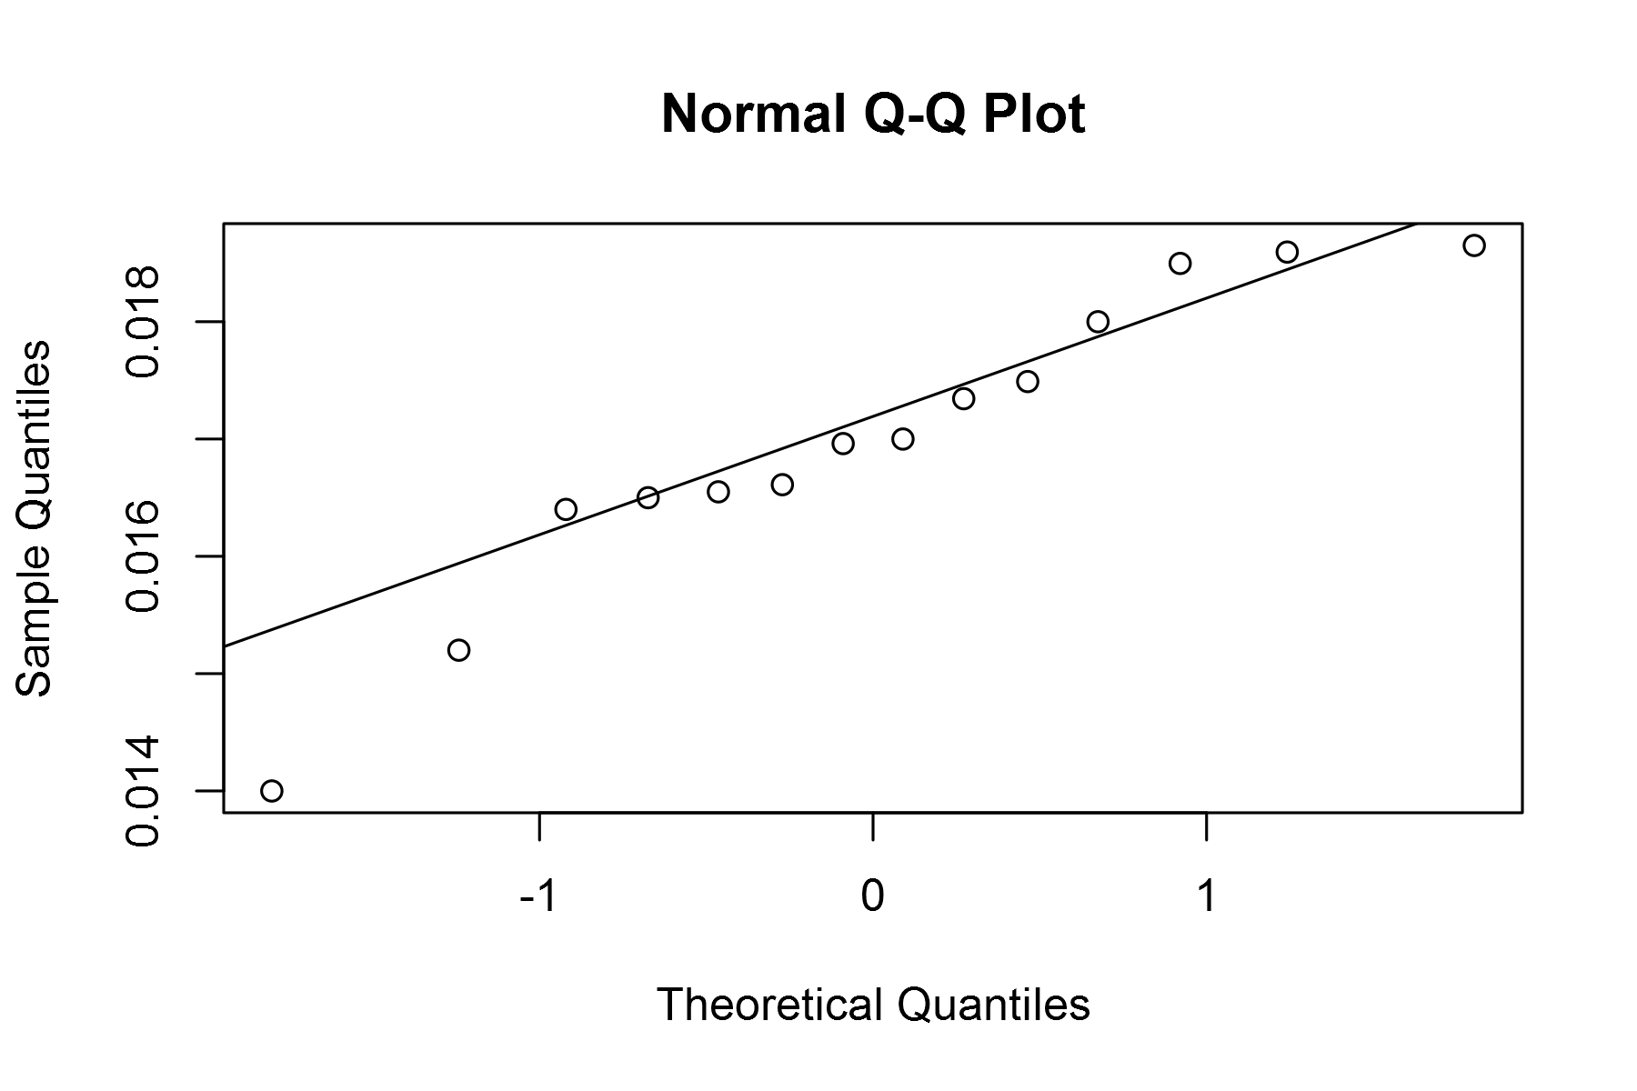

plot of chunk unnamed-chunk-4

## geom_smooth: method="auto" and size of largest group is <1000, so using loess. Use 'method = x' to change the smoothing method.

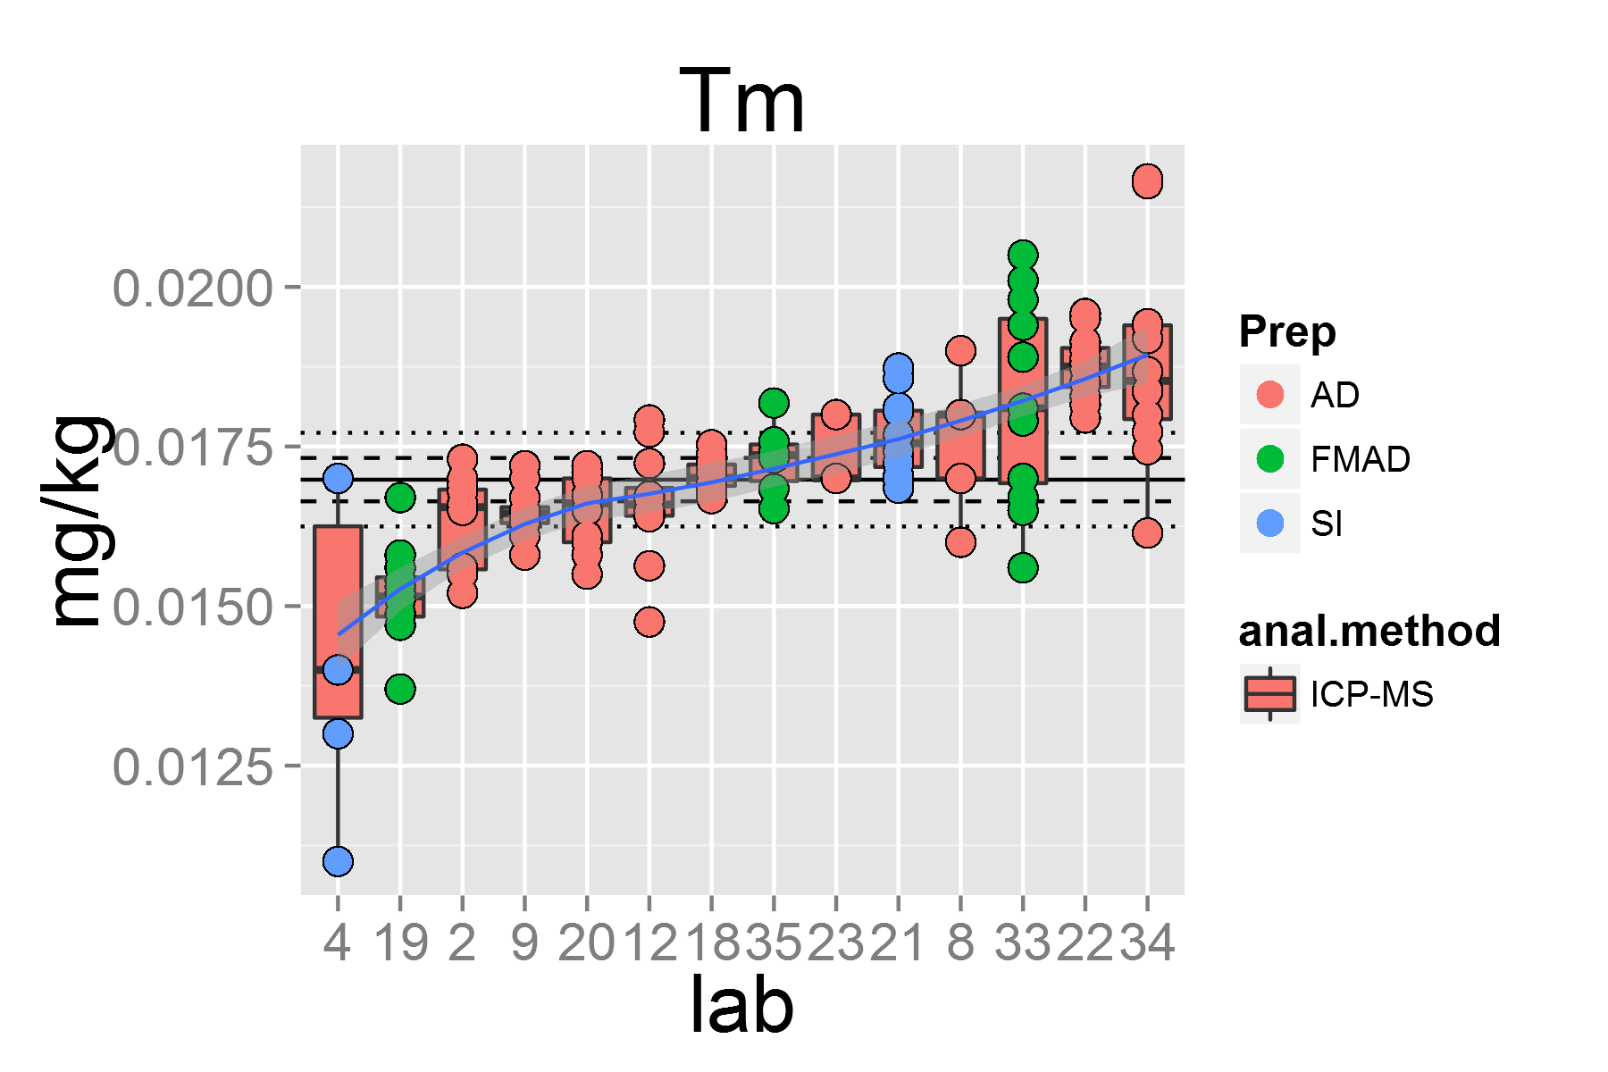

plot of chunk unnamed-chunk-4

## [1] "U.1"

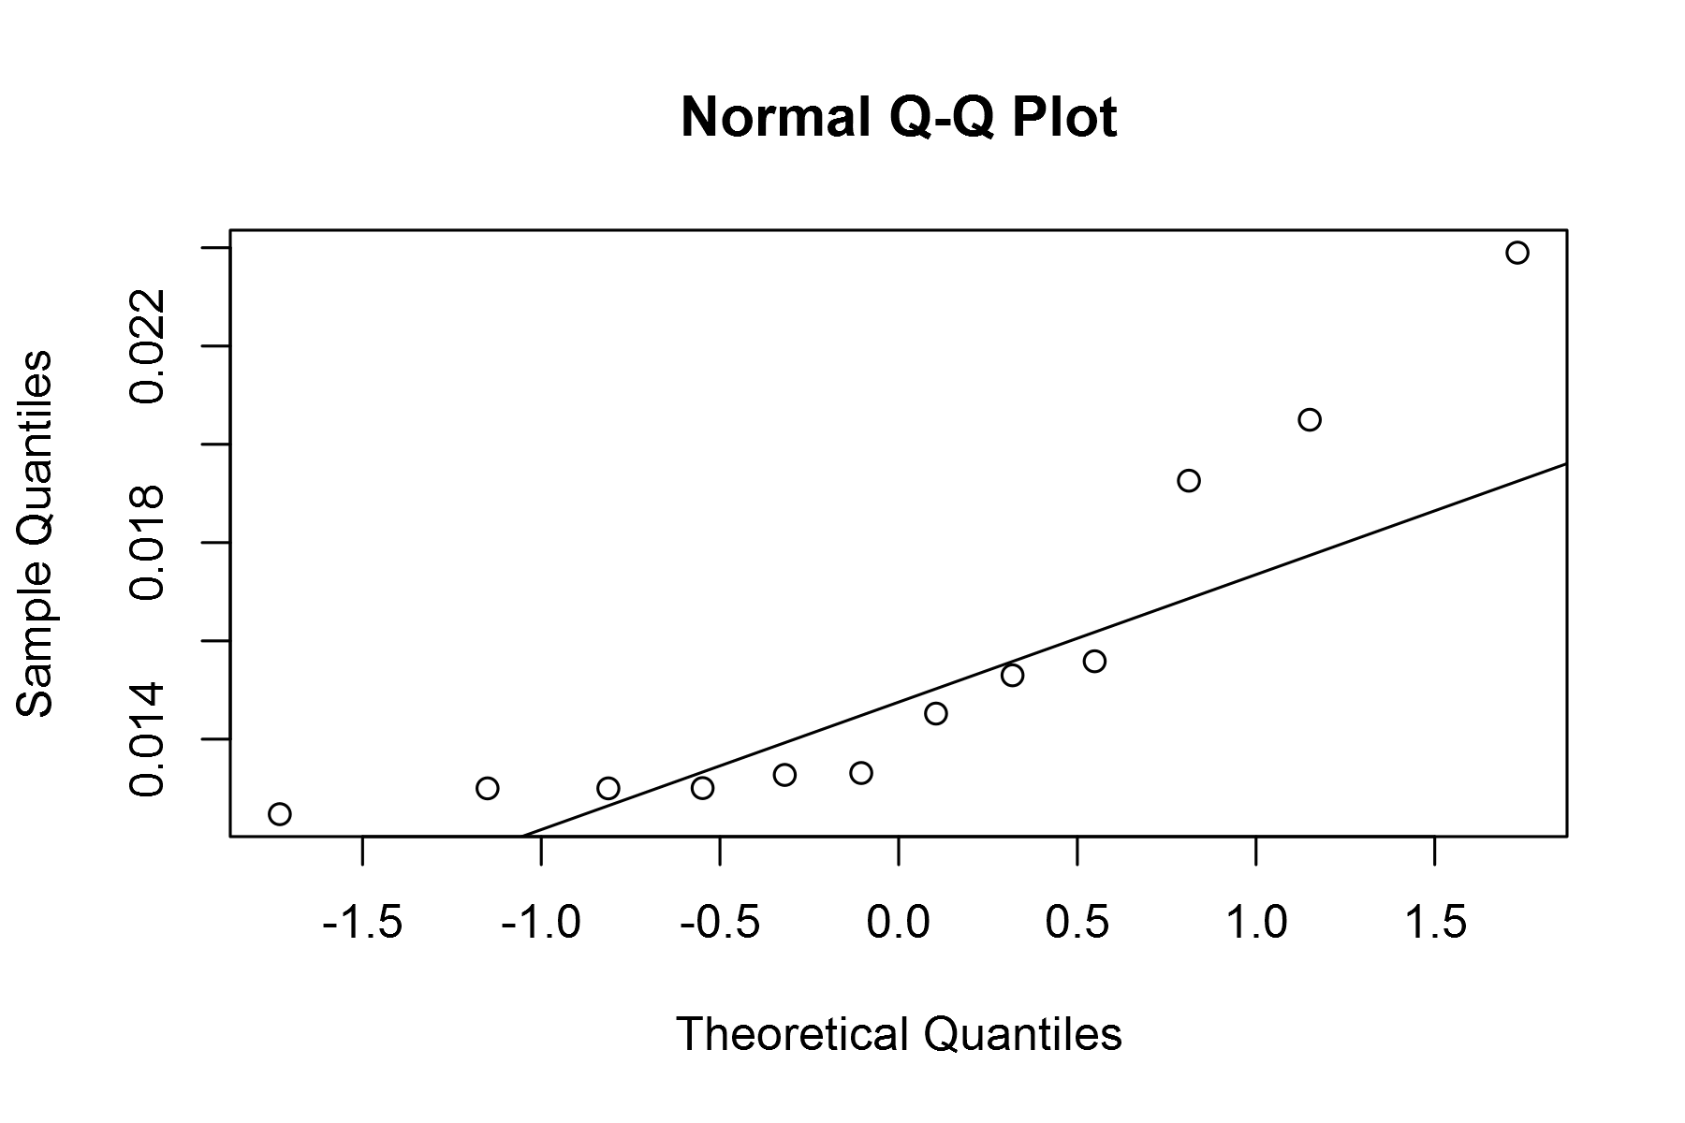

plot of chunk unnamed-chunk-4

## geom_smooth: method="auto" and size of largest group is <1000, so using loess. Use 'method = x' to change the smoothing method.

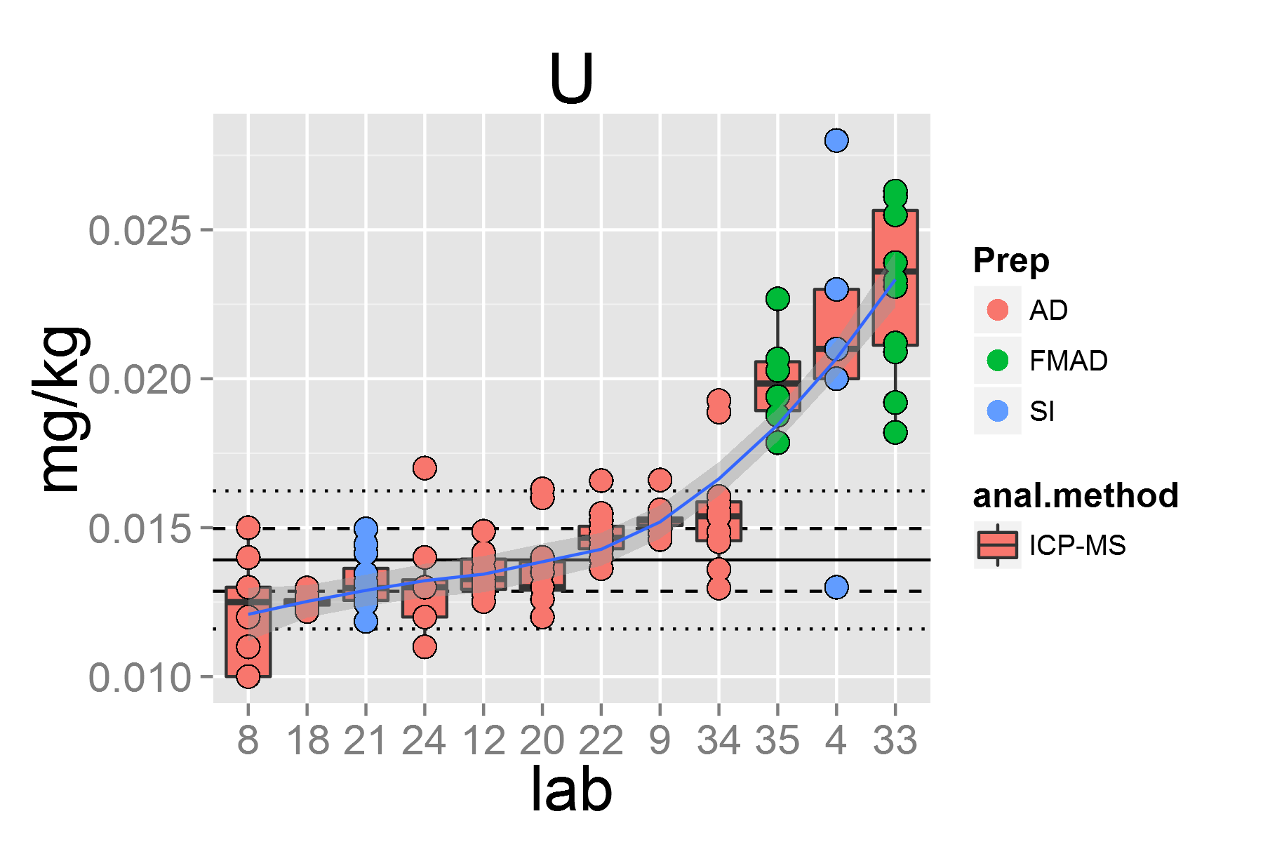

plot of chunk unnamed-chunk-4

## [1] "V.1"

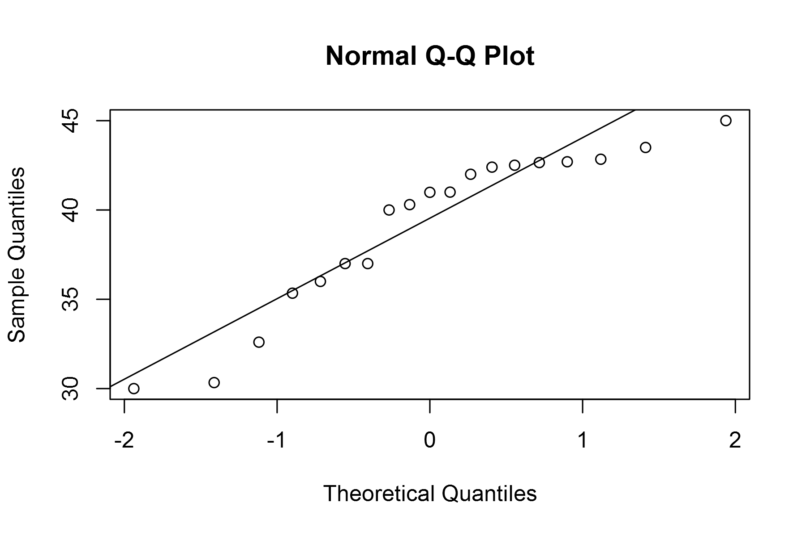

plot of chunk unnamed-chunk-4

## geom_smooth: method="auto" and size of largest group is <1000, so using loess. Use 'method = x' to change the smoothing method.

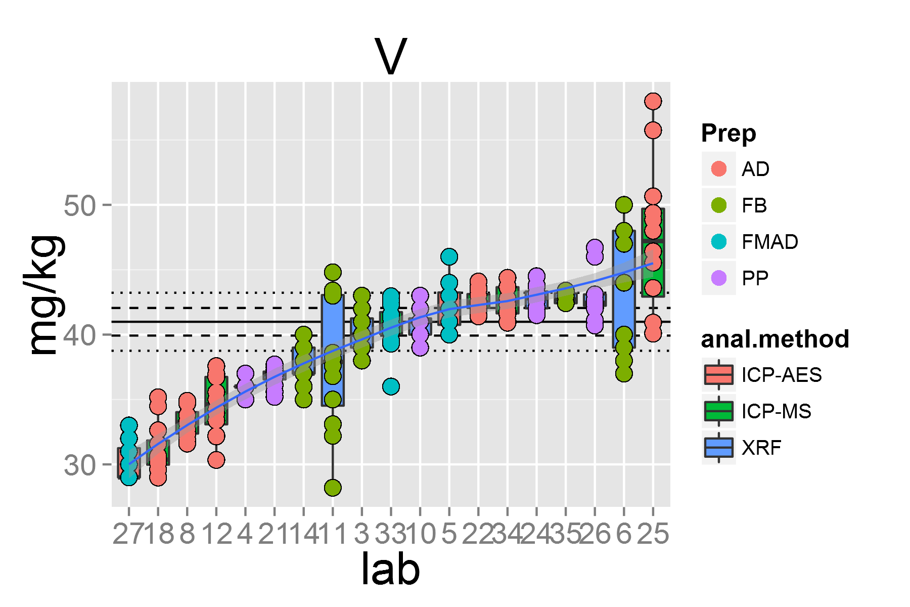

plot of chunk unnamed-chunk-4

## [1] "Y.1"

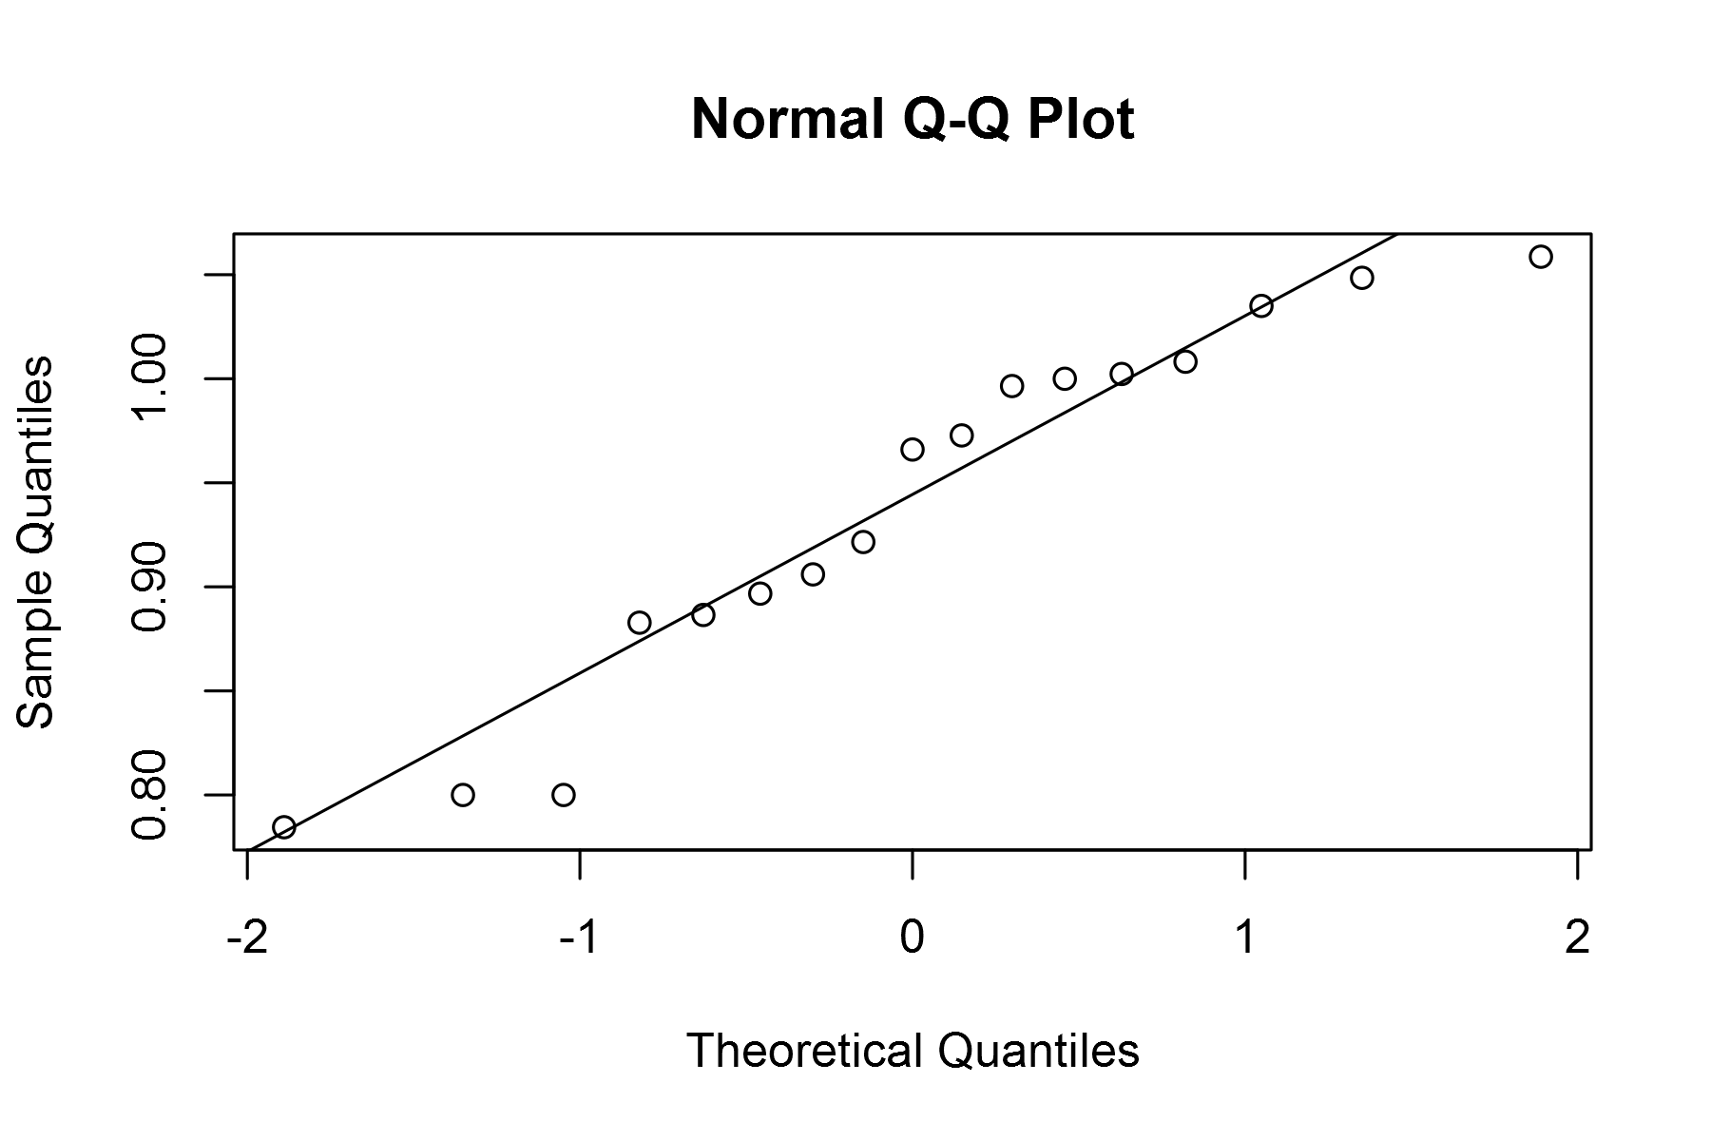

plot of chunk unnamed-chunk-4

## geom_smooth: method="auto" and size of largest group is <1000, so using loess. Use 'method = x' to change the smoothing method.

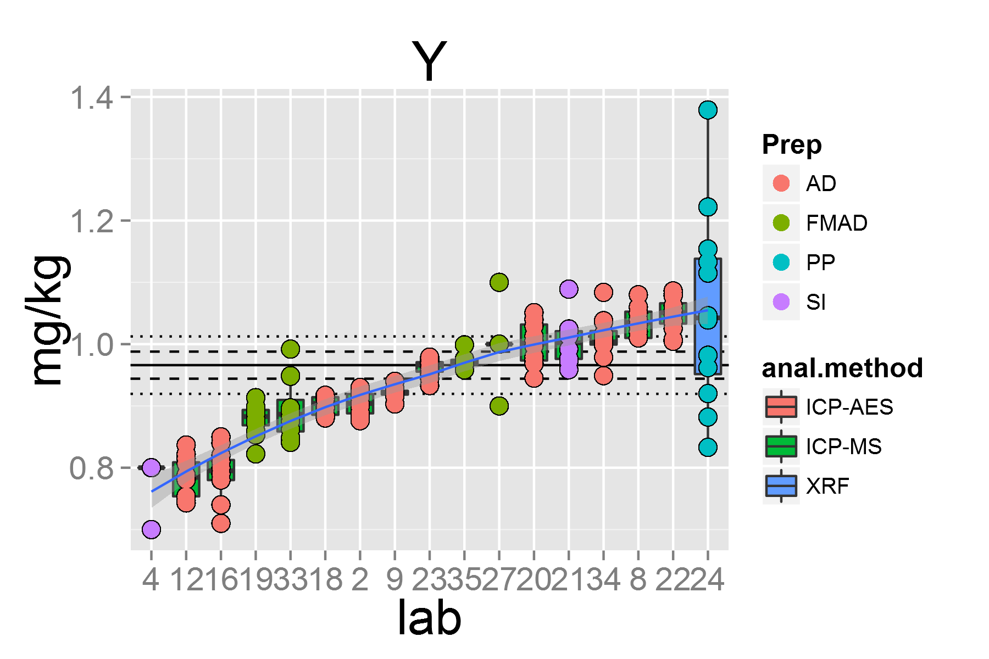

plot of chunk unnamed-chunk-4

## [1] "Yb.1"

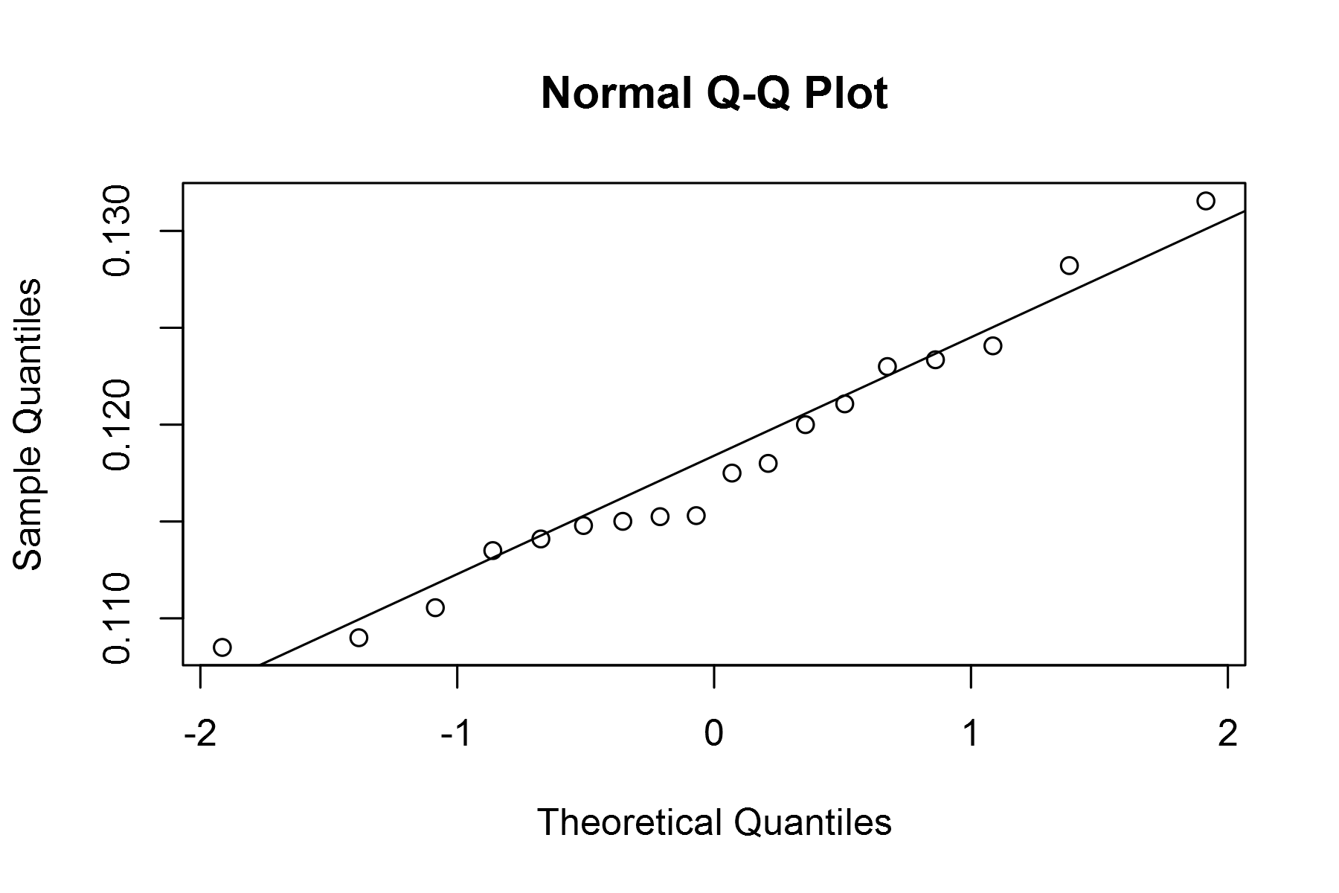

plot of chunk unnamed-chunk-4

## geom_smooth: method="auto" and size of largest group is <1000, so using loess. Use 'method = x' to change the smoothing method.

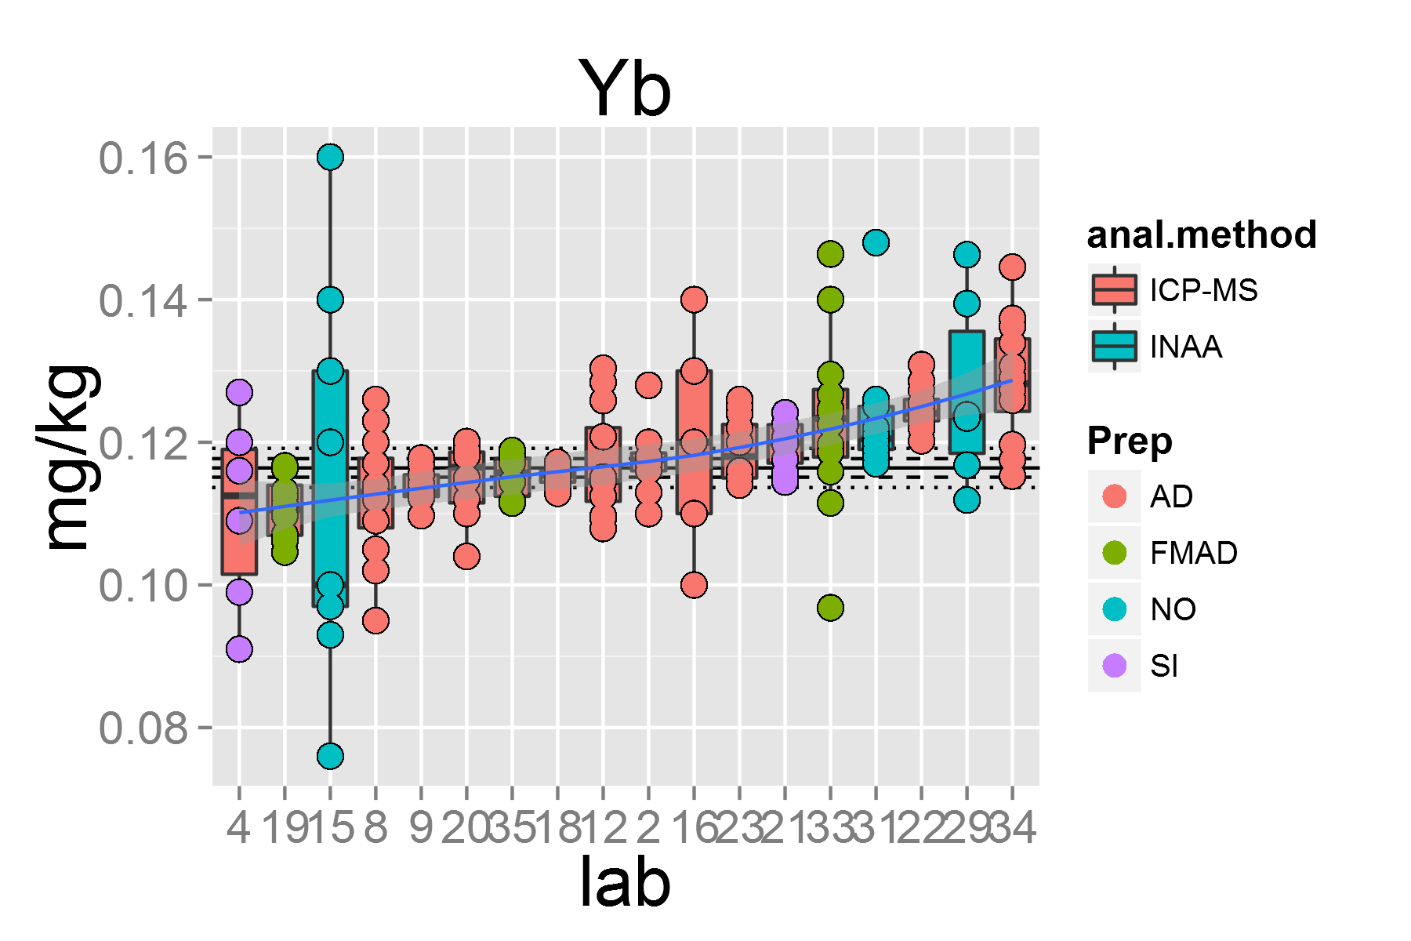

plot of chunk unnamed-chunk-4

## [1] "Zn.1"

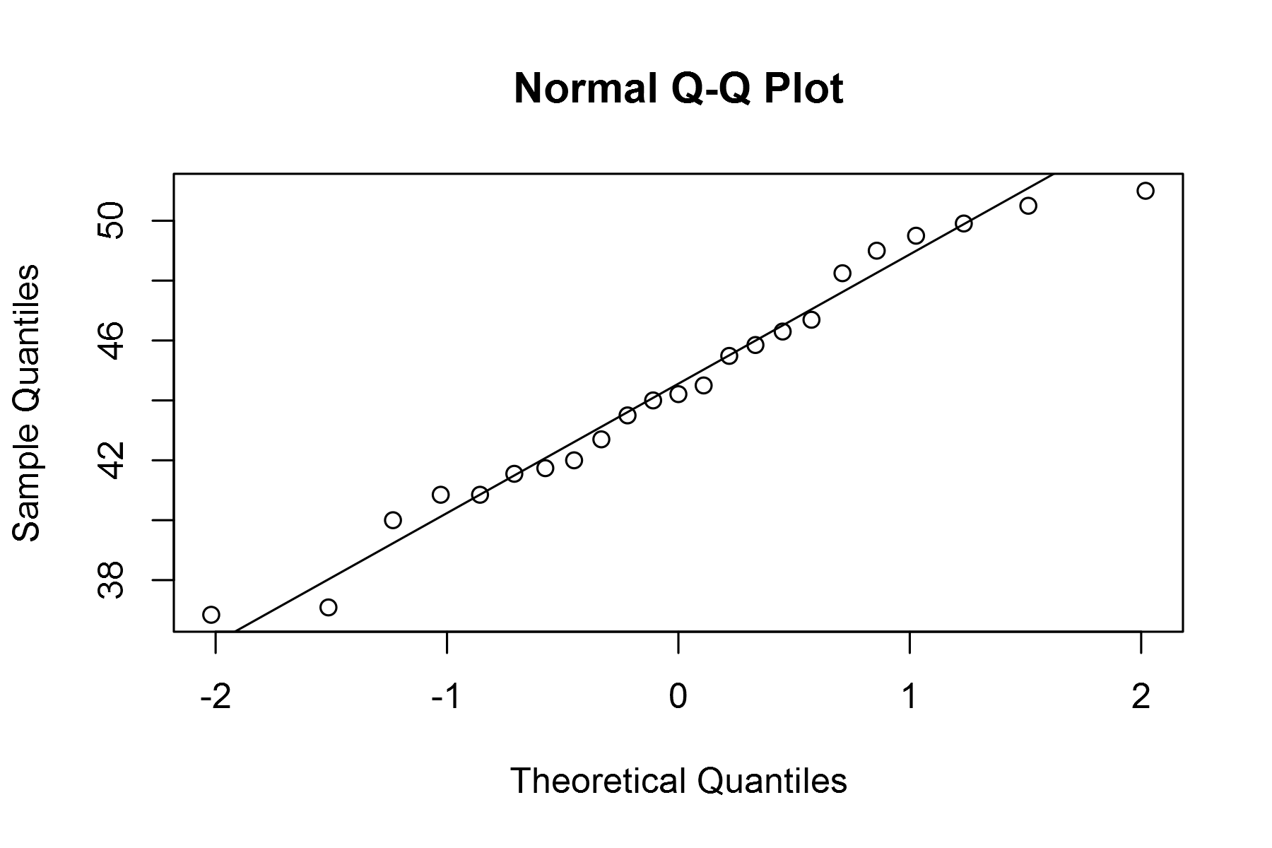

plot of chunk unnamed-chunk-4

## geom_smooth: method="auto" and size of largest group is <1000, so using loess. Use 'method = x' to change the smoothing method.

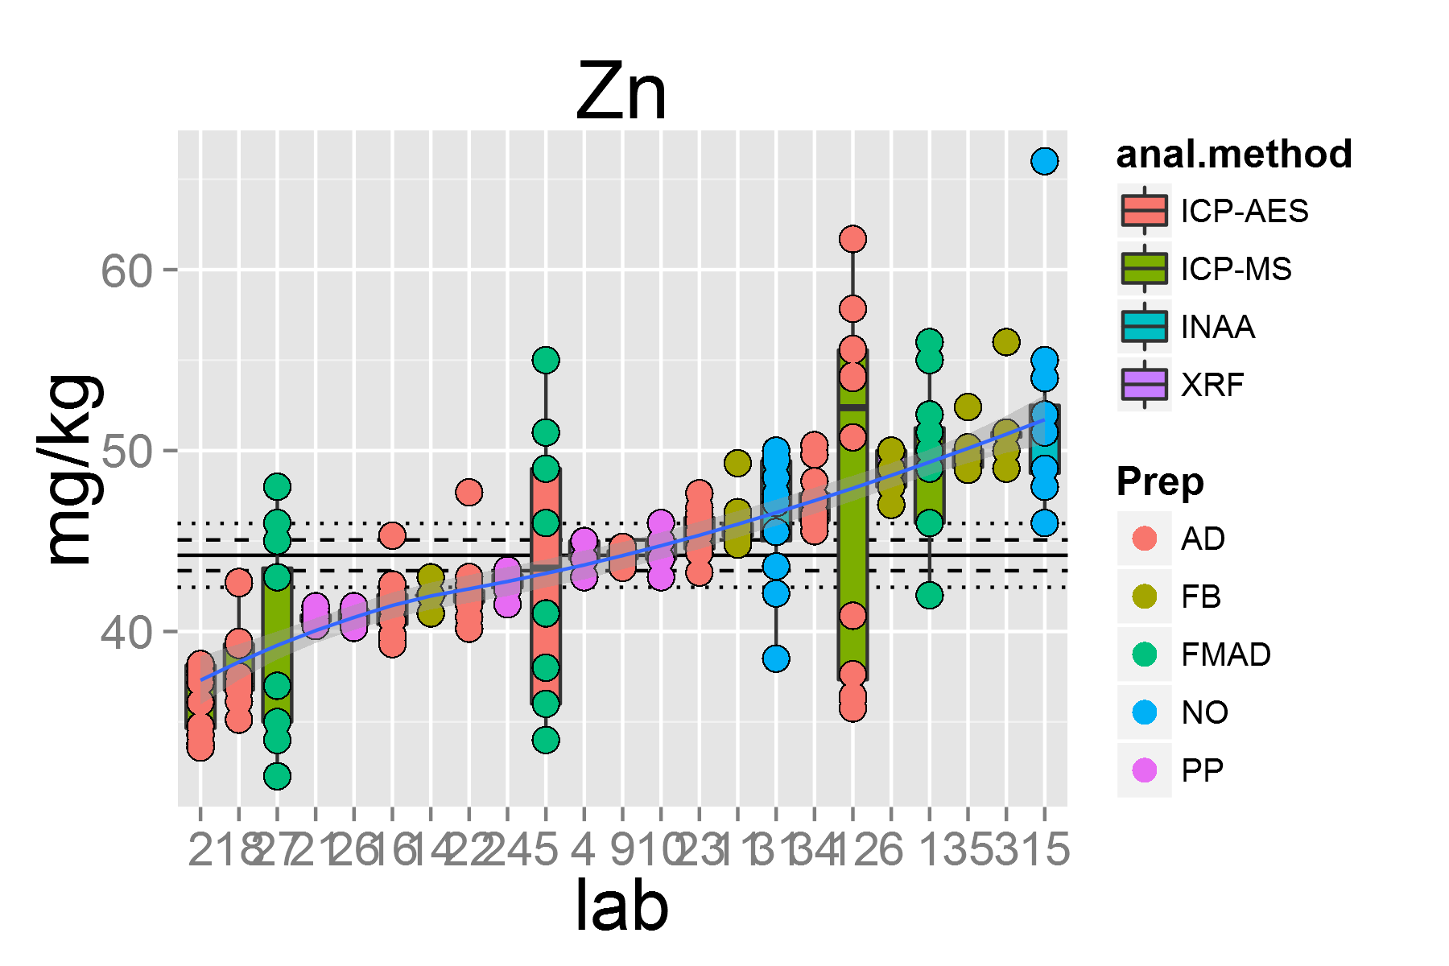

plot of chunk unnamed-chunk-4

## [1] "Zr.1"

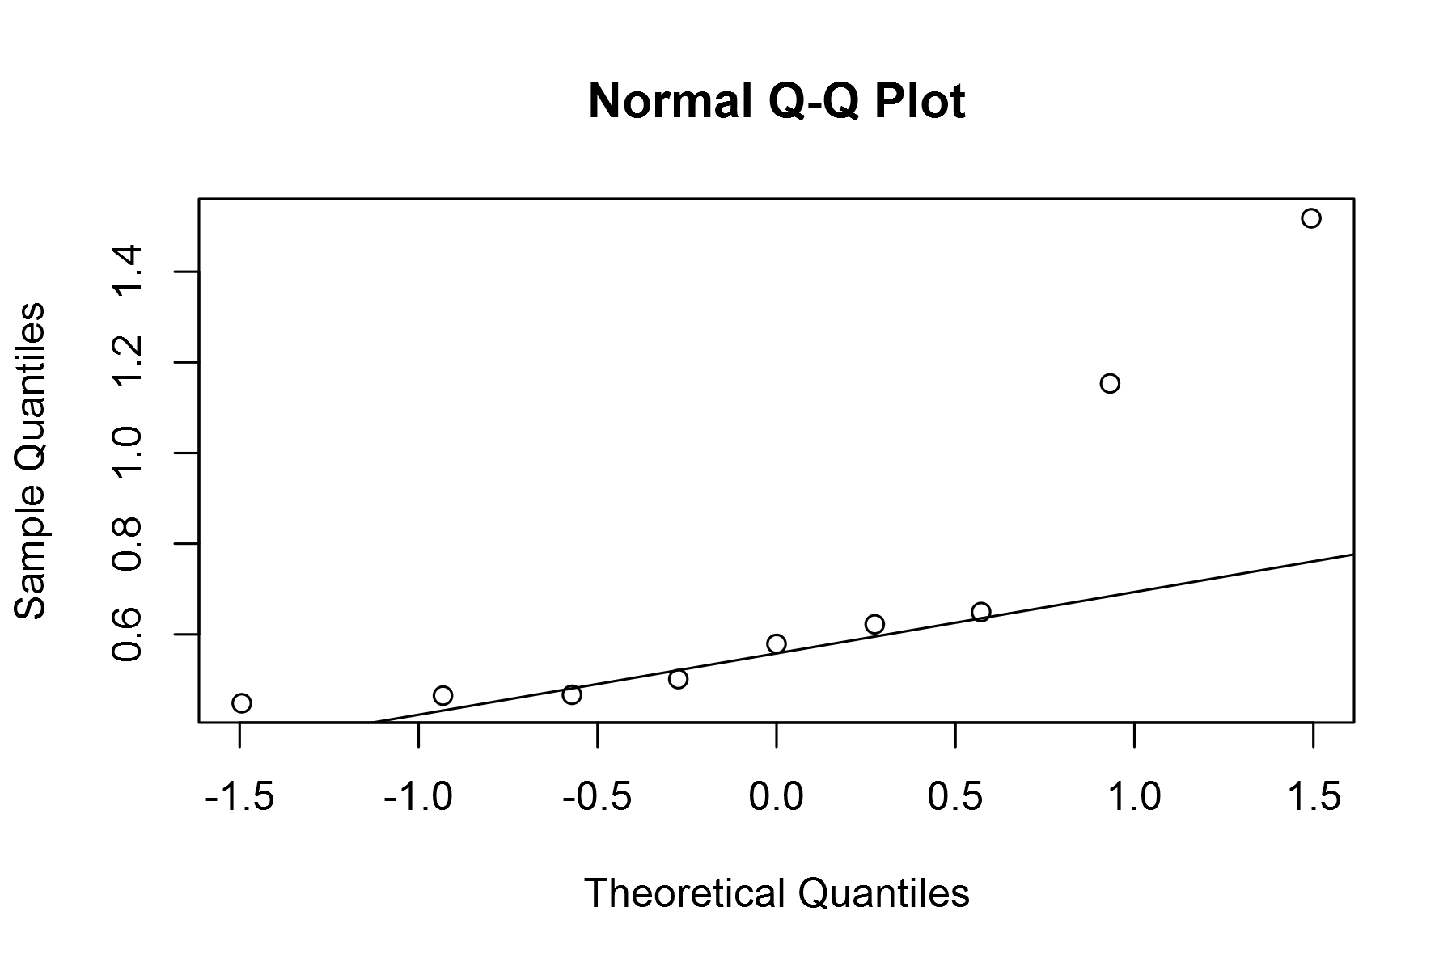

plot of chunk unnamed-chunk-4

## geom_smooth: method="auto" and size of largest group is <1000, so using loess. Use 'method = x' to change the smoothing method.

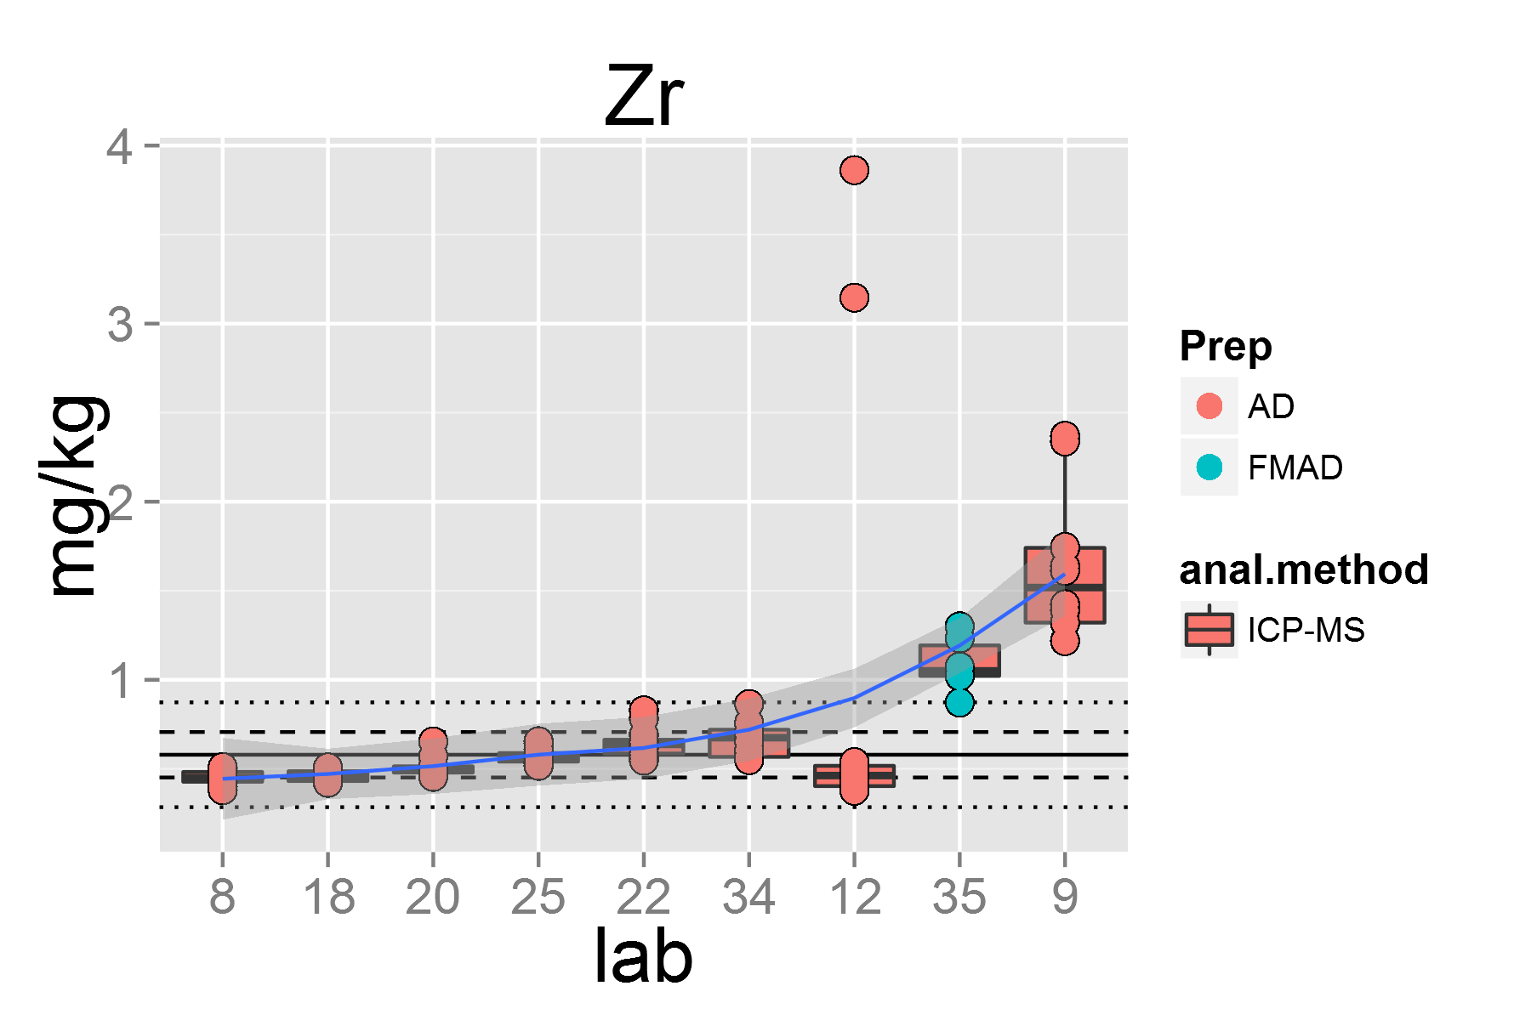

plot of chunk unnamed-chunk-4

df1 <- read.table("~/GitHub/GOMcertification/df1.txt", header=T, quote="\"")  
final <- ddply(df1, c("date","RM","measurand","based.on", "unit"), numcolwise(meanGOM))  
write.csv(final,"MUHall.csv")

#### final

# kable(final, format = "markdown", padding=0, digits=c(0,0,0,0,3,3,3,3,3,3,3,3,4,4,4,0,0,3,3,0))  
#library(xtable)  
#xt <- xtable(final, digits=c(0,0,0,0,0,3,3,3,3,3,3,3,3,3,3,2,0,0,3,3,0))  
#print(xt, type="html")  
#library(Gmisc)  
# htmlTable(final)

certified.values <- data.frame(final$date, final$RM, final$measurand, final$t.value, final$labs.remaining, final$property.value, final$U, final$unit)  
names(certified.values) <- c("date", "RM", "measurand", "t.value", "n", "PV", "U", "unit")  
write.table(certified.values, "CV1.txt", row.names=FALSE)  
CV2 <- subset.data.frame(certified.values, n >= 10) # CV based on IAG protocol with n >= 10  
CV3 <- subset.data.frame(certified.values, n < 10) # Information value based on IAG protocol with n < 10  
write.table(CV2, "CV2.txt", row.names=FALSE) # just CV  
write.table(CV3, "CV2.txt", row.names=FALSE, append=TRUE, col.names=FALSE) #CV and IV  
CV <- read.table("~/GitHub/GOMcertification/CV2.txt", header=TRUE, quote="\"")  
#xtCV <- xtable(CV, digits=c(0,0,0,0,2,0,4,4,0))  
#print(xtCV, type="html")  
kable(CV, digits=c(0,0,0,2,2,4,4,0), padding=1)

|  |  |  |  |  |  |  |  |
| --- | --- | --- | --- | --- | --- | --- | --- |
| date | RM | measurand | t.value | n | PV | U | unit |
| 2014-08-03 | MUH | Al2O3 | 2.09 | 20 | 1.3300 | 0.0188 | g/100g |
| 2014-08-03 | MUH | Ba | 2.12 | 17 | 4.9050 | 0.2870 | mg/kg |
| 2014-08-03 | MUH | CaO | 2.09 | 21 | 1.2150 | 0.0104 | g/100g |
| 2014-08-03 | MUH | Ce | 2.16 | 14 | 0.1985 | 0.0166 | mg/kg |
| 2014-08-03 | MUH | Co | 2.08 | 22 | 106.9000 | 2.4500 | mg/kg |
| 2014-08-03 | MUH | Cr | 2.09 | 21 | 2706.0000 | 57.7000 | mg/kg |
| 2014-08-03 | MUH | Cs | 2.18 | 13 | 0.0976 | 0.0028 | mg/kg |
| 2014-08-03 | MUH | Cu | 2.12 | 17 | 18.8900 | 0.7020 | mg/kg |
| 2014-08-03 | MUH | Dy | 2.12 | 17 | 0.1542 | 0.0066 | mg/kg |
| 2014-08-03 | MUH | Er | 2.12 | 17 | 0.1090 | 0.0022 | mg/kg |
| 2014-08-03 | MUH | Eu | 2.14 | 15 | 0.0266 | 0.0010 | mg/kg |
| 2014-08-03 | MUH | Fe2O3T | 2.07 | 23 | 8.5850 | 0.0534 | g/100g |
| 2014-08-03 | MUH | Ga | 2.23 | 11 | 1.4000 | 0.0949 | mg/kg |
| 2014-08-03 | MUH | Gd | 2.20 | 12 | 0.1104 | 0.0044 | mg/kg |
| 2014-08-03 | MUH | Hf | 2.18 | 13 | 0.0374 | 0.0126 | mg/kg |
| 2014-08-03 | MUH | Ho | 2.18 | 13 | 0.0352 | 0.0015 | mg/kg |
| 2014-08-03 | MUH | K2O | 2.16 | 14 | 0.0109 | 0.0028 | g/100g |
| 2014-08-03 | MUH | La | 2.14 | 15 | 0.1344 | 0.0062 | g/100g |
| 2014-08-03 | MUH | LOI | 2.08 | 22 | 9.3350 | 0.0880 | g/100g |
| 2014-08-03 | MUH | Lu | 2.13 | 16 | 0.0190 | 0.0009 | mg/kg |
| 2014-08-03 | MUH | MgO | 2.07 | 23 | 38.2800 | 0.1630 | g/100g |
| 2014-08-03 | MUH | MnO | 2.09 | 21 | 0.1176 | 0.0014 | g/100g |
| 2014-08-03 | MUH | Na2O | 2.11 | 18 | 0.1000 | 0.0099 | g/100g |
| 2014-08-03 | MUH | Nd | 2.14 | 15 | 0.1745 | 0.0072 | mg/kg |
| 2014-08-03 | MUH | Ni | 2.09 | 21 | 2102.0000 | 26.2000 | mg/kg |
| 2014-08-03 | MUH | P2O5 | 2.18 | 13 | 0.0081 | 0.0022 | g/100g |
| 2014-08-03 | MUH | Pr | 2.18 | 13 | 0.0347 | 0.0019 | g/100g |
| 2014-08-03 | MUH | Rb | 2.16 | 14 | 0.2680 | 0.0291 | mg/kg |
| 2014-08-03 | MUH | Sc | 2.10 | 19 | 9.2090 | 0.3670 | mg/kg |
| 2014-08-03 | MUH | SiO2 | 2.08 | 22 | 40.3500 | 0.1700 | g/100g |
| 2014-08-03 | MUH | Sm | 2.12 | 17 | 0.0674 | 0.0021 | mg/kg |
| 2014-08-03 | MUH | Sr | 2.07 | 24 | 8.5290 | 0.2950 | mg/kg |
| 2014-08-03 | MUH | Tb | 2.14 | 15 | 0.0212 | 0.0007 | mg/kg |
| 2014-08-03 | MUH | Th | 2.23 | 11 | 0.0160 | 0.0042 | mg/kg |
| 2014-08-03 | MUH | TiO2 | 2.07 | 24 | 0.0346 | 0.0019 | g/100g |
| 2014-08-03 | MUH | Tm | 2.16 | 14 | 0.0170 | 0.0007 | mg/kg |
| 2014-08-03 | MUH | U | 2.20 | 12 | 0.0139 | 0.0023 | mg/kg |
| 2014-08-03 | MUH | V | 2.10 | 19 | 40.9900 | 2.2400 | mg/kg |
| 2014-08-03 | MUH | Y | 2.12 | 17 | 0.9660 | 0.0465 | mg/kg |
| 2014-08-03 | MUH | Yb | 2.11 | 18 | 0.1164 | 0.0028 | mg/kg |
| 2014-08-03 | MUH | Zn | 2.07 | 23 | 44.2100 | 1.7700 | mg/kg |
| 2014-08-03 | MUH | As | 2.36 | 8 | 3.5820 | 0.7380 | mg/kg |
| 2014-08-03 | MUH | Be | 4.30 | 3 | 0.0124 | 0.0042 | mg/kg |
| 2014-08-03 | MUH | CO2 | 12.71 | 2 | 1.0210 | 0.6850 | g/100g |
| 2014-08-03 | MUH | FeO | 4.30 | 3 | 3.3000 | 1.6100 | g/100g |
| 2014-08-03 | MUH | H2O. | 3.18 | 4 | 0.1162 | 0.1250 | g/100g |
| 2014-08-03 | MUH | Li | 2.45 | 7 | 1.6780 | 0.4650 | mg/kg |
| 2014-08-03 | MUH | Nb | 2.36 | 8 | 0.0585 | 0.0224 | mg/kg |
| 2014-08-03 | MUH | Pb | 2.36 | 8 | 0.4356 | 0.0652 | mg/kg |
| 2014-08-03 | MUH | Sb | 2.78 | 5 | 0.1353 | 0.0192 | mg/kg |
| 2014-08-03 | MUH | Sn | 3.18 | 4 | 0.0600 | 0.2290 | mg/kg |
| 2014-08-03 | MUH | Ta | 2.31 | 9 | 0.0059 | 0.0059 | mg/kg |
| 2014-08-03 | MUH | Tl | 12.71 | 2 | 0.0034 | 0.0012 | mg/kg |
| 2014-08-03 | MUH | Zr | 2.31 | 9 | 0.5790 | 0.2940 | mg/kg |

REE.chondrites <- read.csv("~/GitHub/REE/REE.chondrites.csv", sep=";") # reading chondrite normalisig values from file  
REE.chondrites <- rename(REE.chondrites, c("norm"= "REE")) # renaming the column to make it suitable for merging  
REE <- c("La","Ce","Pr", "Nd", "Pm", "Sm", "Eu", "Gd", "Tb", "Dy", "Ho", "Er", "Tm", "Yb", "Lu") # needed for extracting the REE from the final table sheet  
RM <- read.table("~/GitHub/GOMcertification/CV2.txt", header=TRUE, quote="\"") # reading all the finalised property values  
RM.REE <- subset(RM, measurand %in% REE, select=c(RM,measurand,PV)) # extacting onl the REE values  
RM.REE <- rename(RM.REE, c("measurand"="REE")) # renaming the column head suitable for merging  
RM.REE <- merge(REE.chondrites, RM.REE, by = "REE", all.x=TRUE) # merging the data set so that element Pm is also included  
RM.normalised <- ddply(RM.REE, c("RM"), transform, normalised = PV/chondrite) # adding a chondrite normalised column  
RM.normalised[15,5] <- (RM.normalised[9,5]+RM.normalised[11,5])/2  
REEtheme <- theme_grey() + theme(plot.title = element_text(colour = "black", size = rel(2)))+ theme(axis.title.x = element_text(size = rel(1.8)))+ theme(axis.title.y = element_text(size = rel(1.8)))+theme(axis.text.x = element_text(size = rel(1.2))) + theme(axis.text.y = element_text(size = rel(1.2)))  
p <- ggplot(data=RM.normalised, aes(x=REE, y=normalised, group=1)) + geom_line(size= 1.2)  
p + scale_x_discrete(limits=c("La","Ce","Pr", "Nd", "Pm", "Sm", "Eu", "Gd", "Tb", "Dy", "Ho", "Er", "Tm", "Yb", "Lu")) + coord_trans(y="log2") + REEtheme

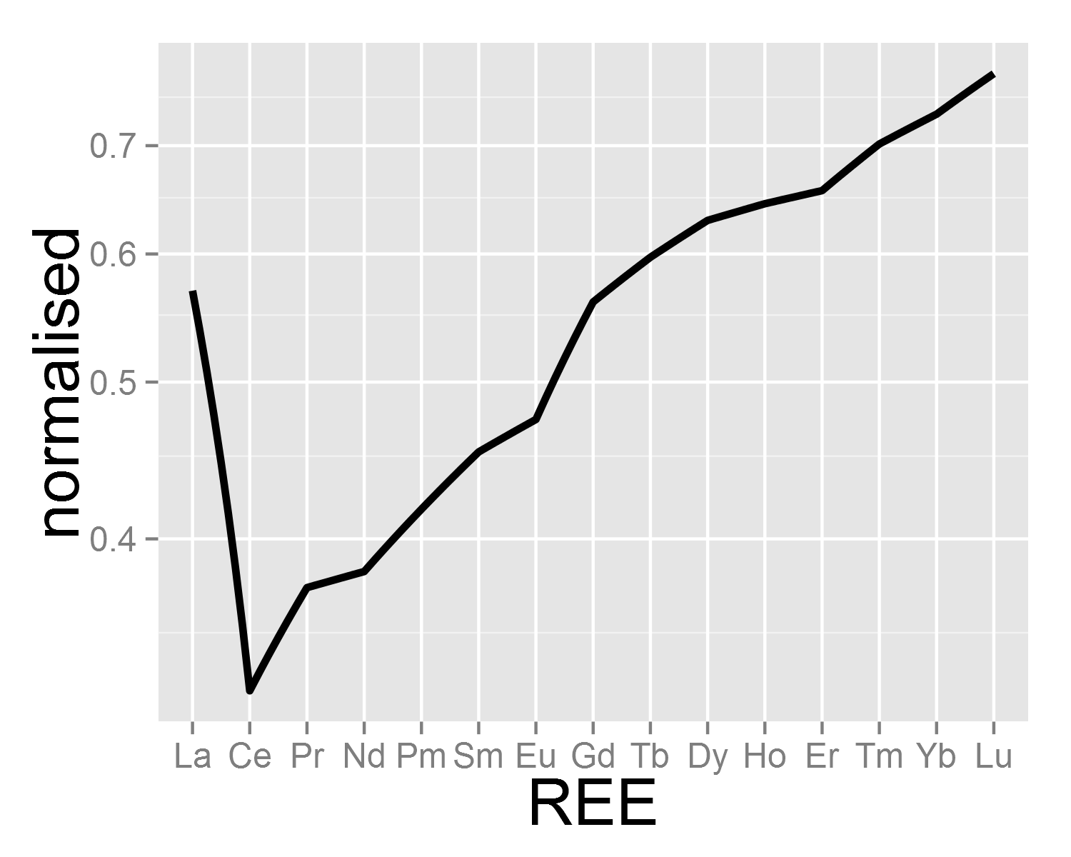

plot of chunk unnamed-chunk-6

sessionInfo()

## R version 3.1.1 (2014-07-10)  
## Platform: x86_64-w64-mingw32/x64 (64-bit)  
##   
## locale:  
## [1] LC_COLLATE=German_Austria.1252 LC_CTYPE=German_Austria.1252   
## [3] LC_MONETARY=German_Austria.1252 LC_NUMERIC=C   
## [5] LC_TIME=German_Austria.1252   
##   
## attached base packages:  
## [1] grid stats graphics grDevices utils datasets methods   
## [8] base   
##   
## other attached packages:  
## [1] knitr_1.6 plyr_1.8.1 nlme_3.1-117 ape_3.1-4   
## [5] metRology_0.9-17 plotflow_1.0 gridExtra_0.9.1 ggplot2_1.0.0   
##   
## loaded via a namespace (and not attached):  
## [1] colorspace_1.2-4 digest_0.6.4 evaluate_0.5.5   
## [4] formatR_0.10 gtable_0.1.2 htmltools_0.2.4   
## [7] labeling_0.2 lattice_0.20-29 MASS_7.3-33   
## [10] munsell_0.4.2 numDeriv_2012.9-1 proto_0.3-10   
## [13] Rcpp_0.11.2 reshape2_1.4 rmarkdown_0.2.50   
## [16] scales_0.2.4 stringr_0.6.2 tools_3.1.1   
## [19] yaml_2.1.13